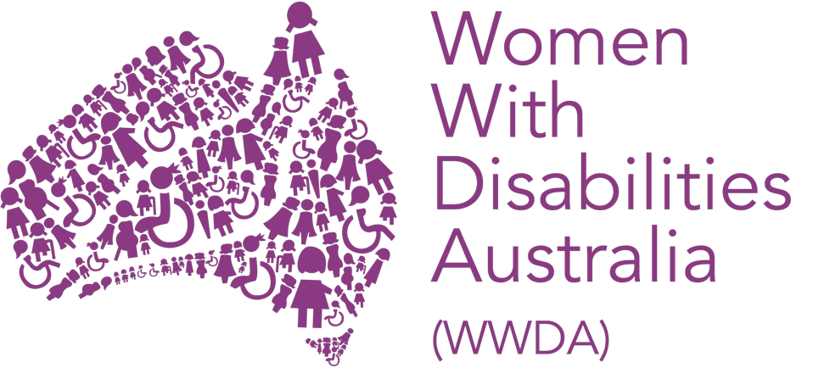

ANNUAL GENERAL MEETING

INFORMATION PACK

Annual General Meeting Papers for the Reporting Period
(1 July 2020 – 30 June 2021)

Women With Disabilities Australia (WWDA) Inc
PO Box 407, Lenah Valley TAS 7008
Ph: 0438 535 123
E: officeadmin@wwda.org.au

Contents

WWDA Annual General Meeting 2021 Agenda 3

Minutes of the 2020 WWDA National Annual General Meeting 4

WWDA Financial Statements and Auditors Report 7

WWDA Board 2021-2022 8

Confirmation of WWDA Board Meeting dates for 2021-2022 10

Appointment of WWDA Public Officer for 2021-2022 11

Appointment of WWDA Auditor for 2021-2022 12

Women With Disabilities Australia (WWDA)

National Annual General Meeting (AGM)
Wednesday 24th November 2021
6pm – 7pm Australian Eastern Daylight Time
via Zoom Videoconference

AGENDA

1. Welcome to Country by Yvonne Weldon

2. Address from Senator the Hon Marise Payne, Minister for Women

3. Present

4. Apologies

5. Ratification of Minutes: WWDA National Annual General Meeting 2020

6. WWDA Staff Presentations:

- Heidi La Paglia, Director, WWDA Policy and Programs
- Saphia Grant – Manager, WWDA LEAD Project
- Vanamali Hermans – Project and Policy Officer, WWDA Projects
- Tess Moodie – Senior Policy Officer, Disability Royal Commission

7. Tabling of Audited Financial Statements

8. Announcement of WWDA Board 2021-2022

9. Confirmation of WWDA Board Meeting Dates for 2021-2022

10. Appointment of WWDA Public Officer for 2021-2022

11. Appointment of WWDA Auditor for 2021-2022

Women With Disabilities Australia
Minutes of the 2020 Annual General Meeting (AGM)
Wednesday 16th December 2020

Agenda Item 1: Welcome – from the WWDA President

WWDA President, Tricia Malowney OAM, welcomed all participants to the 2020 WWDA Annual General Meeting, including those WWDA members who had called in via Zoom to join the AGM. Tricia gave the formal Acknowledgement to Country and also acknowledged the dedication and service provided to WWDA by the late Sue Salthouse who was tragically taken in an accident earlier this year.

Agenda Item 2: Present

Tricia Malowney, Pamela Menere, Allirra Honner, Carolyn Frohmader, Sharon Williams, Libbi Cunnington, Heidi La Paglia, Jacinta Carlton, Mali Hemans, Julia Svaganovic, Maria Scharnke, Helen Pritcher, Tanya Carrol, Natasha Wilmann, Elania Alien, Karleen, Helen Said, Diana Piantedos, Grace, Raelene Bock, Kylee Roberts, Taminka Hanscamp, Roni Corne, Tamara, Auslan Interpreter Nick and Captioners David and Debbie.

Agenda Item 3: Apologies

WWDA received formal apologies for the WWDA AGM from Jody Barney and Donna Justo.

Agenda Item 4: Ratification of Minutes: WWDA National Annual General Meeting 2019

Motion: That the Minutes from the WWDA Annual General Meeting held on Sunday 10th November 2019 be accepted as a true and correct account of that meeting.

Moved: Pamela Menere
Seconded: Allirra Honner

Agenda Item 5: Tabling of WWDA Presidents Report – Tricia Malowney

Tricia Malowney OAM tabled her written report, which had been provided in advance to the WWDA Board members in the AGM Papers for 2020.

Motion: That the WWDA President’s report be accepted as an official report of this Meeting.

Accepted unanimously.

Agenda Item 6: Tabling of WWDA Executive Director Report – Carolyn Frohmader

The Executive Directors written Report was provided to the WWDA Board members in the AGM Papers for 2020, two weeks prior to the meeting. Carolyn spoke to her written report and highlighted some of WWDA’s key achievements over the funding period of 2019-2020, and the difficulties WWDA faced this year due to the impact of the COVID pandemic. Carolyn advised those present that more detail on WWDA’s achievements will be available in WWDA’s Annual Report for 2019-2020 that will be made publicly available tomorrow.

Motion: That the WWDA Executive Director’s report be accepted as an official report of this Meeting.

Accepted unanimously.

Agenda Item 7: Tabling of Audited Financial Statements

The Audited Financial Statements 2019-2020 were provided to the WWDA Board members in the AGM Papers for 2019-2020 two weeks prior to the AGM. Pamela Menere (WWDA Treasurer) spoke to the Audited Statements. Pamela thanked Carolyn Frohmader, Cody Burdon and Sharon Williams for their work in managing WWDA’s finances.

Motion: That the Audited Financial Statements for 2019-2020 be accepted as an official report of this Meeting.

Moved: Pamela Menere
Seconded: Tanya Carrol

Agenda Item 8: WWDA Management Committee 2020-2021

WWDA President Tricia Malowney formally announced the WWDA Management Committee for 2020-2021. The WWDA Management Committee 2020-2021 is as follows:

Tricia Malowney - Term expires 2022
Pamela Menere - Term expires 2022
Allirra Honner - Term expires 2022
Jody Barney - Term expires 2022

WWDA will be calling for nominations for the Board in late February - early March 2021 to fill the available positions.

Agenda Item 9: Confirmation of Board Meeting Dates for 2020-2021

President Tricia Malowney announced the WWDA Management Committee meeting dates for the 2020-2021 year:

Wednesday 24th February 2021 at 4.30pm Eastern Summer Time
Wednesday 28th April 2021 at 4.30pm Eastern Summer Time
Wednesday 30th June 2021 at 4.30pm Eastern Standard Time
Wednesday 25th August 2021 at 4.30pm Eastern Standard Time
Wednesday 27th October 2021 at 4.30pm Eastern Summer Time

Annual General Meeting 2021

Wednesday 24th November 2021 at 4.30pm Eastern Summer Time (TBC)

Agenda Item 10: Appointment of the WWDA Public Officer for 2020-2021 by the WWDA Board

Jessica White (ACT) was re-appointed as WWDA Public Officer for the 2020- 2021.

Agenda Item 11: Appointment of WWDA Auditor for 2020-2021

Motion: That Bentley’s Hobart is appointed as WWDA’s Auditor for the 2020-2021 financial year.

Moved: Pamela Menere
Seconded: Allirra Honner

The meeting formally closed at 1.11 pm

Women With Disabilities Australia (WWDA)

Financial Statements
1 July 2020 – 30 June 2021

The audited WWDA Financial Statements 1 July 2020 - 30 June 2021 are provided as a separate attachment to this document.

The Independent Auditors Report 1 July 2020 - 30 June 2021 is also provided as a separate attachment.

Women With Disabilities Australia (WWDA)

WWDA Board

2020 – 2021
2021 - 2022

The membership of the WWDA Board for the reporting period July 2020 – June 2021 was as follows:

Tricia Malowney - Term expires 2022
Jessica White - Term expires 2020 (Stepped down in October 2020)
Monique Crowden - Term expires 2020 (Resigned in October 2020)
Allirra Honner - Term expires 2022
Jody Barney - Term expires 2022 (Resigned in August 2021)
Tricia Malowney - Term expires 2022 (Resigned in August 2021)

The WWDA Board Executive 2020-2021 was as follows:

Tricia Malowney – President
Jessica White – Vice President
Pamela Menere – Treasurer

During the reporting period 1 July 2020–30 June 2021, there were the following changes to the WWDA Board:

Monique Crowden resigned from the Board in October 2020.
Jessica White stepped down for a period in October 2020 and re-joined the Board in September 2021.

NB: Although outside the reporting period (July 2020 – June 2021) for the purposes of the 2021 WWDA Annual General Meeting, the additional information is provided:

Tricia Malowney - Resigned from the WWDA Board in August 2021
Jody Barney - Resigned from the WWDA Board in August 2021

WWDA Board Election Process 2021

In August-September 2021, WWDA invited Expressions of Interest from WWDA members (who had been members for at least a period of 12 months), to nominate for vacant positions on the WWDA Board, to be announced at the WWDA AGM 2021. As a Disabled People’s Organisation (DPO), WWDA members have the right to elect their Board representatives.

WWDA employed the services of the company ‘GoVote Pty Ltd’, which conducted all aspects of the election process for WWDA, to ensure an independent, transparent, and democratic process.

The following WWDA Board members will continue their tenure for 2021-2022, as their terms have not expired. These Board members are:

Pamela Menere - Term expires 2022
Jessica White - Term expires 2024 (formally re-elected)
Allirra Honner - Term expires 2022

Five new Board members will join Pamela, Jessica, and Allira, and will serve a three-year term. The five successful Board members, as elected by the WWDA membership through the independent ‘GoVote’ election process, will be announced at the WWDA AGM.

The new WWDA Board will then elect the Board Executive positions through a nomination process, at the first Board meeting held following the AGM.

Women With Disabilities Australia (WWDA)

WWDA Board
Confirmation of Meeting dates for 2022

The proposed WWDA Board Meeting dates for 2022 are as follows:

WWDA Board Meeting dates for 2021 - 2022 are proposed as follows:

Wednesday 15th December 2021 - at 4.00pm Eastern Summer Time [to elect WWDA Executive]

Wednesday 23rd February 2022 at 4.00pm Eastern Summer Time
Wednesday 27th April 2022 at 4.00pm Eastern Summer Time
Wednesday 29th June 2022 at 4.00pm Eastern Standard Time
Wednesday 24th August 2022 at 4.00pm Eastern Standard Time
Wednesday 26th October 2022 at 4.00pm Eastern Summer Time

Proposed Annual General Meeting 2022

Wednesday 23rd November 2022 at 6.00pm Eastern Summer Time

NB: The proposed meeting dates and frequency of WWDA Board meetings, will be confirmed by the WWDA Board at the first meeting following the AGM.

Women With Disabilities Australia (WWDA)

Appointment of WWDA Public Officer
2021 - 2022

The WWDA Management Committee is required to appoint a Public Officer for WWDA for the 2021-2022 year. WWDA’s Public Officer for the 2021-2022 is:

Jessica White – jessica.white.97@outlook.com

Women With Disabilities Australia (WWDA)
Appointment of WWDA Auditor for 2021 - 2022

Each year at the AGM, the WWDA Board is required to appoint an auditor for the following year.

WWDA appoints Bentleys Tasmania to continue as our audit company:

Bentleys Tasmania
Level 2/39 Sandy Bay Rd,
Battery Point TAS 7004, Australia
Ph: +61 3 6242 7000
E: admin@bentleystas.com.au
W: https://www.bentleys.com.au/offices/bentleys-tasmania/

