Women With Disabilities Australia

wwda.org.au

**WWDA Youth   
Survey on Your Period and Safer Sex**

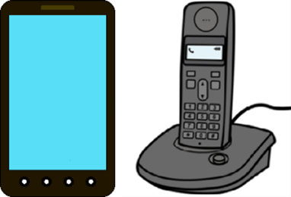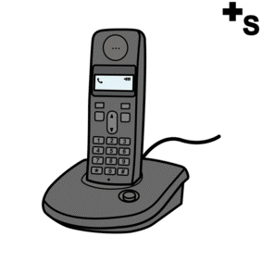

**You need help**

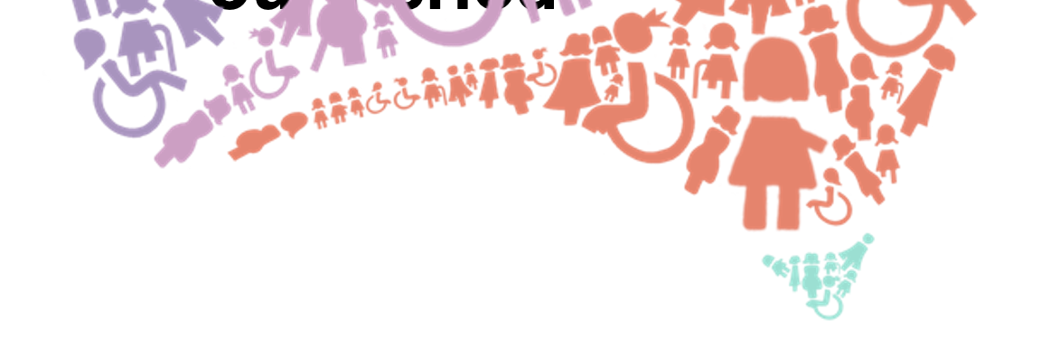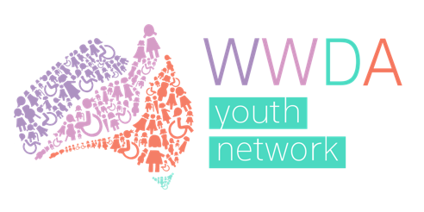

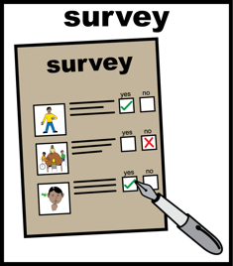

You read some of the questions.

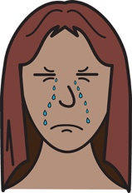

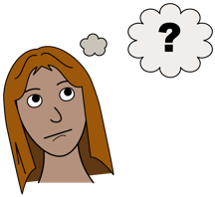You may feel

* + - * sad
      * worried
      * confused.

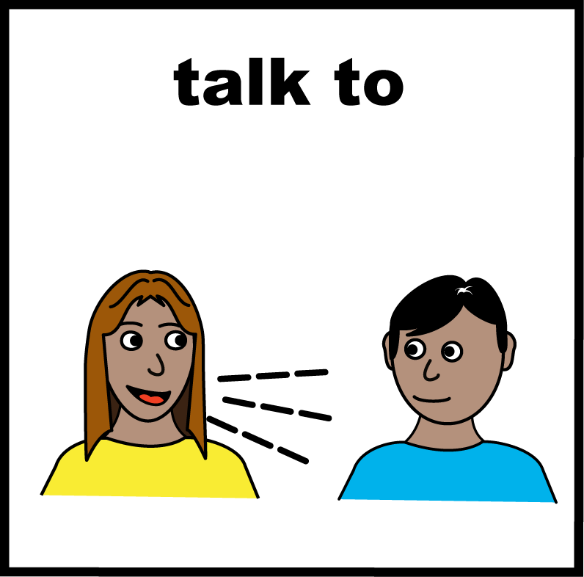

You want to talk about

* + - * how you feel
      * what you can do now.

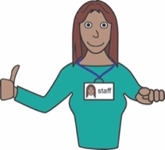

This fact sheet has services that you can talk to.

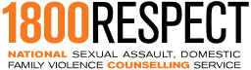

**1800RESPECT**



1800 Respect are open

* all day and night
* all year.

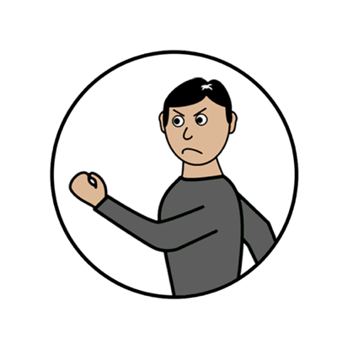

1800 RESPECT can talk to you about

* violence
* abuse

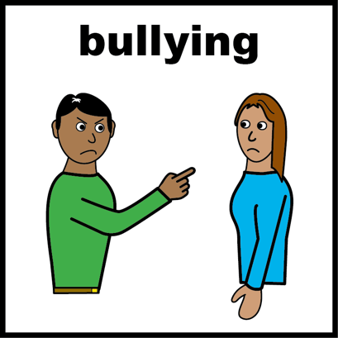

* someone making you feel bad.

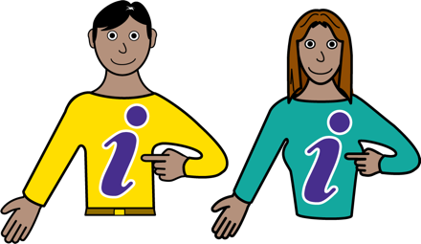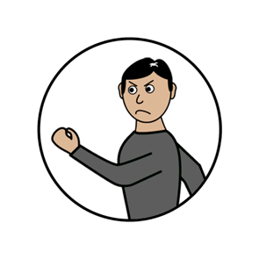

Learn more about

* violence
* abuse

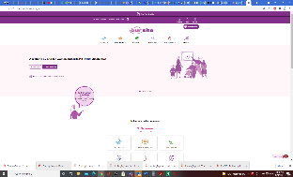

Go to www.oursitewwda.org.au

Click on **Easy English** at the top.

**Now.**

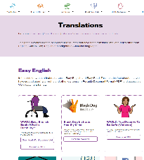

Click **Safety from Violence**.

There is lots of information here. Like

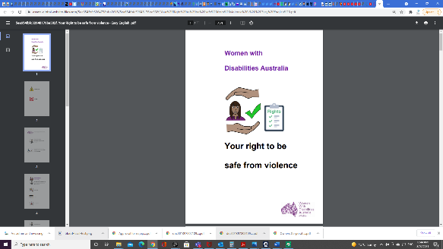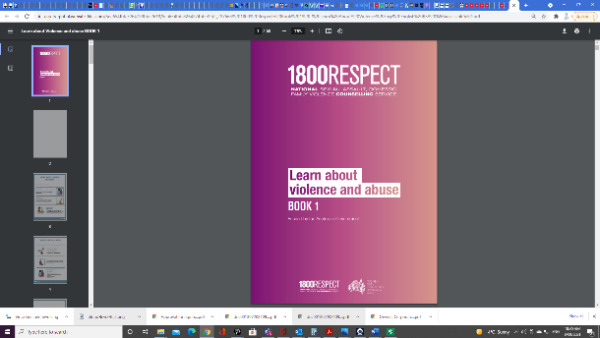

* Your right to be safe from violence
* 1800 Respect. Book 1. Learn about violence.



Call 1800 737 732.

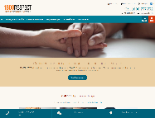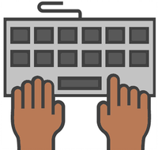

On your computer.

Website www.1800respect.org.au

Find the button at the bottom called

**Chat online**.

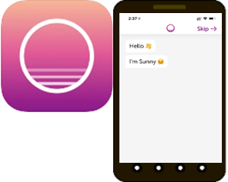

1800RESPECT has an App.

It is called Sunny.

Sunny is for women and girls who

* have a disability.



Sunny can help you

* learn about violence
* get help
* tell your story.



Download Sunny from

* Google play store
* App store.

**Lifeline**

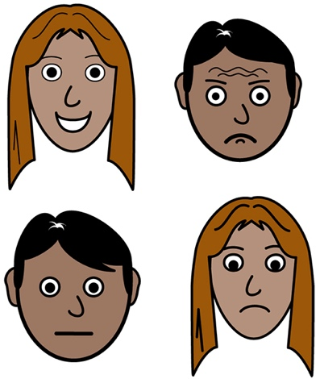

Lifeline can help when

* there is something really bad in your life
* you think you may hurt yourself.

Lifeline is open



* all day and night
* all year.



Call 13 11 14.

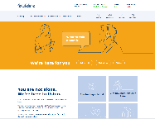

On your computer.

Website www.lifeline.org.au

Find the button in the middle called

**Chat with us**.

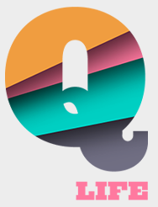**QLife**

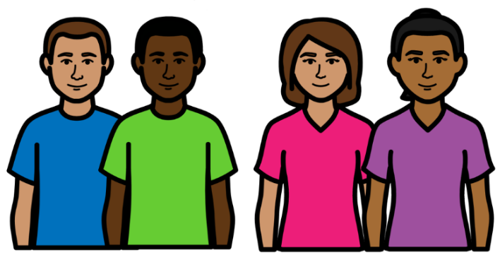

QLife is for people who are

* lesbian
* 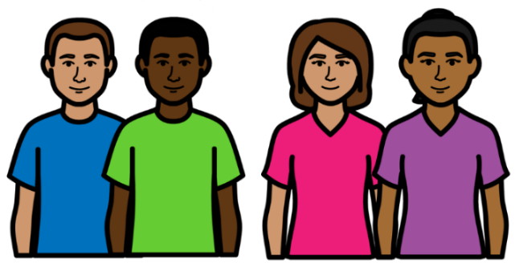gay
* bisexual
* transgender
* queer
* intersex.



We sometimes write LGBTIQA+

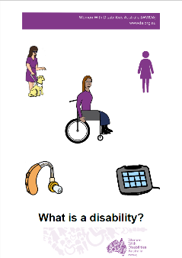Want to know **what Is LGBTIQA+?**

Find out more. Read it in Easy English.

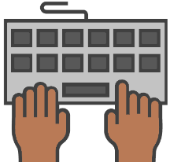

Go to **www.oursite.wwda.org.au**

Open the search window

Type **WWDA Easy English Book.**

**What is a LBTIQA+?**

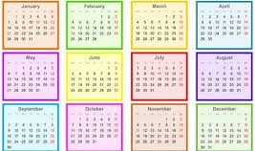

QLife are open

* every day of the year

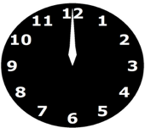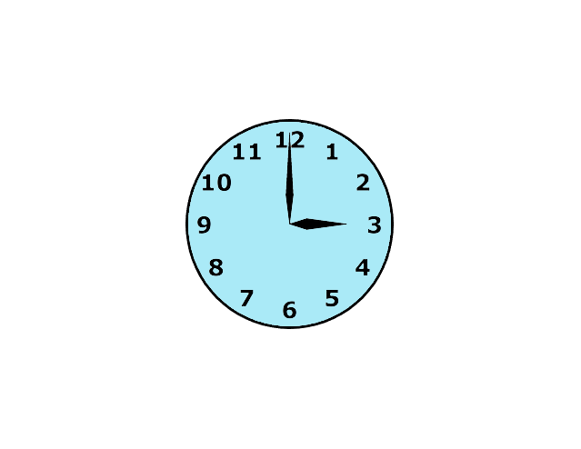

* 3 pm to midnight.



Call 1800 184 527.

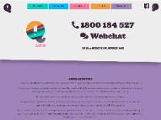

On your computer.

Website www.qlife.org.au

Find the button in the middle called **webchat.**

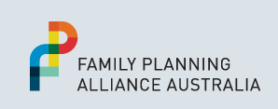**Family Planning**

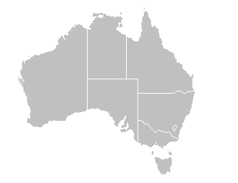

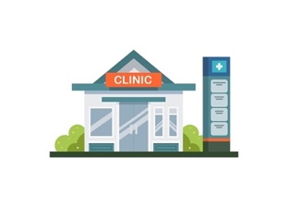Family Planning Alliance Australia has a list of family planning services in each state.



You can talk to your Family Planning service about lots of things. Like

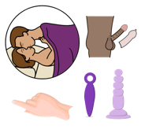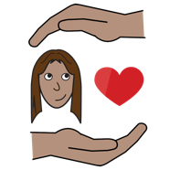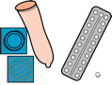

* sex
* contraception

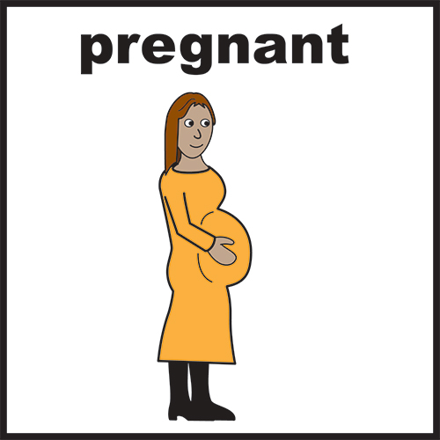

* pregnancy
* having babies.



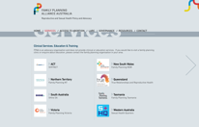On your computer.

Website [**familyplanningallianceaustralia.org.au/services**](http://familyplanningallianceaustralia.org.au/services/)





Choose the service in your state.

Go to its website.

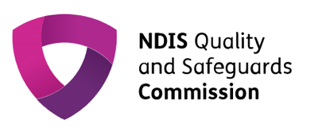**NDIS Quality and Safeguards Commission**

****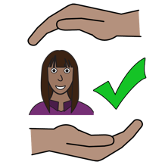NDIS Quality and Safeguards Commission make sure NDIS services

* treat you well
* keep you safe.

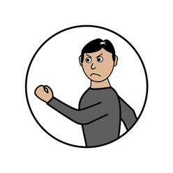

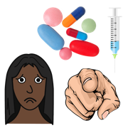NDIS Quality and Safeguards Commission can help you if a service

* makes you do something you do not want to do
* does violence to you.

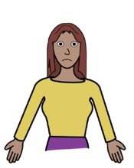

They can help you complain about a service.

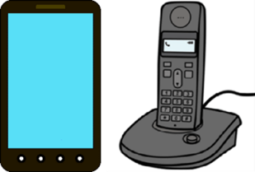Call [**1800 035 544**](tel:1800035544)**.**



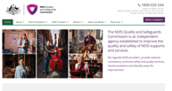On your computer.

Website [**https://www.ndiscommission.gov.au/**](https://www.ndiscommission.gov.au/)

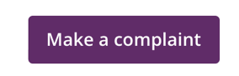

Find the button called **Make a complaint**

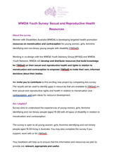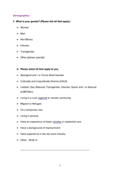**This survey**

# This fact sheet is based on the WWDA Youth Survey: Sexual and Reproductive Health Resources. **Who wrote this fact sheet?** Women With Disabilities Australia wrote this fact sheet in 2021. 2021.

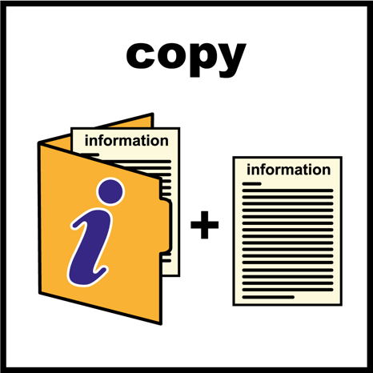  
**Copyright**   
© Copyright Women With Disabilities Australia (WWDA) Inc. 2021. All intellectual property rights, including copyright and patents, in this fact sheet is owned and licensed by Women with Disabilities Australia Inc.

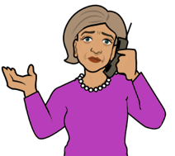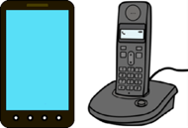**Images**We have used images from

* ****COMPIC
* Easy On The I
* 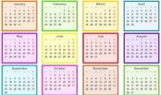Google Images
* Inspired Services
* 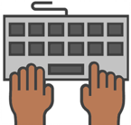Picto-Selector



* Spectronics
* The Noun Project.