Women With Disabilities Australia
wwda.org.au
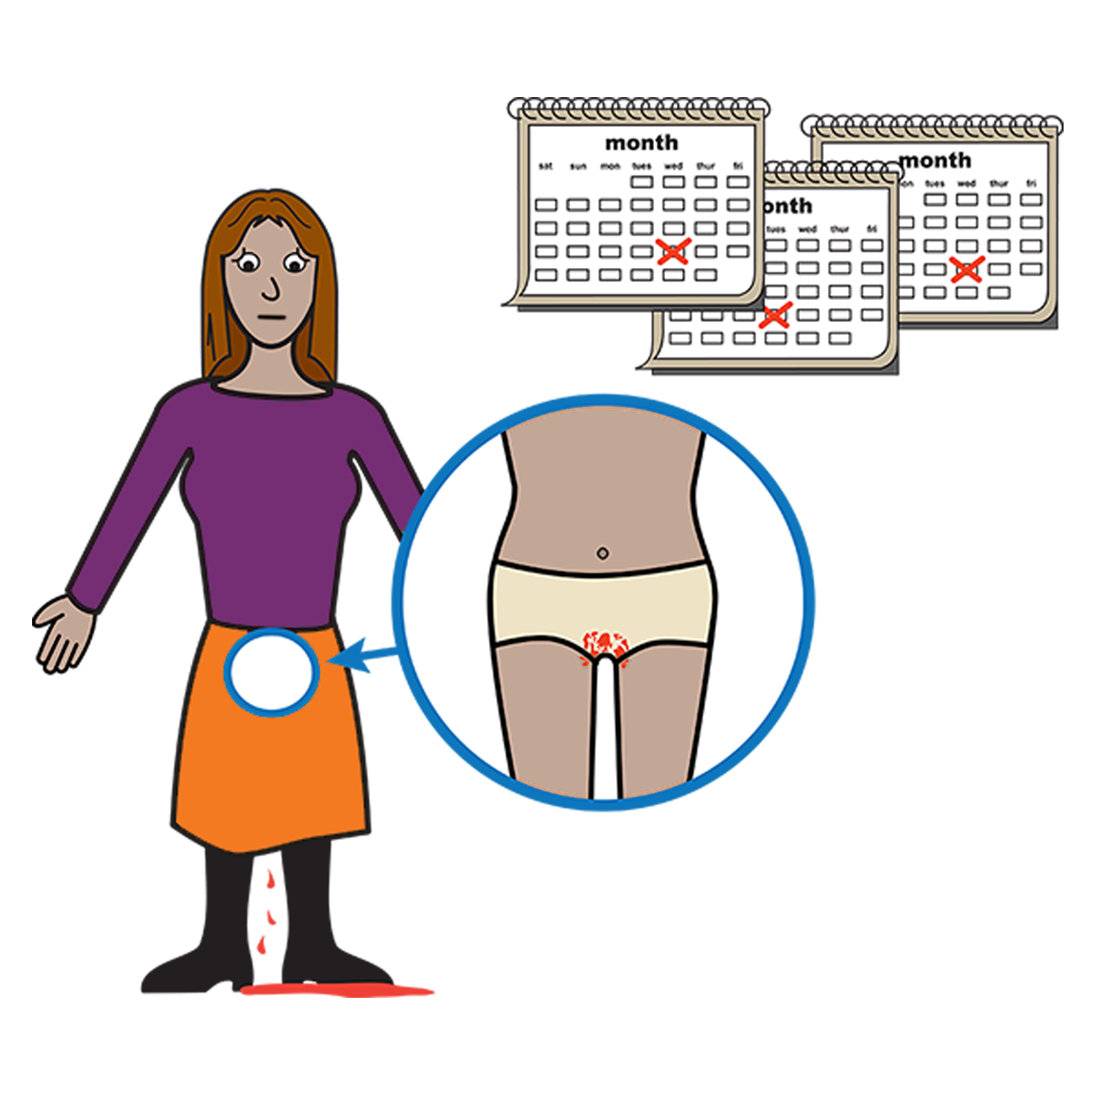
WWDA Youth Fact Sheet

Your period. It is
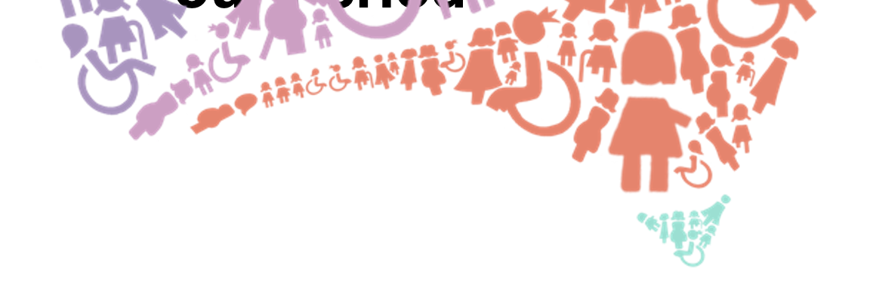
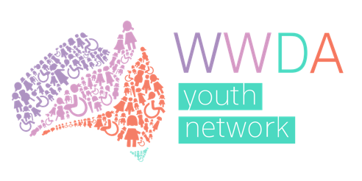
called Menstruation.

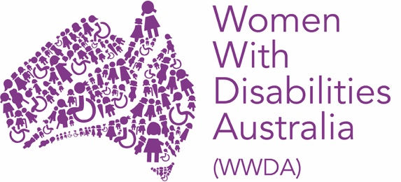
We are Women With Disabilities Australia.

This book is about your period.
Your period is also called menstruation.

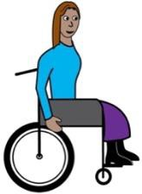

We wrote this book for women and girls with disability.

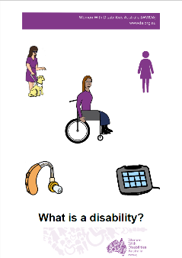
Do you think you have a disability?
Find out more. Read it in Easy English.

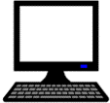
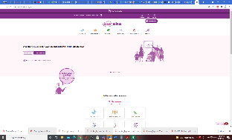
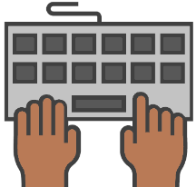
Go to www.oursite.wwda.org.au
Open the search window
Type WWDA Easy English Book.
What is a Disability?
What is my period?
It is also called Menstruation.

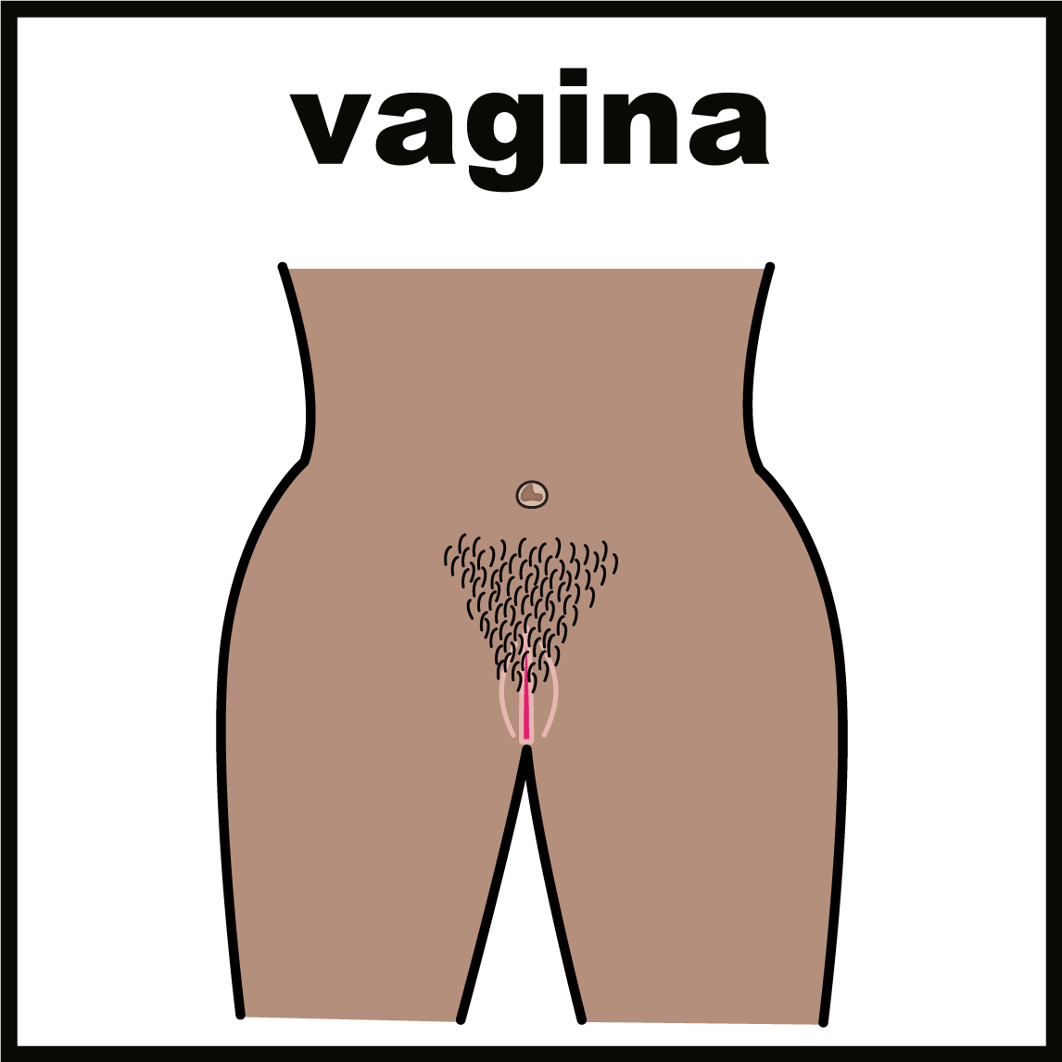
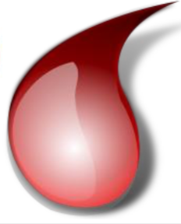
Your period is when you bleed from your vagina.

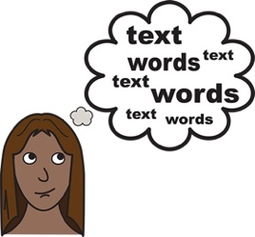

Some people call their period other things.

Like

- time of the month.

When will I get my period?

Most girls get their first period when they go
through puberty.

This is any time from 10 years old
to 15 years old.

You will get your period:
- about once a month
- for 4 to 7 days.

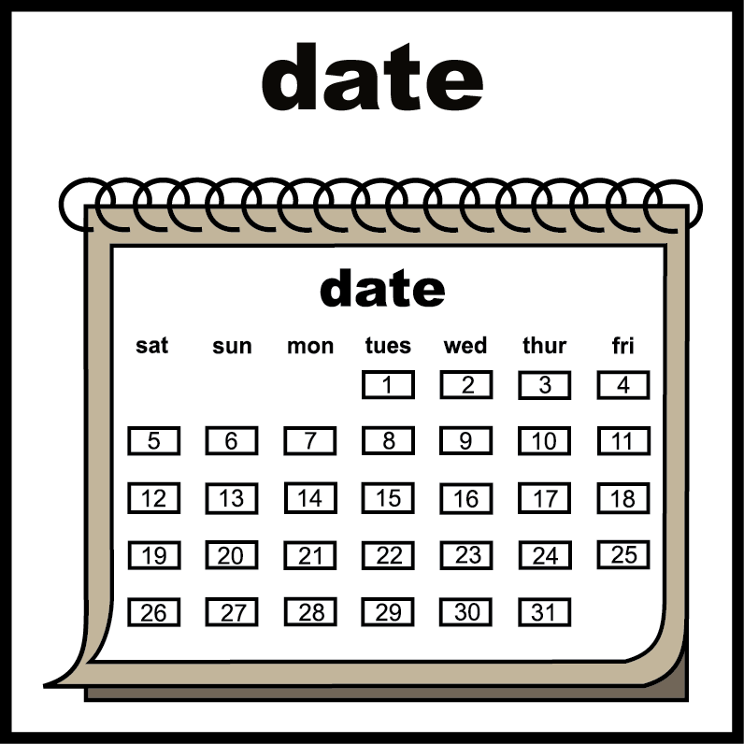
Some people have periods for a different time.
Like
- every 6 weeks
- for 5 days.

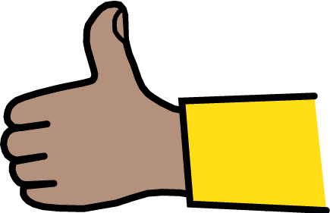
This is OK.

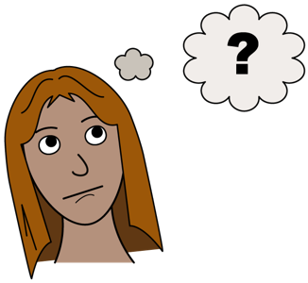
Why do I get a period?

Girls are born with 2 ovaries. They are inside your body. You cannot see them.

Your ovaries have eggs in them. They are for when you start a baby.

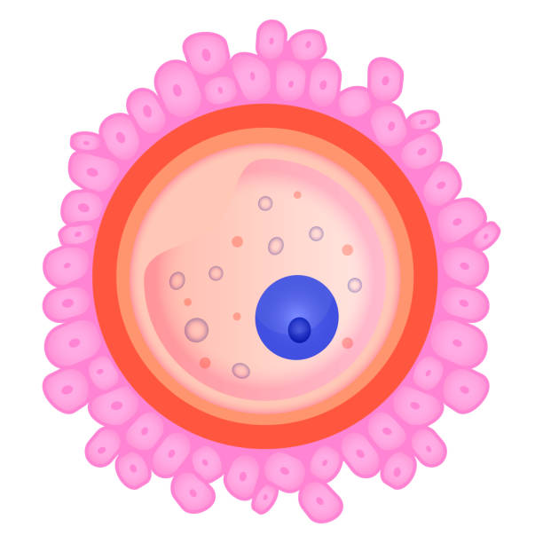
Each month your body lets an egg go.

When you do not want to get pregnant the egg:
- must come out of your body
- comes out in some blood

This is when you have your period.

How will you feel when
you have your period?

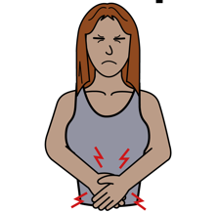

Your stomach may hurt.

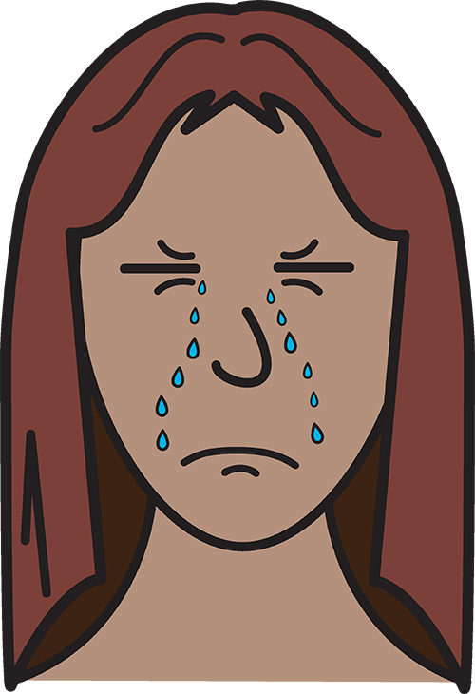
You may feel
- grumpy
- sad.

You do not need to worry.
This is OK.

What if the pain is really bad?

Some people may have a lot of pain that does not go away.

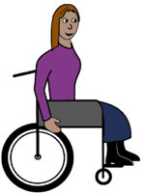
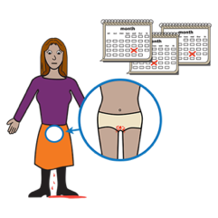

This means you could have a disability or illness that makes your period harder.

Like

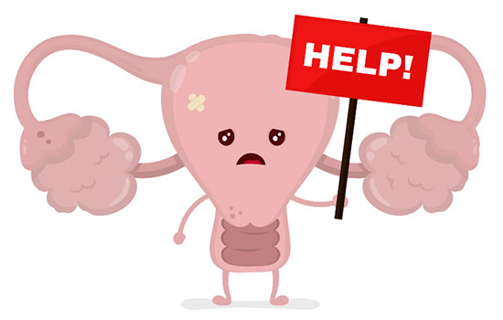
- Endemetriosis
Endemetrosis is when your body grows tissue outside of your uterus.

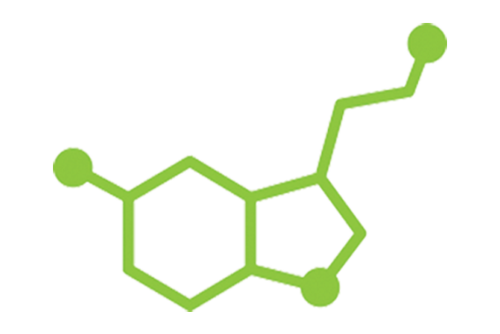
- Polycistic Ovary Syndrome or PCOS
PCOS is a condition that changes your hormones.

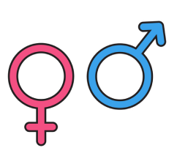
Hormones are chemicals inside your body that are said to be male or female.

Do you think you have a disability or illness that makes your period harder?

You should talk to your doctor.

What to do when your

period starts.

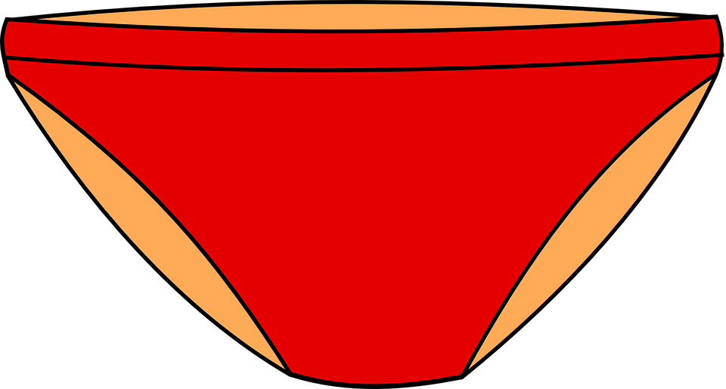

You need to wear something to catch the blood.

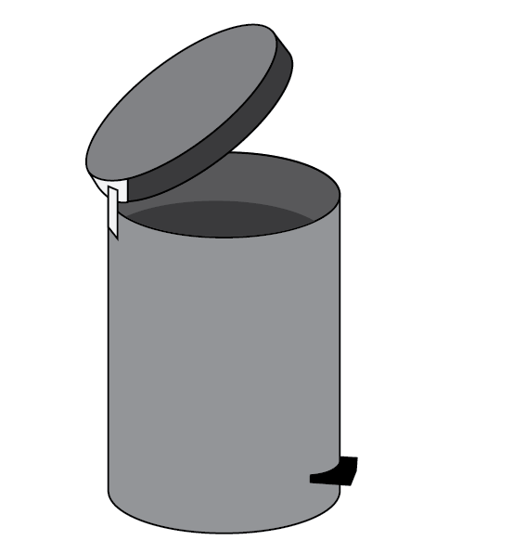

You can use something you throw away

after it is used.

or

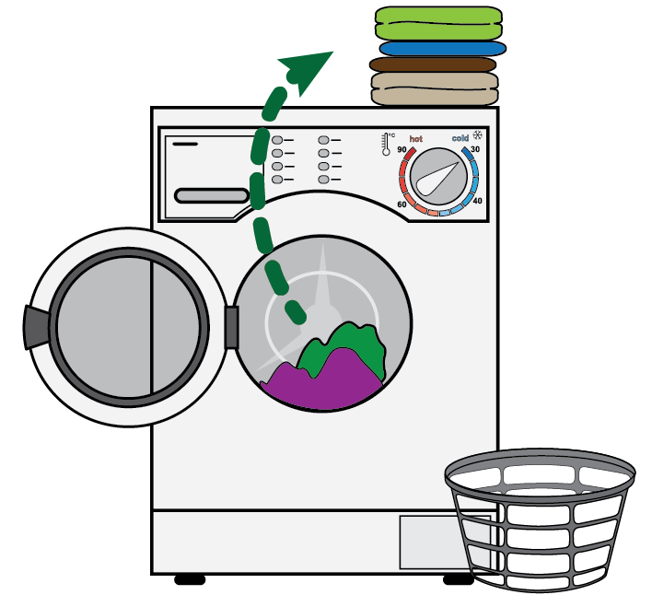

You can use things that you wash.

You can then use them again.

There are things to use. Then throw away.

Like

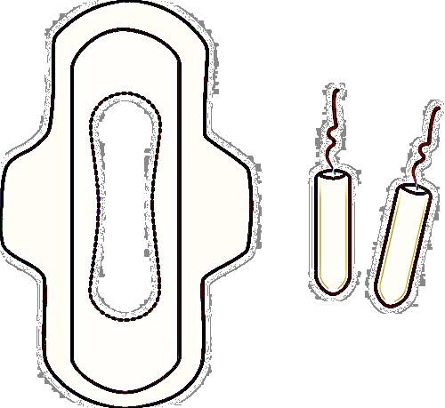
- sanitary pads.

You wear them in your underpants.

or

- tampons. You put them in your vagina.

You can buy these from most shops.

Like
- supermarkets
- chemists.

There are things to use. Then wash and use again. Like

- period proof underwear

- menstrual cups

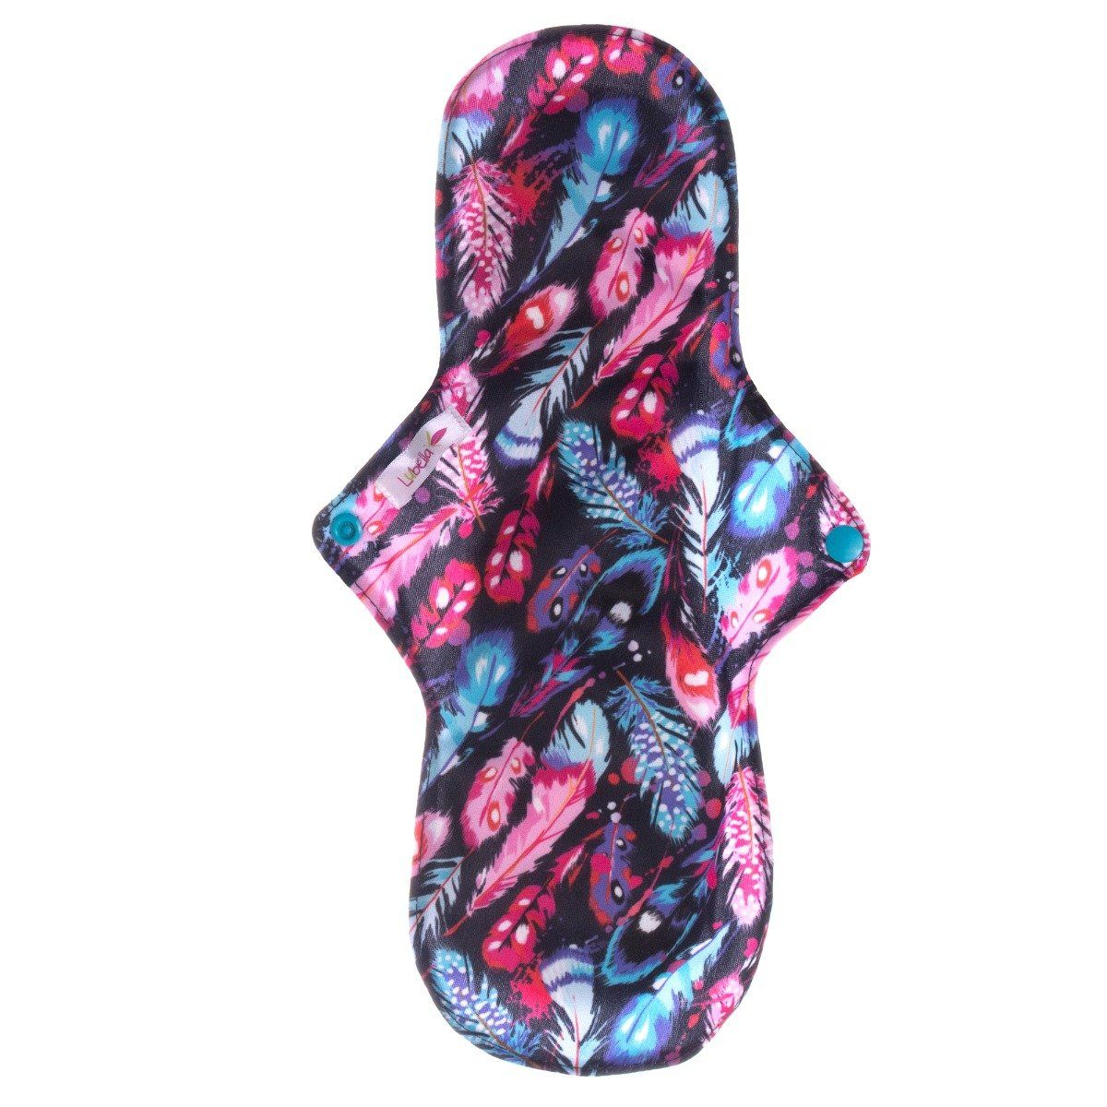

- cloth pads.

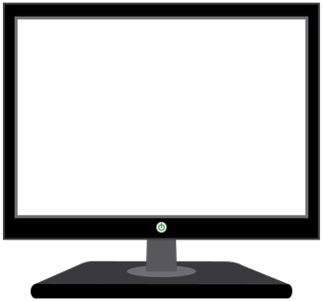

Learn more about the things you can re-use:

www.lunette.com.au/blogs/news/green-your-teens-period
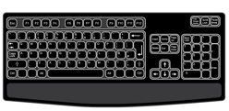

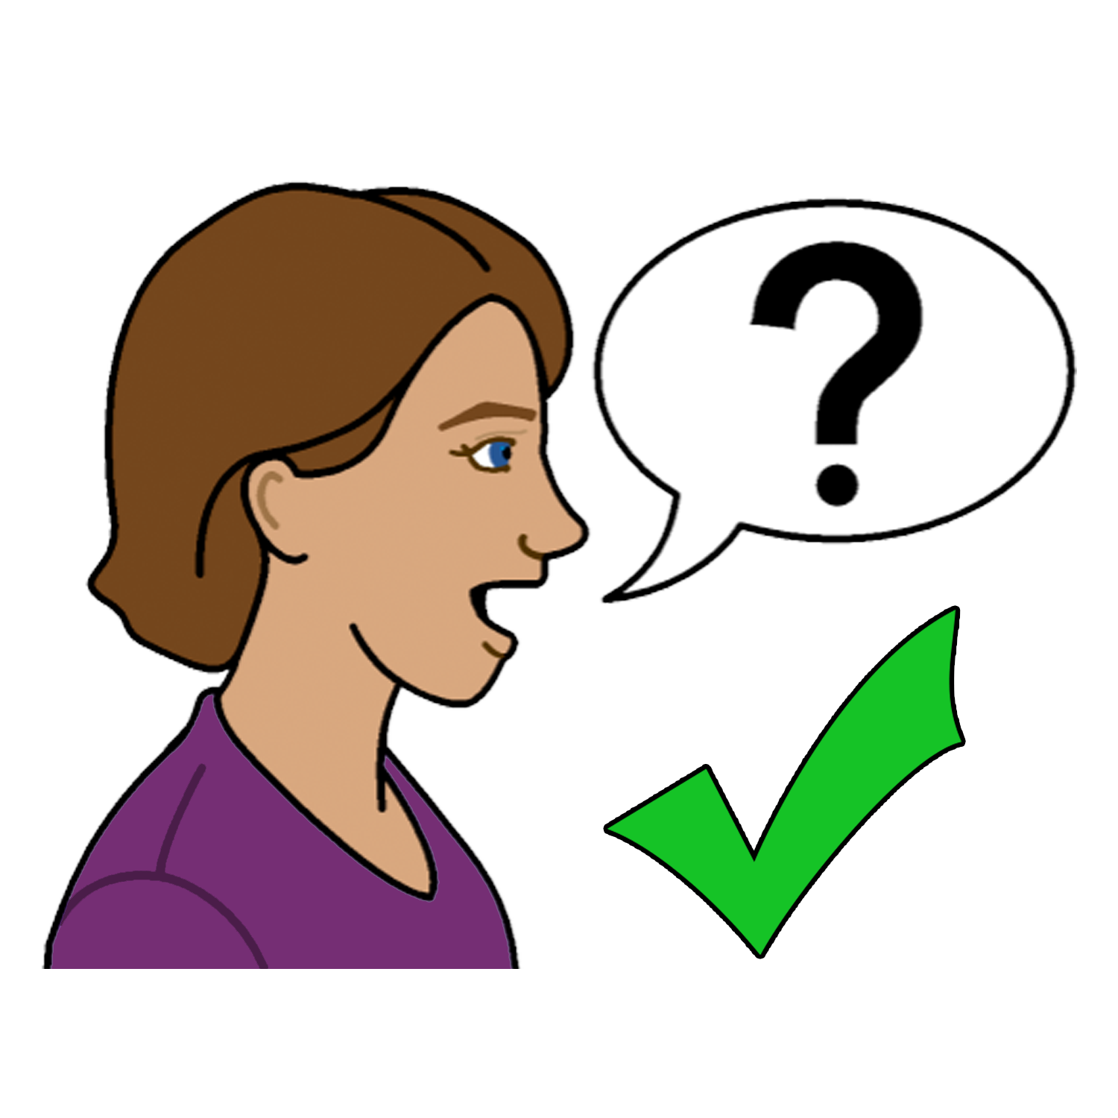
To find out more
You can talk to

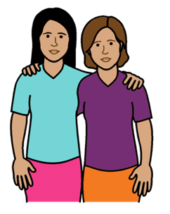
- a friend
- a family member

- your doctor

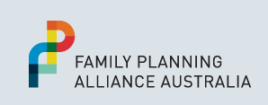
- your local Family Planning Service.
Go to: www.familyplanningallianceaustralia.org.au/services

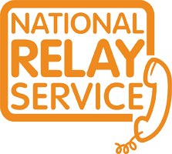
You can use the National Relay Service
when you call a service
Call: ………….. 1800 555 677
TTY: …………. 133 677

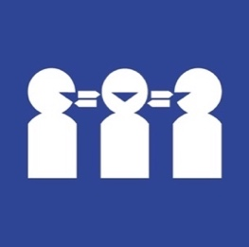
Need a translator
Call ………….. 131 450

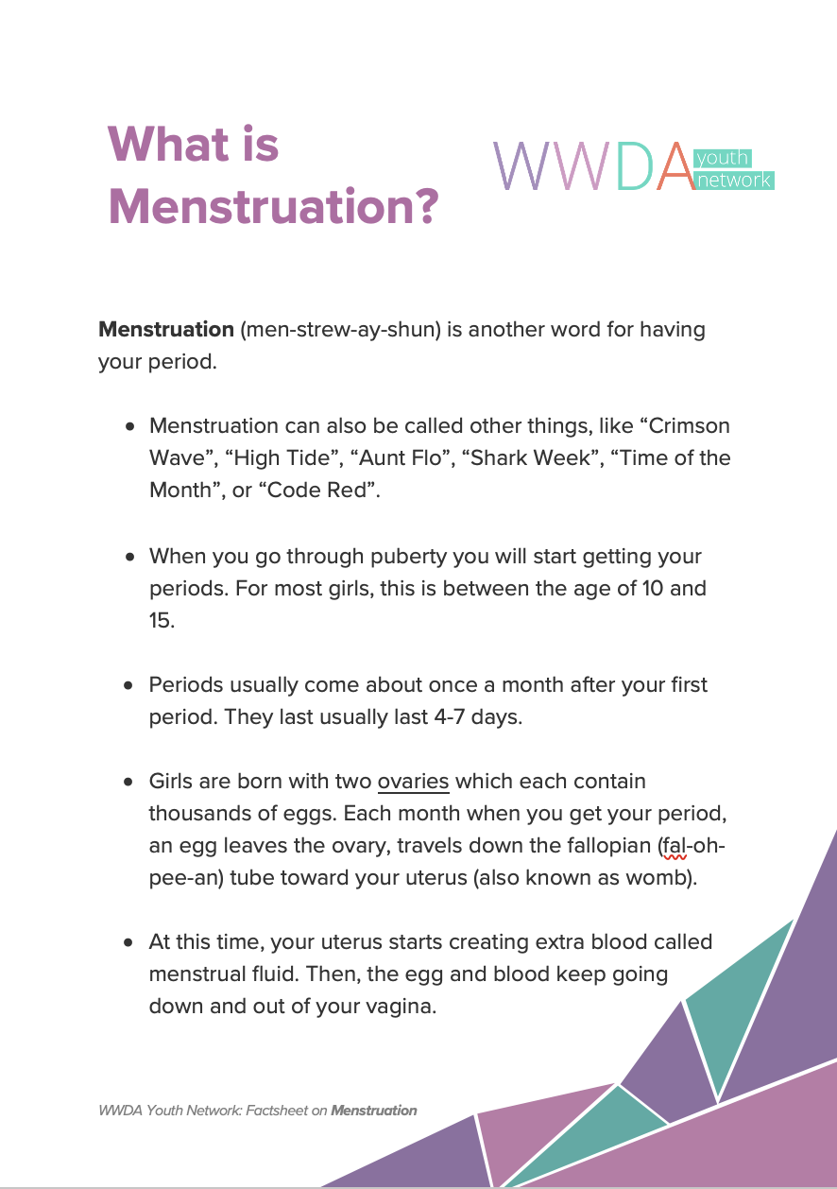
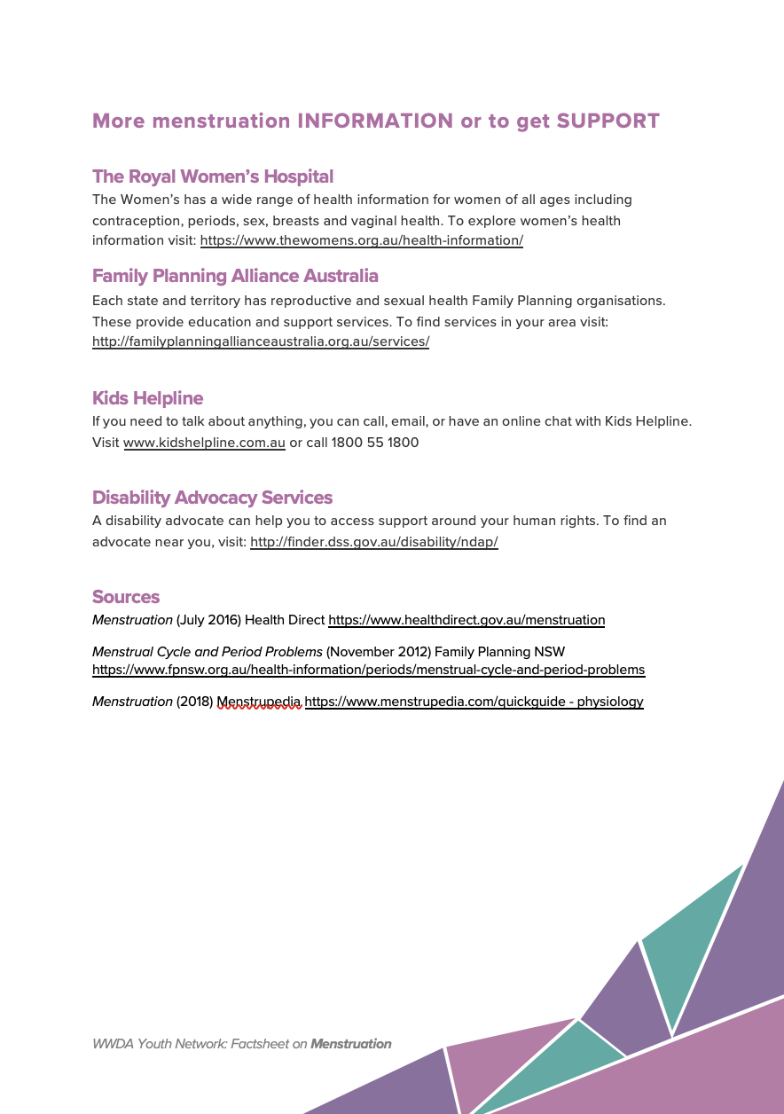
This fact sheet

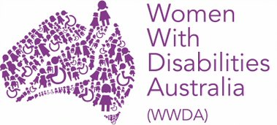
This fact sheet is based on the WWDA Youth Fact Sheet: What is Menstruation.
Who wrote this fact sheet?
Women With Disabilities Australia wrote this fact sheet in 2019-2020.
Copyright
© Copyright Women With Disabilities Australia (WWDA) Inc. 2020. All intellectual property rights, including copyright and patents, in this survey is owned and licensed by Women with Disabilities Australia Inc.
Images
We have used images from
- Easy On The I
- Google Images

