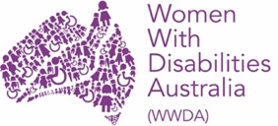
Women With Disabilities Australia
National Alliance
Policy Advisory Group (PAG)

Application Form

Easy Read version

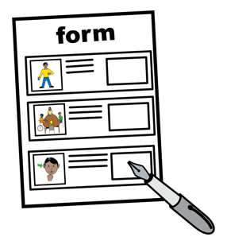
About this form

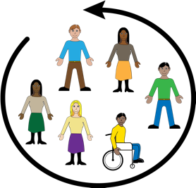
WWDA is inviting WWDA members to apply to join the WWDA Alliance Policy Advisory Group

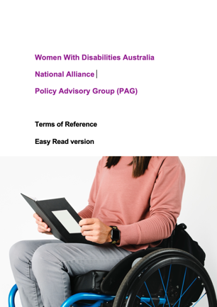
You can read about the Policy Advisory Group in our Easy Read book Women With Disabilities Australia National Alliance Policy Advisory Group (PAG) Terms of Reference

You can apply for the committee using this form.

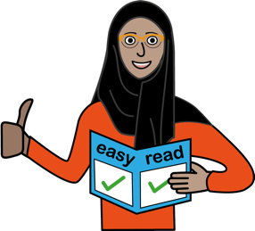
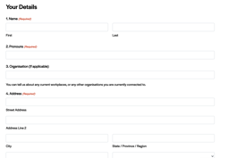
This form is an Easy Read version of an online form.
You can find the online form at https://wwda.org.au/nwa-pag-eoi/
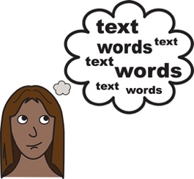
Some words in this form are bold and underlined.
We explain these words mean.

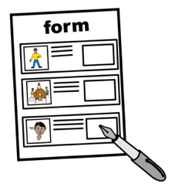
To complete the form

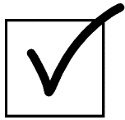
- tick the boxes

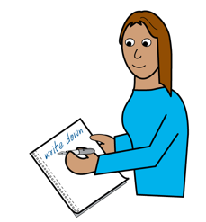
- write on the lines

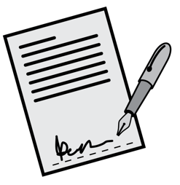

- sign the form.

What is in this form?

About this form 2
What is in this form? 4
Where to send the form 5
You Need Help 6
Contact us 7
Part 1. About you 8
Part 2. Your skills and experiences 21
Part 3. Your support needs 27

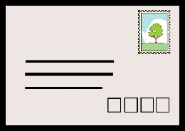
Where to send the form

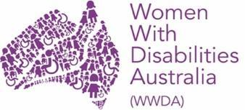
Send to WWDA

- email Director@wwda.org.au

- post
Women With Disabilities Australia
PO Box 407
Lenah Valley TAS 7008.

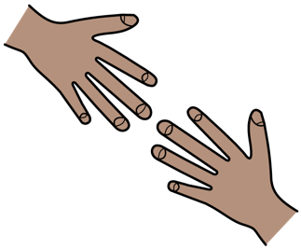
You Need Help
You can ask for help to fill in this form.

You can ask someone you trust. Like

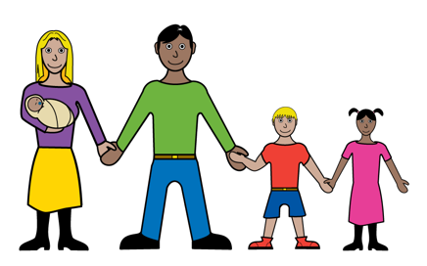
- a family member

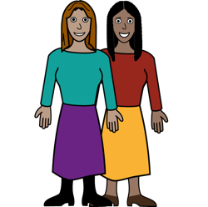
- a friend

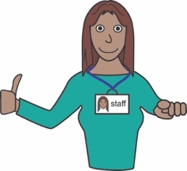
- a support worker
- a carer.

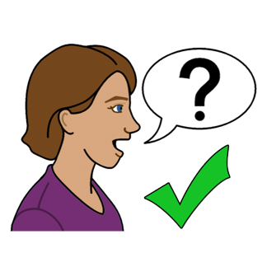
Contact us

You can contact us if have any questions or would like us to help you complete this form.

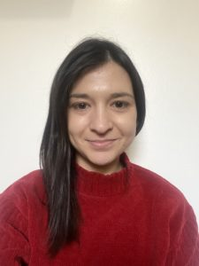
Contact WWDA’s
Director of Policy and Programs
Heidi La Paglia

- email Director@wwda.org.au

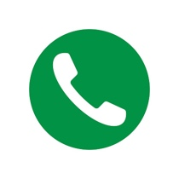
- call 0448 417 850

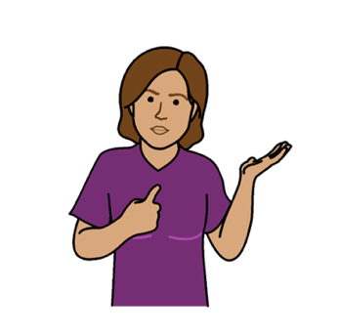
Part 1. About you

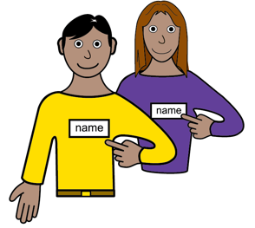

- My name is

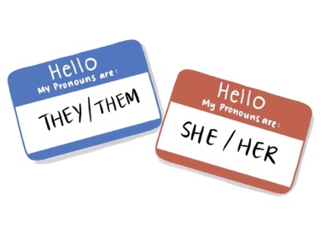
- My pronouns are

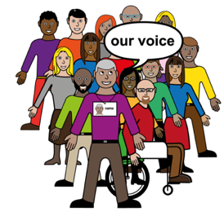
- I represent this organisation or group

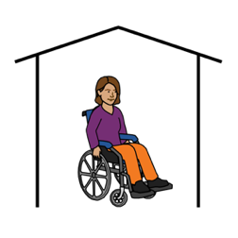
- I live at

- My email is

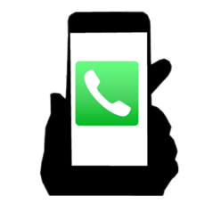
- My phone number is

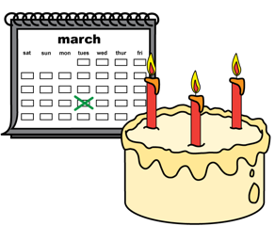
- I was born on
Write the day / month / year

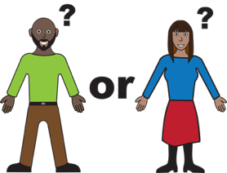
- My gender is

      - man

      - woman

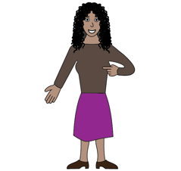

      - feminine identifying
You see yourself as a woman

      - non-binary
This means you are
- not a man
- or a woman.
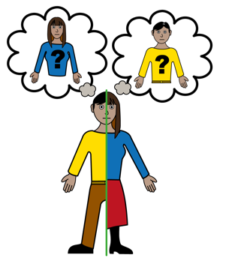

- transgender
You have changed your gender.

- other (tell us below)

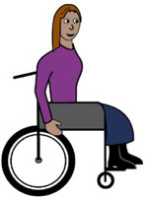
- Do you have a disability?

- Yes

- No

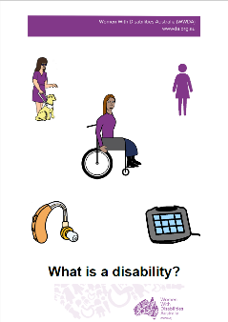
Find out about disability.
Read it in Easy English.

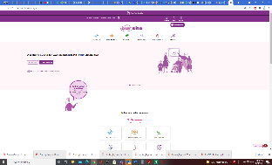
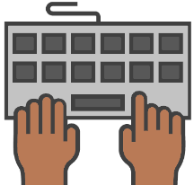
Go to www.oursite.wwda.org.au
Open the search window
Type WWDA Easy English Book.
What is a Disability?
- Tick any disabilities that you have

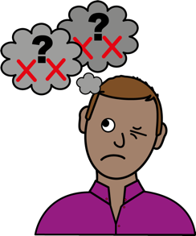

- intellectual disability
Like
        - it is hard to think
        - you need support.

- neurodiverse
Like
        - you are Autistic
        - you have ADHD.

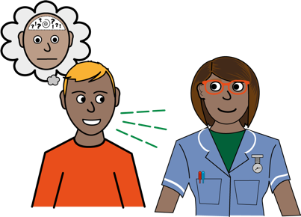
- psychosocial disability
Like
        - you have schizophrenia
        - you have anxiety.

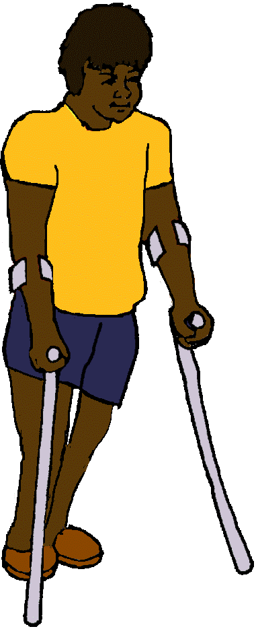
- physical disability

Like
- you use a wheelchair
- you use a walking stick or frame.

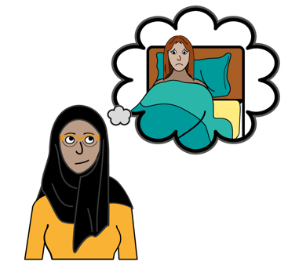
- chronic illness or medical condition

Like
        - you have arthritis
        - you have endometriosis.

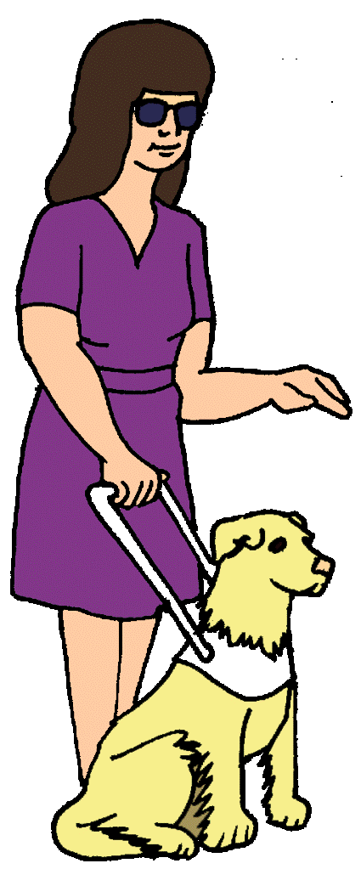

- blind or vision impaired

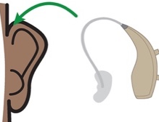
- D/deaf or hard of hearing

- other (tell us below)

_______________________

- Choose any that are you.

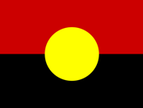
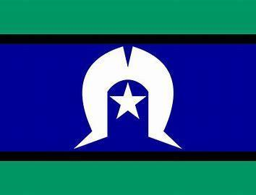

- Aboriginal and/or Torres Strait Islander

- lesbian, gay, bisexual, transgender,
intersex, queer or asexual (LGBTIQA+)

Want to know what Is LGBTIQA+?
Find out more. Read it in Easy English.

Go to www.oursite.wwda.org.au
Open the search window
Type WWDA Easy English Book.
What is a LBTIQA+?

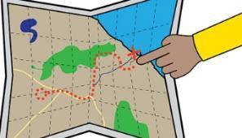
- rural, regional or remote

This means you are far from a big city.
Like
- you live on a farm
- you live in the country.

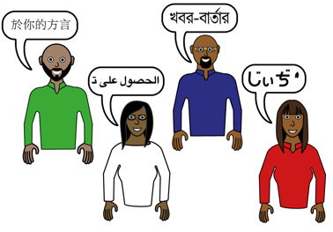

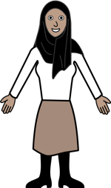
- culturally or linguistically diverse
Like
- your main language is not English
- you wear a headscarf
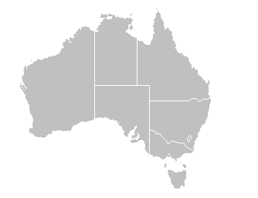
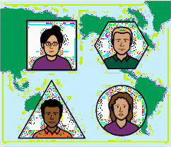
- migrant

This means you moved to Australia.
You moved from a different country.

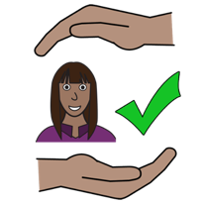
- refugee

You came to
Australia to be safe.
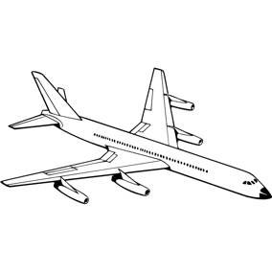
- on a temporary Visa
This means you are in Australia
for a short time.
You will go back to your country.

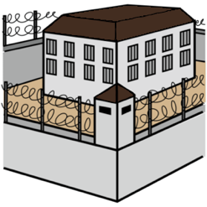
- you have been in jail

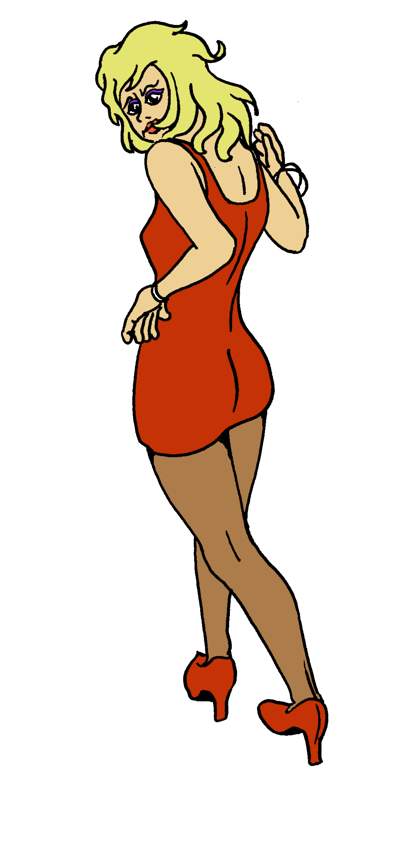

- you have done sex work

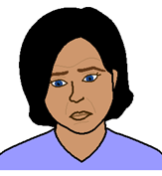
- you live in poverty

This means you don’t have much
money for important things. Like
- food
- clothes
- medications.

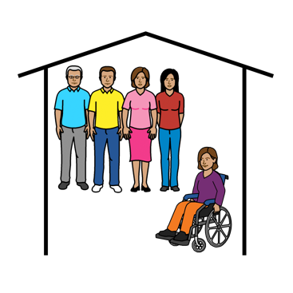

- you have lived somewhere
without your family
Like
- in foster care
- in a group home for people with disability.

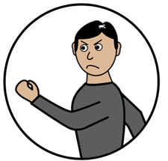

- you have experienced violence

- other (tell us below)

_______________________

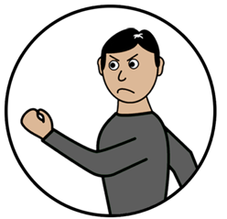
Learn about
- violence
- abuse.

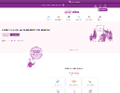
Go to www.oursitewwda.org.au
Click on Easy English at the top.

Now.

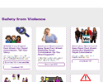
Look for the Safety from Violence part.

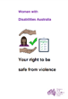
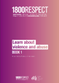
There is lots of information here. Like
- Your right to be safe from violence
- 1800 Respect. Book 1. Learn about violence.

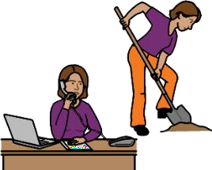
Part 2. Your skills and experiences

- I am good at

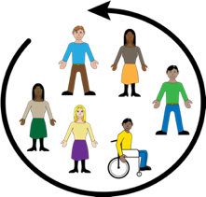
- I would like to join the WWDA
Policy Advisory Group because

- Choose any area that you have skills or experience in

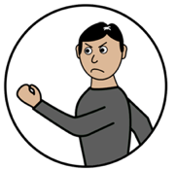

- lived experience of violence or abuse

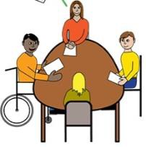

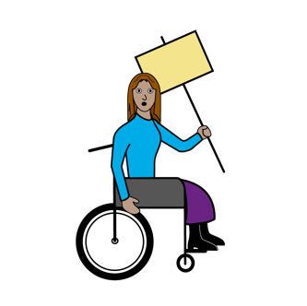
- taking part in a community group or campaign.
Like
- attending protests
- going to group meetings.

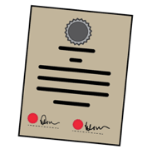
- policy
Like

- writing a policy submission to an organisation or government
- telling an organisation what to put in a submissions to a government

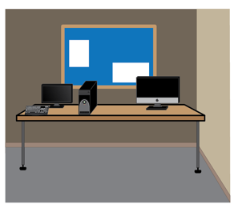
- communication and media

Like
- speaking to a newspaper or tv reporter
- posting on social media for an organisation or group

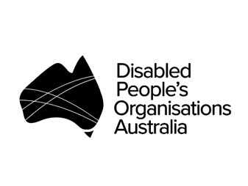

- working with a Disabled Peron’s Organisation.
Also known as a DPO.
Like
- working at a DPO as an employee
- taking part on a DPO advisory group
- volunteering at a DPO event

A Disabled Person’s Organisation or DPO is an organisation that is run by and for people with disability.

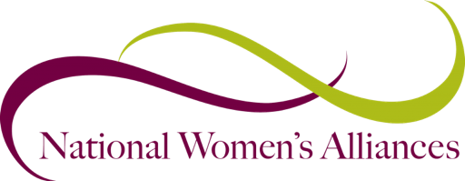

- working with a National Women’s Alliance.
Also known as a NWA.
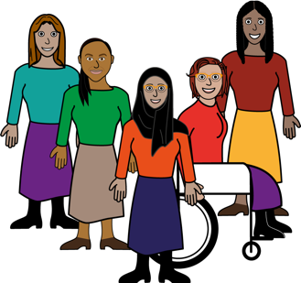
Like
- working at a NWA as an employee
- taking part on a NWA advisory group
- volunteering at a NWA event

A National Women’s Alliance or NWA is an organisation that speaks up for women.

      - speaking up for yourself
Like
- saying what supports you need
- applying for the NDIS

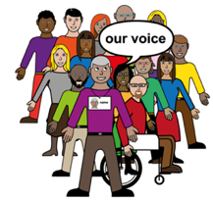
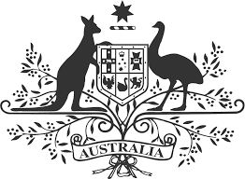
      - speaking up for others

Like
- writing a submission about women with disability
- telling the government what needs to change.

      - disability consultation
Like
- getting paid to write something for a disability organisation
- getting paid to represent people with disability

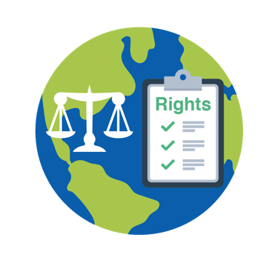

      - international human rights
Like
- attending a United Nations event
- understanding the Convention on the Rights of Persons with Disabilities (CRPD).

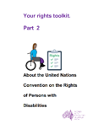
Learn about the CRPD
Read about the CRPD in Easy English.

Go to www.oursitewwda.org.au
Click on Easy English at the top.

Now.

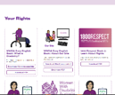
Go to the Your Rights part.
Click the Your Rights Toolkit button.

Here is our CRPD fact sheet.

Part 3. Your support needs

The WWDA Policy Advisory Group will
meet online using zoom.

The WWDA Policy Advisory Group will
also have papers to read before each meeting.

Zoom
A program that allows you to run or join a meeting online.
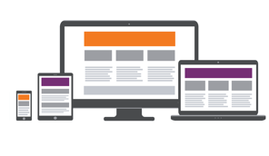
Zoom can be used on:
- a computer or laptop
- a smart phone
- on a tablet or iPad.

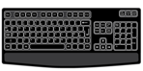
- To take part in zoom meetings I need

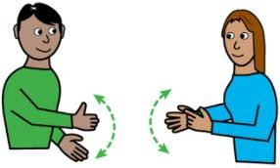

      - an Auslan interpreter

      - captions or subtitles

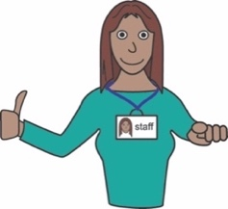

      - a support person

      - other (tell us below)
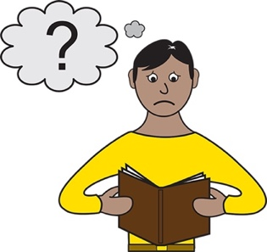
- To understand information, I need

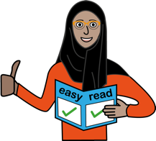
Easy Read

large print

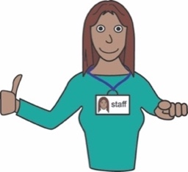
a screen reader

a support person

Braille

other (tell us below)

- Is there anything else you would like us to know?

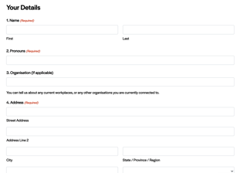
This form

This form is based on the WWDA National Alliance Policy Advisory Group Application Form.

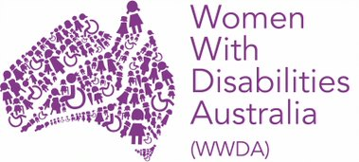
Who wrote this form
Women With Disabilities Australia wrote this survey in 2021. 2021.
Copyright
© Copyright Women With Disabilities Australia (WWDA) Inc. 2021. All intellectual property rights, including copyright and patents, in this survey is owned and licensed by Women With Disabilities Australia Inc.
Images
We have used images from
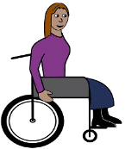
- COMPIC
- Easy On The I
- Google Images.

