Women With Disabilities Australia
National Alliance
Policy Advisory Group (PAG)

Terms of Reference

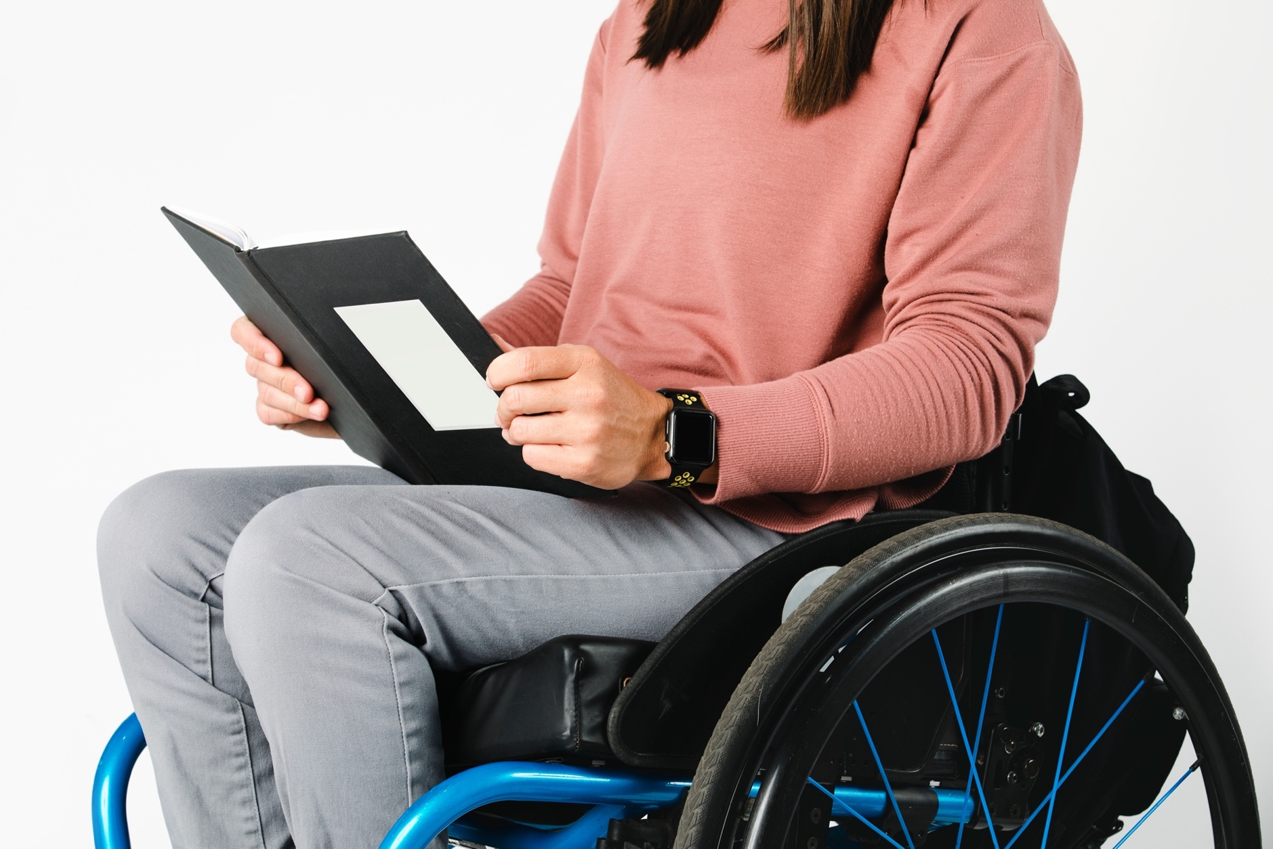
Easy Read version

About this document

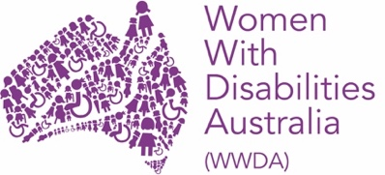
We are Women With Disabilities Australia. We will write WWDA when we talk about us.

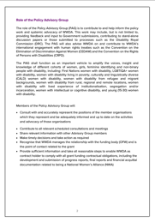
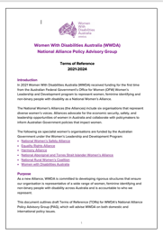
This document is a summary of the WWDA
National Alliance Policy Advisory Group
Terms of Reference.
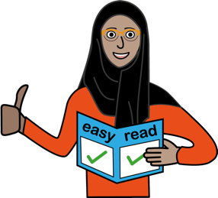
This document is written in an easy to read way.
We have written some words in bold underline.
We explain these words in the document.

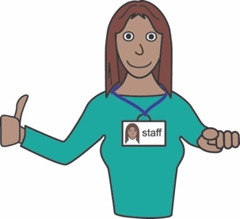
You can ask for help to read this document.
A support person may be able to help.

What is in this document?

About this document 2

About WWDA 4

About the National Women’s Alliances 6
About the WWDA National Alliance Policy Advisory Group 8
Organisational Members 11
Individual Members 12
Meetings of the WWDA Policy Advisory Group 16
Support and Pay 17
Any questions? 18

About WWDA

WWDA is run by and for
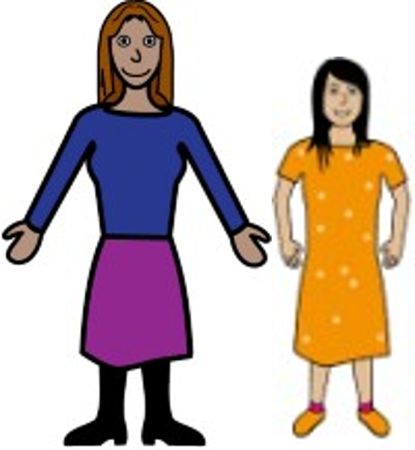
- women and girls

- feminine identifying people

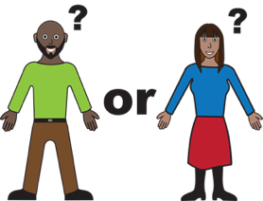
- and non-binary people

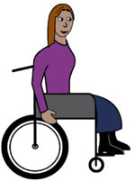
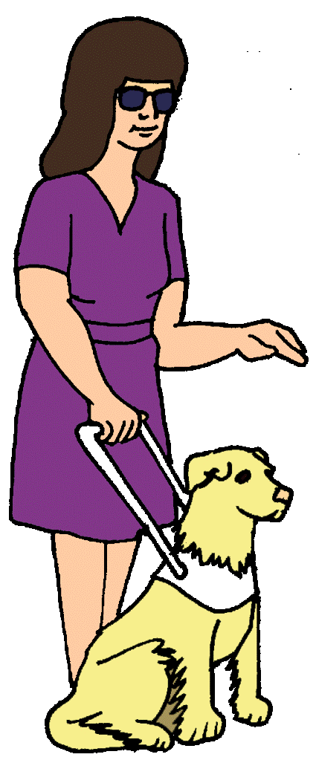
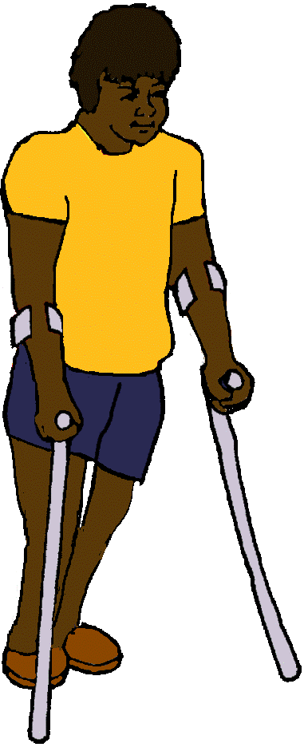
- who have a disability
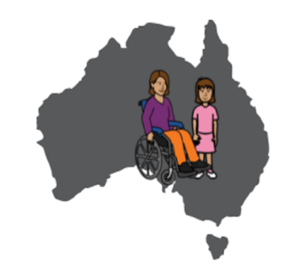
and

- who live in Australia.
Non-Binary is a way to describe the gender of people who are not women or men.

Feminine identifying is a way to describe people who see themselves more as a woman than a man.

Learn about disability.
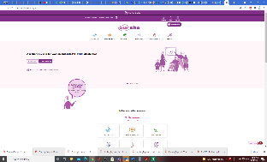
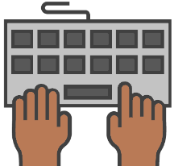
Go to www.oursite.wwda.org.au
Open the search window
Type WWDA Easy English Book.
What is a Disability?

WWDA helps all women, girls, feminine identifying and non-binary people with disability have good lives.

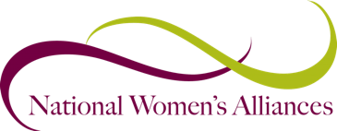
About the National Women’s Alliances

National Women’s Alliances are a group of 6 organisations that speak up for women.

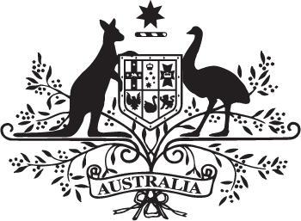
The National Women Alliances are funded by the Australian Government.

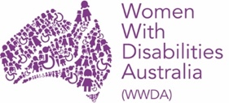
In 2021, WWDA was funded as a National Women’s Alliance for women, girls, feminine identifying and non-binary people with disability.

As a National Women’s Alliance we
- speak up for women, girls, feminine identifying and non-binary people with disability
- tell the Government what needs to change.
The other National Women’s Alliances are

- The National Women’s Safety Alliance

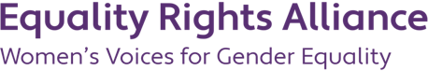
- Equality Rights Alliance

- Harmony Alliance

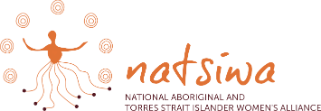
- National Aboriginal and Torres Strait Islander Women’s Alliance

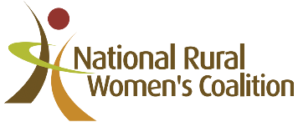
- National Rural Women’s Coalition.

About the WWDA National
Alliance Policy Advisory Group

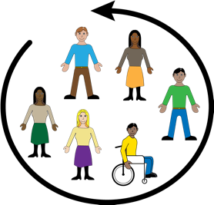
WWDA is starting a National
Alliance Policy Advisory Group.

The Advisory Group will tell WWDA

- what women, girls feminine identifying and non-binary people with disability need to live good lives

- what WWDA should tell Government.

The Advisory Group will also help WWDA make resources for women and girls with disability. Like

- fact sheets

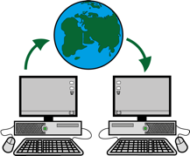
- website information

- videos.

The WWDA Alliance Policy Advisory Group will include 10 members who

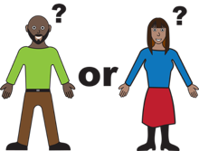
- are women
- feminine identifying
or
- non-binary people

- have any type of disability

and

- live in Australia.

Organisational Members
3 members of the Policy Advisory Group will represent the following groups

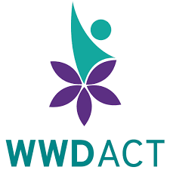
- Women With Disabilities ACT

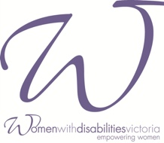
- Women With Disabilities Victoria

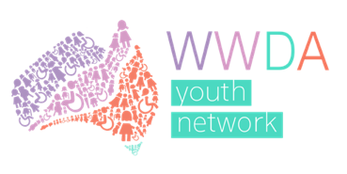
- The WWDA Youth Advisory Group.

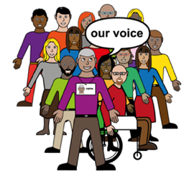
To represent means to speaks up for another person or group of people.

Individual Members

7 members of the Policy Advisory Group will be individuals who are full members of WWDA.

To be a full member of WWDA you must be
- a woman or non-binary person
and
- have a disability.

It is free to be a WWDA member.

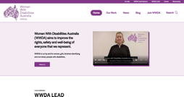
You can join on the WWDA website.
Go to www.wwda.org.au
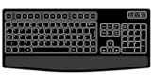
Click on the button Join WWDA.
Members of the Advisory Group will include women with disability who

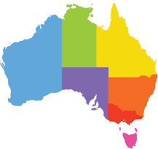
- come from different states and territories in Australia

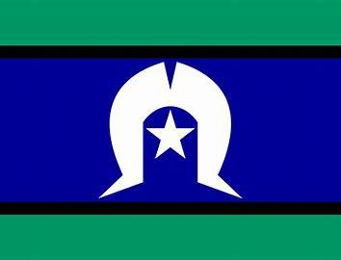
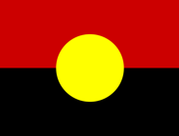
- are Aboriginal and/or Torres Strait Islander

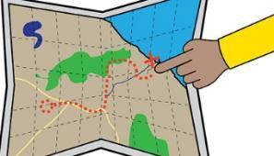
- are from rural, regional or remote places
This means you are far from a big city.
Like
- you live on a farm
- you live in the country.

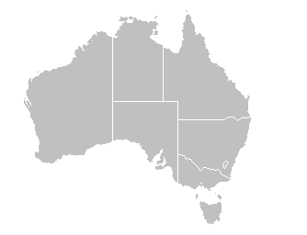
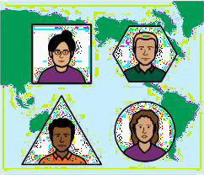
- are a migrant or refugee
This means you moved to Australia.
You moved from a different country.
- are lesbian, gay, bisexual, transgender,
intersex, queer or asexual (LGBTIQA+)

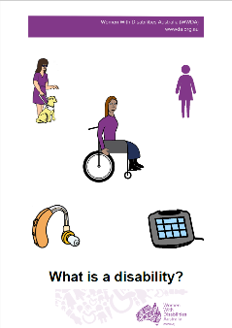
Want to know what Is LGBTIQA+?
Find out more. Read it in Easy English.

Go to www.oursite.wwda.org.au
Open the search window
Type WWDA Easy English Book.
What is a LBTIQA+?

Some members of the Advisory Group may also

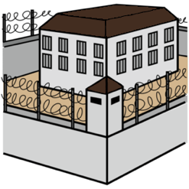
- have been in jail

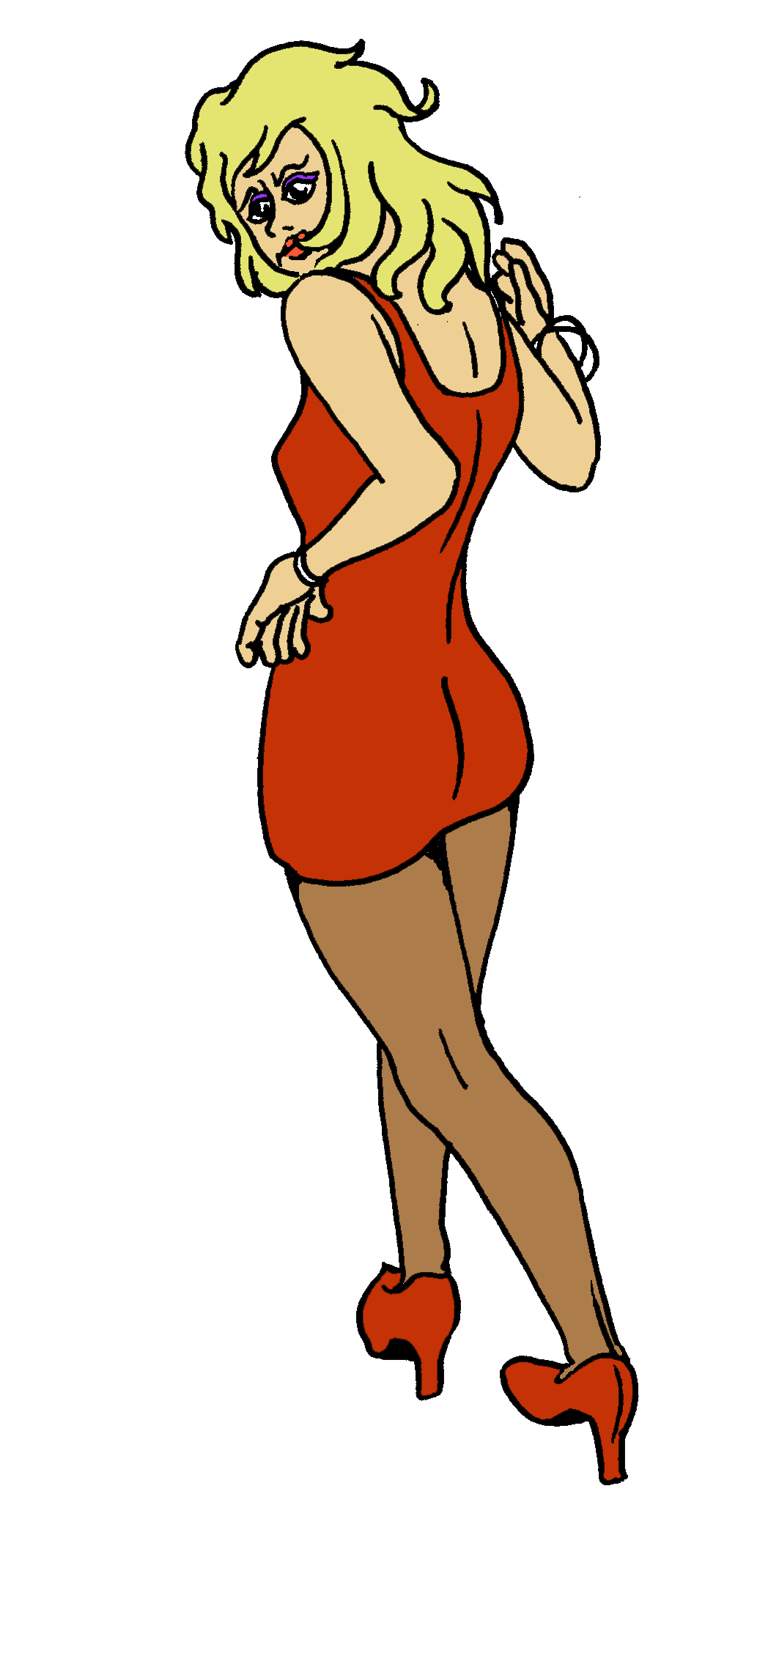
- have done sex work

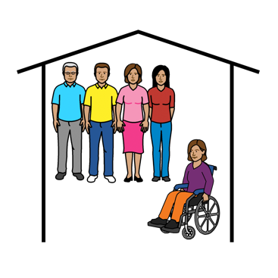
- have lived somewhere without your family
Like
- in foster care
- in a group home for people with disability.

Meetings of the WWDA National Alliance Policy Advisory Group
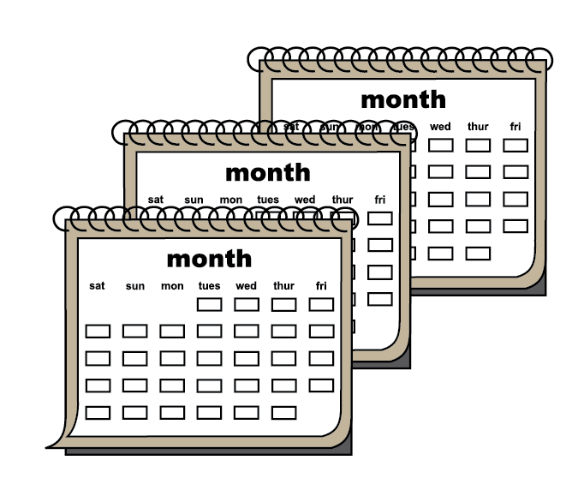
The WWDA Policy Advisory Group will meet
- 4 times a year
- from February 2022
- until March 2024.

Meetings will be held on Zoom.
Zoom is a program that allows you to run or join a meeting online.

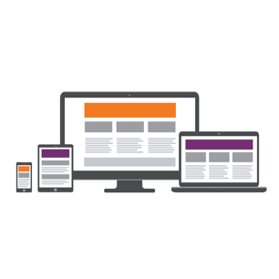
Zoom can be used on:
- a computer or laptop
- a smart phone
- on a tablet or iPad.

Support and Pay
WWDA will support members of the Policy Advisory Group to
- take part in meetings
- talk to government.

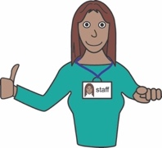
We can support people by paying for things like
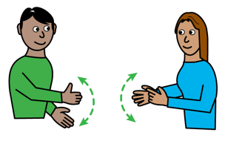
- support people
- Auslan
- captions.

All Policy Advisory Group members will be paid
$100 for each meeting:
- as a gift card or
- by invoice.

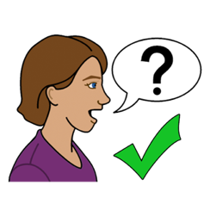
Any questions?

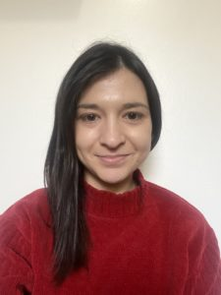
Contact WWDA’s
Director of Policy and Programs
Heidi La Paglia

- email Director@wwda.org.au

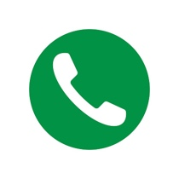
- call 0448 417 850

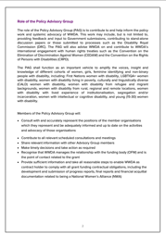
This document

This document is based on the WWDA National Alliance Policy Advisory Group Terms of Reference

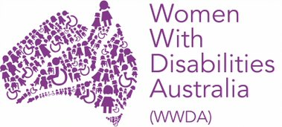
Who wrote this survey?
Women With Disabilities Australia wrote this document in 2021.
Copyright
© Copyright Women With Disabilities Australia (WWDA) Inc. 2021. All intellectual property rights, including copyright and patents, in this survey is owned and licensed by Women With Disabilities Australia Inc.
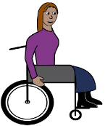
Images
We have used images from
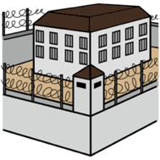
- COMPIC
- Easy On The I
- Google Images
- Inspired Services.

