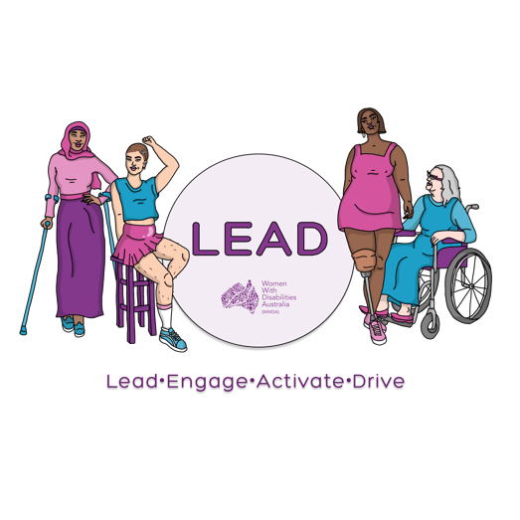
0477 076 098
lead@wwda.org.au
www.wwda.org.au/project/lead

WWDA LEAD Scholarships Application form

Thank you for your interest in the WWDA LEAD Scholarship Program.

Return this form
Please return this form by
- Email to lead@wwda.org.au
- OR:
- Send to us at PO Box 407 Lenah Valley, Tasmania 7008, Australia
Successful Applicants will be notified on 18th March 2022.

Name:___________________________________________________
Organisation (if applicable):__________________________________
Postal Address:___________________________________________
_________________________________________________________
Postcode:_____________________ State:_______________________
Phone:___________________________________________________
Email:____________________________________________________

Are you a current WWDA Member? ı Yes ı No
Please note you will need to sign up to be a WWDA member to take part in the WWDA LEAD Scholarship program.

To sign up please click here WWDA Membership form

Please note that you will need to be:

  - a women, girl, feminine identifying or non-binary person with disability
  - being aged 15 years or above
  - living in Australia.

Selection Criteria Questions
Selection of participants will be based on the answers to the following questions. If you require more space, please attach further pages.

- Can you tell us why you would like to be involved in the WWDA LEAD Scholarship program?

- What is the most important issue/s that you would like to learn about or take action on that affects women, girls and non-binary people with disabilities?

- How do you think taking part in a leadership or training course would help you to do this?

- What is the course or other opportunity that you would like to take part in?

  - What is the cost of course?

  - What are the dates?

- By the end of the WWDA LEAD Scholarship opportunity what do you want to have achieved?

- How do you think by doing this course it will help WWDA or WWDA’s work?

Access & Support

What are your access and support needs if required?

Return this form
Please return this form by Friday 18th March 2022
- Email to lead@wwda.org.au
- OR
- Send to us at PO Box 407 Lenah Valley, Tasmania 7008, Australia
Contact us
If you require any further information you can contact us in the following ways.
- Email Saph Grant at lead@wwda.org.au
- Call or text Saph on 0477 076 098
- You can use the National Relay service To call us Call 1800 555 677 Ask for 0477 076 098
- You can use TTY 133 677 Ask for 0477 076 098
- Need a translator? Call 131 450 Ask for 0477 076 098
- Send a letter to PO Box 407, Lenah Valley, Tasmania 7008, Australia
Women With Disabilities Australia (WWDA)
PO Box 407, Lenah Valley, Tasmania 7008, Australia

