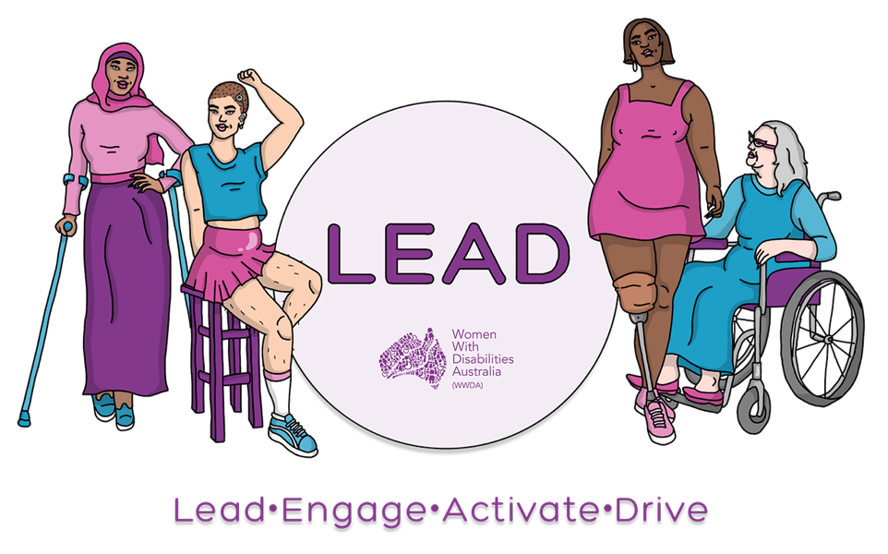

WOMEN WITH DISABILITIES AUSTRALIA (WWDA)

Leadership Statement

March 2022

First Edition

PUBLISHING INFORMATION

Women With Disabilities Australia (WWDA) (2022). ‘Leadership Statement: First Edition.’ March 2022. WWDA, Hobart, Tasmania.

Acknowledgments

WWDA acknowledges the Traditional Owners of the land on which this publication was produced. We acknowledge Aboriginal and Torres Strait Islander people’s deep spiritual and cultural connection to this land. We extend our respects to community members and Elders past and present.

Women With Disabilities Australia (WWDA) acknowledges the National Disability Insurance Scheme (NDIS) Information, Linkages and Capacity Building (ILC) Program for proving the funding to enable WWDA to produce this Statement.

Women With Disabilities Australia (WWDA) would also like to acknowledge the WWDA LEAD Project Steering Commitee and Caroline Lambert who oversaw the co-design of this statement. WWDA also acknowledges Ailie Banks who created the illustrations.

Contact

Women With Disabilities Australia (WWDA)
PO Box 407, Lenah Valley, 7008 Tasmania, Australia
Phone: +61 438 535 123
Email: officeadmin@wwda.org.au
Web: www.wwda.org.au
Facebook: www.facebook.com/WWDA.Australia
Twitter: www.twitter.com/WWDA_AU

Winner, National Human Rights Award 2001
Winner, National Violence Prevention Award 1999
Winner, Tasmanian Women's Safety Award 2008
Certificate of Merit, Australian Crime & Violence Prevention Awards 2008
Nominee, UNESCO Prize for Digital Empowerment of Persons with Disabilities 2021
Nominee, National Disability Awards 2017
Nominee, French Republic's Human Rights Prize 2003
Nominee, UN Millennium Peace Prize for Women 2000

Women With Disabilities Australia (WWDA) has Special Consultative Status with the Economic and Social Council of the United Nations.

Disclaimer

The views and opinions expressed in this publication are those of Women With Disabilities Australia (WWDA) and not necessarily those of our funding bodies. All possible care has been taken in the preparation of the information contained in this document. WWDA disclaims any liability for the accuracy and sufficiency of the information and under no circumstances shall be liable in negligence or otherwise in or arising out of the preparation or supply of any of the information aforesaid.

This work is copyright. Apart from any use as permitted under the Copyright Act 1968, no part may be reproduced without written permission from Women With Disabilities Australia (WWDA).

© 2022 Women With Disabilities Australia (WWDA).

ABN: 23 627 650 121

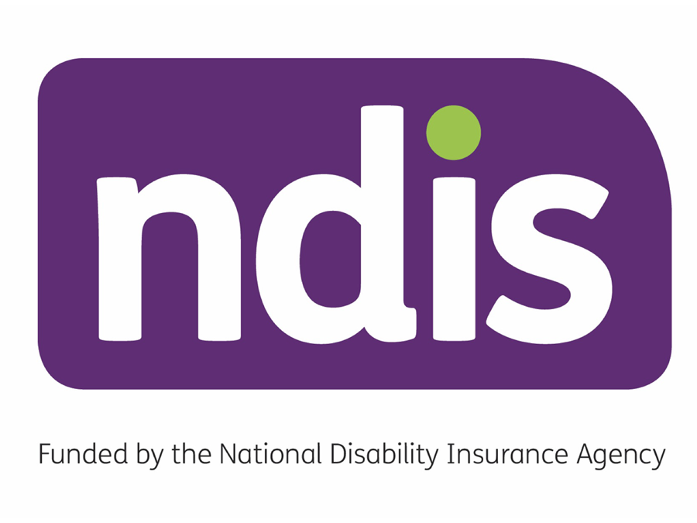

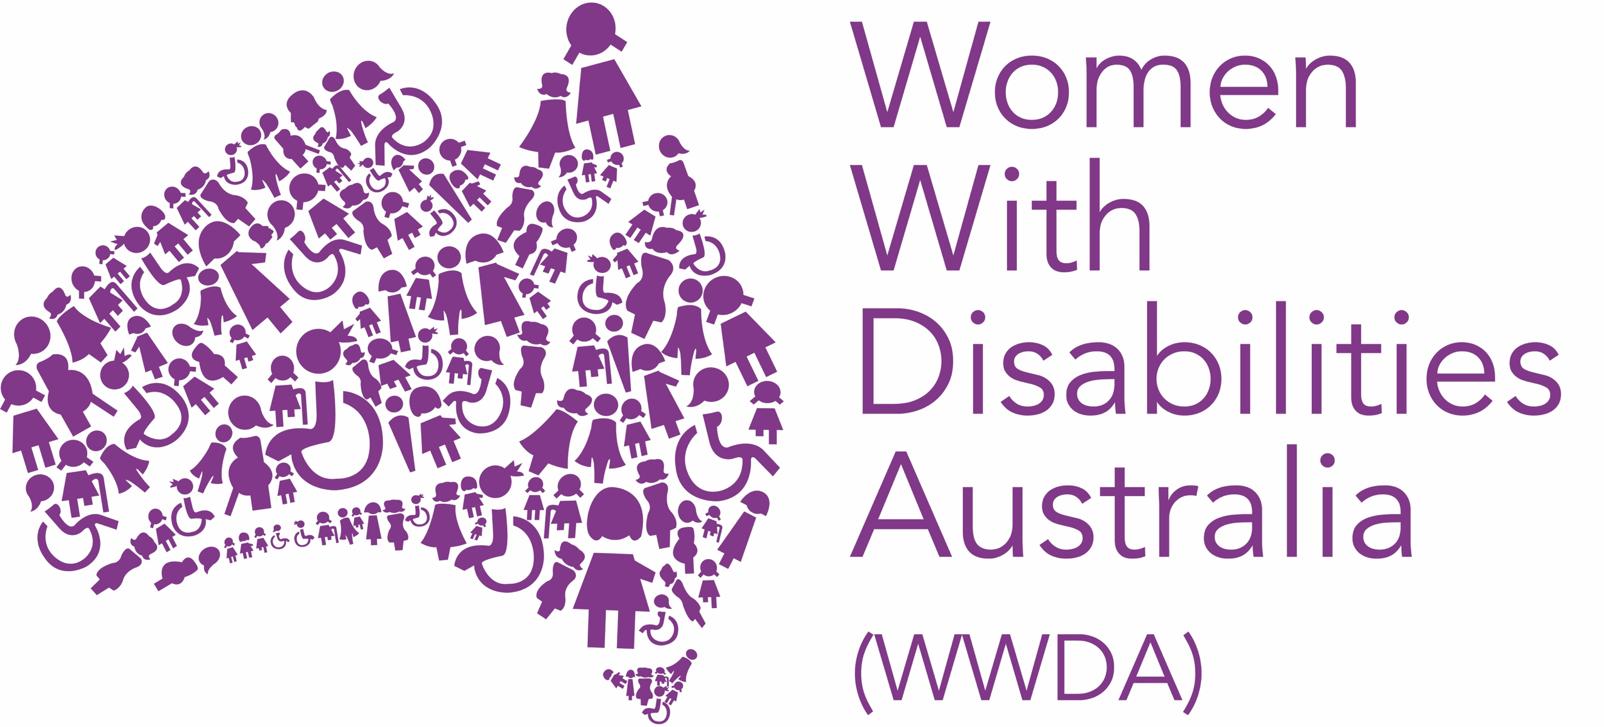

INTRODUCTION

Women With Disabilities Australia (WWDA) is the award winning, national Disabled People’s Organisation (DPO) and National Women’s Alliance (NWA) for women, girls, feminine identifying and non-binary people with disabilities in Australia.

Disabled People’s Organisations are recognised around the world, and in international human rights law, as self-determining organisations led by, controlled by, and constituted of, people with disabilities. DPOs are organisations of people with disabilities, as opposed to organisations which may represent people with disabilities. The United Nations Committee on the Rights of Persons with Disabilities has clarified that Governments should give priority to the views of DPOs when addressing issues related to people with disabilities.

WWDA uses the term ‘women and girls with disabilities’ on the understanding that this term is inclusive of women, girls, feminine identifying and non-binary people with disabilities in Australia.

WWDA represents more than two million individuals in Australia. We have affiliate organisations and networks in most States and Territories of Australia, and we are internationally recognised for our work to advance the rights and freedoms of women and girls with disabilities. WWDA holds Special Consultative Status with the Economic and Social Council of the United Nations. This means that WWDA is formally recognised by the United Nations for our expertise in gender and disability. It also allows WWDA to be invited to, and formally contribute to, the work of the United Nations.

Australia is a signatory to seven international human rights treaties. These are:
- the Convention on the Rights of Persons with Disabilities (CRPD).
- the Convention on the Elimination of All Forms of Discrimination against Women (CEDAW).
- the International Covenant on Civil and Political Rights (ICCPR).
- the International Covenant on Economic, Social and Cultural Rights (CESCR).
- the Convention on the Rights of the Child (CRC).
- the Convention against Torture and Other Cruel, Inhuman or Degrading Treatment or Punishment (CAT).
- the Convention on the Elimination of All Forms of Racial Discrimination (CERD).

In addition to these seven international human rights treaties, in 2009, Australia also formally endorsed the United Nations Declaration on the Rights of Indigenous Peoples (UNDRIP) - an international human rights instrument that sets a standard for the protection of Indigenous rights. By signing up to these international human rights treaties, Australia has agreed to implement their requirements within Australia. Most of these seven treaties include responsibilities to improve the rights of people with disability, of women, and of other marginalised groups.

All of WWDA’s work is grounded in a human rights-based framework that links issues of gender and disability to civil, political, economic, social, and cultural rights. This means that WWDA uses the international human rights treaties to which Australia has signed up to, to guide and inform all our work. WWDA does this, because our key mission is to advance and promote the human rights and freedoms of all women and girls with disabilities.

To promote the rights and freedoms of all women and girls with disabilities, WWDA works at the national and international levels as a systemic advocacy organisation. Systemic advocacy focuses on introducing and influencing long term changes to ensure that the rights of people with disabilities are attained and upheld to positively affect the quality of their lives. For WWDA, systemic advocacy is about working to influence positive changes to improve laws, policies, and services to be inclusive of, and responsive to, women and girls with disabilities and to work towards raising community awareness and education of disability and gender-equality issues.

WWDA’s work always seeks to support and empower individuals to realise their human rights, while also creating greater awareness among governments and other relevant institutions about their obligations to do the same.

CONTEXT

Since our formal incorporation in 1995, WWDA has received thousands of reports from women and girls with disabilities, their supporters, and many organisations that there is a lack of representation and inclusion of women and girls with disabilities in leadership roles and in public decision-making forums across Australia. The United Nations has also expressed its concern about this and has asked the Australian Government to improve leadership and decision-making opportunities for women with disabilities.

Despite some improvements over time, women and girls with disabilities are still being told that they cannot ‘lead’ and are rarely given opportunities to participate meaningfully in leadership programs, opportunities, or training.

As the national organisation for women and girls with disabilities across Australia, WWDA has a diverse and wide-reaching base of members, all with rich experiences, skills, and knowledges that, although often overlooked, make them valuable leaders and contributors in all aspects of society.

As such, WWDA believes that promoting the leadership of women with disabilities is also about seeking to transform society’s understanding, definitions, and presentations of what ‘leadership’ means. For WWDA, this means challenging traditional and hierarchical forms and styles of leadership.

WWDA supports the leadership potential of all our members by making space for individuals to share stories and experiences, as well as facilitating conversations on what the experience of marginalisation means for women and girls with disabilities.

In 2019, with support from the National Disability Insurance Scheme’s Information, Linkages and Capacity Building (ILC) Program, WWDA commenced a new and ground-breaking project called WWDA LEAD – Lead, Engage, Activate and Drive – to promote and advance the leadership, agency, autonomy, human rights and freedoms of women, girls, feminine identifying and non-binary people with disabilities, both individually and collectively.

In preparation for this Statement, WWDA has worked in a co-design framework and approach with the WWDA LEAD Project Steering Committee, made up of experienced and diverse women with disabilities from across the country.

Through this process and space, WWDA has recognised and explored existing leadership struggles, progress, and achievements, including the feminist and transformative leadership that made up the history of the disability rights movement and the formation of WWDA, as well as the work of marginalised communities such as that of First Nations peoples, Lesbian, Gay, Bisexual, Transgender, Intersex and Queer (LGBTIQA+), Culturally and Linguistically Diverse (CaLD) and Migrant and Refugee communities.

OUR VISION STATEMENT

“Seeing things as they will be… a world which values the leadership of women and girls with disabilities in all our diversity”.

WWDA strives towards a world in which all women and girls with disabilities enjoy the same rights and opportunities as non-disabled people. We envision a society transformed for future generations by building on the hard work, lived experience and rich knowledge base of women and girls with disabilities now and throughout history. WWDA asserts that political, economic, social, and cultural systems and structures that are inclusive of women and girls with disabilities must be fully accessible, include supports, and respect, consult, engage with, and value women with disabilities in all our diversity.

OUR PRINCIPLES

1. Lead by lifting others up.

“Leadership that creates space for others to join, feel and be heard too”.

WWDA believes in advocating with kindness and compassion by supporting all women and girls with disabilities, regardless of gender, age, education, employment status, sexual orientation, cultural background, and other identity markers, to engage in meaningful processes, activities and conversations about their experiences and the barriers they face to access and participate in leadership spaces.

In practice this looks like:

  - Creating opportunities and avenues that centre the voices of marginalised women within the disability community, such as First Nations women and refugee and migrant women with disabilities who continue to be subjected to both systemic ableism and racism. By lifting the most impacted, it lifts all of us up.

  - Supporting the formal and informal leadership development of individuals through the provision of information and programs that train, mentor, and empower women and girls with disabilities.

  - Platforming women and girls with disabilities, by inviting them and appointing them to be represented on and in structures within which they have not historically been invited to participate. This includes on Boards and Committees, in political parties, on the executives of community groups and more.

  - Supporting women and girls with disabilities individually and collectively, to share their stories and increase awareness of what it is like to live within structures that are not designed for their community.

2. Value diversity and lived experience.

“Promoting the status of women and girls with disabilities in all our diversity”.

WWDA asserts that full accessibility and inclusivity in all areas of public, private, educational, political, economic, social, and cultural life must be standard, not an optional addition. Women and girls with disabilities should not have to fight for their right to occupy spaces and positions.

In practice this looks like:

2.1. Recognising women with disabilities as the experts of their experiences, identities, bodies, and lives.

2.2. Providing information in multiple, accessible formats (e.g., in accessible word documents and PDFs, Easy Read and/or Easy English, video, audio, Auslan and creative formats).

2.3. Ensuring full and uncompromised accessibility so that no-one is isolated or excluded and they can participate fully in social, cultural, economic, academic, and political life.

2.4. Including and encouraging the meaningful participation of all women and girls with disabilities, including those who are also Aboriginal and/or Torres Strait Islander, Lesbian, Gay, Bisexual, Transgender, Intersex and / or Queer (LGBTIQA+), Culturally and / or Linguistically Diverse (CaLD), Migrant or Refugees and/or from rural or regional locations.

3. Challenging and transforming traditional views of leadership.

“Women with disabilities are not problems to be ‘fixed’, we are problem solvers”.

WWDA endorses acknowledging, respecting, including, supporting, and valuing the personal and unique leadership styles and dimensions of women with disabilities. In line with the principles of intersectional feminist disability leadership, WWDA aspires to be self-aware, compassionate, solution-focused, trauma informed, collaborative, and collective in its presentation.

In practice this looks like:

3.1. Recognising many women with disabilities learn leadership skills through community and life experience and experience barriers to, and/or, are not offered formal training and education. Therefore, women with disabilities need to be supported to build their skill set to be considered a leader or capable of leading.

3.2. Creating spaces and opportunities run by and for women with disabilities, to learn and build their skill sets so they are well prepared for leadership positions.

3.3. Understanding that leadership can present differently to traditional definitions in private and public, formal, and informal settings, during different life stages, across visible and invisible disabilities, as well as other intersections based on race, Indigeneity, gender, sexuality, religion, culture, education, or class. Due to a multitude of societal barriers, such as those based on cost, physical access or discrimination, women with disabilities often learn leadership skills through life experience or community volunteering as opposed to formal leadership education or training.

3.4. Acknowledging that the leadership of women with disabilities is not limited to Board rooms or committees and can take place in a multitude of different settings and spaces, including closed settings such as prisons, group homes, aged care facilities and psychiatric wards.

3.5. Rejecting the ‘Medical Model of Disability’, which sees women with disabilities as sick and needing to get better, or as broken and needing fixing. This model is inherently underpinned by ableism and condones systems that devalue and segregate women with disabilities. In place of the Medical Model of Disability, many disability advocates, and Disabled Peoples Organisations (DPO’s) use the ‘Social Model of Disability’ which views societal barriers as the problem, not the person. This model focuses on the need to change the environment and structures to adapt to women with disabilities.

3.6. Embracing the ‘Human Rights Model of Disability’. WWDA ascribes to and endorses the ‘Human Rights Model of Disability’ which recognises women with disabilities as people who have rights. It involves moving away from seeing women with disabilities as having a 'problem', towards making sure they experience the same respect, dignity, and equal rights as others. The ‘Human Rights Model of Disability’ is about supporting and celebrating difference and working to address the structural barriers that prevent women with disabilities from fully taking part in society. An important part of a human rights approach to disability is making sure that women with disability have the right to make their own choices and to be involved in all of the decisions that affect them. It also means creating the conditions that enable women with disability to participate in society on an equal basis as others, including in education, in employment and in politics.

4. Care for self to care for community.

“The relationships we have with ourselves, and others are the most important resources that we have”

WWDA encourages practicing self-care, healthy boundaries, personal development and upskilling while using inclusive, diverse, collaborative approaches as “many hands make light work” for a sustainable leadership approach. While we recognise intersectional feminist disability leadership is often responsive and reactive, we likewise acknowledge its slow, intentional, and relational approach, abiding by the mantra that “slow and steady wins the race”.

In practice this looks like:

4.1. Valuing unique, individual, and collective presentations of leadership, including individuals’ participation in leadership as self-advocates, as well as advocacy and leadership as part of a group, community, or organisation.

4.2. Sometimes being both the person who gives encouragement and support, and sometimes being the person accepting encouragement and support.

4.3. Understanding that women with disabilities can be seen as trailblazers, even when that may not be their perception of themselves.

4.4. Acknowledging that the role of trailblazer can lead to expectations of leaders who do not take breaks, never say no, always strive for perfection and consistently perform over and above the expectations of non-disabled people to get through doors, over barriers and be given opportunities to participate.

4.5. Understanding that expectations on women with disabilities capacity and personal development to fit narrow traditional views of ‘what is a leader’ can be inaccessible, unfair, unsafe, unreasonable, and unhelpful.

4.6. Providing women with disabilities opportunities for rest and reflection within their leadership journeys.

4.7. Creating safe and supportive leadership training environments for women with disabilities that are trauma-informed and free from both interpersonal and structural violence.

5. Nothing about us without us.

“Inclusion not segregation”

WWDA believes that women and girls with disabilities must be included and empowered to participate in decisions that affect them. Acknowledging the existing work, lived experience and knowledges of women and girls with disabilities throughout history, as well as the barriers that prevent the full and equal participation of women and girls with disabilities; decision-makers and authorities must make concerted and organised efforts to ensure that relevant policies and programs are co-designed by and for women and girls with disabilities and meet the needs of their community.

In practice this looks like:

5.1. Operationalising the principles embedded in the international human rights treaties to which Australia is a party, such as the Convention on the Rights of Persons with Disabilities, with the aim of creating a world where women and girls with disabilities don’t have to actively fight for their participation and inclusion but are included without question.

5.2. Facilitating meaningful and non-tokenistic participation of women and girls with disabilities in decision-making processes at all levels, on all issues that impact them, including, but not limited to issues such as where they live, the supports and healthcare they receive, and the way they participate in education, employment, politics, and the community.

5.3. Consistently recognising, platforming citing, and utilising work done, and work being done, by and for women and girls with disabilities.

5.4. Adequately resourcing and supporting the sustainability and growth of Disabled People’s Organisations and community groups run by and for women and girls with disabilities.

5.5. Acknowledging that the feminist disability community in Australia must hold themselves accountable to the idea of “Nothing about us without us” and centre the voices and leadership of First Nations women with disabilities. We cannot fully understand how ableism operates on stolen, sovereign Aboriginal and Torres Strait Islander lands without first understanding and recognising ableism’s relationship with ongoing colonial violence.

