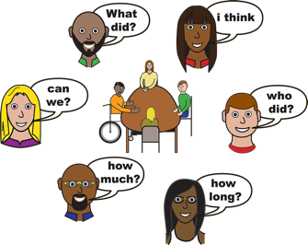
Women With
Disabilities Australia

Culturally and linguistically diverse women with disability focus groups.
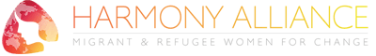
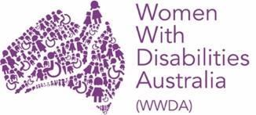
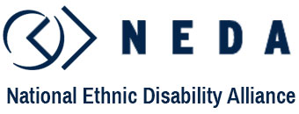

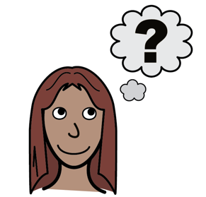

Part 1.
About the focus groups.
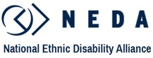
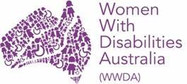
We are WWDA, NEDA and Harmony Alliance.

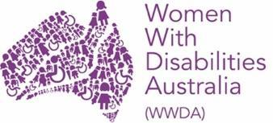
WWDA means
Women With Disabilities Australia.

WWDA is the national disability organisation for women and girls with disability.

NEDA means
National Ethnic Disability Alliance.

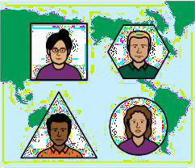
NEDA is the national disability organisation for people with disability who are from culturally and linguistically diverse backgrounds.

The full name for Harmony Alliance is
Harmony Alliance: Migrant and Refugee Women for Change.

Harmony Alliance is the national organisation for women from migrant and refugee backgrounds.

WWDA, NEDA and Harmony Alliance are running focus groups for culturally and linguistically diverse women and girls with disabilities.

Focus groups are small groups of people talking together.
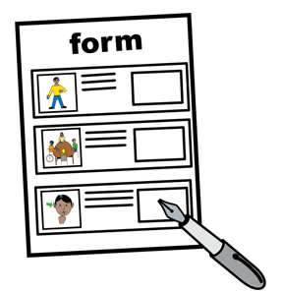
We want to know if we can ask you questions in the focus groups. You can tell us in this form.

You must be

- 15 years old or more

- a woman
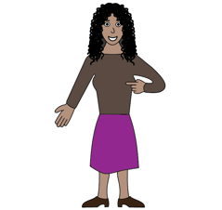
- a girl
- woman identifying
You see yourself as a woman.
or
- non-binary.
Your gender is not male or female.

You must also be
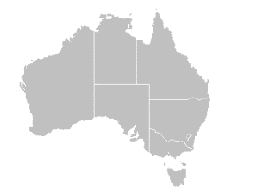
- a migrant
You moved to Australia.
You moved from a different country.

or

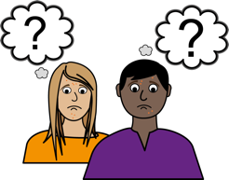
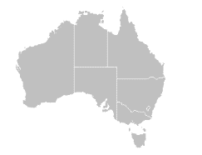
- an asylum seeker
You came to Australia to be safe.
The government has not decided what safety you need yet.

or

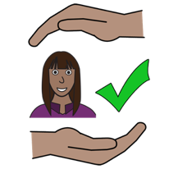
- a refugee
You came to Australia to be safe.
The government has decided you need safety.

and you have
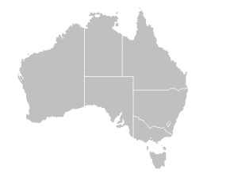
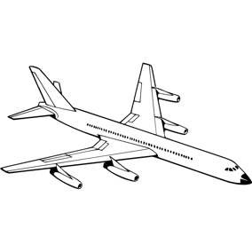
- a temporary visa
You are in Australia for a short time.
You will go back to your country.
or

- a permanent visa
You are in Australia for a long time.
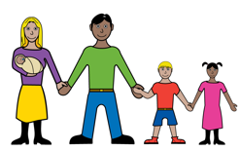
You will not go back to your country.

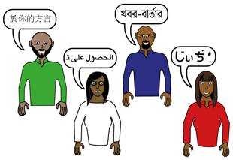
or
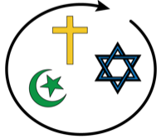
- culturally and/or linguistically diverse.
You come from a different culture or speak a different language. You or your family might:
    - speak a language that is not English
    - be born or come from somewhere outside of Australia
    - belong to a different religion
    - belong to a different race/colour
    - belong to a different ethnic group

Do I have to join the focus group?
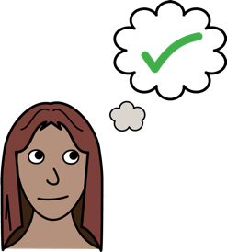
You can choose to take part in the focus group.

You can choose to answer our questions.

You do not have to.
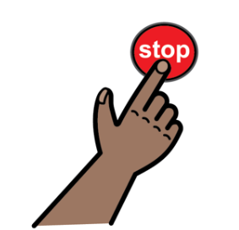
You can choose to stop at any time.

Where will the groups be held?

The focus groups will be held on zoom.

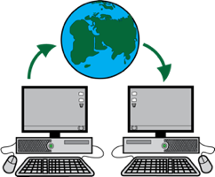
Zoom is a program that allows you to run or join a meeting online.

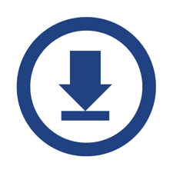
You can download zoom online at:
https://zoom.us/download

Zoom can be used on:
- a computer or laptop
- a smart phone
- on a tablet or iPad.
The focus group will have:
- subtitles for what people say.

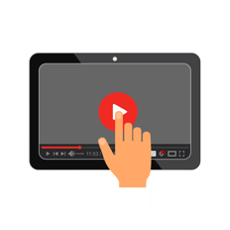
We will record the focus groups so we can remember what you say. We won’t show anyone else the recordings.

When will the groups be held?
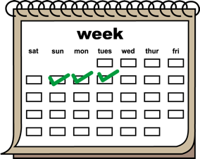
The focus groups will be held on three different days.

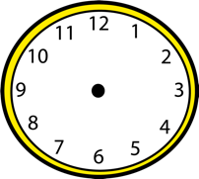
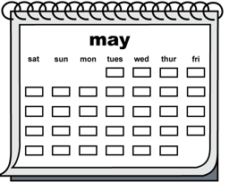
- Monday 9 May 2022

  - at 3pm – 5pm AEST

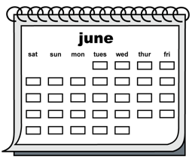
- Tuesday 28 June 2022

  - at 12:30pm – 2:30pm AEST

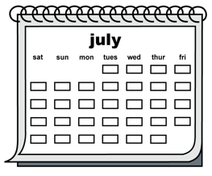
- Friday 15 July 2022

  - at 10am – 12pm AEST.

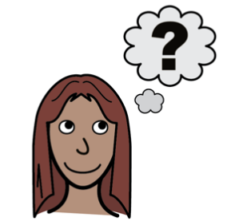
What do we want to know?
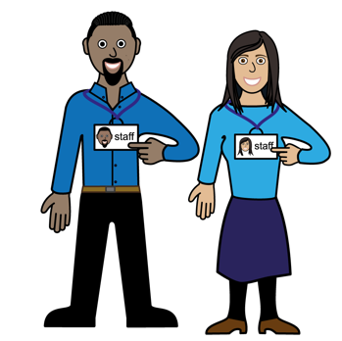
We want to know if
- you use disability and health supports and services
- what is stopping you from using disability and health supports and services.

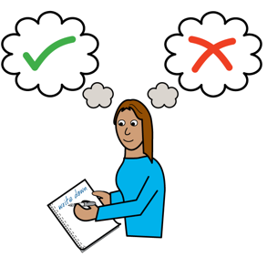
We want to know about the
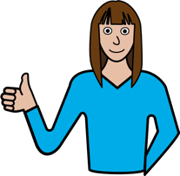
- bad things that have happened to you
getting disability support
- good things that have happened to you gettings disability supports
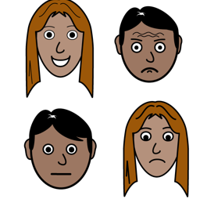
- what you think needs to change.
We want to know how using supports and services makes you feel.

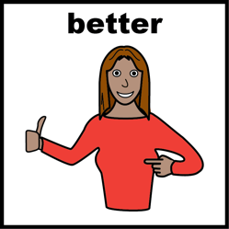
We also want to know anything else that is important to you.
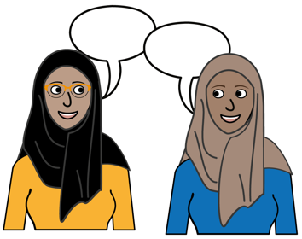

You can be open and honest when sharing your story.

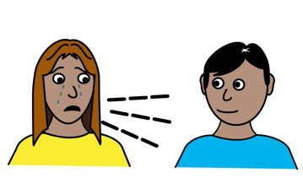
Sharing your stories can be hard.

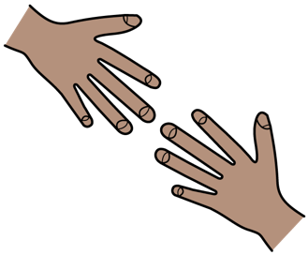
There will be a support person in the focus groups to talk to if you need them.

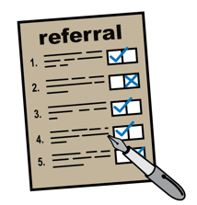
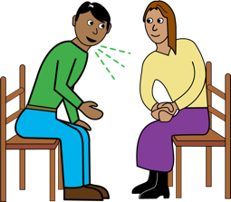
This person can make a referral if you need support.
This means they will give you information about how to get more support.

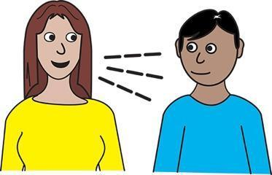
What will you do with what I tell you?
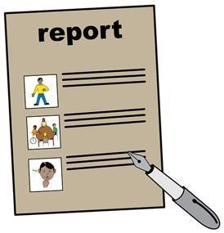
We will use the information you give us in the focus groups to write a report.

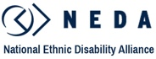
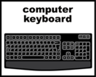
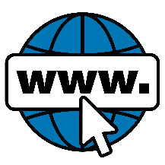
The report will be on WWDA, NEDA, and Harmony Alliance websites.
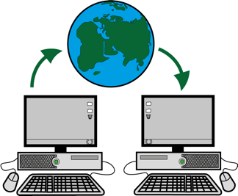

This means that the report can be viewed by anyone anywhere.
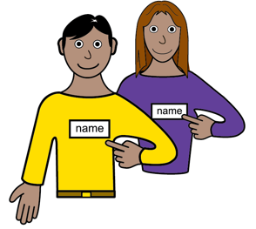

We will not use your name in the report.

We may use the things you say for other things.
Like
- social media posts
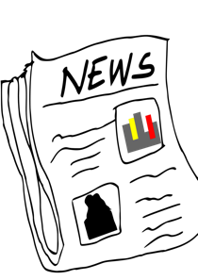
- newsletters.

We will not show images of you or share your name or your personal details.
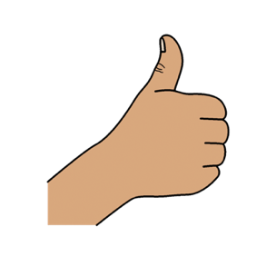
We would like to know if you are happy for us to use the things you tell us in these ways.
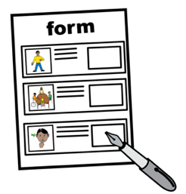
You can tell us on this form

Part 2.
Easy Read Form.

How do I use this form?

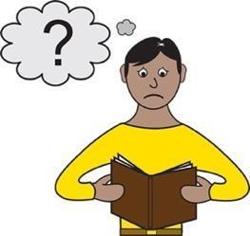
- Read the form

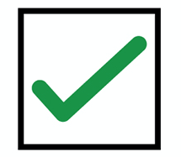
- Tick the boxes if it is okay for us to collect and use
your information

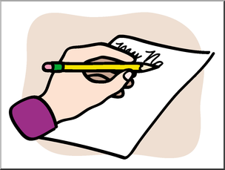
- Sign this form

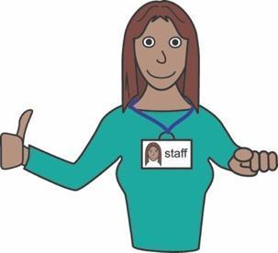
You can ask someone you trust to help you fill out this form. Like
- a friend
- family member
- a carer
- support person.

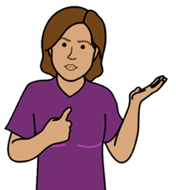
About you

My name is

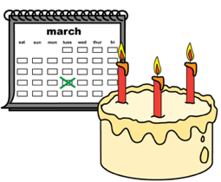
My age is
Write how many years old you are

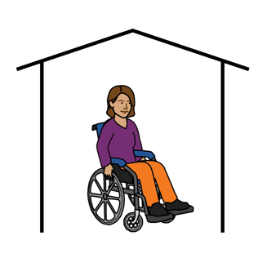
I live at
We will send your gift card here

My email is

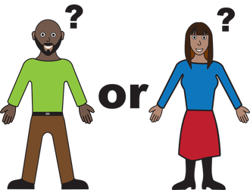
My gender is (choose all that apply)

Man
Woman

Non-Binary
This means your gender is not male
or female.

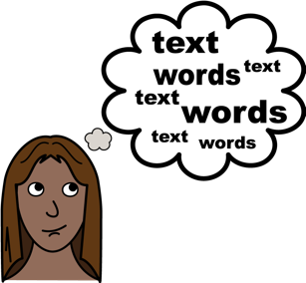

I use another word (tell us below)

____________________________________________

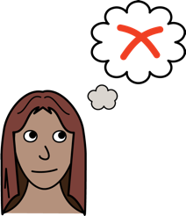
I do not want to say

I am (choose all that apply)

- a migrant

- an asylum seeker

- a refugee

- have a temporary visa
- have a permanent visa

- culturally and/or linguistically diverse.

(Please tell us what language you use at home)
____________________________
____________________________

I am happy to take part in a

focus group

I would like to attend the focus group on
- Monday 9 May 2022

  - at 3pm – 5pm AEST

- Tuesday 28 June 2022

  - at 12:30pm – 2:30pm AEST

- Friday 15 July 2022

  - At 10am – 12pm AEST

I understand the group will be on zoom.

To take part in zoom I need

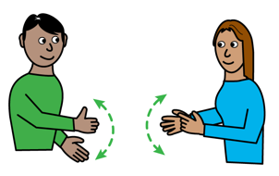
Captions

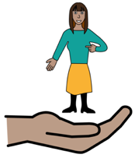
Auslan

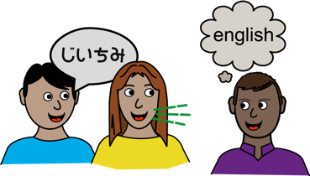
A support worker

A language interpreter
(Please tell us what language)
____________________________
Something else (please tell us)

____________________________
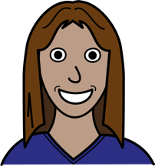
I am happy for the focus group to be
recorded by
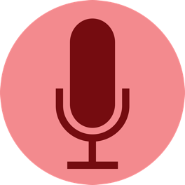

- audio

- audio and video

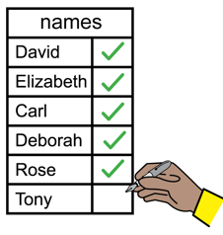
I am happy for my name to be
written in the list of people who
joined the focus group in the report.

I understand that my
information will be kept safe.
It will not be shared publicly.

I am happy for WWDA, NEDA and Harmony Alliance to use the things I say without using my name
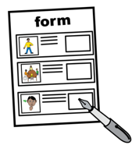

- in a report

- on websites

- on Facebook

- on Instagram

- on Twitter

- in newsletters.
Please sign here
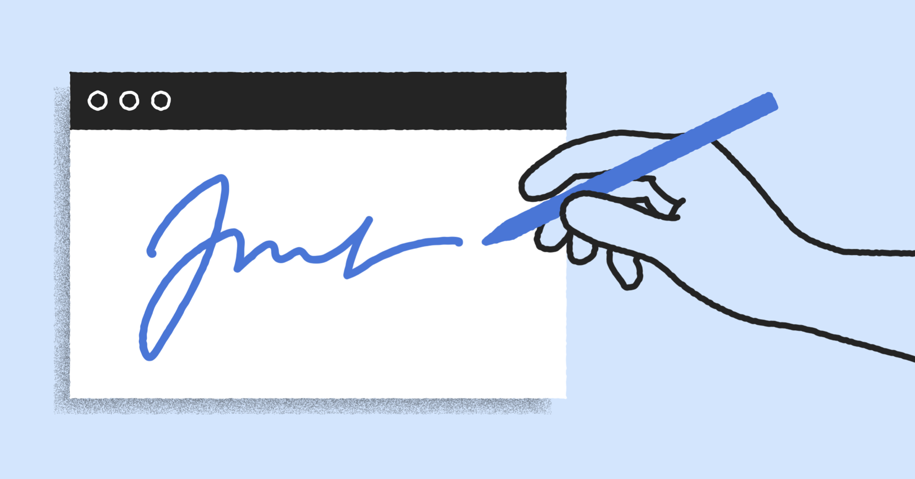

_____________________________________________________________________

Signature Date

If you are under 18, please have your parent or guardian sign below:

_____________________________________________________________________

Parent/Guardian Name and Contact Number

_____________________________________________________________________

Signature Date

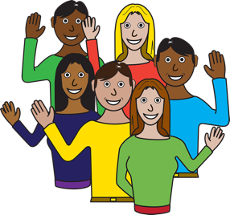
Thank you for your time!

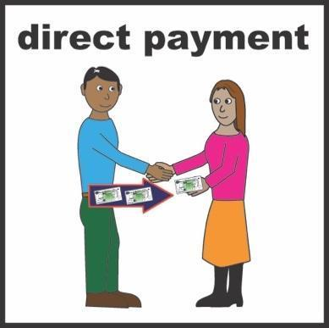
We will give you a $50 voucher at the end of the
focus group to thank you for your time.

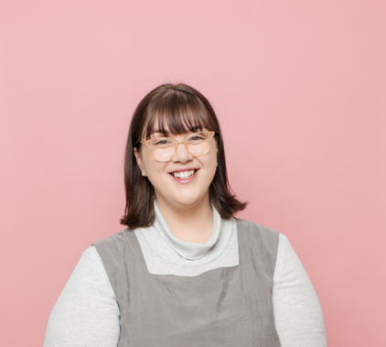
If you have any questions about
you can ask Mali
Email project@wwda.org.au
Call 0467 813 094

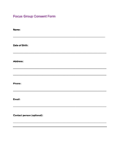
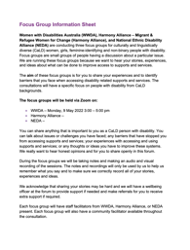
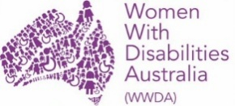
This document
This document is based on the WWDA, NEDA and Harmony Alliance registration form and consent form for the Culturally and Linguistically Diverse (CaLD) Women With Disability Focus Group Series 2022.
Who wrote this document?
Women With Disabilities Australia wrote this document in 2022.
Copyright
© Copyright Women With Disabilities Australia (WWDA) Inc. 2022.
All intellectual property rights, including copyright and patents, in this form is owned and licensed by Women With Disabilities Australia Inc.

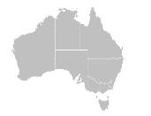
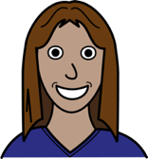
Images
We have used images from
- Easy On The I
- Google Images
- The Noun Project.

