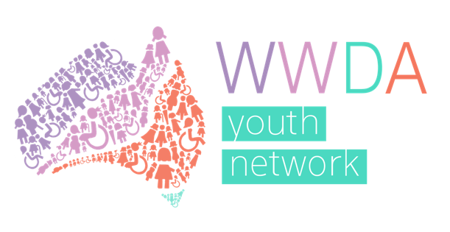
Women With Disabilities Australia
Youth Advisory Group

Application form

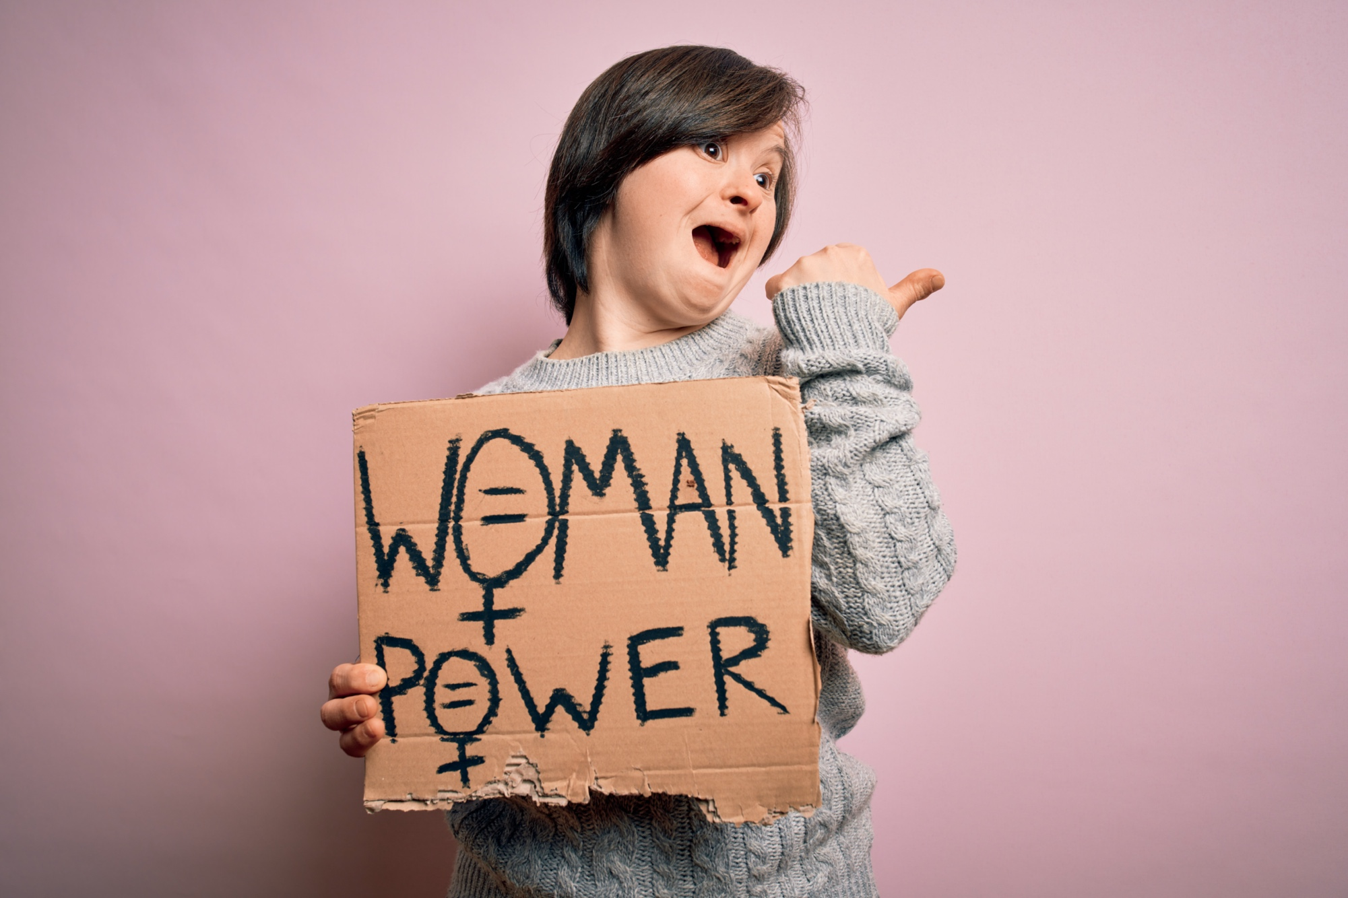
Easy Read version

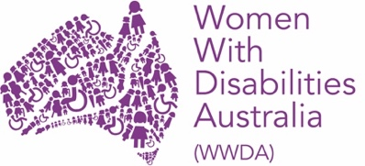
About WWDA
We are Women with Disabilities Australia. We will write WWDA when we talk about us.
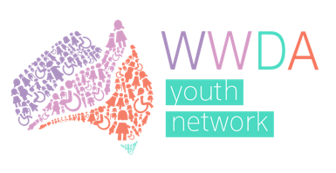
WWDA Youth is a group run by WWDA for young women, girls and non-binary young people who:
- are under 30
- have a disability.

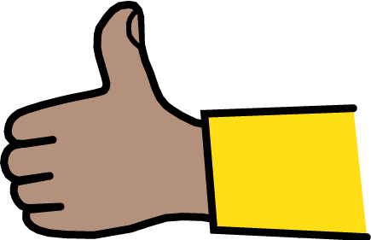
The WWDA Youth Network supports young women and girls with disability have good lives.

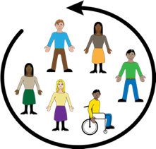
WWDA is starting a WWDA Youth Advisory Group.
You can read about this in the WWDA Youth Advisory Group Terms of Reference on the WWDA Youth Network website at: http://youth.wwda.org.au/wwda-youth-advisory-group/

About this form
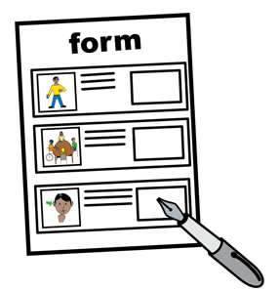
WWDA is inviting young women and non-binary young people with disability to apply to join the WWDA Youth Advisory Group.
You can apply using this form.

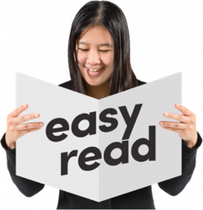
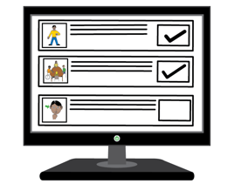
This form is an Easy Read version of an online form.
You can find the online form at:

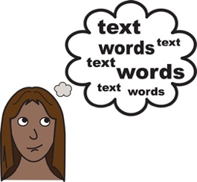
Some words in this form are bold and underlined.
We explain these words mean at the end of the form.

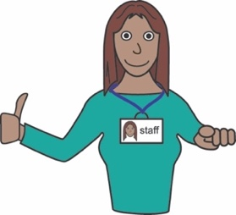
You can ask for help to read and complete the form.
A support person may be able to help you.

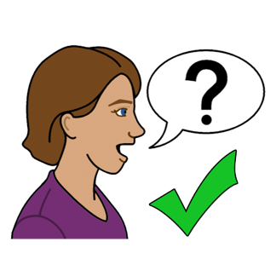
Contact us
You can contact us if have any questions or would like us to help you complete this form.
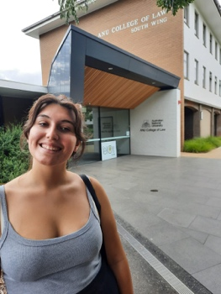
Contact our Youth Development Officer, Margherita:
- email ydo@wwda.org.au
- call 0488 758 539

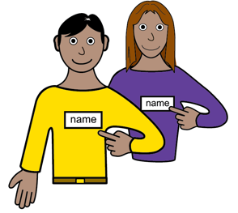
About you
My name is

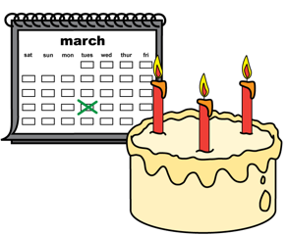
I was born on
Write the day / month / year

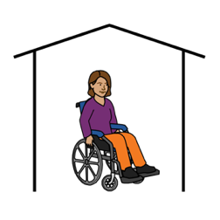
I live at

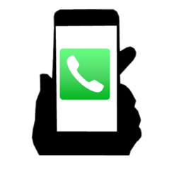
My phone number is

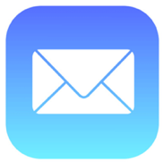
My email is

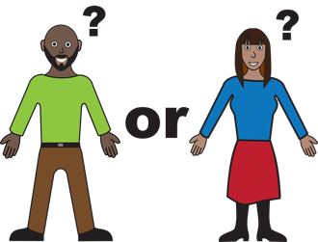
My gender is:

Male
Female

Non-Binary

Other

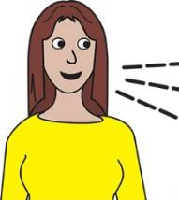
My main language is:

English
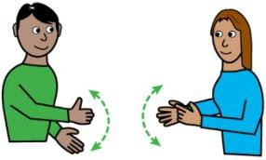

Auslan

Other
I am:

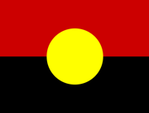
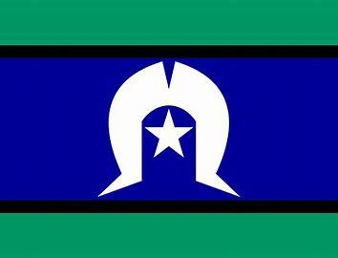

Aboriginal or Torres Strait Islander
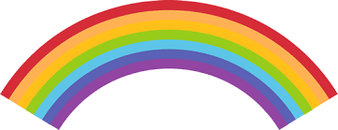
Lesbian, Gay, Bisexual, Transgender,
Intersex, Queer or Asexual (LGBTIQA+)

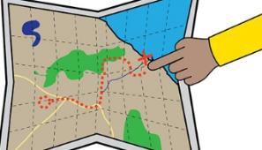
From a rural, regional
or remote area

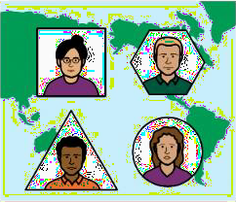

A migrant or refugee.

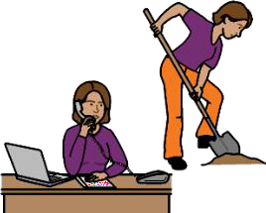
Your skills and experience
I am good at:

I would like to join the WWDA Youth Advisory Group because:

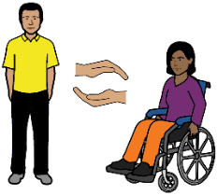
Your support needs
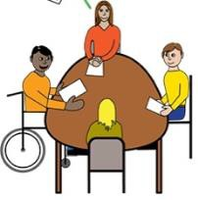
The WWDA Youth Advisory Group will meet online using zoom.
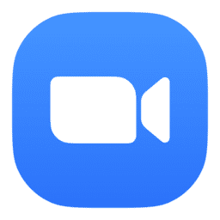
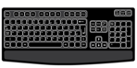
To take part in zoom meetings I need:

An Auslan interpreter

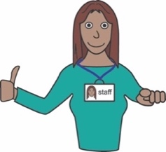
Captions or subtitles

A support person

Other

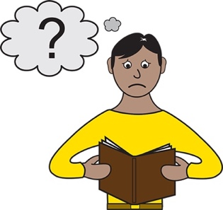
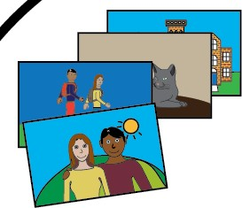
To understand information, I need:

Easy Read

Large print
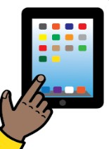

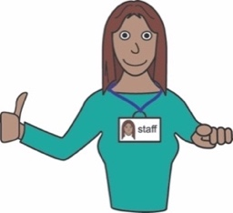
A screen reader

A support person

Braille

Other

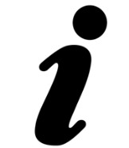
Is there anything else you would like to tell us?
Please write it in the space below:

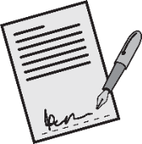
Your signature

Date today (Date/Month/Year)

How to send us your form
Send the completed form to us by:

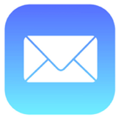
- email: ydo@wwda.org.au

or

- post:
Po Box 407.
Lenah Valley TAS 7008.

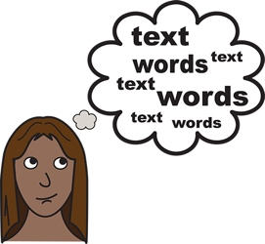
Word list
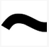
Non-Binary
Non-Binary is what we call the gender of people who do not identify as male or female.

Gender
Your gender It is about how you see yourself or how you identify Like you can identify as a man or woman.

LGBTIQA+
LGBTIQA+ means diverse sexualities and genders. The letters in LGBTIQA+ stand for Lesbian, Gay, Bisexual, Transgender, Intersex, Queer and Asexual. We explain these words below.

Lesbian
A woman who has romantic feelings for other women.
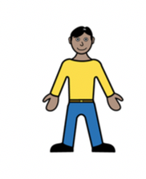
Gay
A man who has romantic feelings for other men.
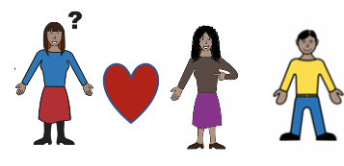
Bisexual
A person who has romantic feelings for more than one gender.
Transgender
A person whose gender does not match the sex they were given at birth. For example, a person who is a woman, but was born male is transgender.

Intersex
A person whose body is not male or female.

Queer
Another word used to talk about the LGBTIQA+ community.
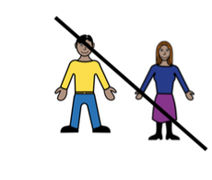
Asexual
A person that does not have sexual feelings for other people.

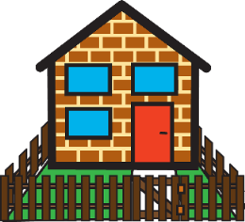
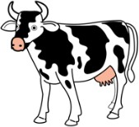
Rural
Places that are rural are away from the city.
You may live in a rural place if you live:
- on a farm
- in a small town.
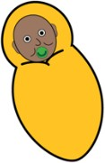
Migrant or Refugee
A migrant or Refugee s someone who lives in a different country to where they were born.

Auslan
Auslan is the sign language people use in Australia if they are deaf or find it hard to hear.

Zoom
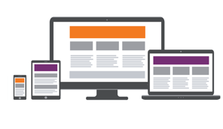
A program that allows you to run or join a meeting online.
Zoom can be used on:
- a computer or laptop
- a smart phone
- on a tablet or iPad.

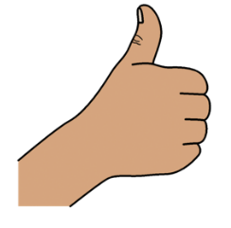
Thank you

Who wrote this book?
Women with Disabilities Australia wrote this document in 2020.
This document is for information only.

Copyright
© Copyright
Women with Disabilities Australia (WWDA) Inc. 2020.

All intellectual property rights, including copyright and patents, in this book is owned and licensed by Women with Disabilities Australia Inc.

The images used in this fact sheet
Easy on the I Images © 2018 Leeds and York Partnership NHS Foundation Trust. Used with permission. www.easyonthei.nhs.uk
Disabled People’s Organisations logos. Used with permission.

