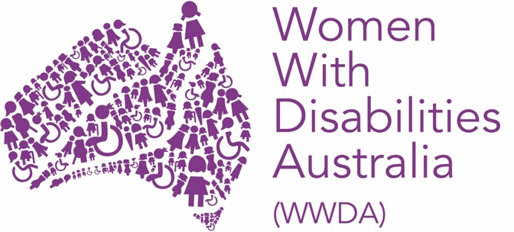

Women with Disabilities Australia (WWDA)

Our Site Expansion Project
Project Steering Committee

Application Form

2022 - 2024

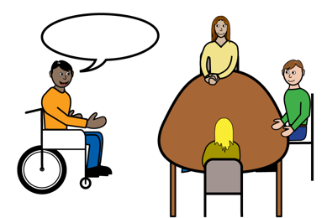
About this form

WWDA is inviting women and non-binary people with disability to show interest in joining the WWDA Project Steering Committee.

You can read about the Expression of Interest in our Easy Read book about the Project Steering Committee.

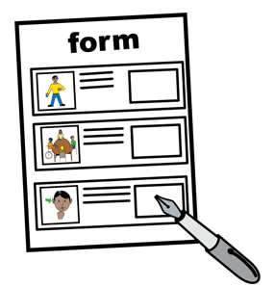
You can apply for the committee using this form.

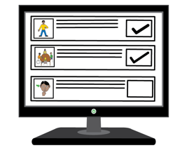
This form is an Easy Read version of an online form.

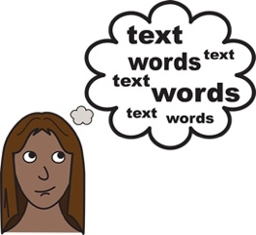
Some words in this form are bold and underlined.
We explain what these words mean at the end of this form.

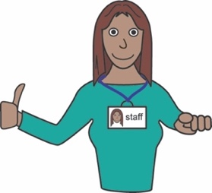
You can ask for help to read and complete the form.
A support person may be able to help you.

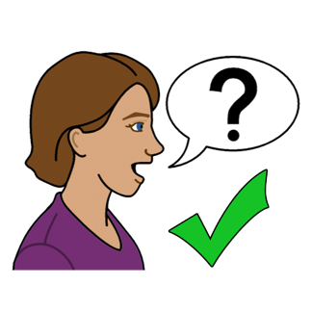
Contact us
You can contact us if have any questions or would like us to help you complete this form.

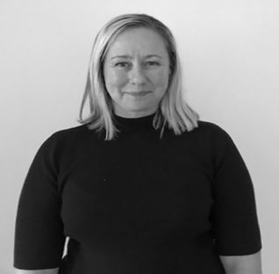
You can contact our Project Director, Libbi by email at libbic@wwda.org.au

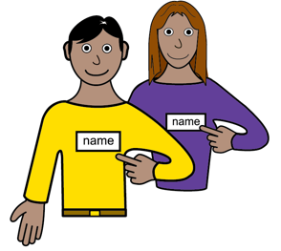
About you
My name is

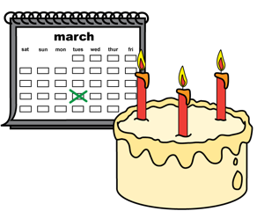
I was born on

Write the day / month / year

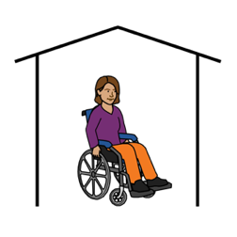
I live at

My phone number is

My email is

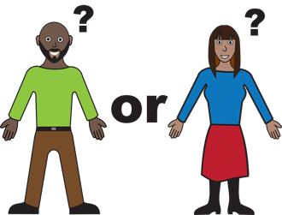
My gender is:

Male
Female

Non-Binary

Other

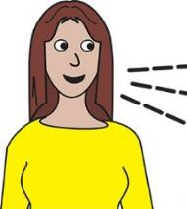
My main language is:

English
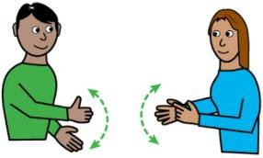

Auslan

Other

I am:

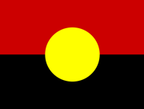
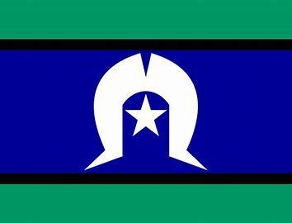

Aboriginal or Torres Strait Islander

Lesbian, Gay, Bisexual, Transgender,
Intersex, Queer or Asexual (LGBTIQA+).

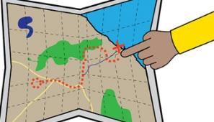
From a rural, regional

or remote area.

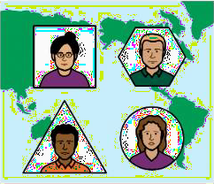

A migrant or refugee.

Your skills and experience
I want to join the Project Steering committee because:

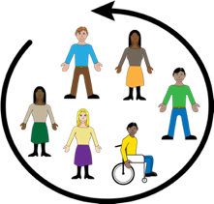
What are the most important things for women and non-binary people, and girls with disabilities?

Can you tell us what co-design means to you?

___________________________________________
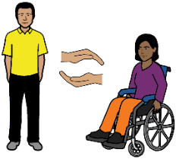

Your support needs

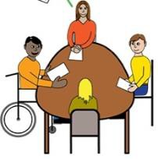
The project steering committee will meet online using zoom.

To take part in zoom meetings, I need:

An Auslan interpreter

Captions or subtitles
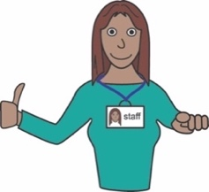
A support person

Other

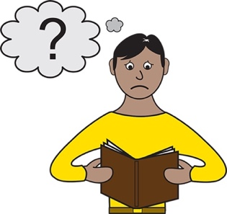

To understand information, I need:

Easy Read

Large print

A screen reader

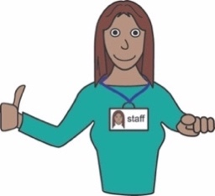

A support person

Braille

Other

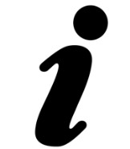
Is there anything else you would like to tell us?
Please write it in the space below:

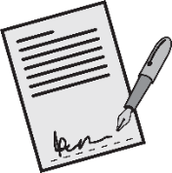

Your signature

Date today (Date/Month/Year)

How to send us your form
Send the completed form to us by:

- email: libbic@wwda.org.au

or

- Post:
Po Box 407.
Lenah Valley TAS 7008.

Or

- Phone or SMS Libbi on 0448 417 875

Please send the completed form to us by 16 July 2022

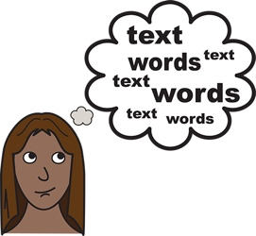
Word list
Non-Binary
Non-Binary is what we call the gender of people who do not identify as male or female.

Gender
Your gender It is about how you see yourself or how you identify Like you can identify as a man or woman.

LGBTIQA+
LGBTIQA+ means diverse sexualities and genders. The letters in LGBTIQA+ stand for Lesbian, Gay, Bisexual, Transgender, Intersex, Queer and Asexual. We explain these words below.

Lesbian
A woman who has romantic feelings for other women.

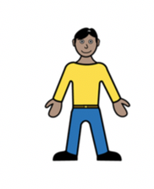
Gay
A man who has romantic feelings for other men.

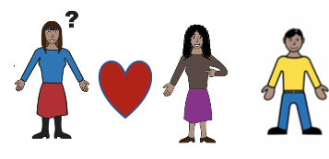
Bisexual
A person who has romantic feelings for more than one gender.

Transgender
A person whose gender does not match the sex they were given at birth. For example, a person who is a woman but was born male is transgender.

Intersex
A person whose body is not male or female.

Queer
Another word used to talk about the LGBTIQA+ community.
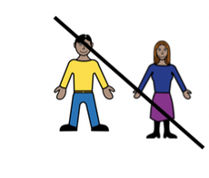
Asexual
A person that does not have sexual feelings for other people.

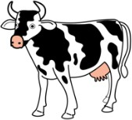
Rural
Places that are rural areas away from the city.
You may live in a rural place if you live:
- on a farm
- in a small town.

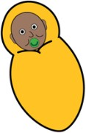
Migrant or Refugee
A migrant or Refugee s someone who lives in a different country from where they were born.

Auslan
Auslan is the sign language people use in Australia if they are deaf or find it hard to hear.

Zoom
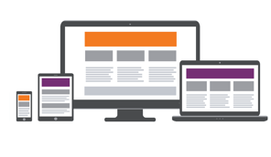
A program that allows you to run or join a meeting online.
Zoom can be used on:
- a computer or laptop
- a smartphone
- on a tablet or iPad.
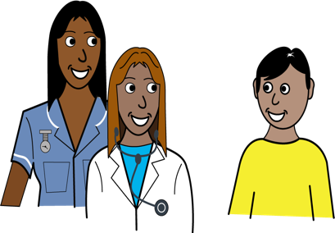
Service
A service is a person or an organisation that provides you with things like.
- Food
- Medicine
- Support care

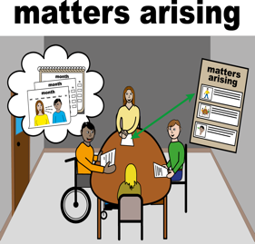
Project Steering Committee
A group of people who help a project to be a good project. A good project
- Includes many people
- Does what it is meant to do
- Can help make services better.

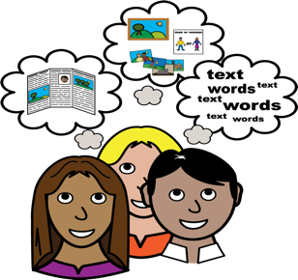
Co-design
Co-design means that we make things together to make them better for the people we use them. We Think that this is the best way to make things for people.

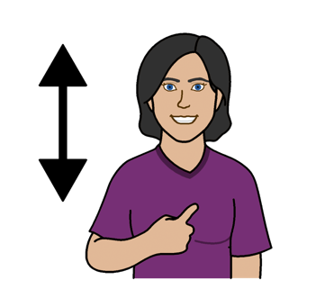
Experience
This is what you know about yourself and things that have happened in your life. We think this is very important.

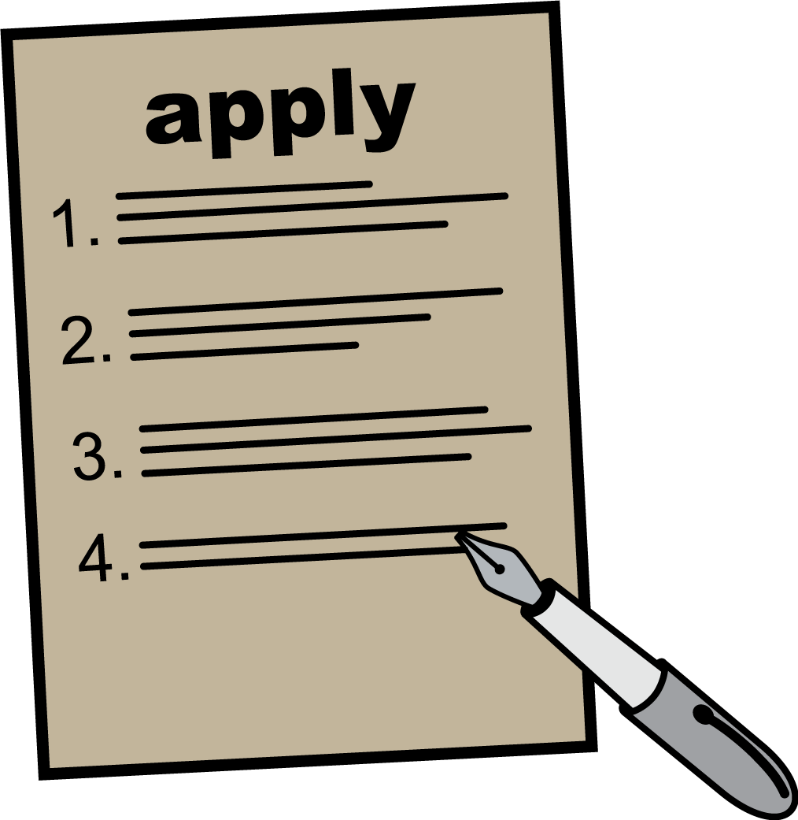
Application form
It is a form you can write or type on to tell us you want to be involved in this committee. In the form, you tell us about yourself and give us information so we can contact you.

Expression of Interest
An expression of interest is when you let an organisation know you are interested in becoming involved in a project, a job or an advisory role.

Easy Read
Easy Read is a way of presenting information and words in a way that makes it easier for people to understand

Thank you

Who wrote this book?
Women with Disabilities Australia wrote this document in 2022
This document is for information only.

Copyright
© Copyright
Women with Disabilities Australia (WWDA) Inc. 2020.

This book's intellectual property rights, including copyright and patents, are owned and licensed by Women with Disabilities Australia Inc.

The images used in this fact sheet
Easy on the I Images © 2018 Leeds and York Partnership NHS Foundation Trust. Used with permission. www.easyonthei.nhs.uk
Disabled People’s Organisations logos. They are used with permission.

