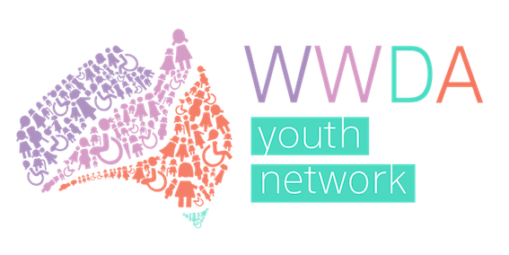
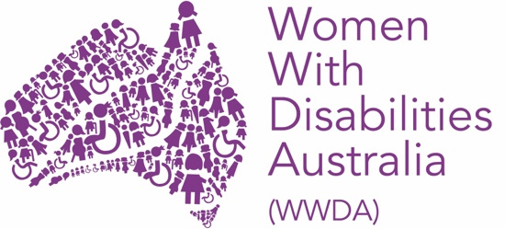

Women With Disabilities Australia (WWDA)

Report from the United Nations Conference of State Parties (COSP) on the Convention on the Rights of Persons with Disabilities (CRPD) 15th Session, New York, 2022

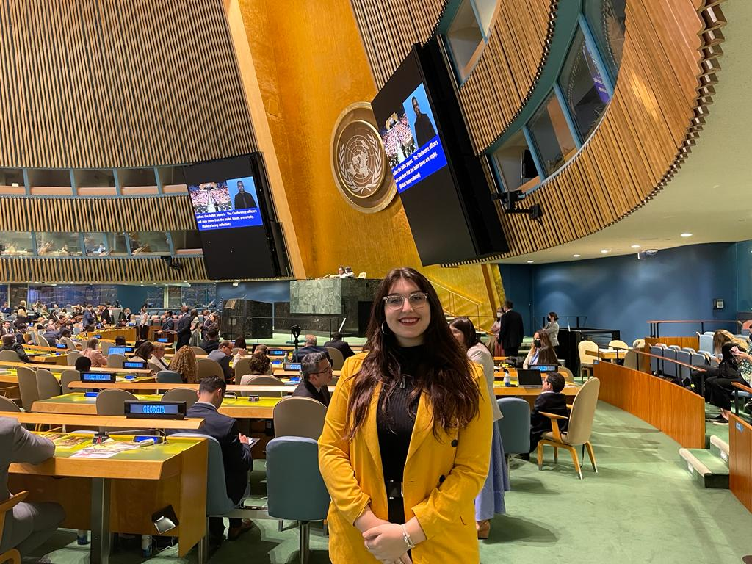
By Margherita (WWDA) August 2022, Youth Development Officer

Introduction and Background

It was a privilege to be able to represent young Australians and Women With Disabilities Australia (WWDA) at the 15th Conference of State Parties on the Convention on the Rights of Persons with Disabilities (CRPD) held in New York. I’d like to thank and acknowledge the hard work of Carolyn Frohmader, Heidi La Paglia and Saphia Grant for supporting me both leading up to and at the conference.

The Convention on the Rights of Persons with Disabilities was adopted by the United Nations General Assembly by its resolution 61/106 of 13 December 2006. It came into force on 3 May 2008 upon the 20th ratification. Article 40 of the Convention stipulates that “The States Parties shall meet regularly in a Conference of States Parties in order to consider any matter with regard to the implementation of the present Convention.” Since 2008, yearly sessions of the Conference of States Parties have been held at United Nations Headquarters, New York.

For the past couple of years, the conference has been online due to COVID-19, and this was the first time many had convened in person. This unique aspect of the 15th session was overarching in all aspects of the practical and logistical parts of the conference. It meant that many people were still participating online, that most side events were online and the attendance of member nations was both in person and online.

Leading up to the conference, I was able to attend briefings ran on behalf of the Department of Social Services and Department of Foreign Affairs and Trade, as well as separate briefings ran by disabled peoples organisations (DPO’s). Both of these trainings were incredibly helpful, and I was able to learn from people who had already attended multiple times.

In attending the conference, I was supported by and learnt so much from the community of people from disabled peoples organisations, which I am so thankful for.

Civil Society Day

On the first day of the conference week, we attended a civil society day as a group from Australia and met with Ambassador to the United Nations Mitch Fifield.

The civil society day was mostly online, with us attending as a group in a conference room. We were able to listen to various speakers from international organisations and start preparing for the conference. A theme that emerged from the day was “de-institutionalisation” that was followed on from 2019.

Meeting with the Ambassador was particularly interesting as it was interesting to ask him about disability rights and his role at the conference.

Formal Conference Proceedings

The conference was opened with the official proceedings, and the general debate, which involved member nations, organisations and UN agencies speaking.

The general debate continued for the first day, and then was continued at the end of the remaining days.

During the general debate, members of the DPO’s spoke, with a highlight being Damian Griffis from First Peoples Disability Network speaking about having a first nations voice to the CRPD. Considering the debate currently happening in Australia, this was such an important contribution.

Matilda from Queensland Advocacy and Inclusion also spoke about the Optional Protocol Against Torture and Cruel, Inhuman and Degrading Treatment and Punishment (OPCAT), which was a new theme.

The remaining days were round tables on the three sub themes being:
- Innovation and technology advancing disability rights

- Economic empowerment and entrepreneurship of persons with disabilities

- Participation of persons with disabilities in climate action, disaster risk reduction and resilience against natural disasters

Kelly Cox from People with Disabilities Australia spoke about people with disability during the floods, which was particularly moving.

Side Events

I attended a significant amount of side events, with two being in person and the rest online.
WWDA did its own side event about Our Site, which was early in the week.

I attended QAI’s side event about OPCAT monitoring and implementing, which gave further information on implementing OPCAT monitoring.

Jordan presented on their long term de-institutionalisation plans and how they were able to assess and implement a plan, as well as what they were planning to do to further the plan. This was for me one of the most interesting side events, as I was able to really learn about de-institutionalisation and how a country has implemented its plans.

Bus Stop Films presented a series of their films, as well as a panel interview which was so interesting, and wonderful to have a different variety of side events that gave us insight into more than just policy and plans.

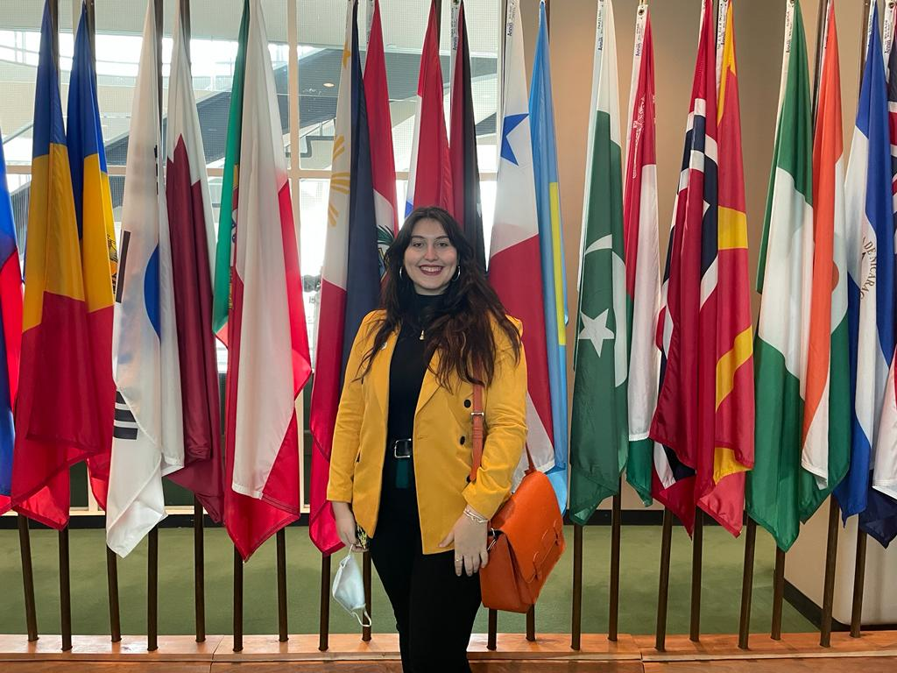

Summary of Conference Learnings.

It was such an honour to go to New York and attend the conference. Not only was I able to interact and grow with the community of disabled people in Australia, as well as meet new people in the community, I was able to learn about a wide array of new ideas and projects to implement in my own youth work and advocacy.

