Women With Disabilities Australia (WWDA)
Youth Advisory Group

Reproductive Health, Menstruation, Contraception and Disability:

A Resource for Young People

October 2022

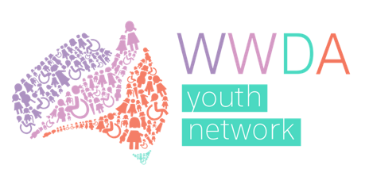
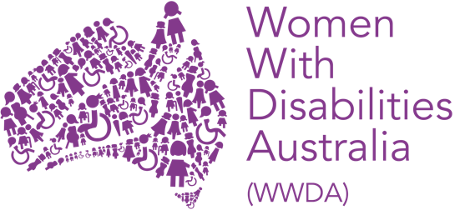

Publishing Information

Women With Disabilities Australia (WWDA) (2022). ‘Reproductive Health, Menstruation, Contraception and Disability: A Resource for Young People.’ Developed by the WWDA Youth Advisory Group (YAG); October 2022. WWDA: Hobart, Tasmania.

Acknowledgments

WWDA acknowledges the traditional owners of the lands on which this publication was produced. We acknowledge Aboriginal and Torres Strait Islander people’s deep spiritual connection to this land. We extend our respects to community members and Elders past, present, and emerging.

This resource was created in Co-Design with the WWDA Youth Advisory Group (WYAG). We would like to acknowledge and thank:

Ajar Sana, Amy James, Amy Marks, Ana Pike, Bianca Templar, Charlotte Young, Cindy Liu, Claire Bertholli, Claire Lock, Emily Sullivan, Is Hay, Jade Taylor, Jessi Townley, Lily Hodgson, Luna Rybak, Margot Beavon-Collin.

All illustrations by: Lisa Rime at contact-pod@hotmail.com

This Resource was developed through a funding grant from the Australian Consumers Health Forum (CHF). WWDA acknowledges, with thanks, the support of the CHF.

Contact

Women With Disabilities Australia (WWDA)
Contact: Carolyn Frohmader, CEO
PO Box 407, Lenah Valley, 7008 Tasmania, Australia
Phone: +61 438 535 535
Email: carolyn@wwda.org.au
Web: wwda.org.au
Facebook: facebook.com/WWDA.Australia
Twitter: twitter.com/WWDA_AU

Winner, National Human Rights Award 2001
Winner, National Violence Prevention Award 1999
Winner, Tasmanian Women's Safety Award 2008
Certificate of Merit, Australian Crime & Violence Prevention Awards 2008
Nominee, UNESCO Prize for Digital Empowerment of Persons with Disabilities 2021
Nominee, National Disability Awards 2017
Nominee, French Republic's Human Rights Prize 2003
Nominee, UN Millennium Peace Prize for Women 2000

Women With Disabilities Australia (WWDA) has Special Consultative Status with the Economic and Social Council of the United Nations
Disclaimer

The views and opinions expressed in this publication are those of Women With Disabilities Australia (WWDA) and not necessarily those of our funding bodies. All possible care has been taken in the preparation of the information contained in this document. WWDA disclaims any liability for the accuracy and sufficiency of the information and under no circumstances shall be liable in negligence or otherwise in or arising out of the preparation or supply of any of the information aforesaid.

This work is copyright. Apart from any use as permitted under the Copyright Act 1968, no part may be reproduced without written permission from Women With Disabilities Australia (WWDA).

© 2022 Women With Disabilities Australia (WWDA).

ABN: 23 627 650 121

Contents

1. Reproductive Health & Young Persons with Disability 4
1.1 Menstrual Cycle 4
1.2 When to see your doctor about your periods 7
1.3 Medications to control periods 8
1.4 Conditions that May Cause Menstrual Issues and Common Symptoms 10
1.5. Period Aids and Products – Things to Consider 17
1.6 Advocating for Yourself 27
2. Contraception 28
2.1. Contraception Choices 28
2.2. Medication Clashes 36
2.3. Advocating for Yourself 38
2.4. Sexually Transmitted Infections (STI's) 39
2.5. What Happens During an STI Test? 43

Reproductive Health & Young Persons with Disability

Menstruating with a disability, including for victim-survivors of abuse, can be different and difficult to manage. This resource aims to give general information on menstruation, contraception, and sexually transmitted infections (STIs) to young people with disability.

This Resource has been developed by young women, girls, feminine identifying and non-binary persons with disability.

1.1 Menstrual Cycle

The menstrual cycle is made up of distinct phases: menstruation, ovulation, follicular and luteal phases.

Menstruation (the period) is only one part of the cycle that those born with ovaries experience. Most people have two ovaries which contain thousands of eggs when their period first starts. On average, this is at about 12 years of age. The eggs reduce in number over the years, ending at menopause (your last/final period) when there are no eggs.

The beginning of your cycle is the first day of your period. During this phase, the body eliminates the lining of the uterus, which had built up in the last phase. This lining contains blood, fluid and mucus called the ‘period’, menses, or menstruation. There may be other names for this in your culture or taught to you by your family and friends. It is normal for period loss to range from bright red to brown in colour.

Periods usually last 4 – 7 days. However, they can fluctuate in length and amount of blood lost.

It is important to monitor, track or get support to track the time between your periods. If the time between your periods or length of periods changes drastically or in a way that is unusual to your cycle, it is time to see your doctor.

Follicular Phase

The follicular phase overlaps with menstruation as it starts on the first day of menstruation and ends with ovulation. It is defined by the release of a specific hormone from both the pituitary gland in the brain and the ovaries, which stimulates some of the eggs/follicles and begins to prepare to release a single egg – called ovulation (sometimes multiple eggs can be released).

Ovulation Phase

Ovulation is the next phase, the release of a mature egg as stimulated by hormones, including oestrogen. The egg is funneled into the fallopian tube and travels towards the uterus.

Luteal Phase

During ovulation, the egg bursts from its sac. The sac stays near the surface of the ovary and releases oestrogen and progesterone hormones. These hormones thicken the uterus lining to prepare it to receive the fertilised egg (egg and sperm together to form pregnancy). This phase lasts about two weeks. If the egg is not fertilised, the lining is shed. This begins the next period and the menstrual cycle all over again.

1.2 When to see your doctor about your periods

When seeking support and help for menstrual conditions, it is of the utmost importance to keep yourself safe and comfortable. You have the right to have someone accompany you to any appointments you may need to attend.

Some things to look out for include:

- If you have epilepsy, you might have more seizures before and during your period.
- If you are having very bad pain during or before your period.
- If there is a sudden change in colour, length, and time between your periods, possibly following a new treatment or medication.
- If your period stops for more than 60 days.
- If your periods are heavier than usual – note that some people with reproductive health conditions may still have regular periods.
- If you suddenly get a fever, diarrhoea, vomit or feel sick.

1.3 Medications to control periods

Medications are available to control heavy bleeding, pain, and other symptoms such as nausea. There are two groups of medications: non–hormonal and hormonal.

Non-hormonal options include tranexamic acid (for very heavy periods) and anti-inflammatory medications. Tranexamic acid requires a doctor’s prescription.

The hormonal options include the contraceptive pill or ring, progesterone only hormonal medications, including oral and injectable, and the hormonal intrauterine device (IUD).

In cases of major health problems which don’t respond to medications, a person may consider an operation to stop their period. Sometimes heavy periods are treated with surgery, for example to remove a fibroid (a lump in the muscle of the uterus) or to reduce the lining of the uterus. The uterus can be removed in an operation known as a hysterectomy.

A hysterectomy is a serious operation that you must be fully educated on and informed about. You must be sure that this is the best option for you.

Another surgical procedure that can be used to treat heavy bleeding is called ‘endometrial ablation’. Endometrial ablation is a medical procedure that is used to remove, or destroy, the lining of the uterus (endometrium). This procedure treats the lining of the uterus to control or stop bleeding without having to remove the uterus. However, most women are not able to become pregnant after an ablation; therefore, you should not have an endometrial ablation if you may want to become pregnant in the future.

Medications and their influence on periods and the menstruation cycle

For people with disability, various medications can influence periods and hormones. It is important to ask or find out if the medication you are on can influence your period, and if so how. This is something best talked about with your doctor.

Medications can be a common cause of irregular periods. Anti-psychotics, anti-depressants, weight loss medications, steroids, hormones, and ADHD medications are just some examples of medications that can alter menstrual cycles.

1.4 Conditions that May Cause Menstrual Issues and Common Symptoms

Abnormal Uterine Bleeding means:

Shorter, longer, heavier, or more frequent menstrual cycles.

Bleeding between periods or during/after sex.

There may be an underlying condition.

Dysmenorrhoea means:

Severe and frequent menstrual cramps.

High levels of pain.

Potential nausea or vomiting.

Amenorrhoea means:

Not having a period.

Excludes pre-puberty, pregnancy, lactation, and menopause.

Heavy Menstrual Bleeding (also known as Menorrhagia) means:

Heavier bleeding.

Periods lasting more than 7 days.

Needing to change period product (e.g., tampon, pad) every hour.

Passing blood clots larger than a 50-cent coin.

The amount of blood loss interferes with your daily life.

Spotting or bleeding often between periods.

Gynaecological Disorders or Conditions

Endometriosis
Tissue like the lining of the uterus (womb) grows outside the uterus, usually in the pelvis, around and on the ovaries and the abdomen lining.

Symptoms can include:
- Pain including cramps, bowel pain, pain with urinating, lower back pain.
- Bleeding or spotting between periods.
- Difficulty getting pregnant.
- Stomach (digestive) problems.

Polycystic Ovarian Syndrome (PCOS)
The cause of PCOS is not entirely understood, however it is known that hormones, including androgens and insulin, play a role in disrupting ovarian function. Often, there will be a family history.

Symptoms can include:
- Irregular or absent menstrual cycle.
- Acne.
- Thinning of hair on your head or a more noticeable amount of hair on the face (nipples and/or chest).
- Skin tags.
- Difficulty gaining or losing weight or maintaining weight.

Premenstrual Syndrome (PMS)
It is not clear why some people develop PMS and Premenstrual Dysphoric Disorder (PMDD). There appears to be very complex interactions between certain chemicals in the brain and progesterone that leads to symptoms.

PMS occurs with ovulation and not without, nor after menopause. Many symptoms can occur before and during a period. Symptoms settle, and there is at least a week without any symptoms after the period.

Premenstrual dysphoric disorder (PMDD) is a more serious form of PMS. PMDD affects about 3-8% of women with PMS.

There is a wide range of symptoms that can occur with both PMS and PMDD, including emotional and physical – such as:
- Irritability
- Anxiety
- Forgetfulness /lack of concentration
- Mood swings
- Teariness
- Anger
- Sore breasts
- Bloating
- Fluid Retention
- Depression

Catamenial Epilepsy
Catamenial Epilepsy refers to seizures that occur to some menstruating people with epilepsy, where seizures are exacerbated (or occur only) in relation to the menstrual cycle. The reasons are not completely understood, but progesterone or progesterone like hormones may be prescribed.

Symptoms can include:
- Twitching
- Jerking
- Confusion
- Sudden emotional changes
- Vision changes
- Dizziness
- Lack of control over breathing or bladder function

For people with disability, the symptoms of menstrual conditions can often overlap with disability related symptoms or experiences. This means that it is even more important to monitor changes in the menstrual cycle and check any changes with your doctor or someone you trust who may be able to help you investigate the changes.

“I’ve struggled with PCOS and the symptoms that come with it for years. It has made me feel insecure about my hormonal acne and increased growth of hair on my face and body. Because of the irregular menstrual cycles, I’ve found it important to track my ovulation and mood fluctuations, so I’m prepared for when my period comes with little notice!”
- Maayan

Menstruating as a Transgender or Non-Binary Person

Menstruation can sometimes be a distressing experience for people who don’t identify with their assigned sex at birth. For example, if you get your period and you don’t identify as a woman, feelings of discomfort or anxiety might arise due to the fact that society associates periods with women. This experience of uneasiness may also be referred to as gender dysphoria.

Gender dysphoria is defined as the feeling of unease or discomfort that may arise when people whose gender identities are different from their assigned sex at birth. Not everyone who is trans or non-binary experiences gender dysphoria. But for some people, menstruation can contribute to the feeling of dysphoria. The sight of menstrual blood or period products may also be visually triggering because of their gendered associations.

As a trans or gender-diverse person, who is menstruating, you may face different complexities and challenges seeking support within the health system. You may encounter language which is not inclusive or identity-affirming.

There may be LGBTIQA+ friendly doctors and health service providers in your area. DocDir is a directory of LGBTIQA+ friendly practitioners which can be found online. You can also use TransHub "10 Questions to Ask Your Doctor to know if they are trans friendly" guide.

Support for Victim-Survivors of Abuse

Many victim-survivors of abuse may have menstrual problems due to prior abuse, including sexual violence. This may include starting to menstruate or bleed at an earlier age, or later than average. When seeking support and help for menstrual problems, it is of the utmost importance to keep yourself safe and comfortable. You have the right to have someone accompany you to any appointments you may need to attend.

WWDA’s Our Site website includes various resources and information for victim survivors, and stories from those who have experienced managing periods and more.

You can also call 1800RESPECT on 1800 737 732 or chat to someone online at any time if you require support regarding violence or abuse.

1.5. Period Aids and Products – Things to Consider

There are a wide variety of period products on the market, and this list is not exhaustive. A wide variety of these products may be available through the National Disability Insurance Scheme (NDIS).

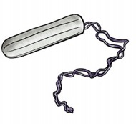
Tampons
A tampon is a tightly rolled piece of cotton that goes inside your vagina to soak up the blood before it leaves your body. Tampons have a string at the end to help pull them out of the vagina when they need to be changed.

Some Strengths:
- Easily available
- Cost friendly short term
- Easily transportable
- May be more comfortable in a wheelchair or moving around
- Tampons with applicators may be easier to apply

Some Weaknesses:
- Must be inserted
- Must be changed often
- Not all types are enough for heavy flow
- Small risk of Toxic Shock Syndrome (TSS)
- May contribute to gender dysphoria
Disposable Sanitary Pads
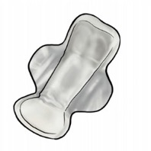
A pad is a strip of thick, soft material that absorbs liquid. It sticks inside your underwear and soaks up period blood. It is held in place by a sticky strip on the back and often has wings that wrap around underwear. There are many types of pads for various amounts of blood or “flow”.

Some Strengths:
- Easily available
- Cost friendly short term
- Easily transportable
- May be available through the NDIS
- Easy to use – although unwrapping may be hard

Some Weaknesses:
- Not sensory friendly, crinkly wrapping
- Uncomfortable/difficult to place if sitting in a wheelchair
- Must be changed often
- Can’t be worn with all underwear
- Can’t be worn swimming/showering/bathing

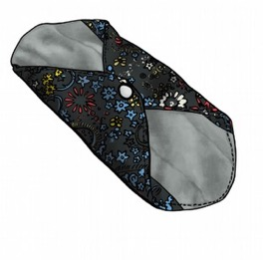
Reusable Sanitary Pads

These are the same as disposable sanitary pads but are made with fabric instead. They do not have any sticky side and instead clip onto the underwear with wings.

Some Strengths:
- Re-usable – environmentally friendly and less expensive in the long term
- Easily transportable
- Easy to use
- May be more sensory friendly

Some Weaknesses:
- Harder to purchase in person
- Initially expensive
- Must be changed often
- Can’t be worn swimming/showering/bathing
- May contribute to gender dysphoria

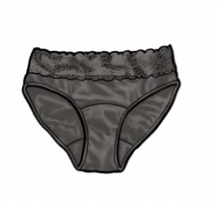
Period Underwear

Period underwear are types of underwear that have an absorbent material in the crotch area. This absorbs the blood without having to put anything on top of your underwear or in your vagina.

Some Strengths:
- Some brands may be available through the NDIS
- Brands make feminine and boxer versions
- Re-usable – environmentally friendly and less expensive in the long term
- More comfortable
- Do not need to constantly change throughout the day

Some Weaknesses:
- Initially expensive
- Must be washed by hand
- Not all types are enough for heavy flow
- Can’t be worn swimming/showering/bathing
- Harder to purchase in person
- May have an odour if not cleaned regularly

“I have period every four of week. First I had big white pants (sort of like pull up nappies). They would rip apart. Too much between my legs. Then flesh coloured disposable undies.
They also would rip when pulled up.
Sanitary pads were better than the white pants but difficult to take off, blood got around and went on my pants.”

“Advice from a lady with a teenaged girl helped my mum find Modibodi undies with an absorbent crotch. Pretty good! Good to pull up (they don’t rip), sometime a small lump between legs. I still need someone to help me straighten the lump. Only feels a little bit wet when I have my period, mostly feels dry. Sometimes it can get smelly. Mum puts them in the washing
machine.”
Liners
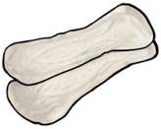
Liners are smaller strips of a soft material similar to disposable sanitary pads but absorb less.

Some Strengths:
- Easily Available
- Cost friendly short term
- Easily transportable

Some Weaknesses:
- Have to be changed often
- Are thin
- May move around in underwear
- Can’t be worn swimming/showering/bathing

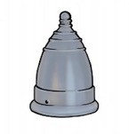
Menstrual Cups

A small, flexible cup that is made of silicone or latex rubber which is inserted into the vagina. It opens inside the vagina to catch and collect the blood flow.

Some Strengths:
- Re-usable – environmentally friendly
- Less expensive in the long term
- Holds more blood, so may need to be changed less often depending on flow

Some Weaknesses:
- Difficult to insert and requires extensive hand motion
- Can be difficult to remove without a mess as the cup needs to stay upright
- Must be washed by hand
- Don’t work for all anatomies
- May contribute to gender dysphoria

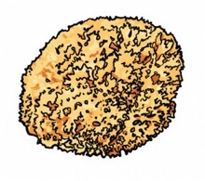
Sea Sponges

A type of sea sponge used like a tampon but is re-usable and often does not have a string.

Some Strengths:
- Re-usable – environmentally friendly
- Less expensive in the long term
- Easily transportable
- Absorbent

Some Weaknesses:
- Have to be changed often
- Harder to purchase in person
- Not all types are enough for heavy flow
- Require regular, thorough cleaning
- Can be messy and difficult to remove
- Have a particular feel which may not suit sensory needs

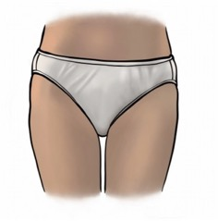
Disposable Underwear

Period underwear that is disposable.

Some Strengths:
- Easily Available
- May be more comfortable

Some Weaknesses:
- Blood may leak
- Not all types are enough for heavy flow
- Costly over time
- Harder to purchase in person depending on underwear type
- Can’t be worn swimming/showering/bathing

Support for Financing and Finding Period Products

Many period products can be expensive, both reusable items such as menstrual cups and one-time use products that must be repurchased often such as tampons and disposable pads. Period poverty is incredibly common, and many young people may need support to purchase these products.

For young people with disability, this cost is often heightened. Those on the NDIS can sometimes be supported financially, however the cost is still significant.

Supports for financial costs can be found through service providers such as community centres, women centres, foodbanks and LGBTIQA+ centres.

1.6 Advocating for Yourself

Menstruating as a person with a disability can be incredibly difficult due to the structure and attitude of some health and social services. This can make advocating for yourself in conversations about menstrual conditions and period pain even more difficult. It is important to remember that there are a variety of organisations and further resources that can support you, including community and local groups which can share advice about supports in your local area.

Doctors, support workers and carers may assume that you have a menstrual condition because you are not being supported to manage menstrual hygiene. It is important to differentiate between symptoms and lack of access, support, or care. In these situations, finding support to attend doctors’ appointments can be an important part of advocating for your needs.

2. Contraception

Once you have started having your periods, you may be able to get pregnant. This can happen after sex when semen and eggs meet.

Contraception is the intentional management of menstruation and ovulation through various social and cultural practices or medical interventions such as prescribed hormones, technologies, or surgical procedures.

Some forms of contraceptives can also be used for acne and other hormonal related matters, including managing heavy periods or PMS. Some forms of contraception are also used to prevent Sexually Transmitted Infections (STI’s) e.g., external condoms and dental dams.

2.1. Contraception Choices

There are many different methods and types of contraception. Some are easier to use and/or are more effective than others. Using contraception allows people to have sex while aiming to prevent an unplanned pregnancy. The following examples are not an exhaustive list.

Internal and External Condoms

External condom: A single-use method of contraception that provides coverage externally and acts as a fluid barrier. It can be used in various places, such as oral, penile, or anal.

Internal condom: A single-use method of contraception inserted vaginally and acts as a fluid barrier. When used correctly, condoms can be 75- 88% effective in preventing pregnancy and STIs.

The Pill

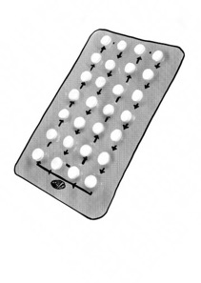
The 'Pill’ usually refers to the combined oral contraceptive or vaginal ring, which contains two hormones: oestrogen and progestogen. The pill must be taken every day at the same time to be effective. Most packets have 21 hormonal pills and 7 sugar pills, but some are 24 hormonal pills and 4 sugar pills. Sugar pills do not contain hormones, so the hormone level drops causing a withdrawal bleed or “fake period”. Some doctors suggest skipping the sugar pills if you don’t want your period for some time.

The combined pill or ring works by stopping ovulation and making the mucous at the cervix (the entrance to the uterus) very sticky to block sperm getting in. The pill cannot stop STIs. On average it can be 91-94% effective in preventing pregnancy.

The Mini Pill

The mini pill only contains a low dose of progestogen. If taken correctly it can be highly effective but usually about 91-94% effective in preventing pregnancy. It makes the cervical mucous sticky.

Depo Provera/Ralovera
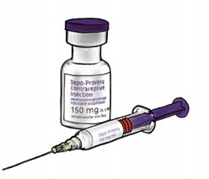
Depo Provera™/Ralovera™ is a long-acting hormone injection that contains a progestogen hormone and is administered every 12 weeks. It can be 99.5% effective in preventing pregnancy, however, it is usually around 94% but cannot prevent STI’s.
Depo Provera™/Ralovera™ can have serious side-effects if taken for too long (i.e., longer than 2
years).

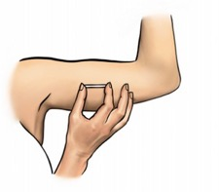
Implanon

The Implanon™ is a small rod contraceptive (4cm long) that contains a progestogen hormone. It is inserted by a healthcare provider into your inner upper arm and lasts for 3 years. It is 99.95% effective in preventing pregnancy but cannot prevent STIs.

Hormonal IUD
(Mirena)™ Kyleena™
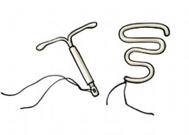
These IUDs are small, T-shaped devices made of material containing progesterone of varying doses and are fitted inside your uterus by a health professional and last for 5 years. They are 99.8% effective in preventing pregnancy.

Copper IUD
The copper IUD is inserted the same way as the Mirena but is made of copper and does not contain hormones. The copper IUD is also a form of emergency contraception and can be inserted up to 120 hours (five days) after unprotected sex. It is 99% effective at preventing pregnancy.

Female Sterilisation
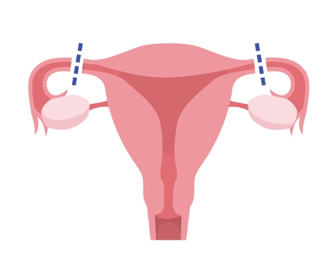
Female Sterilisation is a permanent form of contraception by operation and does not stop periods. It is most commonly referred to as a ‘tubal ligation’ which is a surgical procedure that blocks the fallopian tubes that carry the egg to the uterus (womb). In men, the operation is called a vasectomy.
Another type of permanent sterilisation is through a surgical operation called a ‘hysterectomy’ (removal of the uterus/womb). You can't become pregnant after you've had a hysterectomy, and menstruation also stops.

Forced Sterilisation
Sterilisation can be forced or coerced upon women and girls with disability, without their consent or knowledge. The United Nations has made it clear that forced sterilisation of disabled women and girls is an act of sexual violence, a form of torture, and a form of social control. The United Nations has also made it clear that sterilisation of children (including those with disability) and of adults without their prior, full and informed consent – must be prohibited by law (unless it is done as a life saving measure).

Therefore, as an adult, you should only decide on sterilisation as a contraceptive method if you feel absolutely sure you don't want children in the future. The decision must be your own decision, and nobody should “talk you into” or force you to be sterilised.

Emergency contraceptive pills

There are three types of emergency contraception.

- Levonorgestrel emergency contraceptive pill - available without a prescription from pharmacies. There are lots of different brand names. It can be used up to 3 days or 72 hours after unprotected sex.
- Ulipristal acetate emergency contraceptive pill - available without a prescription from pharmacies. It is called Ella and can be used up to 5 days or 120 hours after unprotected sex.
- Copper intrauterine device (IUD) - inserted within 5 days of unprotected sex by a trained doctor or nurse.

Both types of pills are available over the counter at most pharmacies and family planning clinics without a prescription. It is important to note that you should be taking the correct amount for your weight. Some pills require users to take two depending on this. Emergency contraceptive pills are 85% effective at preventing pregnancy.

You may also be asked verbally or to fill in a piece of paper with information which may ask personal questions and the reason why you want the emergency contraception pill. It may be helpful to bring someone along if you are going alone for support. You should never feel forced to disclose any medical conditions, but if you feel you are on medication that may interact, you can talk to the pharmacist about interactions.

2.2. Medication Clashes

As with all medication and medical treatments, there are clashes that can cause contraceptive medications to be ineffective. The most common cause of a medication clash is with hormonal contraception including the pill, mini pill, implants, and injections.

For example, the pill can be less effective and therefore heighten the risk of pregnancy if it is combined with:

- Some antibiotics
- Some antiretroviral medication used to treat HIV
- Some epilepsy medication
- Some antidepressants
- Some anti-fungal medication
- St John’s Wort (a herbal remedy)

If you are taking hormonal birth control, it is of utmost importance to ask your doctor (or healthcare provider) and confirm with your pharmacist that your medication does not interfere. If it does, you may have to use alternative contraceptives.

Some contraceptives may be harmful if used long-term. If you are thinking of using certain contraceptives long-term, such as the pill or mini pill, or injectable contraception (such as Depo-Provera) it is important you talk to your doctor or other health service provider, about the long-term effects. If you are between the ages of 25 – 30, your contraception plans may differ, especially if you are in a long-term relationship or thinking of having a child.

2.3. Advocating for Yourself

For people with disability, it can often be difficult to have doctors, support workers, carers and others treat your interest in sex as real and provide you with the correct care and guidance. Doctors may be hesitant to provide you with prescription contraceptives and may disregard the autonomy you have over your own body.

During these conversations, you must remember that it is important to trust that you do have the right to decisions and to lead the management of your contraceptive choices.

You also have the right to have someone you trust to accompany you to any appointments you may need to attend and/or procedures you may need to have undertaken.

Further Resources and Support

There are various online and physical resources for contraception access. You can find a Family Planning Clinic in your area on the Family Planning Alliance Australia website. Your local health centre, women's centre or community service could also have more information on services available in your local area.

2.4. Sexually Transmitted Infections (STI's)

Chlamydia

Chlamydia is an STI caused by a specific strain of bacteria. It spreads through vaginal, anal, or oral sex with someone who already has it.

Symptoms may include (but are not limited to)
- Painful Urination
- Discharge
- Painful intercourse
- Bleeding between periods or testicular pain

Gonorrhoea

Gonorrhoea infection caused by a bacteria. It can be transmitted through sexual contact with the penis, vagina, mouth or anus of an infected person.

Symptoms may include (but are not limited to):
- Greenish, creamy discharge
- Pain while urinating
- Heavier periods
- Pain during sex
- Itching and soreness in the anus
- Rectal bleeding

Genital Herpes

Genital Herpes is an infection caused by the herpes simplex virus. It can be transmitted through sexual contact with the penis, vagina, mouth, or anus of an infected person.

Symptoms may include (but are not limited to):
- Small red blisters in the genital area
- Ulcers
- Scabs and pain or itching in the genital area

Human Immunodeficiency Virus (HIV)

HIV is a virus that attacks the body’s immune system, making it difficult for the body to fight off simple infections. It can be transmitted via the exchange of body fluids from those who already have it, including semen and vaginal secretions.

Symptoms may include (but are not limited to):
- Fever
- Headaches
- Rash
- Sore throat
- Swollen lymph glands

Syphilis

Syphilis is a bacterial infection that spreads from person to person via skin or contact with sores on the genitals, rectum or mouth.

Symptoms may include (but are not limited to):
- Body rash
- Sores
- Fatigue
- Fever

Pubic Lice (Crabs)

Pubic lice are small, flat, light- brown insects found in the hair in the genital area. They can be transmitted through sexual activity with someone who already has pubic lice.

Symptoms may include (but are not limited to):
- Inflammation
- Itching
- Blue or small spots of blood on skin around genitals.

Scabies

Scabies is a skin infestation caused by small mites. You can get scabies with prolonged skin to skin contact with an infected person or partner.

Symptoms may include (but are not limited to):
- Rash
- Sores
- Thick crusts on the skin
- Excessive itching

Hepatitis

Hepatitis A and B are viruses that can occur from any sexual activity with an infected person, through fluids and contact. Hepatitis C occurs more commonly from sharing needles but can occasionally be contracted by sexual activity.

Symptoms may include (but are not limited to):
- Fever
- Fatigue
- Loss of appetite
- Dark urine
- Nausea, vomiting.

2.5. What Happens During an STI Test?

When seeking contraceptives or STI testing, there might be questions that are hard to understand. Some clinics may assume the sex or gender of you and/or your partner, may not be inclusive, and have a conservative way of thinking. You may be required to answer their questions in order to get the proper care. It may be helpful to ask a friend or someone you trust to come with you or clarify with a trusted health provider.

A test for STIs may be a urine test, a swab from the cervix, a swab from a herpes-like blister or a blood test.

How to have Disability Led Conversations about STIs

It is important to get tested regularly, ask partners if they have been tested recently and, use contraceptives that protect against STIs (such as internal condoms or dental dams).

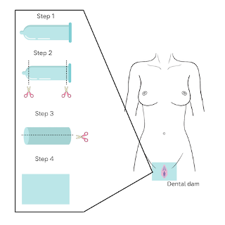

Dental Dams: (It is important to understand that dental dams are NOT a contraceptive – they are a barrier method for STI prevention).

A dental dam is a thin piece of latex used to provide protection for oral sex. It may be placed over a vulva or anus before or during oral sex. May be helpful in preventing STIs or HIV, however the effectiveness rate is unknown. Dental Dams are generally difficult to find in stores and you might have to get them from a sexual health clinic or a sex shop.

The symptoms for STIs may overlap with disability related symptoms or experiences. This can make it harder to differentiate if it is an STI or a disability related symptom. It may also make it harder to diagnose or get checked due to a lack of accessibility measures. Many of the symptoms also overlap with each other – a test or medical professional will be able to differentiate.

“My doctor suggested I get an STI test after starting birth control and becoming sexually active. She gave me a swab to put into my cervix. It was difficult because of my limited ability, so I got support to lift up my legs from my mum. The doctor was caring and understanding.”
- Araan

