Women With Disabilities Australia
Blog or Story Call-Out

Easy English Version

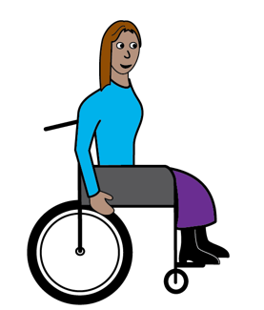

Are you a woman with disability?

Are you a girl with disability?

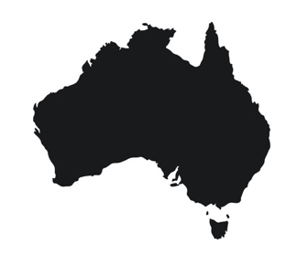

Do you live in Australia?

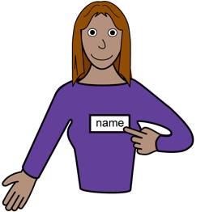
Yes?
We want to hear from you!

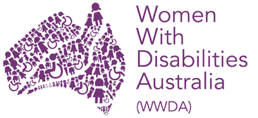
We are Women With Disabilities Australia. We will write WWDA to talk about us.

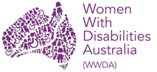
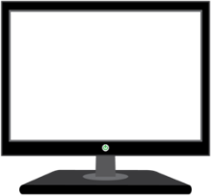
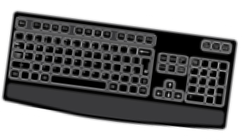
WWDA has a new blog. The blog is on the WWDA website or Our Site.
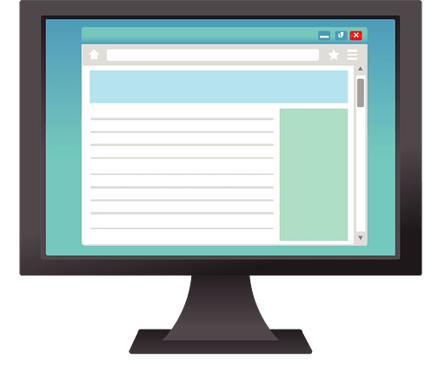
A blog is webpage where people share stories about an issue.

Our blog is about
- women and girls with disability
- who are leaders
- who have a story to share.

Tell us your stories. We will put them on the blog. Your blog can be about different things, such as being a leader.
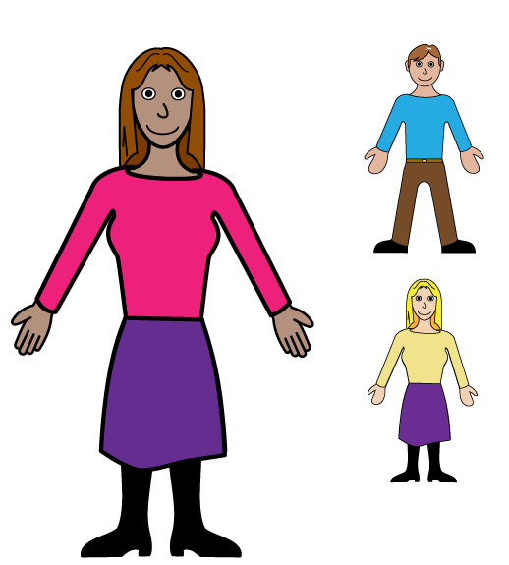
Being a leader looks different for everyone. Your story can be about:
- a new job
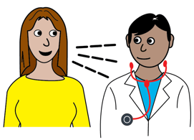
- speaking up for yourself
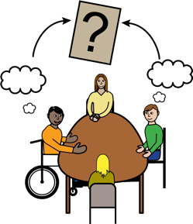
- going to a big event.

You can tell us your story using:
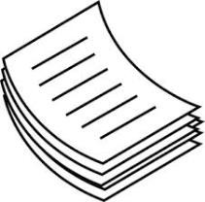
- words
- video
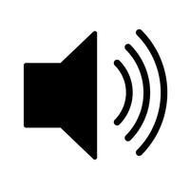
- sound
- pictures.

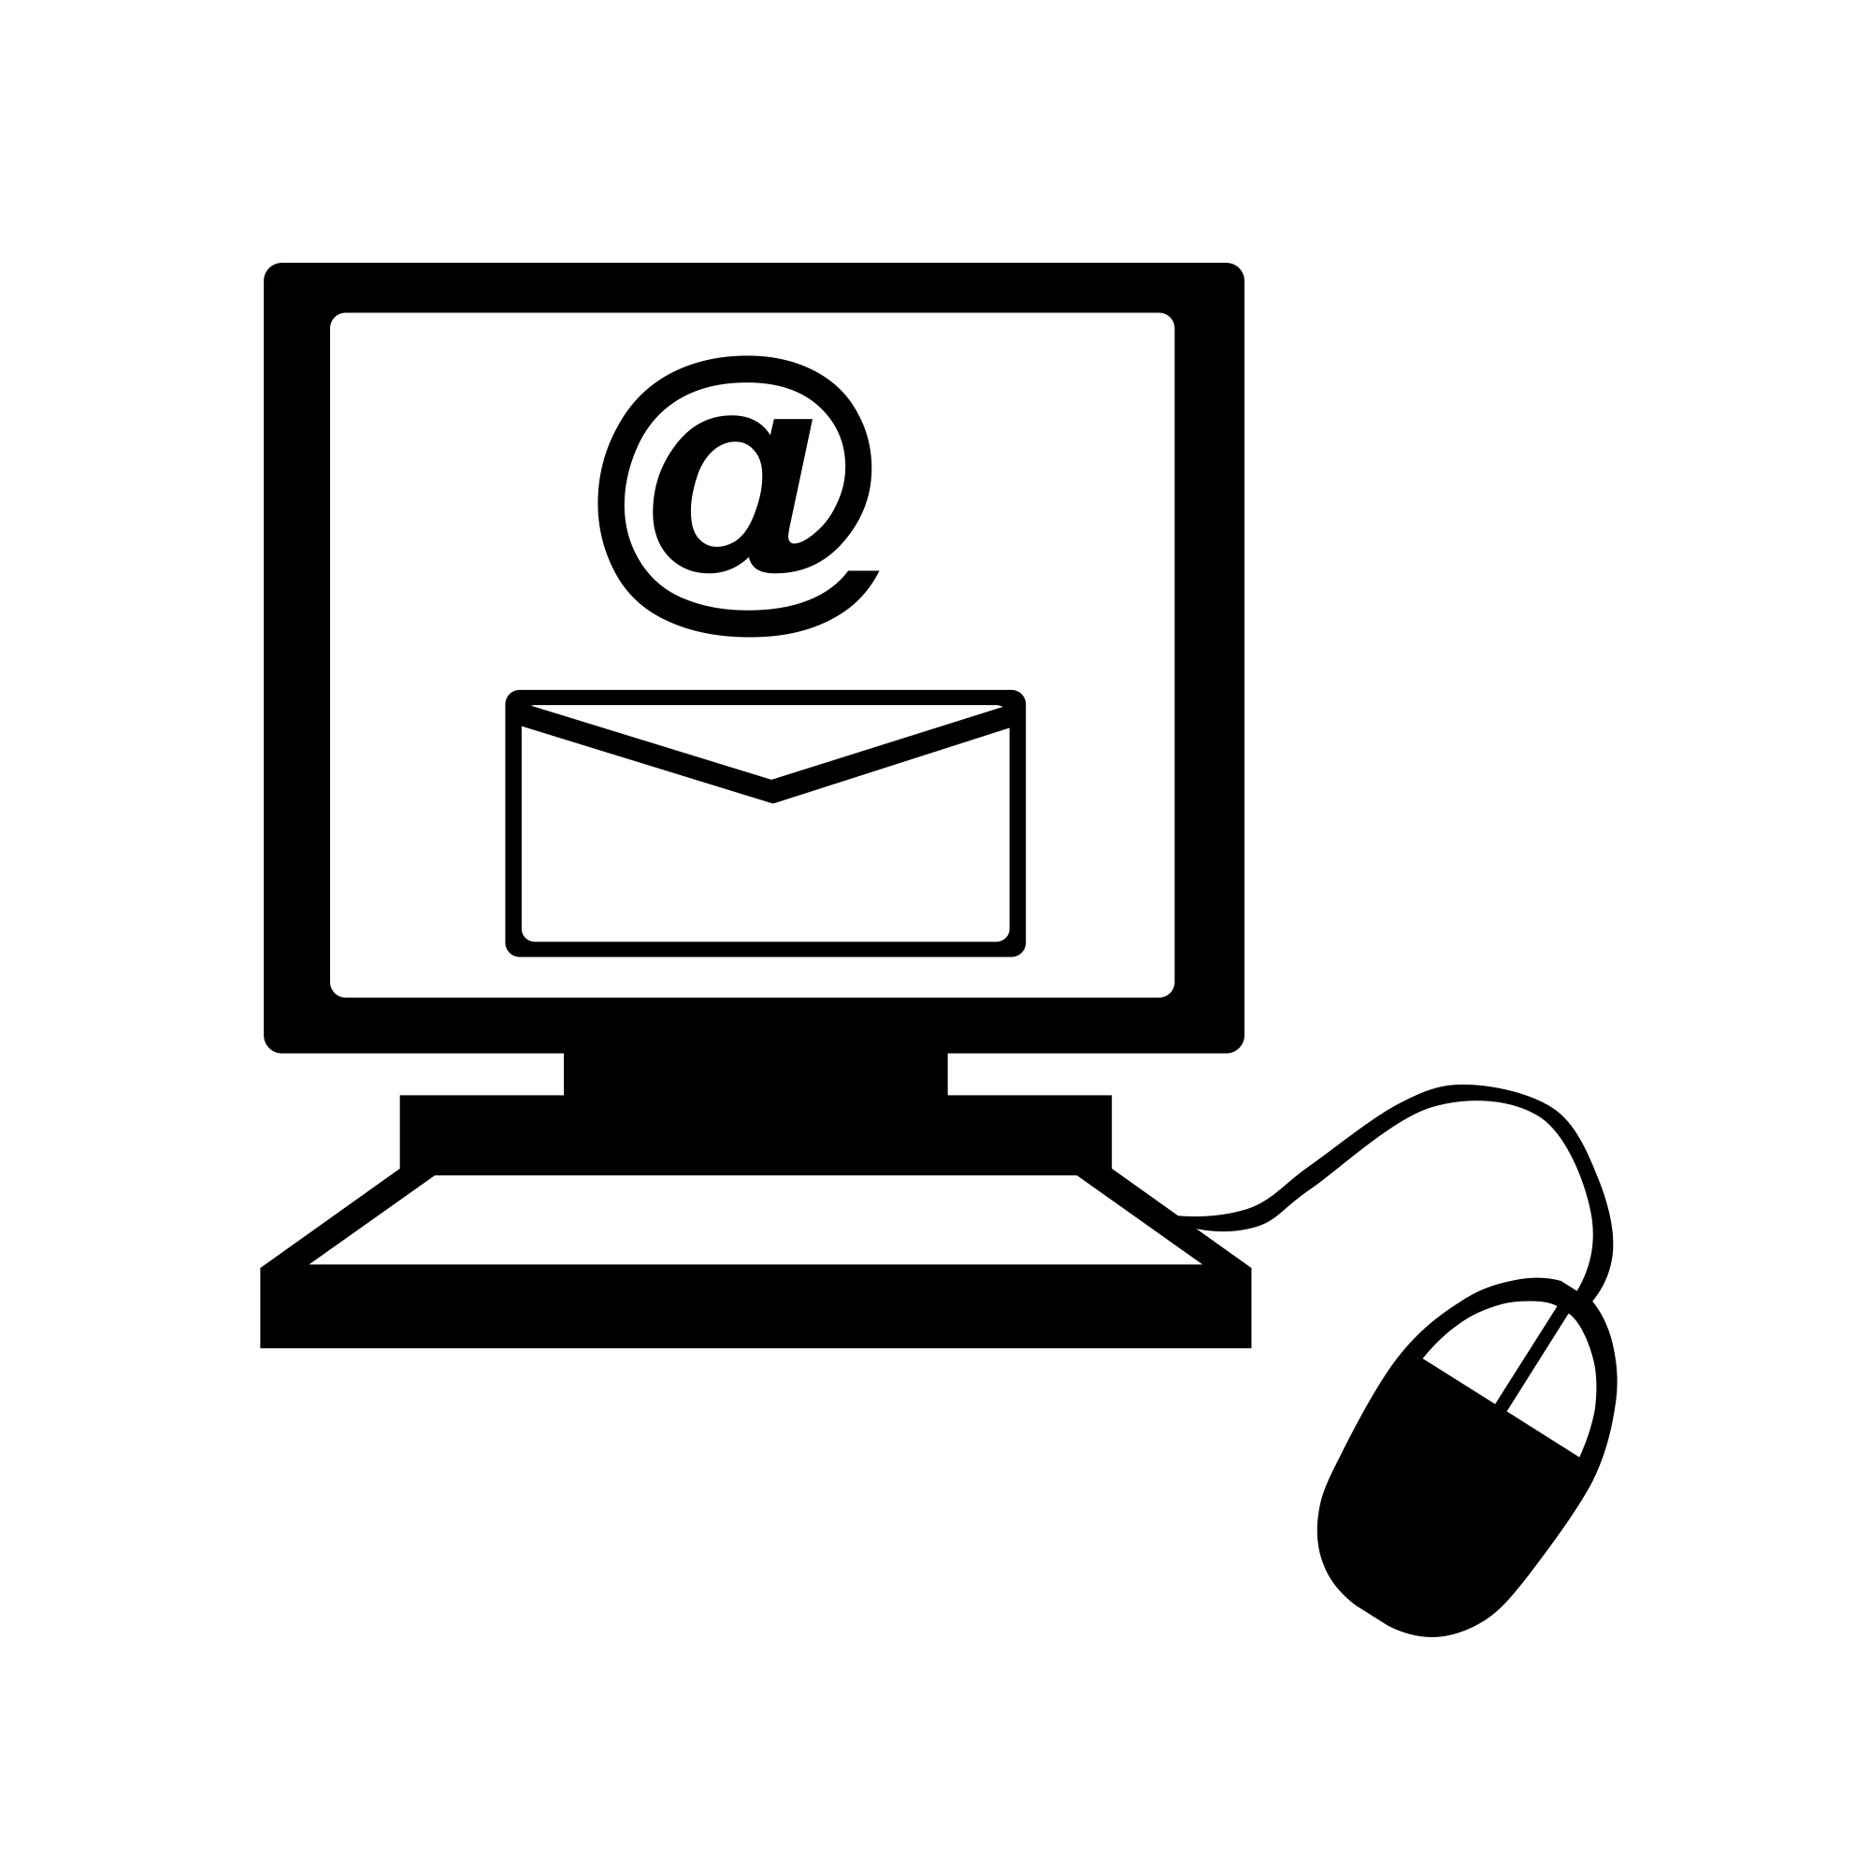
Send your story to WWDA by email.
Email blogs@wwda.org.au.

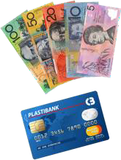
We will pay you $100 for your story.

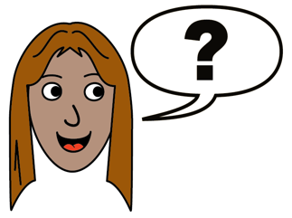
Do you have questions?
Email blogs@wwda.org.au.
Call 0457 527 016

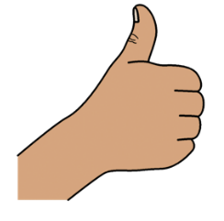
Thank you

Who wrote this document?
Women with Disabilities Australia wrote this document in 2020. This document is for information purposes only.

Copyright
© Copyright
Women with Disabilities Australia (WWDA) Inc. 2023.

All intellectual property rights, including copyright and patents, in this book is owned and licensed by Women with Disabilities Australia Inc.

The images used in this document
Easy on the I Images © 2018 Leeds and York Partnership NHS Foundation Trust. Used with permission. www.easyonthei.nhs.uk

