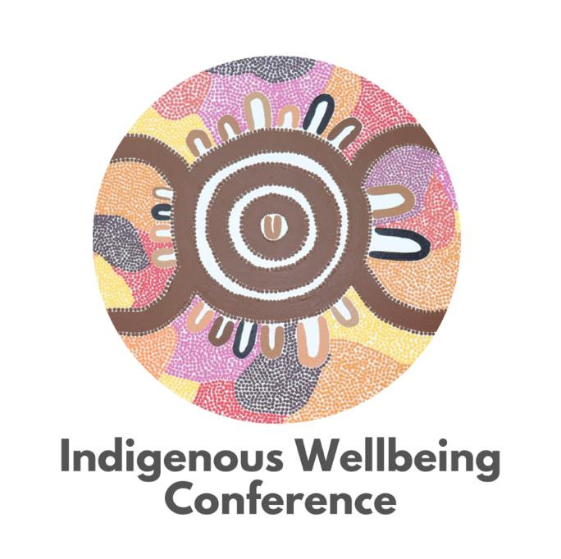

Indigenous Wellbeing Conference – October 2022, South Australia.

Tweets and information presented by Cheryl Parker

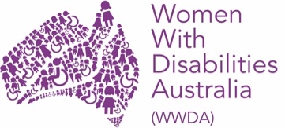

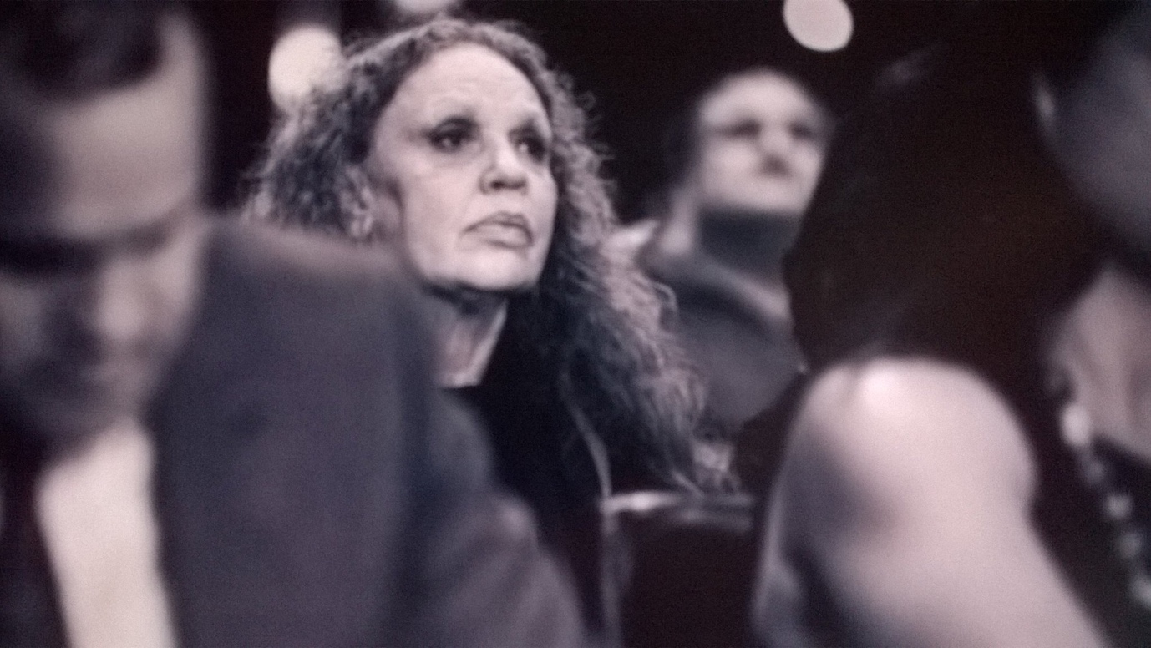

Hello, my name is Cheryl I am so happy to be a representative of Policy for all women and girls with a disability. I am a proud Wiradjuri nation woman and I live on Wangal land. My skills include Advocacy, Leadership, Research and Community development. I want you to know that you are heard by all of us and together we can make change.
I recently attended the Indigenous Wellbeing conference online and listened with interest to local speakers and international guests. In this report I have added speakers that I found interesting. There were others that I have not mentioned.
The conference opened with a Welcome to country by Uncle Moogi a first nations man from Adelaide.
Day 1
“Pangkarra ia, Kaurnaku yarta, maiyarta. Kaurna pangkarra Crystal Brookunungku kauwantila, Cape Jervisana patpangka, karnurna paintyila marrikurlu We would like to acknowledge the traditional custodians of the land on which we meet today and pay respects to elders past, present, and emerging. Niina marni (welcome) everyone to this year’s Indigenous Wellbeing Conference hosted on beautiful Kaurna country. Ngaityu yungantalya (thank you) for your support and involvement. United, there will be a stronger yangadlitya (vision for the future) for all First Nations Australian, Māori and Pasifika people. We believe this panpapanpalya (conference) will provide a platform for First Nations Australian, Māori and Pasifika people to come together, collaborate, ngutu-atpanthi (teach), learn, create, and lead programs and services for greater social and emotional wellbeing.”
“Before we begin, we would also like to honour and acknowledge people who have lived experience of mental health issues and distress and the lived experience of their carers and kinship groups. Freedom from stigma and discrimination, living healthy, dignified, and meaningful lives is everyone's right. We acknowledge and respect the wisdom that their experiences and expertise brings to our purpose and work. A huge thank you to Uncle Moogi for the wonderful smoking ceremony and Welcome to Country. #IWC22 starts NOW!”
“We are honoured to have Alison Carroll, Josephine Mick & Pantjiti Lewis from the NPY Women's Council speak on 'Power of the Ngangkari - Ngankari’s Traditional Healers Practices' at #IWC22 Ngaanyatjarra Pitjantjatjara Yankunytjatjara Women’s Council’s (NPYWC) is a service delivery, advocacy and support organisation created by Anangu women from the 28 remote communities in the tristate border region of NT, SA and WA. NPYWC delivers services and programs working with Anangu to improve their health, wellbeing and safety. Remoteness, limited services, language, literacy and cultural differences are the basis for many of the challenges faced by NPY Women's Council members. Trauma and mental health issues disproportionately affect many anangu (aboriginal people of this region) and can have a profound impact on children. NPYWC recognises that there are multiple knowledge systems in this region, as well as many languages, and that we need to share these understandings before we can develop effective responses to contemporary problems.”
“The NPY Women's Council Uti Kulintjaku is a multi-award-winning arts and social innovation project, initiated and led by senior Anangu women and ngangkari. Uti Kulintjaku works to address cycles of trauma and improve the mental health and wellbeing of Aboriginal people in remote desert communities, developing innovative arts and media to explore the psychosocial experiences of trauma and depression. The project strengthens the capacity of anangu women to address mental health and related issues in ways that draw on their strengths, traditional knowledge and culture as well as their new knowledge of western mental health. It strengthens the capacity of the local mental health team to engage with and communicate more effectively with anangu, to ‘see through their eyes’.”
“Closing out day one of #IWC22 is Jack Buckskin (Kuma Kaaru), who will share his story from a very low income childhood to travelling the world, promoting the works of language empowerment and endangered languages. He will share how others can start their journey, by giving strategies to be put in place. Jack will share that resilience and hard work can pay off and any child can be who they want to be and do what they want to do.”
Day 2
“Our opening keynote panel workshop on day TWO of #IWC22 on Cultural Resilience and Social Justice included a brainstorming session with delegates, which was centered around: What are we doing, What can you do, to strengthen a sense of belonging in our Mob, in our hapū, our people - at work, school and in our wider communities? Why is this so important for the wellbeing of our future generations?”
“Lyndon Reilly's presentation aims to acknowledge the good works of contemporary Queensland Aboriginal and Torres Islander male warriors/leaders. In addition, he will provide as yet unrecorded evidence of Aboriginal and Torres Strait Islander men’s engagement in working constructively towards individuals, families and communities’ health and wellbeing including the prevention of family violence”
“Te Kurahuna: Mahi a Atua is the deployment of Mātauranga Māori, Pūrākau, Feedback Informed Treatment and associated techniques and knowledge that support this paradigm shift. Dr Diana Kopua will share Te Kurahuna Ltd’s vision, strategy and outcomes as they expand to create social impact. Te Kurahuna Co-Manukura Tohunga Mark Kopua will discuss the significant change that occurred in both Te Tairawhiti and Hauraki through the implementation of Mahi-a-Atua.”
