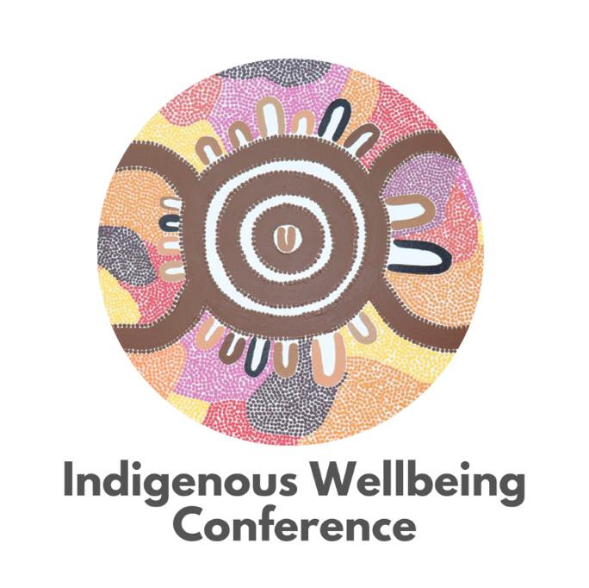

WWDA Youth

Indigenous Wellbeing Conference – October 2022, South Australia.

Report presented by Lily Hodgson

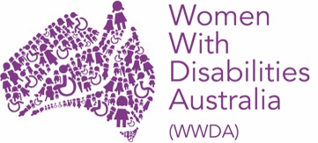

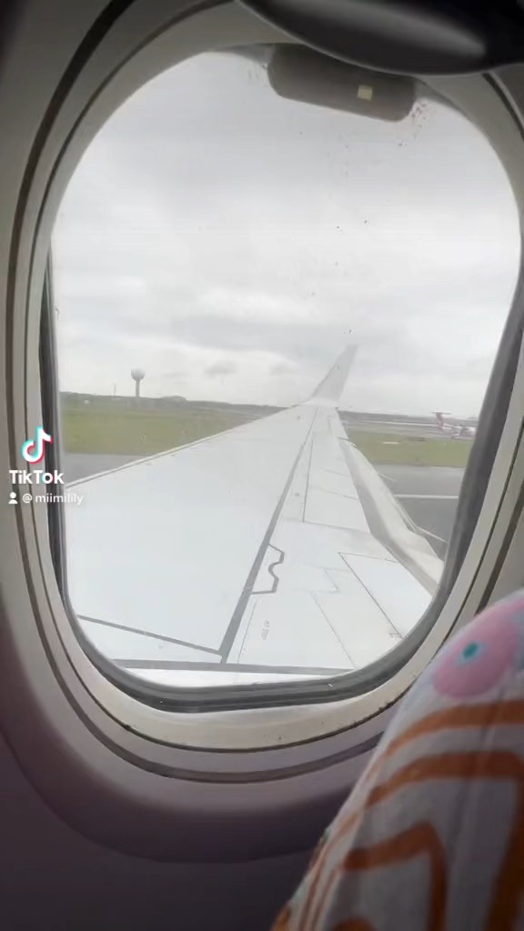
The journey to the conference was a little tricky. This is only because, I was asked also if I had a preferred seat for flying to limit my flare ups, as I struggle to sit for long periods of time due to restless legs. I had requested an aisle seat either at the back of the plane or in the emergency exit row, so I would have the ability to stand up and walk the aisle.
I’m not sure what happened, but my seat both to and from Kaurna Country was in the middle of the plane and was also the window seat.

Whilst the view was nice and would be enjoyable for most people, unfortunately my disability strongly disagreed and my body is paying for it now.
Once I had landed in Adelaide, I also had no idea how to get about or where to go, so with that being said Uber was the only option.

As mentioned above with not being able to sit for long periods of time, it was extremely handy that I was staying in the same building as to where the Indigenous Well-being Conference was being held.

It made it a little easier for me to be able to return to my room during lunch / periods that my FND was causing me high amounts of pain, so that I could have the chance to stretch and attempt to relieve my symptoms, whilst only being a 5-minute walk away to return to the presentations. In that sense ease of access was fantastic.

The conference itself was amazing and well thought out. It began with an incredible opening ceremony by Uncle Moogy, a Kaurna man, who gave us a smoking and song to welcome us to his Country. The conference facilitators had it set up so that at least 3 programs were running at the same time, so we had lots of choices to where in the building we’d go/see.
Along with the conference being well hosted and thought out, the content was extremely relevant, helpful, and informative.

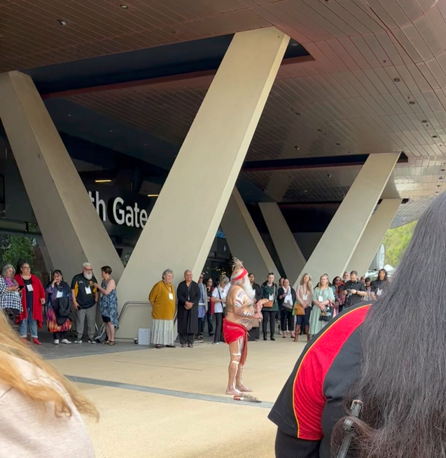
There was an awesome focus on identity for mob in our community who are disconnected from land, culture, and people, along with not having the ability to access mainstream medical services.

Along with this, there is a huge backing and empowerment focus for community to be able to return to traditional practices in times of crisis, for example during the floods if there’s no power or food in the shops, then to be able to feed the mob by hunting, fishing and making damper.
Many discussions were held on the reasons as to why community has such a distrust in the medical model and what we can do to change it.

I was very fortunate to have a yarn with Gale Lose, a proud Aboriginal woman working for NSW Ministry for health, who is acting on the lack of cultural lens and resource when it comes to First Nations reaching out for help.

I also got to speak with HealingWorks Australia compiled of Kaela & Dean Bayliss and their team including Joe, who spoke about how their organisation works and what their goals are. (Dean was not well and couldn’t attend the conference) I have met Dean and Kaela before at one of their workshops which is the I-ASIST program; this is created to prevent First Nations suicide and how to talk to mob in a culturally safe environment.

I am very grateful to WWDA for asking me to and being able to attend the conference. It was a great learning and networking experience and would very much love to attend next year’s conference, and only wish more people were able to see these years!

