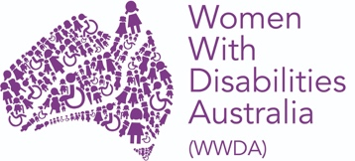

WWDA LEAD- Lead | Engage | Activate | Drive

Building Capacity of Women and Girls with Disability in Australia

Individual Capacity Building – Progress report number one

Organisation name: | Women With Disabilities (Australia)
Agreement ID: | 4-DEJJ3RV
Project title: | WWDA LEAD- Lead | Engage | Activate | Drive  Building Capacity of Women and Girls with Disability in Australia
ILC activity area: | Individual Capacity Building
Activity type: | ICB & OCB
Activity start date: | 1/07/2020
Activity end date: | 31/07/2023
Activity area postcode/s (if not state or national) | National
Funded for Organisational Capacity Building? | Yes
Total funding (GST inclusive): | $2,139,280.00

Section a. Activity operational information

Locations during this reporting period
Has the location of your activities changed from your last report?: Yes
If yes, please list the new postcodes: 7000, 2042, 3031, 2601.

Optional comments: Staff for the project have been recruited from across Australia and currently staff are working remotely from Sydney, Canberra, Melbourne and Hobart. WWDA is committed to providing employment opportunities to women with disability. WWDA is also committed to modelling good practices in disability employment, demonstrating that women with disability can be supported to work in flexible ways, including by working remotely.

ILC Project Staff
How many paid staff, currently involved in the project, identify as having a disability?: 5
How many volunteer staff, currently involved in the project, identify as having a disability?: TBD (to be determined).
How many paid staff, identifying as having a disability, currently have leadership responsibilities?: 2
How many volunteers staff, identifying as having a disability, currently have leadership responsibilities?: TBD.
Total number of paid staff (with and without disability) are involved in activity design and delivery?: 7
Total number of volunteer staff (with and without disability) are involved in activity design and delivery?: TBD.

Optional comments: WWDA operates from a philosophy and model of co-design. Women with disability from around Australia will be engaged in all aspects of the project – including project design, governance, implementation, and monitoring.

Section b. Individual Capacity Building activities
In the last 6 months how many people with disability attended your activities? Please refer to comments below.
In the last 6 months how many family members and carers attended your activities? Please refer to comments below.

Optional comments: Due to the impact of COVID-19 and our revised project start date of July 1 2020, we are yet to commence large scale, event based ICB activities. That said, we have already started delivering activities pursuant to items in our NDIA approved, annual work activity plan.

In relation to item 12 of our annual work activity plan “Increase opportunities for women and girls with disability to participate in public decision-making and representation” and item 9 of our annual work activity plan “Promote peer learning opportunities for women and girls with disability”, since July 2020, WWDA staff members with a disability have:

- Provided case studies and linked WWDA members to ABC reporters and producers on the impact of COVID on women with disability who have experienced domestic violence.

- Worked on an ongoing basis with the ABC to provide expert advice and on feedback on th development of the ABC Editorial Policies guidance note on domestic violence.

- Locked in an externally facilitated planning day for the Project in September 2020.

- Started planning work on a WWDA First Nations Advisory group.

- Participated in following national, ongoing, decision-making and policy leadership committees and fora:

- Advisory group of the Australian Women Against Violence Alliance (AWAVA) - Participation allows WWDA to encourage the consideration and inclusion of the experiences and support needs of women and girls with disability in all of AWAVA’s work related to in the area of preventing and responding to violence against women.
- Our Watch Advisory Group: Prevention of Violence Against Women with Disability Participation on the Advisory group allows WWDA to inform and drive the development of: a resource to guide the prevention of violence against women and girls with disability and a campaign aimed at preventing violence against young women with cognitive and intellectual disabilities.
- Equality Rights Alliance- Participation on the Advisory group allows WWDA to advocate for gender equality, women’s leadership and government policy responses that support women’s diversity in Australia.
- The Shift – Network for the Achievement of Intersectional Gender Equality in Australia- The network has emerged out of a group of advocates who have come together to put a feminist economic perspective on the measures the government is announcing in response to the COVID pandemic. Participation allows WWDA to work alongside the private sector, not-for-profit sector, academics, government, media commentators, journalists, and social media influencers to ensure the voices of disabled women have a seat at the gender equality policy table.
- Our Watch national primary prevention hub stakeholder reference group- The National Primary Prevention Hub will guide and lead primary prevention efforts in Australia, delivered by Our Watch. Particiation in the reference group allows WWDA to share evidence, expertise and learning; facilitate collaboration in policy and practice across Australia, in both government and non-government settings; assess the progress and effectiveness of prevention efforts nationally, and provide evaluation expertise; and support a range of projects to build expert primary prevention capacity, including developing and piloting a national workforce development program to fast-track upskilling of primary prevention practitioners.
- National Youth Disability Forum- The National Youth Disability Network is a new network run by Children and Young People With Disability Australia. Particpation allows WWDA to: connect organisations advocating for young people with disability; share ideas, contacts, skills between disability youth advocacy organisations and; coordinate collaborative advocacy efforts between organisations advocating for the rights and well-being of young people with disability.

Going forward, WWDA will work with its members to develop a “shadowing/observer” process so that members can have input in to committees such as these and experience peer mentoring. A structured EOI process will be undertaken to recruit “shadowers/observers” for these committees. This activity will also increase the engagement of women and girls with disability in WWDA through targeted outreach.

Section c. Program success factors and barriers

Success factors
An engaged online community that can be leveraged for project success
WWDA has existing, strong and reputable engagement with our members and we have online mechanisms in place to manage communication and consultation as well as reach a wide audince. These mechanisms ensure that WWDA can deliver on item 15 of our annual work activity plan “Provide access to information resources developed by and for women and girls with disability”.These mechanisms have started to be strengthened through this current project kick-off phase and and new mechanisms and systems will be developed or reinvigorated. For example:

- Since July 2020, we have been working to reinvigorate WWDA Youth as a vehicle to deliver the outcomes of this project. This has included developing Terms of Reference and an application form for a new WWDA Youth Advisory Committee to drive the WWDA Youth Network and discussing the WWDA Youth Network with stakeholders in the youth sector, including the National Youth Commission and the Commonwealth Network of Children and Young People With Disability (CCYDN). At the end of August, we also represented young women with a disability at the National Youth Futures Summit and took part in a presentation on how economic and wage inequality impacts young women with disability.

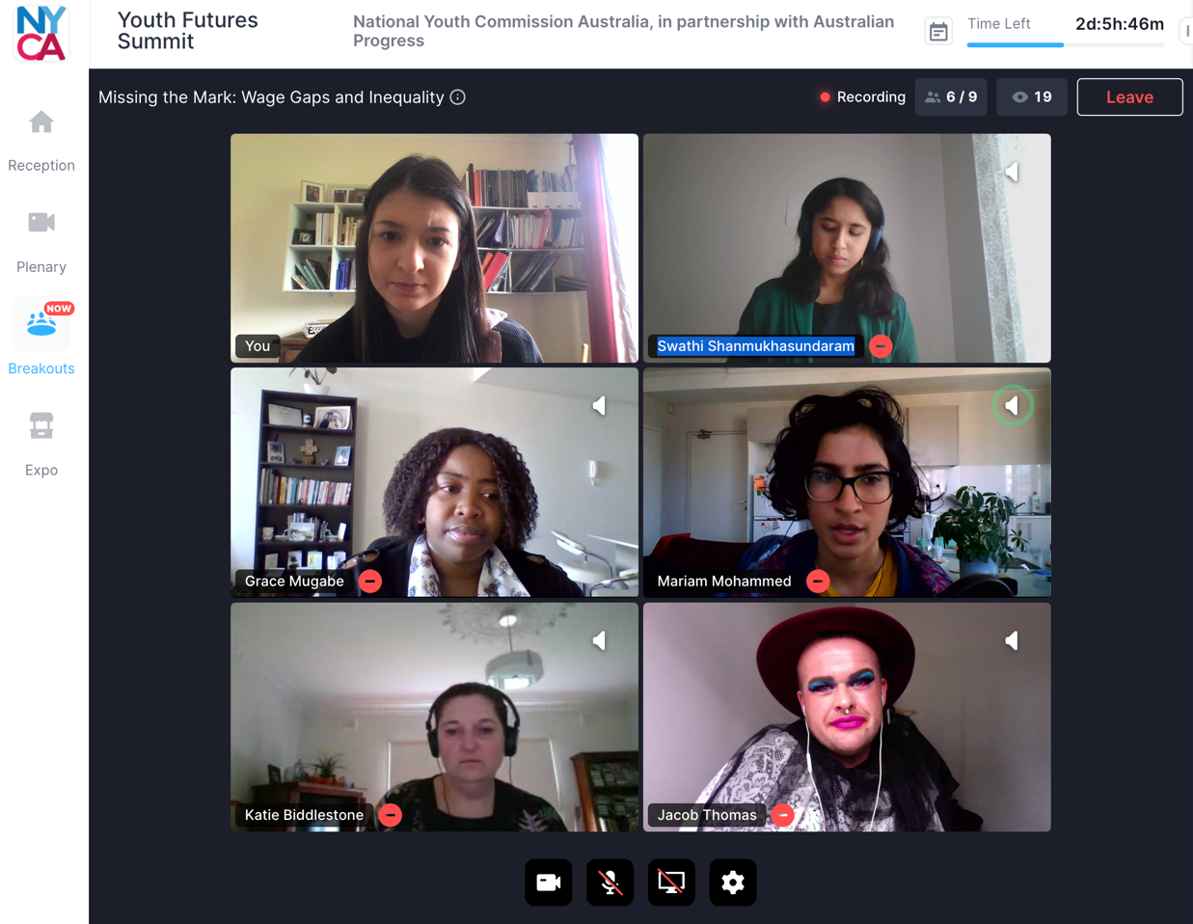

(PIC 1- WWDA Project team member Heidi La paglia – top right corner, presenting at the National Youth Futures Summit)

- Since July 2020, we have been working on designing a process to engage and boost the membership of our closed Facebook Group (currently consisting of 701 members) to deliver the outcomes of this Project.

- WWDA’s newly designed and re-built website (www.wwda.org.au) offers additional opportunities to engage and boost WWDA membership and leverage our other online platforms, including new mechanisms and systems that may be developed through this Project.

Metrics from our Twitter and Facebook (July-August 2020) are attached in Attachment A. These metrics demonstrate WWDA’s electronic engagement influence and reach and highlight the potential for further influence and reach as the project progresses.

Strong partnerships, existing relationships within the disability sector, the women’s sector and academia

WWDA has a collaborative relationship with the six National Women’s Alliances funded by the Australian Government. WWDA will utilise those networks and relationships to foster inclusion of women with disability into the work of the National Women’s Alliances thereby contributing to item 13 of our annual work activity plan “Increase the engagement of women and girls with disability in WWDA through outreach initiatives” and item 12 of our annual work activity plan “Increase opportunities for women and girls with disability to participate in public decision-making and representation”.

Since July 2020, we have:

- Planning work on a webinar with the NRWC - Earlier in the year, WWDA was approached by the National Rural Women’s Coalition (NRWC) to co-host a webinar in October/November 2020. While still in planning, the webinar will be a panel event with WWDA members who are women with disability from regional or rural areas. The discussion will be led by questions based on each panellists’ experiences during COVID19 and how other rural, regional and remote women with disability can access information and leadership opportunities. The webinar will be held via zoom on 14 October 2020 at 1pm-2pm.

WWDA also has a collaborative relationship with the National Disabled People’s Organisations (DPOs) and National Disability Representative Organisations (DROs). WWDA is a founding member of Disabled Peoples Organisations Australia (DPOA), which is made up of four national DPOs: Women With Disabilities Australia (WWDA); First Peoples Disability Network Australia (FPDN); People with Disability Australia (PWDA), and National Ethnic Disability Alliance (NEDA). WWDA also has close working relationships with many national and State/Territory Disability Representative Organisations (DROs) and will utilise all these relationships in project implementation.

Since July 2020, we have:

- Worked with Children and young People with Disability Australia (CYDA) who are keen to support WWDA to reinvigorate the WWDA Youth Network. To commence work on this aspect, WWDA will be attending and presenting at CYDA’s Youth Disability Online summit in late September 2020 and distributing information about opportunities to get involved with the WWDA Youth Network. WWDA will also support young women with disability who join the WWDA Youth Network Advisory Committee to take part in a new training module CYDA have developed for young people with disability.

An experienced project team to ensure project success
WWDA has a very strong and experienced project team with qualifications in project management, stakeholder engagement and social work and senior leadership experience in government and the not-for-profit sectors to ensure that the project is delivered to time and budget. Bios of the project team are available here: https://wwda.org.au/about/board-and-staff/

Barriers
Demands on WWDA as a result of COVID19.

WWDA had to seek a later start date for this Project due to the over-whelming demands placed on our organisation as a result of COVID19. WWDA staff had to be relocated to work from home and some WWDA staff with disability needed extra organisational support due to them being considered high-risk for COVID 19. Additional equipment needed to be purchased, and reasonable adjustments met. The Australian Government established a number of national COVID19 advisory structures which WWDA was requested to be on. Members and constituents of WWDA were unable to seek accessible, timely and relevant information regarding COVID19. WWDA took a leading role in the sector of developing some of this material, including in Easy Read formats. This work is continuing but with the recruitment complete for this Project, organisational capacity is now an optimum level to ensure project delivery.

Section d. Organisational Capacity Building activities
1 - Upskilling, training or developing existing or potential staff, volunteers or committee/board members to improve their leadership, skills and capability (e.g. leadership training for staff, board members and/or volunteers with disability)
2 - Basic level
Enter comments here: As a small organisation completely reliant on project-based government funding WWDA has not had the resourcing previously to invest in staff and Board leadership training. Through this new Project however, we are working to research and explore leadership upskilling opportunities for our staff and Board. A considered, researched and customised plan that aligns upskilling and training to company goals is crucial for success. The following approach, developed by the consulting form PWC, as demonstated in the infographic below, will be used by WWDA to guide the development of our training and development plan.

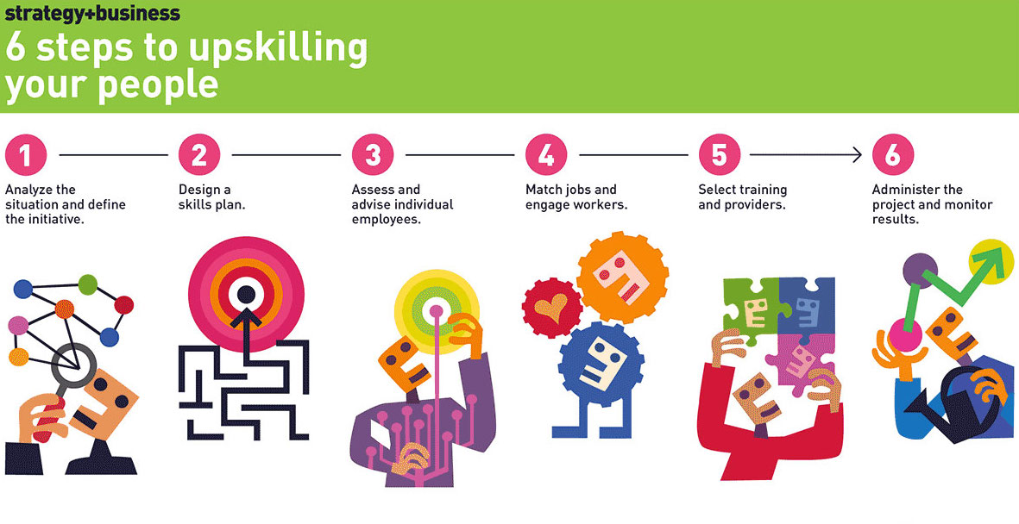
(PIC 2- PWC approach to upskilling staff)

2 - Scoping and developing a business case for revenue generating services that lead towards financial independence (e.g. developing a new social enterprise).
1 - Insufficient level
Enter comments here: Since July 2020, the WWDA Board and executive team have begun strategic discussions on revenue generation. We are currently working on the following:
- Scoping the development of an enterprise wide WWDA IP strategy to support commercialisation of our service offerings.

- Developing a WWDA Co-design model and associated business case for corporates and philanthropy.

- Partnering with academics on research projects bids to diversify our revenue streams.

- Scoping the feasibility of RTO status for WWDA.

3 - Strengthening the quality of organisational activities (e.g. commissioning a risk management framework)
2 - Basic level
Enter comments here: Since July 2020, the WWDA Board and executive team have begun strategic discussions on strengthening the quality of organisational activties. We are currently working on the following:
- A risk management framework- Risk management is central to maximising community outcomes, deriving the benefit of opportunities, managing uncertainty and minimising the impact of adverse events. A risk management framework will be developed and delivered as part of this project. Currenty the WWDA Board and executive team are discussing whether this deliverable will be commissioned or developed inhouse with the involvement of subject matter expertise (SME) input.

- WWDA Constitutional review and update- the WWDA Board and executive team are scoping whether this deliverable will be commissioned to legal SME input or reviewed and updated inhouse with legal SME input.

- Monitoring and evaluation framework- Discussions are being progressed with UNSW who are disability evaluation SMEs to assist WWDA on this deliverable which is item 8 of the annual work activity plan “Develop Project Evaluation and monitoring processes”. The deliverable will include:
  - Program logic
  - Theory of change
  - Data collection methodology
  - Evaluation framework

- Scoping a new CRM system.

- Scoping a new financial management process.

- Scoping a new cloud based organisational information management system.

4 - Develop and implement strategies to upskill the organisation (or parts of organisation) to better function
2 - Basic level
Enter comments here: Since July 2020, we have been working on:

- Upskilling in stakeholder engagement: WWDA has currently analysed our stakeholder engagement processes and procedures and is currently scoping a small group membersip package for IAP2- The International Association of Public Participation. We are currently developing a plan for a comprehensive stakeholder management system and strategy that will allow the organisation to maintain, document and be able to report on progress and updates of relationships with all stakeholders for this project and for WWDA as an organisation with ease. This stakeholder engagement strategy will include:
- Identifying stakeholders (Who?)
- Creating and utlising stakeholder profiles ( Why and What?)
- Defining the stakeholder engagement approach (How?)
- Planning engagements and timley delivery of engagements( When)
- Engaging stakeholders (if network/relationship currently exists) (Do)
- Measuring effectiveness (Results)

If we proceed with membership of IAP2, this membership will give WWDA staff and WWDA board members access to a wide range of benefits. This will improve and enhance organisational reputation through being recognised as a leader in community and stakeholder engagement, while providing the WWDA team with access to the right engagement tools and reources.

- Upskilling in project management- WWDA will be developing a suite of new templates, document control methods and processes based on a combination of Prince2 methododology and the extensive and current WWDA project management processes. This will include referencing the previous ILC grant methodology from the Our Site Project and other best practice co-design methodologies based on a human rights perspective, both nationally and interationally. New project management documentation will potentially include:
- Project Initiation Documention ( Complete)
- Project brief ( Complete)
- Benefits management approach spreadsheet
- Change control approach
- Project stages and milestone report
- Issues register
- Issues report
- Lessons log
- Lessons report
- Quality management approach
- Quality register
- Risk management approach
- Risk register
- Monitoring and evaluation framework
- Final report template
- Document register

- Business continuity planning – the WWDA executive team is working with the WWDA Board to develop a new business continuity plan. COVID 19 has demonstrated the absolute urgency and value of having such a plan in place. The WWDA business continuity plan will potentially include the following:
  - a risk management plan with business impact analysis.
  - an incident response plan, with plan activation, incident response team, communications and contact list.
  - a recovery plan.
  - a test, evaluate and update schedule.
5 - Developing and delivering strategies and activities to support knowledge and skill transfer between board members with and without disability
Enter comments here: WWDA is a DPO run by and for women with disability. All Board members are women with disability.

6 - Developing organisational strategy and future outlook (e.g. conducting needs analysis to better understand emerging priorities of constituent group)
3 - Moderate level
Enter comments here: WWDA is a cross-disability, inclusive, intersectional and trans-national organisation that represents over 2 million women and girls with disability in Australia. Our members come from a diverse range of backgrounds, ages and beliefs. These include Indigenous, CALD, sexuality and gender diverse, and intersex communities. WWDA is unique, in that we have direct membership of women and girls with disability, and a large associate membership which includes families, carers, service providers and more. All WWDA projects and programs are directly informed by, and in response to, the expressed needs of our members. The WWDA Board and WWDA executive team are currently undertaking a review of the WWDA Strategic Plan. A new 5 year WWDA Strategic Plan will be developed as part of this Project. The new Strategic Plan will be developed in direct consultation with WWDA members and will include key priority areas identified by WWDA members. WWDA will utilise a range of engagement and consultation mechanisms and processes to ensure that WWDA members are central to the development of the new 5 year Strategic Plan.
Moving forward, as part of this Project, WWDA will also be focusing on developing and implementing an organisational Communication and Engagement Strategy; standardised Member Satisfaction surveys and related processes; a Member Skills and Interest Audit; a Representatives Register; and a campaign to drive and grow new membership. Future Progress Reports will report on the progress of these initatives.
7 - Establishing and maintaining partnerships to collaborate with other organisations (e.g. developing formal or informal cooperative agreements to share resources or partner in program delivery)
4 - High level

Enter comments here: As stated earlier, WWDA has a collaborative relationship with the six National Women’s Alliances funded by the Australian Government. WWDA will utilise this Project to foster inclusion of women with disability into the work of the National Women’s Alliances. National Disabled People’s Organisations (DPOs) and National Disability Representative Organisations (DROs). WWDA is a founding member of Disabled Peoples Organisations Australia (DPOA), which is made up of four national DPOs: Women With Disabilities Australia (WWDA); First Peoples Disability Network Australia (FPDN); People with Disability Australia (PWDA), and National Ethnic Disability Alliance (NEDA). WWDA also has close working relationships with many national and State/Territory Disability Representative Organisations (DROs); organisations in the women’s sector; human rights NGO’s; academic and research institutes, and will utilise these relationships in project implementation and monitoring.

8 - Developing and delivering strategies and activities to strengthen the involvement of people with disability and/or families and carers in organisational decision making (e.g. recruiting and supporting staff and/or volunteers with disability, or supporting leaders with disability to operate effectively on boards and management committees)
3 - Moderate level
Enter comments here: Since July 2020, we have:
- Recruited 5 staff members for the project all of whom are women with disability. WWDA sees this as a particular success and strength, given that there has been no improvement in labour force participation of women with disability in Australia for over two decades; and employment of women with disability remains a largely unaddressed issue in the national policy context.

- Begun planning work on the constitutional review which will include robust consultation with WWDA members all of whom have a disability.

- Begun work on item 2 of the annual work activity plan “Establish Project Management process and Project Governance structure” which will include the representation of women with disability on various project advisory and steering groups.

- WWDA is currenty scoping the feasibility of developing a disability inclusive procurement policy and disability inclusive HR policy.

9 - Improving organisational systems or processes to deliver organisational efficiencies (e.g. purchasing and installing a new member communication system)
2 - Basic level
Enter comments here: Since July 2020, the WWDA Board and senior management team have begun strategic discussions on strengthening the quality of organisational activties. We are currently working on the following:
- Developed a new, Board approved, delegation of authority policy for the project (please see Attachment B) which is currenty being assessed by the executive team as a model to be adpted as an enterprise wide policy.

- Scoping a new CRM system.

- Scoping a new financial management policy and process.

- Scoping a new cloud based organisational data system.

Document updates
Have you reviewed your Project Plan, Stakeholder Engagement and Events information with current details?: Yes

