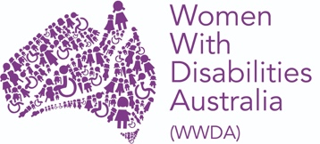
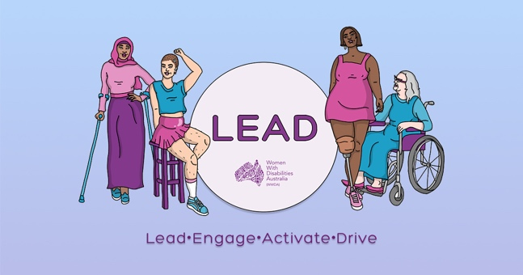

WWDA LEAD- Lead | Engage | Activate | Drive

Building Capacity of Women and Girls with Disability in Australia

Individual Capacity Building – Progress report number two

Organisation name: | Women With Disabilities (Australia)
Agreement ID: | 4-DEJJ3RV
Project title: | WWDA LEAD- Lead | Engage | Activate | Drive  Building Capacity of Women and Girls with Disability in Australia
ILC activity area: | Individual Capacity Building
Activity type: | ICB & OCB
Activity start date: | 1/07/2020
Activity end date: | 31/07/2023
Activity area postcode/s (if not state or national) | National
Funded for Organisational Capacity Building? | Yes
Total funding (GST inclusive): | $2,139,280.00

Section a. Activity operational information

Locations during this reporting period
Has the location of your activities changed from your last report?: No

Optional comments: Staff for the project are based across Australia and currently staff are working remotely from Canberra, Melbourne and Hobart. WWDA is committed to providing employment opportunities to women with disability. WWDA is also committed to modelling good practices in disability employment, demonstrating that women with disability can be supported to work in flexible ways, including by working remotely.

ILC Project Staff
How many paid staff, currently involved in the project, identify as having a disability?: 6
How many volunteer staff, currently involved in the project, identify as having a disability? 27
How many paid staff, identifying as having a disability, currently have leadership responsibilities? 2
How many volunteer staff, identifying as having a disability, currently have leadership responsibilities? 29
Total number of paid staff (with and without disability) are involved in activity design and delivery? 6
Total number of volunteer staff (with and without disability) are involved in activity design and delivery? ( WWDA LEAD Project Steering Committee 7 members and WWDA Youth Advisory Group 13 members)

Optional comments: WWDA operates from a philosophy and model of co-design. Women with disability from around Australia will be engaged in all aspects of the project – including project design, governance, implementation, and monitoring.

Section b. Individual Capacity Building activities
In the last 6 months how many people with disability attended your activities?85 and many individuals have participated on more than one occasion.
In the last 6 months how many family members and carers attended your activities? 28

Optional comments

The WWDA LEAD team have developed a calendar of events for 2021, this includes the following: (Appendix a WWDA LEAD Calender of Events)

- WWDA LEAD Webinar Series
- WWDA LEAD Peer Networking sessions
- WWDA LEAD Scholarship
- WWDA LEAD Art Prize
- WWDA LEAD Social Events

Short Description WWDA LEAD activities listed below:

- Established a WWDA LEAD project steering committee, made up of 7 women with disabilities to oversee the delivery of the WWDA LEAD Project until March 2023 As of 28/2/2021, 2 meetings have been held and will take place every 6 weeks for the duration of the project. We have a wide representation of women in this group, including women from aboriginal and Torres strait Islander community and the culturally and linguistically diverse community.

- Developed a WWDA LEAD Leadership survey with WWDA LEAD project steering committee to gain insights into what women and girls with disabilities would like to see as part of the WWDA LEAD project (Appendix b WWDA LEAD Survey Results)

- First WWDA LEAD Webinar series on Leadership will be hosted on Wednesday 15th March 2021 and is titled “We can all be leaders”. The topic and format of the webinar was chosen by the Project Steering committee after discussion on the survey results recieved. The webinar will feature 4 women talking about their experiences of Leadership and will also be an opportunity to share information and promote the WWDA LEAD scholarships and the WWDA Lead Art Prize. All WWDA LEAD webinars with have close captions and an Auslan interpreter.

- In the last six month the WWDA Youth advisory group has been established with overwhelming success and has driven the youth focus of the WWDA LEAD Project to support initiatives that build the leadership capacity of young women and girls with disability. This has enabled us to engage 13 young people into WYAG, and these13 young people being selected from over 56 applicants from across Australia. We have wide representation of young people in the group, including both rural and remote youth, a first nations young person (with 3 positions earmarked for our first nations representatives) young people from migrant and refuges backgrounds and young people from the LGTBIQA+ community.

- A WWDA LEAD Leadership Blog was launched in September 2020 and we have had over 30 submissions of the stories of leadership of women, girls with disabilities . We release a new leadership blog every two weeks and have found that promoting these individual experiences and stories is encouraging more women and girls with disabilities to share their stories. To go to the WWDA LEAD Leadership blog page please click here.

- A WWDA LEAD Scholarship Program has been developed, including expression of interest form, application from and selection process and will be launched in March 2021.

- A co-design plan is currently being developed to design the WWDA Leadership and Mentoring toolkit that will be launched in late 2023. This will include working in codesign with a WWDA LEAD leadership toolkit committee and then consultations will take place with various communities of women and girls with disabilities in June - November 2021.

- The WWDA LEAD Art Prize will be launched on International Women’s Day, with the aim of encouraging women and girls to demonstrate and share what Leaderships mans to them through various art mediums. The Art Prize will launch March 8 and submissions will be open until 23 July, with an online exhibition, people’s choice award and awards ceremony to follow. Expression of interest, and guidelines will be available in Easy English on the WWDA website.
- Participated in following national, ongoing, decision-making and policy leadership committees.
- Australian Women Against Violence Alliance (AWAVA) Advisory group and Policy Executive - Participation allows WWDA to encourage the consideration and inclusion of the experiences and support needs of women and girls with disability in all of AWAVA’s work related to in the area of preventing and responding to violence against women.
- Commonwealth Children and Young People With Disability Network (CCYDN) Executive Committee – Participation allows WWDA to represent the experiences and needs of young women and girls with disability in Australia at a Commonwealth level.
- Equality Rights Alliance Advisory Group- Participation on the Advisory group allows WWDA to advocate for gender equality, women’s leadership and government policy responses that support women’s diversity in Australia.
- The Shift – Network for the Achievement of Intersectional Gender Equality in Australia- The network has emerged out of a group of advocates who have come together to put a feminist economic perspective on the measures the government is announcing in response to the COVID pandemic. Participation allows WWDA to work alongside the private sector, not-for-profit sector, academics, government, media commentators, journalists, and social media influencers to ensure the voices of disabled women have a seat at the gender equality policy table.
- Our Watch Advisory Group: Prevention of Violence Against Women with Disability Participation on the Advisory group allows WWDA to inform and drive the development of a resource to guide the prevention of violence against women and girls with disability and a campaign aimed at preventing violence against young women with cognitive and intellectual disabilities.
- Our Watch national primary prevention hub stakeholder reference group- The National Primary Prevention Hub will guide and lead primary prevention efforts in Australia, delivered by Our Watch. Participation in the reference group allows WWDA to share evidence, expertise and learning; facilitate collaboration in policy and practice across Australia, in both government and non-government settings; assess the progress and effectiveness of prevention efforts nationally, and provide evaluation expertise; and support a range of projects to build expert primary prevention capacity, including developing and piloting a national workforce development program to fast-track upskilling of primary prevention practitioners.
- Our Watch Media Making Change advisory group - The purpose of WWDA’s role on the Advisory Group is to provide advice to Our Watch representatives on ways to improve representation of domestic and family violence in the media, particularly in relation to stories about women with disability.

- National Youth Disability Forum- The National Youth Disability Network is a new network run by Children and Young People With Disability Australia. Participation allows WWDA to connect organisations advocating for young people with disability; share ideas, contacts, skills between disability youth advocacy organisations and coordinate collaborative advocacy efforts between organisations advocating for the rights and well-being of young people with disability.
- Includability Project Ambassador Committee – new project run by the Australian Human Rights Commission to improve employment opportunities and workforce participation of people with disability.
- Your Story Disability Legal Support (Disability Royal Commission Legal Service) advisory Group – Advisory group to improve the outreach and support provided to people with disability by the Your Story Disability Legal Support service

Section c. Program success factors and barriers

Success factors
Name of success factor

A commitment to co-design in all aspects of WWDA LEAD project delivery.

Since the WWDA LEAD project began we have been able to establish the following advisory groups and committees to ensure that WWDA LEAD is developed in best practice codesign by our community of women and girls with disabilities. WWDA is committed to engaging and empowering women and girls with disabilities to deliver successful project outcomes and impacts for WWDA LEAD by facilitating the following committees and advisory structures:

- WWDA LEAD Project Steering Committee (Biographies can be Found here and commitment to codesign document in appendix c)
- WWDA Youth Advisory Group (Biographies can be Found here)
- WWDA First Nations Lead Group (in development phase)
- Co-Design committee to develop the WWDA LEAD leadership and mentoring toolkit to be launched in late 2022 (in development phase and will be rolled out mid of 2021). We will be asking WWDA LEAD scholarship recipients to be involved in this codesign committee in the development of this toolkit to showcase and share learnings from their leadership and development opportunities.
Name of success factor

An engaged online community that can be leveraged for project success

WWDA has existing, strong and reputable engagement with our members and the community of women and girls with disabilities and we currently improving our online technical delivery methods to be able to connect to a larger audience and diverse. By improving the accessibility and quality on our online events, we are envisaging that our online participants with vision and hearing impairments will be able to engage more with content that we are delivering.
The team will be gauging the success of these new delivery models by using live polls during webinars and online events, and then conducting short questionnaires after the events to indicate and report on the level of engagement and satisfaction with the conent delivered and the overall accessibility of the events.

WWDA already has an active and engaged online community of women and girls with disabilities and this has continued to grow through the combined WWDA general activities, WWDA Youth and WWDA LEAD activities.

Quick snapshot of some increases in membership and online audiences

- Number of new members to WWDA over last six months: 189 new members since August 2020
- New subscribers to WWDA Online Facebook Group: Numbers have increased from 692 members on 18 August 2020 to 909 - total 217 new.
- Social media analytics from our Twitter and Facebook (August 2020 - February 2021) are attached in Attachment d. These analytics demonstrate WWDA’s electronic engagement influence and reach and highlight the potential for further influence and reach as the project progresses.
In addition to this WWDA’s newly designed and re-built website (www.wwda.org.au) offers additional opportunities to engage and boost WWDA membership and leverage our other online platforms, including new mechanisms and systems that may be developed through this Project. This includes a WWDA LEAD blog page where we publish a new blog from the community and women and girls with disabilities talking about what leadership means to them. To go to this new page on the WWDA website please go to: WWDA LEAD Blog

Name of Success Factor
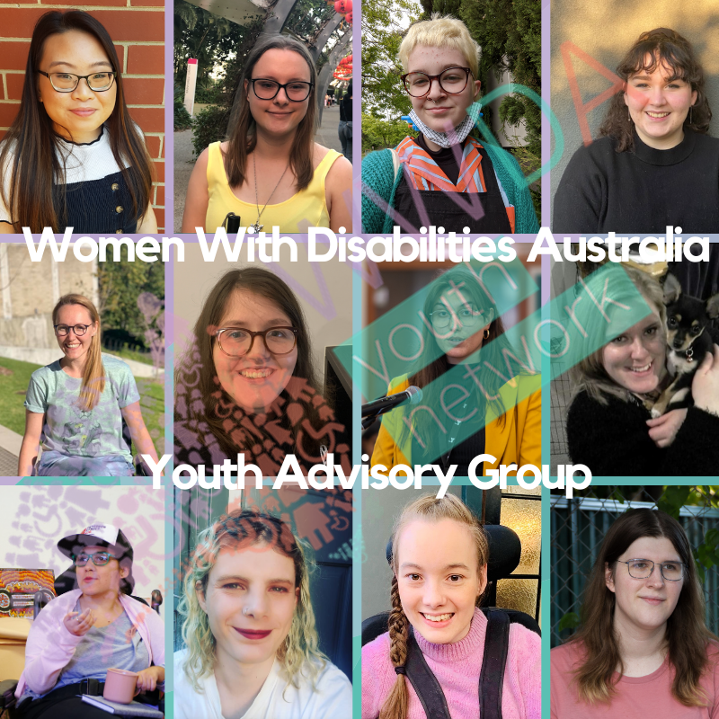
An engaged advisory committee and network of young women and girls with disability

In the last six month the WWDA Youth advisory group has been established with overwhelming success and has driven the youth focus of the WWDA LEAD Project to support initiatives that build the leadership capacity of young women and girls with disability. This has enabled us to engage 15 young people into WYAG, and these15 young people being selected from over 56 applicants from across Australia. We have a wide representation of young people in the group, including both rural and remote youth, a first nations young person (with 3 positions earmarked for our first nations representatives) young people from migrant and refugee backgrounds and young people from the LGTBIQA+ community.

To see the bios of each of our WYAG advisory group please Click here

Since August 2020 YWAG has delivered:
- 2 WYAG meetings
- 1 x WYAG LEAD social catch-up
- 1 x WYAG LEAD peer networking session
- 4 x WYAG newsletters (Monthly from November 2020)

Due to consistent engagement with young women and girls with disability through WWDA Youth, the number of subscribers to our WWDA Youth Network newsletter has already reached 305, which is significant for a newly established network. As outlined in Attachment e, the WWDA Youth Social media pages have also had a substantial increase in followers since the beginning of th WWDA LEAD project.

Name of success factor

Strong partnerships, existing relationships within the disability sector and the women’s sector

WWDA has a collaborative relationship with the six National Women’s Alliances funded by the Australian Government. WWDA will utilise those networks and relationships to foster inclusion of women with disability into the work of the National Women’s Alliances thereby contributing to item 13 of our annual work activity plan “Increase the engagement of women and girls with disability in WWDA through outreach initiatives” and item 12 of our annual work activity plan “Increase opportunities for women and girls with disability to participate in public decision-making and representation”.

WWDA also has a collaborative relationship with the National Disabled People’s Organisations (DPOs) and National Disability Representative Organisations (DROs). WWDA is a founding member of Disabled Peoples Organisations Australia (DPOA), which is made up of four national DPOs: Women With Disabilities Australia (WWDA); First Peoples Disability Network Australia (FPDN); People with Disability Australia (PWDA), and National Ethnic Disability Alliance (NEDA). WWDA also has close working relationships with many national and State/Territory Disability Representative Organisations (DROs) and will utilise all these relationships in project implementation.

Since August 2020, some of the things WWDA have done include:

- Worked with Children and young People with Disability Australia (CYDA) who are keen to support WWDA to reinvigorate the WWDA Youth Network. To commence work on this aspect, WWDA will be attending and presenting at CYDA’s Youth Disability Online summit in late September 2020 and distributing information about opportunities to get involved with the WWDA Youth Network. WWDA is also working with CYDA and other state based youth disability organisations to support members of the WWDA Youth Network Advisory Committee to take up leadership training and opportunities within the Australian disability sector. In December 2020, WWDA’s staff member Heidi also presented at CYDA’s youth leadership summit.
- Worked with the Commonwealth Children and Youth Disability Network (CCYDN) to engage young women and girls with disability in international leadership training, representation and networking opportunities, including the CCYDN’s Inclusion, Disability, Equality, Action and Support (IDEAS) Capacity Building Programme. Since August 2020, WWDA’s representative, Heidi has also presented at and helped coordinate a number of events for young people with disabilities, including: CCYDN’s ‘Taking Charge of Our Future’ (post COVID-19) event, CCYDN’s COVID-19 Hospital Communication Passport Launch and 4 separate CCYDN’s workshops on: disability advocacy, disability rights, social media campaigning and gender equality.
- Worked with the Advisory group of the Australian Women Against Violence Alliance (AWAVA) to improve consideration and inclusion of the experiences and support needs of women and girls with disability in all of AWAVA’s work related to in the area of preventing and responding to violence against women. In October 2020, WWDA’s project officer Heidi presented on a webinar hosted by AWAVA on freedom from sexual and gender-based violence.
- Worked with Our Watch Advisory Group: Prevention of Violence Against Women with Disability Participation on the Advisory group allows WWDA to inform and drive the development of a resource to guide the prevention of violence against women and girls with disability and a campaign aimed at preventing violence against young women with cognitive and intellectual disabilities. Recent work on the advisory group has involved contributing to and reviewing a 70+ page handbook on preventing violence against women with disability
  - purpose: to equip organisations, supporters and the community to prevent violence against women.
- Worked with Equality Rights Alliance (ERA) to advocate for gender equality, women’s leadership and government policy responses that support women’s diversity in Australia. In February, WWDA staff attended and suppprted WWDA Youth Advisory Group members to participate in workshops and meetings to inform the feminist principles that underpin ERA’s work. In October 2020, WWDA’s Project and Policy Officers, Heidi and Mali presented at an ERA webinar on the impact of the Federal Budget on women. The #BlokeBasedBudget webinar.
- Worked with The Shift – Network for the Achievement of Intersectional Gender Equality in Australia- The network has emerged out of a group of advocates who have come together to put a feminist economic perspective on the measures the government is announcing in response to the COVID pandemic. Participation allows WWDA to work alongside the private sector, not-for-profit sector, academics, government, media commentators, journalists, and social media influencers to ensure the voices of disabled women have a seat at the gender equality policy table.
- Provided feedback an interview with the social deck – on improving communications about Cervical screening to women with disability
purpose: to improve accessibility of communications / to increase numbers of women with disability having cervical screens.
- Worked with Our Watch Prevention Hub meeting participated in Our Watch Media Making change advisory group in regard to coordinate work on violence prevention (DFV)
- Took part in an interview with the Australia ReMADE project about the public good and what would be considered as priorities for women with disability.
- Provided advice to the Immigration Advice and Rights Centre about a new project they are implementing to develop resources for migrant women from non-English speaking backgrounds who are experiencing violence
- Provided feedback to the Department of Social Services about the Personal Care in Schools Policy.
- Provided feedback and advice on Blue-Knot Reference Group on creation of National Trauma-Informed Disability Practice Guidelines

Success factor

An experienced project team to ensure project success

WWDA has a very strong and experienced project team with qualifications in project management, stakeholder engagement and senior leadership experience in government and the not-for-profit sectors to ensure that the project is delivered to time and budget. Bios of the project team are available here: https://wwda.org.au/about/board-and-staff/

A welcomed and most deserved award for Heidi LaPaglia our Project and Policy Officer for WWDA and WWDA LEAD, who won the Disability Sector Award at Tasmanian Young Achiever Awards Night on 1st October 2020. Heidi is an advocate for young women with disabilities, like herself. Heidi undertook leadership roles for the Tasmania University Union and National Union of Students where she assisted women with disabilities with their welfare and participation. She worked to assist individuals in accessing the National Disability Insurance Scheme. Link to this announcement can be Found here.

Barriers
Demands on WWDA as a result of COVID19.

WWDA had to seek a later start date for this Project due to the over-whelming demands placed on our organisation as a result of COVID19. WWDA staff had to be relocated to work from home and some WWDA staff with disability needed extra organisational support due to them being considered high-risk for COVID 19. Additional equipment needed to be purchased, and reasonable adjustments met.

The team have been able to get back on track with our deliverables and by being flexible and adaptable in establish new ways of engaging with our communities of women and girls with disabilities online and virtually. We have successfully supported many women and girls with disabilities across Australia, individually at times to ensure that they have been able to access online events from locations across Australia, including rural and remotes regions. The WWDA team has been able to be accessible, adaptable, innovative and flexible during the COVID 19 pandemic, and has successfully been able to increase participation in WWDA LEAD and WWDA programs in challenging circumstances.

Whilst face to face consultations and outreach activities have had to be put on hold for to ensure the safety of women and girls with disabilities during the pandemic, we have been able to stage and plan activities, develop risk management plans which will see events go online if required.

Barriers

Engaging with women and girls with disabilities in closed settings.

There are historically and still are barriers in being able to provide and women and girls with disabilities in closed setting with access to the WWDA LEAD project and WWDA membership and activities in general. This is a major concern for WWDA as being able to provide information that is accessible and available to these women and girls in closed settings is not currently being provided. Our engagement and outreach strategy to address these barriers is to be able to promote resources at events and conferences and present at event and conference to enable us to communicate with audience’s that we traditionally cannot
reach.

Section d. Organisational Capacity Building activities

1 - Upskilling, training or developing existing or potential staff, volunteers or committee/board members to improve their leadership, skills and capability (e.g., leadership training for staff, board members and/or volunteers with disability)

2 - Basic level

Enter comments here: As a small organisation completely reliant on project-based government funding WWDA has not had the resourcing previously to invest in staff and Board leadership training. Through this new project however, we are working to research and explore leadership upskilling opportunities for our staff and Board. A considered, researched and customised plan will allow us to focus on how we can best meet the training needs of staff and WWDA board members and to match these organisational and individual goals.

2 - Scoping and developing a business case for revenue generating services that lead towards financial independence (e.g., developing a new social enterprise).

2 –Moderate Level

Enter comments here:

Since August 2020, the WWDA Board and executive team have begun strategic discussions on revenue generation. With a small operational team, our WWDA Board are currently working on the diversifying our revenue streams.

Both the CEO of WWDA and WWDA Policy and Project officer are and have been on several advisory commitees, boards and commonwealth and state, and international governance bodies and their expert advice and representation brings in a small revenue stream for WWDA. WWDA is increasingly being asked to be on additional commitees as subject matter experts and to provide expert advice on strategic federal policy disabilities frameworks.

3 - Strengthening the quality of organisational activities (e.g., commissioning a risk management framework)

3- Moderate Level

Enter comments here:
Since August 2020, the WWDA Board and executive team have begun strategic discussions on strengthening the quality of organisational activities. We are currently working on the following:

- WWDA Constitutional review and update- the WWDA Board and are scoping whether this deliverable will be commissioned or reviewed and updated in accordance with all necessary statutory bodies.

- WWDA Policies and Procedures – the WWDA CEO, Board and staff have worked together to identify the policies and procedures that need to be updated or created within the organisation and have begun work on updating the necessary documentation. So far, 10 entirely new policies have been created to improve organisational effectiveness and safeguards and others are in progress.

- Monitoring and evaluation framework - Discussions around the evaluation and monitoring framework for WWDA LEAD are currently underway and will be included in the next ILC Activity Report in August 2021. We are currently recording data in the forms of surveys, questionnaires, social media analytics online polls in events and event attendance and participation and feedback.

- A new CRM (Salesforce) is being currently integrated into the current WWDA membership and stakeholder engagement systems to ensure relationships are managed effectively and can be reported on with ease and accuracy. All staff will be trained on the use of the new CRM.

4 - Develop and implement strategies to upskill the organisation (or parts of organisation) to better function

3 – Moderate Level

Enter comments here:

Since August 2020, we have been working on:

- Upskilling in stakeholder engagement: We are upskilling our stakeholder engagement systems by integrating the Salesforce CRM into our existing WWDA stakeholder engagement systems. Integration of salesforce into our current WWDA website will enable us to be able to collect data and analytics and provide reports with ease and accuracy, and in addition and can assist in matching WWDA members with leadership opportunities and representation activities. All WWDA LEAD staff will be trained in the use of Salesforce.

- Upskilling in project management- WWDA continues to develop its existing project management processes including on a continual basis that include new templates, document control methods and processes that are ratified at WWDA board Meetings. WWDA delivers our projects using a strong co design model and and continues to build on the previous ILC grant methodology from the Our Site Project and other best practice co-design methodologies based on a human rights perspective, both nationally and interationally. A copy of the WWDA ILC Our Site report can be located here Our Site Final Report August 2020. This report is also provided in Easy Read and this can be located here Our Site Final Report Easy Read.

- All staff have been trained in Easy English and have the ability to translate documents into easy read and easy English formats.

- We are currently in the process of enhancing our virtual events with our delivery of webinars to ensure a great user experience and greater accessibility for participants. All webinars will have improved closed captions with Auslan interpreting at all virtual events. All staff will be trained in learning and being involved in new delivery methods. The improved virtual delivery model will be a major focus until face-to-face opportunities become more feasible. This new delivery model with enhance the national reach of the project as webinars will be available in an enhanced quality in urban, region and remote area. All webinars will be available on demand after the event, allowing people to watch the webinars at a time that is convenient to them.

- WWDA is currently updating all Internal Policies and Procedure’s. So far, 10 entirely new policies have been created to improve organisational effectiveness and safeguards and others are in progress.

5 - Developing and delivering strategies and activities to support knowledge and skill transfer between board members with and without disability

High level

Enter comments here:
WWDA is a DPO run by and for women with disability. All Board members are women with disability.

6 - Developing organisational strategy and future outlook (e.g., conducting needs analysis to better understand emerging priorities of constituent group)

3 - Moderate level

Enter comments here:
WWDA is a cross-disability, inclusive, intersectional and trans-national organisation that represents over 2 million women and girls with disability in Australia. Our members come from a diverse range of backgrounds, ages and beliefs. These include Indigenous, CALD, sexuality and gender diverse, and intersex communities. WWDA is unique, in that we have direct membership of women and girls with disability, and a large associate membership which includes families, carers, service providers and more. All WWDA projects and programs are directly informed by, and in response to, the expressed needs of our members. The WWDA Board and WWDA executive team are currently undertaking a review of the WWDA Strategic Plan. A new 5-year WWDA Strategic Plan will be developed as part of this Project. The new Strategic Plan will be developed in direct consultation with WWDA members and will include key priority areas identified by WWDA members. WWDA will utilise a range of engagement and consultation mechanisms and processes to ensure that WWDA members are central to the development of the new 5-year Strategic Plan.

7 - Establishing and maintaining partnerships to collaborate with other organisations (e.g. developing formal or informal cooperative agreements to share resources or partner in program delivery)
4 - High level

Enter comments here:

As stated earlier, WWDA has a collaborative relationship with the six National Women’s Alliances funded by the Australian Government. WWDA will utilise this Project to foster inclusion of women with disability into the work of the National Women’s Alliances. National Disabled People’s Organisations (DPOs) and

National Disability Representative Organisations (DROs). WWDA is a founding member of Disabled Peoples Organisations Australia (DPOA), which is made up of four national DPOs: Women with Disabilities Australia (WWDA); First Peoples Disability Network Australia (FPDN); People with Disability Australia (PWDA), and National Ethnic Disability Alliance (NEDA). WWDA also has close working relationships with many national and State/Territory Disability Representative
Organisations (DROs); organisations in the women’s sector; human rights NGO’s; academic and research institutes and will utilise these relationships in project implementation and monitoring.

8 - Developing and delivering strategies and activities to strengthen the involvement of people with disability and/or families and carers in organisational decision making (e.g., recruiting and supporting staff and/or volunteers with disability, or supporting leaders with disability to operate effectively on boards and management committees)

3 - Moderate level

Enter comments here:
Since August 2020 we have:

- Begun planning work on the constitutional review with the WWDA Board.

- WWDA is currently updating the Internal Policies and Procedure’s manual.

9 - Improving organisational systems or processes to deliver organisational efficiencies (e.g., purchasing and installing a new member communication system)

2 – Moderate Level

Enter comments here:

Since August 2020, the WWDA team have been updating and implementing the following:

- By updating our CRM system with Salesforce: We are upskilling our stakeholder engagement systems by integrating the Salesforce CRM into our existing WWDA stakeholder engagement systems. Integration of salesforce into our current WWDA website will enable us to be able to collect data and analytics and provide reports with ease and accuracy, and in addition and can assist in matching WWDA members with leadership opportunities and representation activities. All WWDA LEAD staff will be trained in the use of Salesforce.
- WWDA is currently working updating the Internal Policies and Procedure’s manual. So far, 10 entirely new policies have been created to improve organisational effectiveness and safeguards and others are in progress.

- A WWDA LEAD communications strategy will be submitted to the WWDA LEAD Project Steering Committee for feedback and review in March 2021.

Document updates
Have you reviewed your Project Plan, Stakeholder Engagement and Events information with current details? Yes

