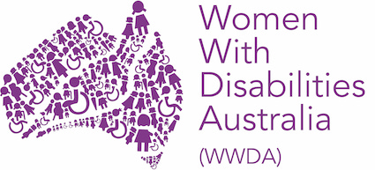 | 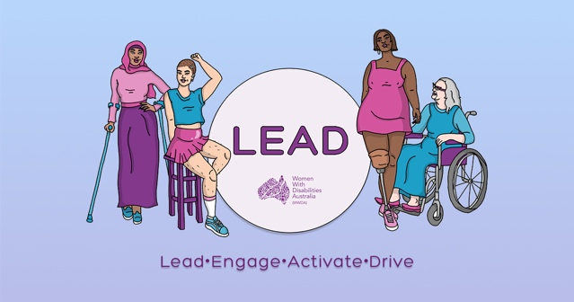 | 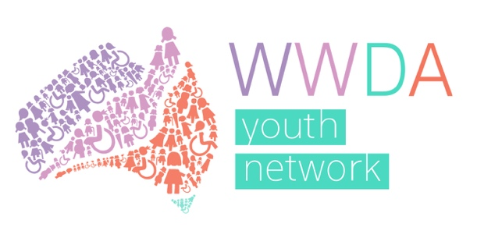

WWDA LEAD - LEAD • ENGAGE • ACTIVATE • DRIVE

‘BUILDING CAPACITY OF WOMEN AND GIRLS WITH DISABILITY IN AUSTRALIA’

Individual Capacity Building – Progress Report Number #3

Women With Disabilities Australia (WWDA)
PO Box 407, Lenah Valley, 7008 Tasmania, Australia
Phone: +61 438 535 123
Email: officeadmin@wwda.org.au
Web: www.wwda.org.au
Facebook: www.facebook.com/WWDA.Australia
Twitter: www.twitter.com/WWDA_AU

Winner, National Human Rights Award 2001
Winner, National Violence Prevention Award 1999
Winner, Tasmanian Women's Safety Award 2008
Certificate of Merit, Australian Crime & Violence Prevention Awards 2008
Nominee, UNESCO Prize for Digital Empowerment of Persons with Disabilities 2021
Nominee, National Disability Awards 2017
Nominee, French Republic's Human Rights Prize 2003
Nominee, UN Millennium Peace Prize for Women 2000

Women With Disabilities Australia (WWDA) has Special Consultative Status with the Economic and Social Council of the United Nations.

INTRODUCTION

Women With Disabilities Australia (WWDA) is the national Disabled People’s Organisation (DPO) for women, girls, feminine identifying and non-binary people with disability in Australia. As an DPO, WWDA is run by and for women, girls, feminine identifying and non-binary people with disability. WWDA uses the term ‘women and girls with disability’, on the understanding that this term is inclusive and supportive of, women and girls with disability along with feminine identifying and non-binary people with disability in Australia.

WWDA represents more than 2 million women and girls with disability in Australia, has affiliate organisations and networks of women with disability in most States and Territories, and is recognised nationally and internationally for our leadership in advancing the rights and freedoms of all women and girls with disability. Our organisation operates as a transnational human rights organisation - meaning that our work, and the impact of our work, extends much further than Australia. WWDA’s work is grounded in a human-rights based framework which links gender and disability issues to a full range of civil, political, economic, social and cultural rights.

This Report is WWDA’s third Progress Report on our Information, Linkages and Capacity Building (ILC) funded Project ‘Building Capacity of Women and Girls with Disability in Australia’ (known as ‘WWDA LEAD’). This ILC Project specifically recognises the need for the adoption of specific measures aimed at the development, advancement and empowerment of women and girls with disability and the promotion of measures to empower them by recognising that they are distinct rights holders, by providing channels to have their voice heard and to exercise agency, by raising their self-confidence and by increasing their power and authority to take decisions in all areas affecting their lives. Women and girls with disability (WGwD) have identified that one of the best ways for them to build their individual capacity is to come together with other WGwD – to share experiences, to gain strength from one another, to learn by doing, to be treated equally, to experience mentorship, and to work together on issues that affect them.

In providing this third Progress Report on WWDA’s ILC Project, WWDA acknowledges the traditional owners of the land on which this publication was produced. We acknowledge Aboriginal and Torres Strait Islander people’s deep spiritual connection to this land. We extend our respects to community members and Elders past, present and emerging.

For more information on the extensive work of WWDA, please see:

https://wwda.org.au
https://oursite.wwda.org.au
https://www.facebook.com/WWDA.Australia
https://twitter.com/wwda_au

WWDA ILC GRANT DETAILS

‘BUILDING CAPACITY OF WOMEN AND GIRLS WITH DISABILITY IN AUSTRALIA’

Organisation name: | Women With Disabilities (Australia) Inc
Agreement ID: | 4-DEJJ3RV
Project title: | WWDA LEAD- Lead • Engage • Activate • Drive  ‘Building Capacity of Women and Girls with Disability in Australia’
ILC activity area: | Individual Capacity Building
Activity type: | ICB & OCB
Activity start date: | 1/07/2020
Activity end date: | 31/07/2023
Activity area postcode/s (if not state or national) | National
Funded for Organisational Capacity Building? | Yes
Total funding (GST inclusive): | $2,139,280.00

SECTION A: ACTIVITY OPERATIONAL INFORMATION

Locations during this reporting period

Has the location of your activities changed from your last report?: No

Optional comments:
Staff for the project are based across Australia and currently staff are working remotely from Canberra, Hobart and North-West Tasmania. WWDA is committed to providing employment opportunities to women with disability. WWDA is also committed to modelling good practices in disability employment, demonstrating that women with disability can be supported to work in flexible ways, including by working remotely.

ILC Project Staff

How many paid staff, currently involved in the project, identify as having a disability?: 7
How many volunteer staff, currently involved in the project, identify as having a disability? 36
How many paid staff, identifying as having a disability, currently have leadership responsibilities? 3
How many volunteer staff, identifying as having a disability, currently have leadership responsibilities? 24
Total number of paid staff (with and without disability) are involved in activity design and delivery? 8
Total number of volunteer staff (with and without disability) are involved in activity design and delivery? 21

Optional comments:
WWDA is an organisation run by and for women with disability and operates from a philosophy and model of co-design. Women with disability from around Australia are engaged in all aspects of the project – including through project design, governance, implementation, and monitoring.

Current paid staff include: 7 women and non-binary people with disability and 1 woman without disability.

Volunteers currently include: 7 project steering committee members, 14 Youth Advisory Group members, 2 Board members (EOI process for WWDA Board is currently out), 3 Community Facebook group moderators and 10 general volunteers.

SECTION B: INDIVIDUAL CAPACITY BUILDING ACTIVITIES

In the last 6 months how many people with disability attended your activities?
Approximately 1,105 and more than 100 have participated on more than one occasion.
Art Prize (115 including judges), Art Prize Awards Ceremony (95), Other webinars (700 including speakers), Peer Networking (50), Training (80), Scholarships (20), Blogs (26), Mentoring (74), Podcast Production (10), Youth social events: Crip Camp viewing and discussion (20), WYAG social hang out (10)

In the last 6 months how many family members and carers attended your activities? (This has not been individually identified, but many women with disability who attend WWDA’s events and activities are supported by family members, friends, carers or support workers)

In the last 6 months, the WWDA LEAD team have been implementing a planned calendar of events for 2021 (See APPENDIX A - WWDA LEAD Calendar of Events), as well as working on a number of other initiatives as part of the WWDA LEAD project. This has included:

- Project Steering Committee (PSC)
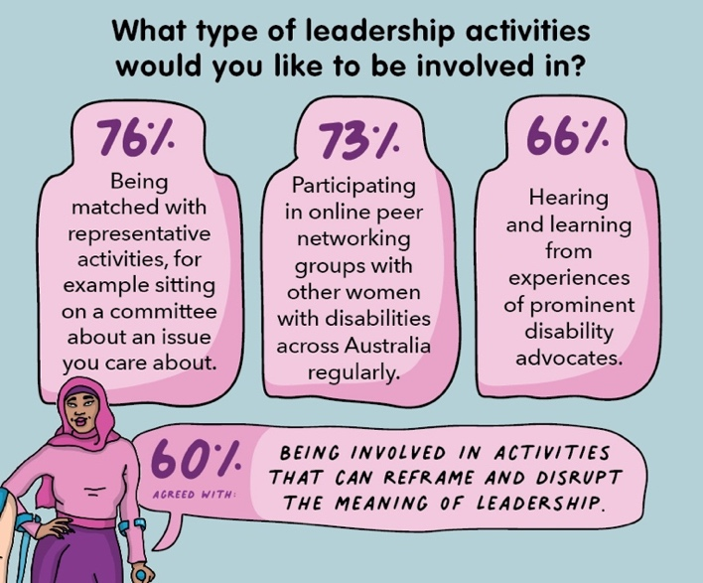
Established a WWDA LEAD project steering committee, made up of 7 women with disability to oversee the delivery of the WWDA LEAD Project until March 2023. As of 28/2/2021, 2 meetings were held in the last reporting period and 5 over this reporting period. PSC meetings will continue every 6 weeks until the end of the WWDA LEAD Project.

- WWDA Surveys

2.1. Leadership Survey
After the WWDA Leadership survey was distributed to WWDA members in early 2021, WWDA published a summary of results on our website, showing what participants wanted from the WWDA LEAD project. This can be viewed on WWDA’s website at:
https://wwda.org.au/2021/03/what-you-told-us-you-wanted-from-wwda-lead/

2.2. Member Satisfaction Survey
The Project team are planning to distribute a member satisfaction survey to track the success of the WWDA LEAD activities in early -mid 2022.

Image above: Some of the key statistics from the leadership survey results.

- WWDA LEAD Project Steering Committee (PSC) Meetings
WWDA LEAD Project staff have been meeting regularly with the WWDA LEAD Project Steering Committee (PSC) to ensure the WWDA LEAD project is driven and governed by women with disability, through co-design methods.

In the last six months, WWDA staff have convened five meetings with the Project Steering Committee, including:

- PSC Meeting #3 - 1st March 2021
- PSC Meeting #4 - 19th April 2021
- PSC Meeting #5 - 10th May 2021
- PSC Meeting #6 - 21st June 2021
- PSC Meeting #7 - 2nd August 2021

These meetings have had good attendance, with most members attending all of them. A list of PSC members can be found on the WWDA website.

- WWDA Youth Advisory Group (WYAG) Meetings
Since the WWDA Youth Advisory Group was started in December 2020, the group has continued to proactively and enthusiastically engage with the organisation and the WWDA LEAD project through their bi-monthly meetings as well as other WWDA LEAD activities. In the last six months, WWDA staff have convened three meetings with the WWDA Youth Advisory Group (WYAG), bringing the total number of meetings to five. These have been held on the following dates:
- WYAG Formal Meeting 3 – 16th April 2021
- WYAG Formal Meeting 4 – 4th June 2021
- WYAG Formal Meeting 5 – 13th August 2021

These meetings have had good attendance, with most members attending all of them. A list of WYAG members can be found on the WWDA Youth website.

- Leadership Statement
On the 21st of August, the WWDA LEAD staff team and PSC members participated in a full day workshop facilitated by experienced consultant, Caroline Lambert to discuss what leadership is and how we define it through our lense of lived experiences and intersections with feminism and disability. From this workshop, the common themes from discussions and shared reflections throughout the day will be pulled together into a leadership statement which includes at least 3 principles of leadership for WGwD (in progress).

- Leadership and Mentoring Toolkit
Consultant Caroline Lambert has been engaged to support the WWDA LEAD team to develop, monitor and evaluate the Leadership and Mentoring Toolkit through the process of non-tokenistic and meaningful co-design with our PSC, WYAG, LEAD activity participants and WWDA members. To start the process, WWDA staff have been having weekly planning meetings with Caroline, and have now drafted:
- A survey to go out to PSC members to gain their input into the design of the Leadership and Mentoring Toolkit
- An expression of interest form and Terms of Reference be distributed to WWDA members to express interest in being part of a Co-Design Committee to drive the development of the Toolkit.

Other activities planned include:
- An in-person meeting (dependent on travel restrictions) with the Toolkit Co-Design meeting

- Webinars
WWDA has planned to hold a number of webinars as part of the WWDA LEAD Webinar Series. The webinar topics have been developed through consultations with women, girls, feminine identifying and non-binary people with disability, including our Project Steering Committee, WWDA Youth Advisory Group and WWDA members. The webinars have received great feedback and offer an opportunity for the platformed speakers to reach new audiences and strengthen their online presentation skills. At the point of writing this report, total views of webinars 1, 2 and 3, was 677. With 306 of those live views and 371 on-demand (post-event) views. Webinars we have hosted so far are listed below.

- Webinar #1 - We Can All Be Leaders: On the 15th of March, WWDA hosted the first WWDA LEAD webinar ‘We Can All Be Leaders,’ with a great panel of four women and non-binary people with disability.
- Webinar# 2 - Scholarships Information Session: On 24 March 2021, the WWDA LEAD team held a webinar information session for people to learn about the WWDA LEAD scholarships before applying (more details about WWDA LEAD Scholarships in point 9 below).
- Webinar #3 - NDIS and Gender: On the 27th May, WWDA hosted the second webinar to discuss why women are not accessing the NDIS at the same rate as men. Our expert panel discussed the current barriers and what we can be done, to ensure equal access to the NDIS.
- Webinar #4 - Avenues of Support: On the 14th July, WWDA hosted the third webinar to discuss avenues of support for women, girls, feminine identifying and non-binary people with disabilities. Our expert panel discussed the tips and tricks to avoid burnout.
- Webinar #5 - Art Prize Awards Ceremony: Announcing the winners of Art Prize categories and an opportunity for members to hear from some of the winners about their creative practice, and most importantly, celebrate the talent and work of our wonderful community.

A full breakdown of webinar analytics can be found in APPENDIX B. All of the webinar recordings can be viewed on WWDA’s website and webinar channel.

- Peer-Networking Sessions
In the last six months, WWDA has hosted 4 (2 general and 2 youth focused) online networking sessions to support members meet peers, network and share experiences and ideas with others engaging in leadership areas. These events have engaged approximately around 50 members total. More information about the peer-networking sessions can be found on WWDA’s website.

- Scholarships
After launching applications for WWDA LEAD scholarships in March, WWDA received a number of impressive applications that were difficult to narrow down for the first round of our scholarships with 14 selected applicants for our first round of WWDA LEAD scholarships.
The WWDA LEAD scholarships, offered to all existing and new WWDA members are an opportunity to apply for a range of leadership and/or training courses that will help develop leadership skills. The first round has now been finalised with the second round to come in 2022. Some of the successful applicants for this round included courses in Training and Assessment, Public Speaking, Personal and Professional Development, Accessibility, Easy English, Health Literacy and Auslan Training. More information about the scholarships can be found on WWDA’s website.

- Mentoring
The WWDA LEAD Mentoring Program aims to help mentees to work towards their leadership goals, build their confidence, gain exposure and broaden networks with support and guidance from their mentor. This is an 8-month program designed to build the confidence, skills and capacity of our members.

To ensure that our provider Brancher can pair people up with someone who will be the best fit for them, we asked members to apply to the program by completing an online application form. This form asked a number of questions about their career stage, goals, personal preferences and what they were hoping to get out of the program. More information about the WWDA LEAD Mentoring Scholarships can be found on WWDA’s website.

“The biggest reason that mentors tell us they love this program is because of the great sense of reward and satisfaction they get from ‘paying it forward.’ Additionally, mentors often report improved leadership and coaching skills.” – Brancher Mentoring Program

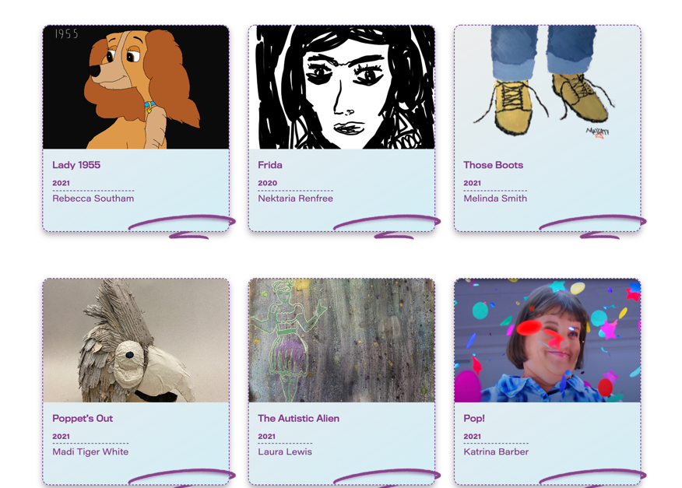
- Art Prize
On International Women’s day this year, WWDA launched our WWDA LEAD Art Prize. We wanted to encourage our community of women, girls, feminine identifying and non-binary people to submit their artwork on the theme ‘We can all be leaders’ in a variety of accessible and creative formats.

An awards ceremony was held on 26 August 2021, and can be viewed on WWDA’s webinar channel. Prize categories were: Under 18s over 18s and People’s Choice.

Overall we received 115 entries in total which are able to be viewed on an online gallery through WWDA’s Oursite website portal.

More details about the Art Prize, including the submission process, can also be found on WWDA’s website.
Image above: A screenshot of the Art Gallery on WWDA’s Our Site.

- WWDA LEAD Blog
Since the WWDA LEAD Leadership Blog was launched in September 2020, we have had over 26 submissions from women, girls, feminine identifying and non-binary people with disability from across Australia. We release a new leadership blog every two weeks and have found that promoting these individual experiences and stories is encouraging more women and girls with disability to share their stories. To go to the WWDA LEAD Leadership blog page please click here.

- Youth Social Events
In one of the early meetings of the WYAG, it was recommended that WWDA hold some social events as part of the WWDA LEAD project to encourage engagement from young women, feminine identifying and non-binary youth with disability. In the last six months, the following events have been held:

13.1. Crip camp screening (23rd July 2021) and discussion (24th July 2021)
In late July the WYAG worked with staff to host an online screening of the documentary Crip Camp, followed by a weekend discussion about the film and how it relates to the lives of young people with disability in Australia. Both events were well attended and encouraged rich discussion among the young people.

13.2. Social YWAG Hang out (5th March 2021)
On 5 March 2021, WWDA staff hosted a social meeting for the WYAG to chat and get to know each other.

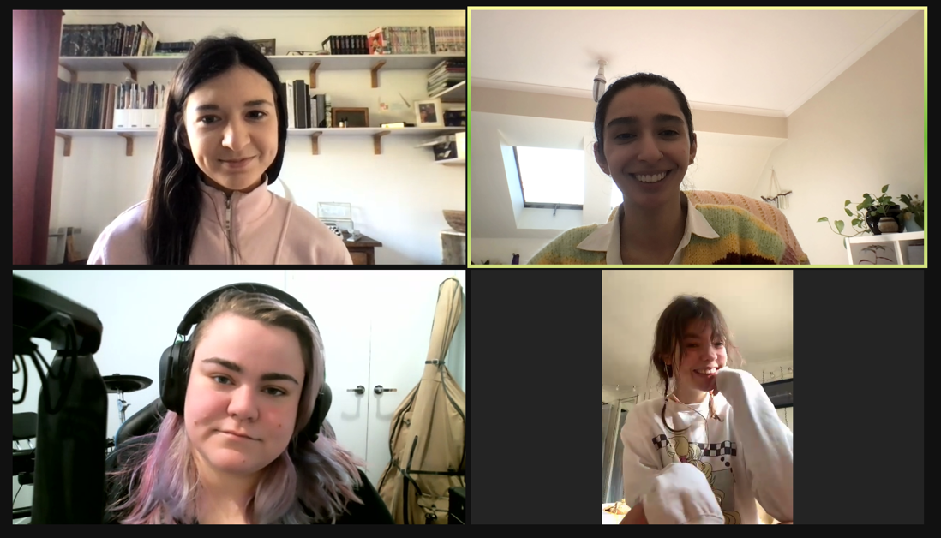
- Podcasts
After discussing the importance of increasing the representation of women and girls with disability in media, the WYAG have worked with WWDA staff in the last six months to create a new podcast featuring women and girls with disability talking about leadership. After a long lead up, involving many discussions with podcast producers and tech companies about accessibility, WWDA has now partnered with 2PHR to produce a monthly podcast. So far, two episodes have been published, and have received fantastic feedback from listeners. With support from WWDA staff the podcasts are being facilitated by members of the WYAG, including Jade Taylor who is hosting the podcasts and Amy James who is creating the music.

These can be viewed on WWDA’s website as well as the 2PRH website.
Image above: Screen shot from the WWDA Youth podcast recording with Chloe Hayden. Image shows WWDA staff members, Heidi La Paglia and Ajar Sana at the top left and right. At the bottom left is WYAG member and podcast host Jade Taylor and at the bottom right is podcast guest, Chloe Hayden.

- WWDA Representation

15.1. Representation Activities
Although WWDA operates with a small operational team, the WWDA CEO, staff, Board and volunteers regularly commit time and resources to representing and advocating for the rights of women and girls with disability through external advisory committees, boards and commonwealth and state, and international governance bodies. A copy of WWDA’s Representation in ongoing and one-off consultations over the last six months is provided in APPENDIX C.

15.2. Representation Guide
In order to better support WWDA members to represent the organisation, WWDA staff have begun work on updating its representation guide. This should be finalised by the next reporting period.

SECTION C: PROGRAM SUCCESS FACTORS AND BARRIERS

SUCCESS FACTORS

- A commitment to co-design in all aspects of WWDA LEAD project delivery.
Since the WWDA LEAD project began we have been able to establish the following advisory groups and committees to ensure that WWDA LEAD is developed in best practice codesign by our community of women and girls with disability. WWDA is committed to engaging and empowering women and girls with disability to deliver successful project outcomes and impacts for WWDA LEAD by facilitating the following committees and advisory structures:

  - The WWDA LEAD Project Steering Committee
  - The WWDA Youth Advisory Group
  - The WWDA LEAD Co-Design Committee - to develop the WWDA LEAD leadership and mentoring toolkit to be launched in late 2022 (in development phase and will be rolled out in September-November of 2021). We will be asking WWDA LEAD scholarship recipients to be involved in this codesign committee in the development of this toolkit to showcase and share learnings from their leadership and development opportunities.

- An engaged membership base that can be leveraged for project success
At the start of the WWDA LEAD project, WWDA already had existing, strong and reputable engagement with our members and the community of women and girls with disability and have since worked extensively on improving our online technical delivery methods of activities and communications to be able to connect to a larger audience and diverse. In order to do this, we have worked extensively with expert tech companies such as JPL media and AI Media and web developers such as Ionata and Handbuilt to improve the infrastructure of our websites, and event platforms. Improving our online delivery methods has been particularly important under the impact of the COVID-19 pandemic, where in-person events and communications have become less and less possible.

As our infrastructure has improved and reach has grown, we have also found that the number of WWDA’s members, followers and supporters have drastically increased. The team has also been gauging the success of these new delivery models by using live polls during webinars and online events, and then conducting short questionnaires after the events to indicate and report on the level of engagement and satisfaction with the content delivered and the overall accessibility of the events.

WWDA already has an active and engaged online community of women and girls with disabilities and this has continued to grow through the combined WWDA general activities, WWDA Youth and WWDA LEAD activities.

- Quick snapshot of some increases in membership and online audiences

  - Number of new members to WWDA over last six months: 428
  - New subscribers to WWDA Online Facebook Group: 414
  - Social media analytics from our Twitter and Facebook (August 2020 - February 2021) are attached in APPENDIX D:
These analytics demonstrate WWDA’s electronic engagement influence and reach and highlight the potential for further influence and reach as the project progresses.

- Overwhelming participation and interest in WWDA’s Art Prize
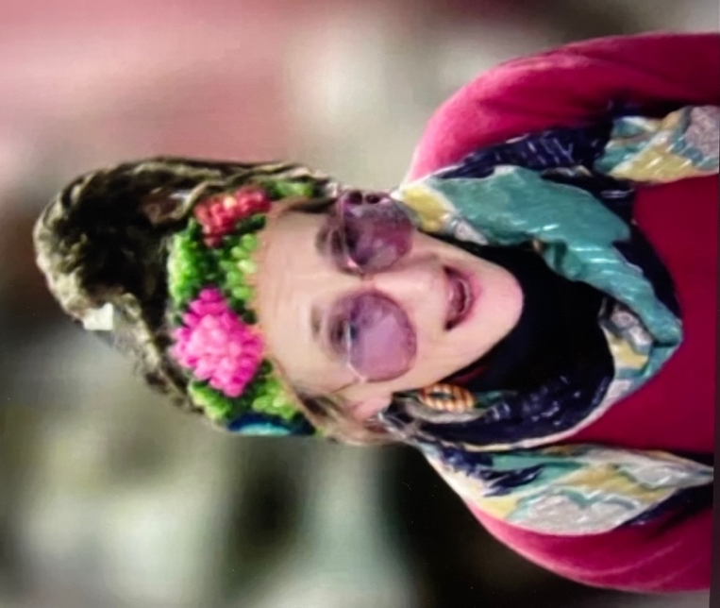
After launching the WWDA LEAD Art Prize on International Women’s Day 2021, we received an overwhelming response with 112 entries received from entrants in all states and territories, living in metropolitan/regional/rural and remote communities. Submissions were made across a wide array of mediums, including sculptures, drawings, acrylic paintings, crochet and fashion, photography, video and digital art. With the help of three judges from the arts sector – Meleika Gesa-Fatafehi, Fiona Hamilton and Larissa MacFarlane - as well as expert advice received from the Arts Law Centre of Australia and a generous prize donation from Accessible Arts, WWDA was able to award 21 entries from across all categories at a Virtual Awards Ceremony. The Ceremony was attended by almost 100 WWDA members, their supporters, friends and family from all over the country and received fantastic feedback. The Ceremony also included speeches from multiple judges and winners who all spoke about how much Art helped them to connect with their community and feel confident in themselves. The Awards Ceremony recording and list of winners can be found on WWDA’s website and all of entries are viewable via the virtual gallery on WWDA’s Our Site.

“The purpose of my art is to allow people from marginalised groups to be seen and heard, and give them the power to be seen authentically.” – Marla Bishop, Winner of the Over18’s Prize.
Image above: Photo of Art Prize judge, Larissa MacFarlane announcing the winners at the Art Prize Awards Ceremony on 26 August 2021.

“I found that i needed something to help me manage my pain. I do it (make art) to bring happiness to other people. When I bring happiness to other people, it gives me happiness.” –Leonine Donahue, Winner of the People’s Choice Award.

“It doesn’t matter if you have disadvantages. You can create something beautiful from the heart.” – Madeline, Runner-Up of the Under 18’s Division.

- Successful Scholarship Program
We had 20 applicants for the Scholarship Program of which 14 were awarded to our members for courses with a total cost under $2000. Originally we were giving 10 scholarships but due to the total cost of courses applied, we were able to stretch funding out to cover 14 scholarships. There have already been expressions of interests about next year’s scholarship program.

- Overwhelming response and interest in the Mentoring Program
We have engaged Brancher as the platform and process to run the WWDA Mentoring Program. We originally envisioned matching 30 pairs (30 mentors and 30 mentees). However, WWDA worked with Brancher to identify 37 well matched pairs of mentors and mentees out of a total of 90 applications for the mentee positions and 52 for mentor positions.

- An engaged WWDA Youth Advisory Group
Since the WWDA Youth Advisory Group was started in December 2020, the group has continued to proactively and enthusiastically engage with the organisation and the WWDA LEAD project through their bi-monthly meetings as well as other WWDA LEAD activities. As a result of their active participation, a number of WYAG members have said that being part of the WYAG has considerably impacted their life and confidence as a community leader.

Two stories of change that have come about as part of the WYAG, are showcased in videos submitted by Margherita Dall’Occo and Amy James.
In Margherita’s video, Margherita describes how being part of the WYAG has changed her life, giving her the support to feel empowered as a disabled young woman and make powerful connections in the disability justice space. In Amy’s video, Amy describes how she loves being part of the group because it supports her to just be herself and pursue her goals of becoming a music star.

Both videos can be watched here.

Image above: Screenshot from video about the WWDA Youth Advisory Group (WYAG) member, made by WYAG member, Margherita Dall’Occo.

BARRIERS

- Demands on WWDA as a result of COVID19
WWDA had to seek a later start date for this Project due to the over-whelming demands placed on our organisation as a result of COVID19. WWDA staff had to be relocated to work from home and some WWDA staff with disability needed extra organisational support due to them being considered high-risk for COVID 19. Additional equipment needed to be purchased, and reasonable adjustments met.

The team have been able to get back on track with our deliverables and by being flexible and adaptable in establishing new ways of engaging with our communities of women and girls with disabilities online and virtually. We have successfully supported many women and girls with disabilities across Australia, individually at times to ensure that they have been able to access online events from locations across Australia, including rural and remotes regions. The WWDA team has been able to be accessible, adaptable, innovative and flexible during the COVID 19 pandemic, and has successfully been able to increase participation in WWDA LEAD and WWDA programs in challenging circumstances. Whilst face to face consultations and outreach activities have had to be put on hold for to ensure the safety of women and girls with disabilities during the pandemic, we have been able to stage and plan activities, develop risk management plans which will see events go online if required.

- Engaging with Aboriginal and Culturally and Linguistically Diverse women and girls with disability
While Women With Disabilities Australia has a broad base of members and followers, spanning every state and territory in Australia; staff have identified that there is still a low participation rate of Aboriginal and Torres Strait Islander women and girls with disability in WWDA’s activities and advisory structures. The reasons for this are varied but include a number of factors such as a lack of WWDA resources and activities that are culturally specific to Aboriginal and Torres Strait Islander communities as well as practical barriers, due to Aboriginal and Torres Strait Islander women with disability being more likely to live in rural and regional areas and in turn, less likely to have the stable internet connection, which is often required to engage in WWDA events. While efforts are being made to tackle these barriers within the WWDA LEAD project, such as liaising with First Nations organisations about how to improve communications; WWDA staff have also identified a need for stand-alone projects in collaboration with partner organisations such as First People’s Disability Network (FPDN) and the National Aboriginal and Torres Strait Islander Women’s Alliance.

- Engaging with women and girls with disability in closed and institutional settings
There are historically and still are barriers in being able to provide and women and girls with disabilities in closed setting with access to the WWDA LEAD project and WWDA membership and activities in general. This is a major concern for WWDA as being able to provide information that is accessible and available to these women and girls in closed settings is not currently being provided. Our engagement and outreach strategy to address these barriers is to be able to promote resources at events and conferences and present at event and conference to enable us to communicate with audience’s that we traditionally cannot
reach.

SECTION D: ORGANISATIONAL CAPACITY BUILDING ACTIVITIES

1. Upskilling, training or developing existing or potential staff, volunteers or committee/board members to improve their leadership, skills and capability (e.g., leadership training for staff, board members and/or volunteers with disability)

– Moderate Level

As a small organisation completely reliant on project-based government funding WWDA has not had the resourcing previously to invest in staff and Board leadership training. Through this new project however, we are working to research and explore leadership upskilling opportunities for our staff and Board.

A considered, researched and customised plan will allow us to focus on how we can best meet the training needs of staff and WWDA Board members and to match these organisational and individual goals.

In the last six months, WWDA staff and volunteers have taken part in a number of training opportunities, including:
- LGBTIQA+ Inclusion training: (6 staff and 16 volunteers, including 13 Youth Advisory Group and 4 Project Steering Committee members). On 24 May, WWDA staff took part in a training session on LGBTIQA+ inclusion with Dr Bree Gorman, who is a leading expert on diversity and inclusion in the workplace in Australia. On 30 April 2021, members of the WYAG and PSC also participated in a separate LGBTIQA+ inclusion training hosted by Drummond Street Services. This training was identified as important early in 2021, when WWDA broadened its definition of members to include: ‘Women, girls, feminine identifying and non-binary people with disability.’

- Project Management Training: (5 staff and 6 PSC members). On 20th August, WWDA LEAD staff and PSC members participated in a full day of Project Management training, run by Non-For-Profit Training.

- Leadership Statement Workshop: (5 staff and 7 PSC members). On 21 August 2021, WWDA staff and Project Steering Committee members took part in a workshop around what leadership means to women and girls with disability.
- Easy English training: Throughout the WWDA LEAD project, 7 staff members and 3 volunteers have undertaken training in Easy English. A further 2 staff and 10 volunteers will be undertaking training September/October.

- Media Spokesperson training: (2 staff). Between June – August 2021, 2 management staff have taken part in media spokesperson training with the Economic Centre for Media and another 3 staff members are scheduled to participate in the same training in the remaining months of 2021. This training has already come into great use, with WWDA staff now working closely with the Economic Media Centre to develop media strategies for activities within the WWDA LEAD project and the organisation more broadly.
- Co-design training: (2 staff). Between May and August 2021, two WWDA staff have attended co-design training sessions to improve WWDA’s ability to facilitate true co-design processes with women and girls with disability.
- Sales Force CRM Training: (6 staff). In the last six months, WWD has been working with information technology professionals to implement a new CRM using SalesForce to streamline the process for increasing membership, engaging with members and tracking membership engagement. At present, 6 out of 8 total staff have taken part in SalesForce training.
- FolkTale App (story telling app) Training: (6 staff). In order to gain feedback from WWDA members about the WWDA LEAD project, WWDA staff have been investigating a number of multi-media creative methods for members to utilise. One of these is through the use of the FolkTale story telling app, which members can use to submit feedback, stories, reflections and more. In the last six months, five staff have been trained in using the Folktale App as both producers and contributors.

- Facebook Moderator Training: (6 staff, 3 volunteers). In May 2021, WWDA staff identified that moderating the community Facebook group would be a good upskilling opportunity for WWDA members. In June 2021, an EOI form was distributed for WWDA members to volunteer for this opportunity and three were selected to assist with moderating the group. In July 2021, the WWDA Media and Communications Officer developed guidelines for moderating the Facebook group and held a training session, attended by 6 staff and 3 volunteers.

2. Scoping and developing a business case for revenue generating services that lead towards financial independence (e.g., developing a new social enterprise)

– Moderate Level

Since February 2021, the WWDA Board and executive team have begun strategic discussions on revenue generation through further grant funding and paid representation activities. With a small operational team, our WWDA Board are currently working on the diversifying our revenue streams. The CEO and staff are and have been on several advisory committees, boards and commonwealth and state, and international governance bodies and their expert advice and representation brings in a small revenue stream for WWDA. WWDA is increasingly being asked to be on additional committees as subject matter experts and to provide expert advice on strategic federal policy disabilities frameworks.

3. Strengthening the quality of organisational activities (e.g., commissioning a risk management framework)

– Moderate Level

The WWDA LEAD team is currently working with an external consultant, Caroline Lambert to develop a comprehensive Monitoring, Evaluation and Learning Framework (MELF) for the WWDA LEAD project. The framework is being developed in close consultation with the Project Steering Committee (PSC) and a first draft will be completed by early 2022. Throughout the WWDA LEAD project, the team have also been recording data and member feedback in the forms of surveys, questionnaires, social media analytics, online polls in events and more.

- Develop and implement strategies to upskill the organisation (or parts of organisation) to better function

– High Level

WWDA continues to develop its existing project and staff management processes including on a continual basis that include new templates, document control methods and processes that are ratified at WWDA board Meetings. WWDA delivers our projects using a strong co design model and continues to build on the previous ILC grant methodology from the Our Site Project and other best practice co-design methodologies based on a human rights perspective, both nationally and interationally. A copy of the WWDA ILC Our Site report can be located here Our Site Final Report August 2020. This report is also provided in Easy Read and this can be located here Our Site Final Report Easy Read.

WWDA is currently updating all Internal Policies and Procedures. So far, over 25 entirely new policies and reporting templates have been created to improve organisational effectiveness and safeguards and others are in progress.

- Developing and delivering strategies and activities to support knowledge and skill transfer between board members with and without disability

– High Level

WWDA is a disabled people’s organisation (DPO) run by and for women with disability. Throughout, WWDA’s history, Board members have always been women with disability.

- Developing organisational strategy and future outlook (e.g., conducting needs analysis to better understand emerging priorities of constituent group)

– High Level

Since the beginning of the WWDA LEAD project, WWDA undertaken a number of initiatives to identify the priorities of women and girls with disability. Some of these initiatives are described briefly below.

- WWDA LEAD Communications Strategy
In early 2021, WWDA’s Communications Officer submitted to the WWDA LEAD Project Steering Committee for feedback and review in March 2021.

- Establishment of Advisory Structures
Since the WWDA LEAD project began we have been able to establish and / or plan for the following advisory groups and committees to ensure that WWDA LEAD is developed in best practice codesign by our community of women and girls with disabilities. WWDA is committed to engaging and empowering women and girls with disabilities to deliver successful project outcomes and impacts for WWDA LEAD by facilitating the following committees and advisory structures:

    - WWDA LEAD Project Steering Committee
    - WWDA Youth Advisory Group
    - WWDA Leadership and Mentoring Toolkit Co-Design committee (EOI Process to be distributed in September 2021)
    - WWDA National Leadership Summit (EOI Process to be distributed in February 2022)

- WWDA Leadership Survey
In early 2021, WWDA launched and completed a survey asking WWDA members to identify what they wanted to see as part of the WWDA LEAD project. The results of this survey have since helped to inform activities organised throughout the project.

- Establishing and maintaining partnerships to collaborate with other organisations (e.g. developing formal or informal cooperative agreements to share resources or partner in program delivery)

– High Level

WWDA has particularly strong collaborative relationships with the National Women’s Alliances (NWA’s), National Disabled People’s Organisations (DPOs) and National Disability Representative Organisations (DROs).

WWDA is a founding member of Disabled Peoples Organisations Australia (DPOA), which is made up of four national DPOs: Women with Disabilities Australia (WWDA); First Peoples Disability Network Australia (FPDN); People with Disability Australia (PWDA), and National Ethnic Disability Alliance (NEDA). WWDA also has close working relationships with many national and State/Territory Disability Representative Organisations (DROs); organisations in the women’s sector; human rights NGO’s; academic and research institutes and will continue to utilise these relationships in project implementation and monitoring.

Through the WWDA LEAD project, WWDA has been able to build on and strengthen these relationships by working collaboratively with partner organisations on WWDA LEAD activities. For example, when rolling out the WWDA LEAD Scholarships Program, the WWDA LEAD Project Team worked with a number of state organisations supporting people with disability (e.g. Women With Disabilities ACT, Women With Disabilities Victoria and the Speak Out Association of Tasmania) to identify their training needs and support them to apply for and use a scholarship to achieve them.

- Developing and delivering strategies and activities to strengthen the involvement of people with disability and/or families and carers in organisational decision making (e.g., recruiting and supporting staff and/or volunteers with disability, or supporting leaders with disability to operate effectively on boards and management committees)

– High Level

In addition to the many activities already mentioned, the WWDA staff team have worked extensively with the WWDA CEO and Board in 2021, to update and improve the process for which WWDA members can apply to join the WWDA Board of Management. This has included:
- Creating and designing a WWDA Board Expression of Interest Form
- Identifying processes the organisation can use to ensure Board elections are run fairly and democratically
- Updating and regularly promoting WWDA membership to all women and girls with disability across Australia.

- Improving organisational systems or processes to deliver organisational efficiencies

– High Level

Since February 2021, the WWDA Board and executive team have begun strategic discussions on strengthening the quality of organisational activities. We are currently working on the following:

- WWDA Constitutional review and update
The WWDA executive team has worked with the WWDA Board to review and update the Constitution. A working draft is now sitting with a lawyer to finalise and take back to the Board for approval.

- WWDA Policies and Procedures
The WWDA CEO and Director of Policy and Programs have worked together to identify the policies and procedures that need to be updated or created within the organisation and have begun work on updating the necessary documentation. So far, over 25 entirely new policies and reporting templates have been created to improve organisational effectiveness and safeguards and others are in progress.

- Monitoring and evaluation framework
The WWDA LEAD team is currently working with an external consultant, Caroline Lambert to develop a comprehensive Monitoring, Evaluation and Learning Framework (MELF) for the WWDA LEAD project. The framework is being developed in close consultation with the Project Steering Committee (PSC) and a first draft will be completed by early 2022. Throughout the WWDA LEAD project, the team have also been recording data and member feedback in the forms of surveys, questionnaires, social media analytics, online polls in events and more.
- CRM system with Salesforce
In the last six months, WWD has been working with information technology professionals to implement a new CRM using SalesForce to streamline the process for increasing membership, engaging with members and tracking membership engagement. Integration of salesforce into our current WWDA website has so far enabled us to be able to collect and maintain information about WWDA members, and collate reports with ease and accuracy. It is also being gradually integrated with WWDA’s communication processes to automate and streamline communications with members. At August 2021, Salesforce, has already been used to automate welcome emails to new members who sign up to WWDA, and to collect information about membership strengths; both of which WWDA has not had the capacity or infrastructure to do before.
At present, 5 of 7 total staff have taken part in SalesForce training.

DOCUMENT UPDATES

Have you reviewed your Project Plan, Stakeholder Engagement and Events information with current details? Yes

