Women Deliver 2023 Oceanic Pacific Regional Convening

WWDA Representation report

June 2023

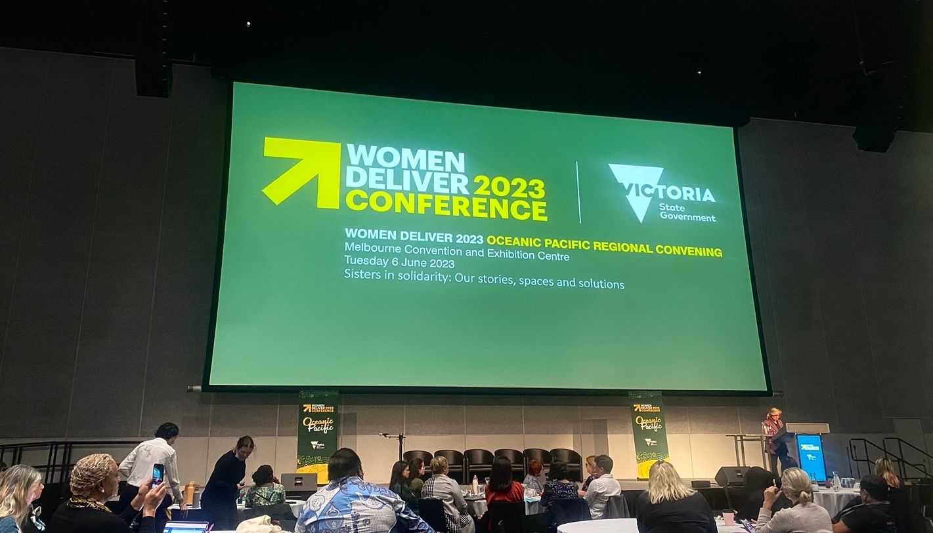

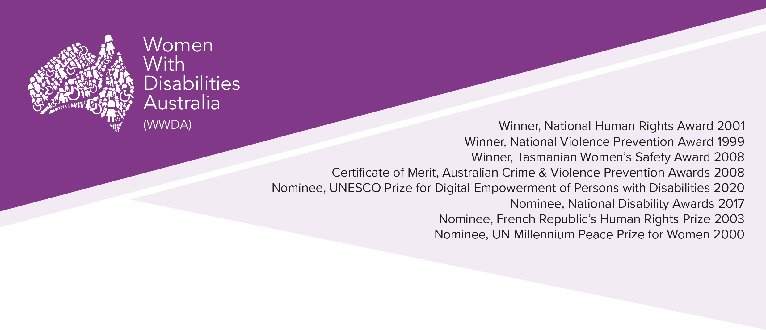
Publishing Information
Women With Disabilities Australia (WWDA) (2023). Report from the Women Deliver 2023 Oceanic Pacific Regional Convening. June 2023. WWDA: Hobart, Tasmania.

Acknowledgments
WWDA acknowledges the traditional owners of the land on which this publication was produced. We acknowledge Aboriginal and Torres Strait Islander people’s deep spiritual connection to this land. We extend our respects to community members and Elders past, present and emerging. This document was written by Sophie Cusworth for and on behalf of Women With Disabilities Australia (WWDA). Women with Disabilities Australia (WWDA) receives part of its funding from the Australian Government, Department of Social Services (DSS). WWDA acknowledges and thanks DSS and the OFW for its support.

Contact
Women with Disabilities Australia (WWDA)
Contact: Carolyn Frohmader, Executive Director
PO Box 407, Lenah Valley, 7008 Tasmania, Australia
Phone: +61 438 535 123
Email: officeadmin@wwda.org.au
Web: www.wwda.org.au
Facebook: www.facebook.com/WWDA.Australia
Twitter: www.twitter.com/WWDA_AU

Disclaimer
The views and opinions expressed in this publication are those of Women with Disabilities Australia (WWDA) and not necessarily those of our funding bodies. All possible care has been taken in the preparation of the information contained in this document. WWDA disclaims any liability for the accuracy and sufficiency of the information and under no circumstances shall be liable in negligence or otherwise in or arising out of the preparation or supply of any of the information aforesaid.

This work is copyright. Apart from any use as permitted under the Copyright Act 1968, no part may be reproduced without written permission from Women With Disabilities Australia (WWDA).

© 2023 Women With Disabilities Australia (WWDA).
ABN: 23 627 650 121

About Women With Disabilties Australia (WWDA)

Women With Disabilities Australia (WWDA) is the national Organisation of Persons with Disabilities (OPD) for women, girls, feminine identifying and non-binary people with disability in Australia. As an OPD, WWDA is run by and for women, girls, feminine identifying and non-binary people with disability.

WWDA uses the term ‘women and girls with disability’, on the understanding that this term is inclusive and supportive of, women and girls with disability along with feminine identifying and non-binary people with disability in Australia.

WWDA represents more than 2 million women and girls with disability in Australia, has affiliate organisations and networks of women with disability in most States and Territories, and is recognised nationally and internationally for our leadership in advancing the rights and freedoms of all women and girls with disability. Our organisation operates as a transnational human rights organisation - meaning that our work, and the impact of our work, extends much further than Australia. WWDA’s work is grounded in a human-rights based framework which links gender and disability issues to a full range of civil, political, economic, social and cultural rights.

Organisations of Persons with Disabilities (OPDs) are recognised around the world, and in international human rights law, as self-determining organisations led by, controlled by, and constituted of, people with disability. OPD’s are organisations of people with disability, as opposed to organisations which may represent people with disability. The United Nations Committee on the Rights of Persons with Disabilities has clarified that States should give priority to the views of OPDs when addressing issues related to people with disability. The Committee has further clarified that States should prioritise resources to organisations of people with disability that focus primarily on advocacy for disability rights and, adopt an enabling policy framework favourable to their establishment and sustained operation.

WWDA Representation Report

On June 6, Women With Disabilities Australia (WWDA) staff member Sophie Cusworth attended the Women Deliver 2023 Oceanic Pacific Regional Convening. The event was part of the Global Dialogue in the lead up to the one of the largest gender equality conferences in the world, Women Deliver 2023. The theme of Women Deliver 2023 is “Spaces, Solidarity, and Solutions”: the event aims to foster inclusive and co-created spaces that promote solidarity and discussion of sustainable solutions on issues of gender equality. WWDA staff member Margherita Dall’Occo-Vaccaro will attend the global conference in Kilgali, Rwanda in July.

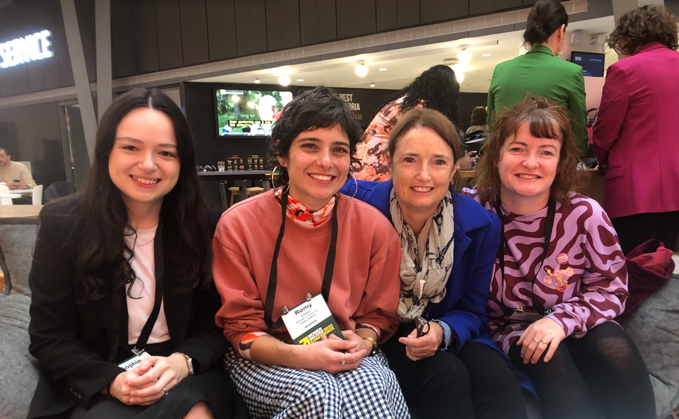

The Women Deliver 2023 Global Dialogue is an opportunity for gender equality advocates from around the world to hold and participate in workshops and discussions on key issues facing women, girls and gender diverse people in their communities, prior to the global conference. The purpose of the Regional Convening was to bring together leaders to discuss and develop key priorities for gender equality in the Oceanic Pacific region, which will be shared with advocates and decision-makers across the world at the global conference. The Regional Convening brought together around 400 attendees, including advocates, women’s rights organisations, and sector partners. It had a strong focus on intersectionality and representation of Indigenous communities across the region, including First Nations Australians.

The President and Chief Executive Officer of Women Deliver 2023, Dr. Maliha Khan, called for an approach that was diverse, safe, accessible, inclusive, outspoken, and brave. This means that delegates were asked to speak honestly and openly, and ensure that all voices could be heard.

The event took place in Melbourne and involved a series of workshops to provide space for discussion on the key issues facing women, girls and gender diverse people across the Oceanic Pacific region. As WWDA’s delegate, Sophie attended sessions on disability, economic empowerment and the care economy, creating feminist policy, and women’s leadership and representation. It was inspiring to hear and learn from leaders and advocates from across the region. As one speaker noted, transformative and innovative solutions require collaboration, and the event provided for unique and rewarding collaborative opportunities.

Some key messages of the Regional Convening included:
- Spaces and strategies must be co-created with people with lived experience of the topics discussed, because “to co-create is to place care at the centre of our actions”.
- People with disability need to be seen and present at events, and to be seen in numbers. Governments and organisations should be prepared to invest more funds to ensure that events are genuinely accessible.
- We must create space and opportunities for young people’s voices to be heard.
- Gender equality policy and strategy must always be tied back to a human rights approach.
- Data collection on human rights violations is crucial, and must be gender specific.
- We cannot achieve gender equality without bodily autonomy and agency. This is particularly important for women and girls with disability who are so often denied their right to bodily autonomy.
- A feminist approach means making all women visible, and taking into account their interests, concerns and opportunities.
- A feminist approach must also be a decolonial approach. We cannot achieve gender equality without dismantling other power structures and the harm that they cause.
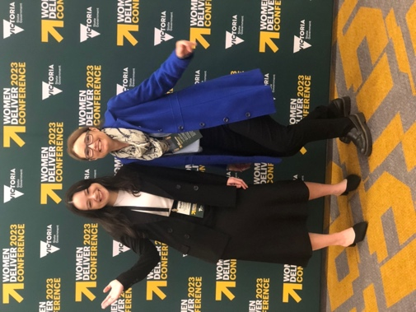
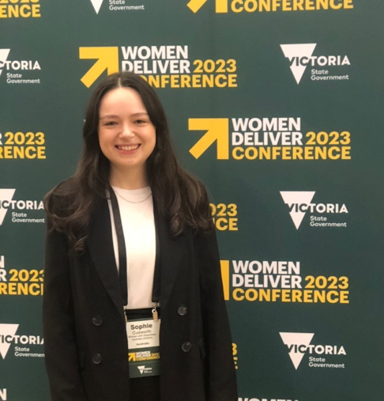
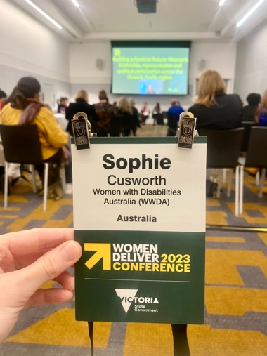

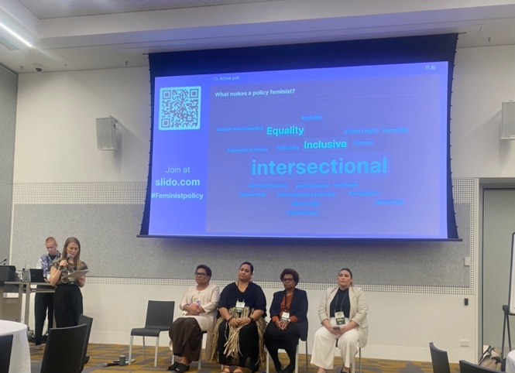
Although it was a valuable day of collaboration and rich discussion, there was concern among delegates with disability about barriers to participation. For example, the meeting room for the session on disability was not set up to be accessible, and accessibility measures that were in place (for example, a designated quiet room) were misused. WWDA also heard that a number of people with disability who were invited to the event were unable to attend due to the inaccessibility of the venue. As a result, the session on disability was attended by a small number of people who were unable to develop recommendations for the Women Deliver 2023 global conference due to limited representation. The group agreed to meet online in June to facilitate greater attendance and to prepare a series of recommendations together. WWDA looks forward to contributing to that discussion, and calls for women with disability to be better supported to attend in-person events and contribute in a meaningful way in future.
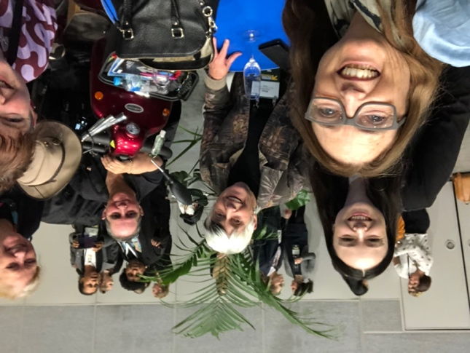

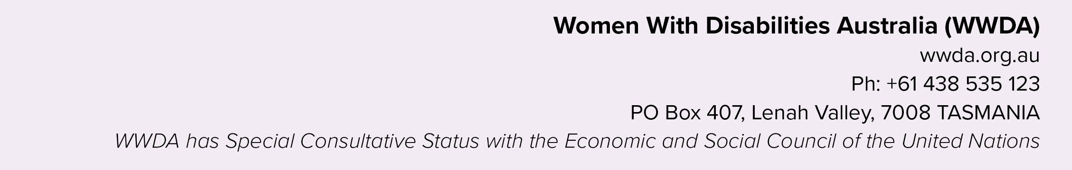
END NOTES

Committee on the Rights of Persons with Disabilities (2018) General comment No. 7, UN Doc No. CRPD/C/GC/7.

