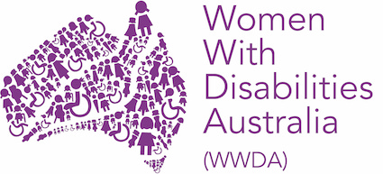
Women With Disabilities Australia (WWDA)
Annual General Meeting (AGM)
3:00pm – 5:00pm AEDT, Friday 15 December 2023
Captions and Auslan provided

AGENDA

Item | Description | Responsible
 | Welcome and introductions  *Note will record the session, seek consent | President
 | Welcome to Country video | President
 | Apologies | President
 | Keynote speaker: Disability Royal Commission | Rhonda Galbally AC
 | Acceptance of minutes of previous annual general meeting  *Motion to be moved and seconded | President
 | President’s report and acceptance of Annual Report  *Motion to be moved and seconded | President
 | Treasurer’s report and approval of Financial Statements  *Motion to be moved and seconded, and vote taken | Treasurer
 | CEO’s report | CEO/staff on behalf of CEO
 | Staff reports | Senior staff
 | Questions to Committee Members  *Questions provided in advance by email where possible | President
 | Appointment of auditor  *Motion to be moved and seconded | Treasurer
 | Membership of Committee of Management for 2023-2024 | Treasurer
 | Meeting close | President

