A Joint Project between:
Accessing Formal Supports in Australia:
The Experiences of Culturally and Linguistically Diverse (CaLD) Women with Disabilities

Aim

The study aimed to address a critical gap in research on the experiences of CaLD women and girls with disabilities (CaLD WGwD) within Australia. It explored how CaLD WGwD experience access to support services in the health and disability sectors, and barriers they face.

Methodology

The study was conducted in 2022 and consisted of three components;
a literature review, an online national multilingual survey, and a set of online focus group interviews.

The literature review highlighted gaps in the existing literature and provided a broad overview of past key issues and experiences faced by CaLD people with disabilities in Australia that informed the online focus groups and the national online survey design.

Key findings

The study gives voice to over 70 CaLD WGwD and offers a meaningful picture of their experiences with support services in Australia, identified access barriers and lived experiences.
- Survey respondents perceived the reasons for discrimination intersect with their disability, gender and the language they speak.
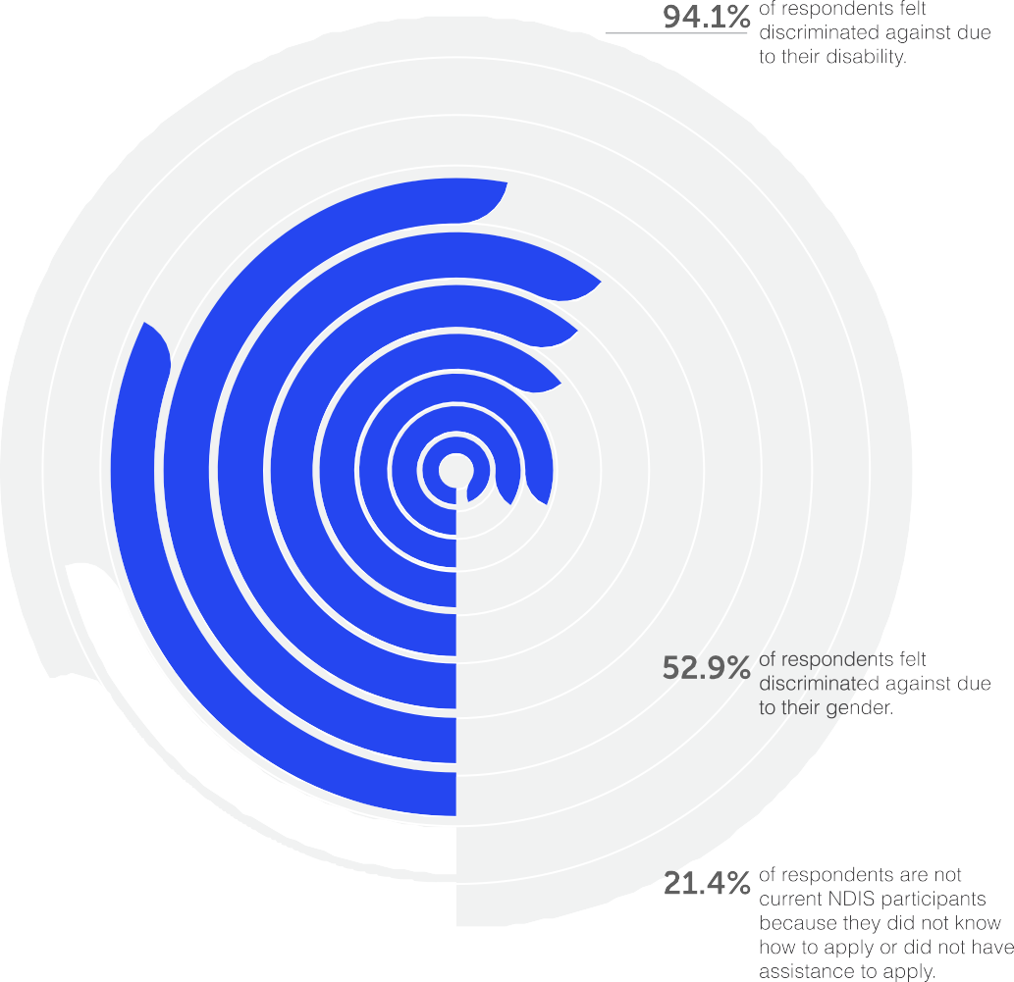
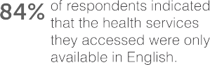
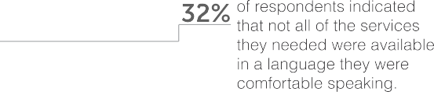
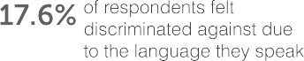
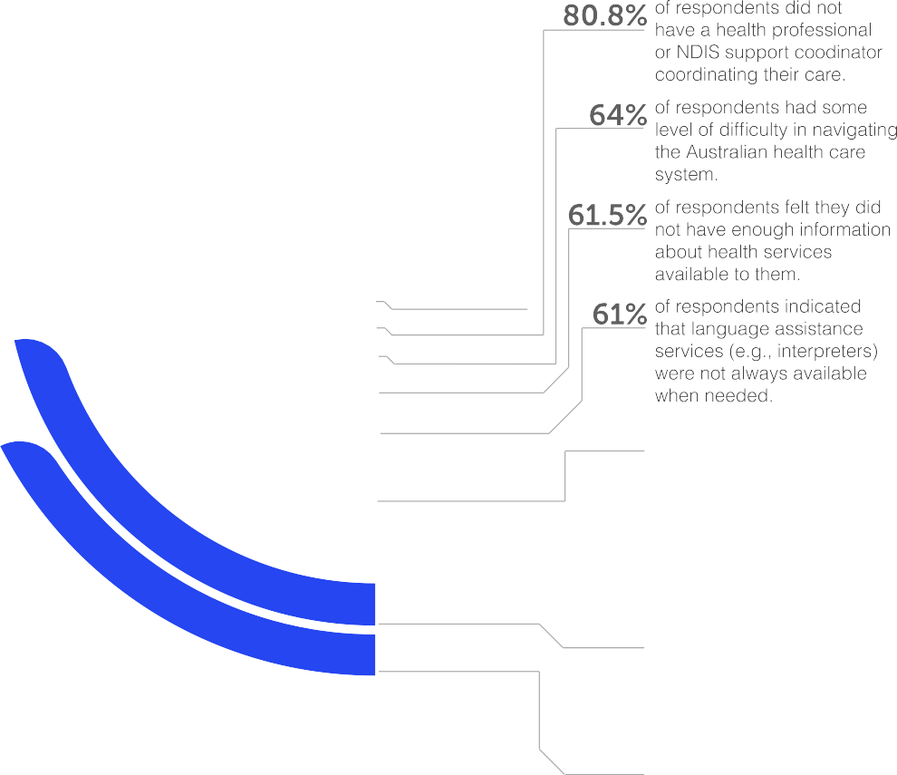
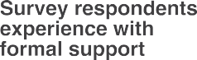
- For those who could access language assistance, they were assigned interpreters who did not speak the relevant language or dialect. Frequently, assumptions were made about the participants’ capabilities according to visible disabilities or linguistic differences. These assumptions often stood in lieu of personal consultation.
- The focus groups also highlighted the inconsistency of outcomes within services, such as the NDIS contributes to confusion, extended periods of inadequate support and overall burnout.
Accessing Formal Supports in Australia:The Experiences of (CALD) Women with Disabilities: Summary
- CaLD women with disabilities experience compounded stigma due to their gender, race, migration status, disability status and cultural and linguistic backgrounds. Many reflected feeling that they were too ‘complex’ to have their needs adequately met by service providers.
- CaLD women with disabilities found that the intersecting stigmas and pressures of being feminine-identifying, CaLD, and disabled have direct impacts on self- esteem, repressing their self-advocacy.

National online survey:

The survey was co-designed with bi- and multilingual experts and used an intersectional feminist approach. It was available in Arabic, English, Mandarin, Nepali, Spanish and Swahili and consisted of 35 multiple-choice questions.

59
CaLD WGwD
completed the survey.

90.5%

The focus group interviews were semi-structured in format and ran for two hours each, with participants prompted on the following topics: inclusion and equality, access to formal supports and services, COVID-19 impacts, access to information, stigma, and access barriers.
of respondents identified as women

2.4%
of respondents identified as non-binary

4.8%
preferred to use another term

69.3%
of respondents were born overseas

31.2%
preferred to use a language other than
English at home

Women with Disabilities Australia (WWDA), Harmony Alliance, and the National Ethnic Disability Alliance (NEDA) have provided 15 recommendations to the Australian Government at the conclusion of the report.
Focus group interviews: A total of 15 CaLD people, predominantly identifying as women and some as non-binary, took part in the focus groups. Participants identified their cultural heritage from a wide variety of countries, and there was a wide variety of lived experiences of migration and disability.

