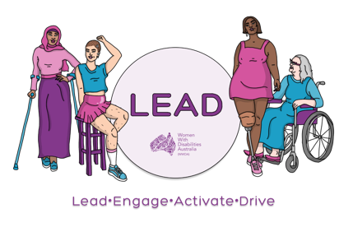

Influence in Decision-Making as a Citizen
Workshop Two (2)

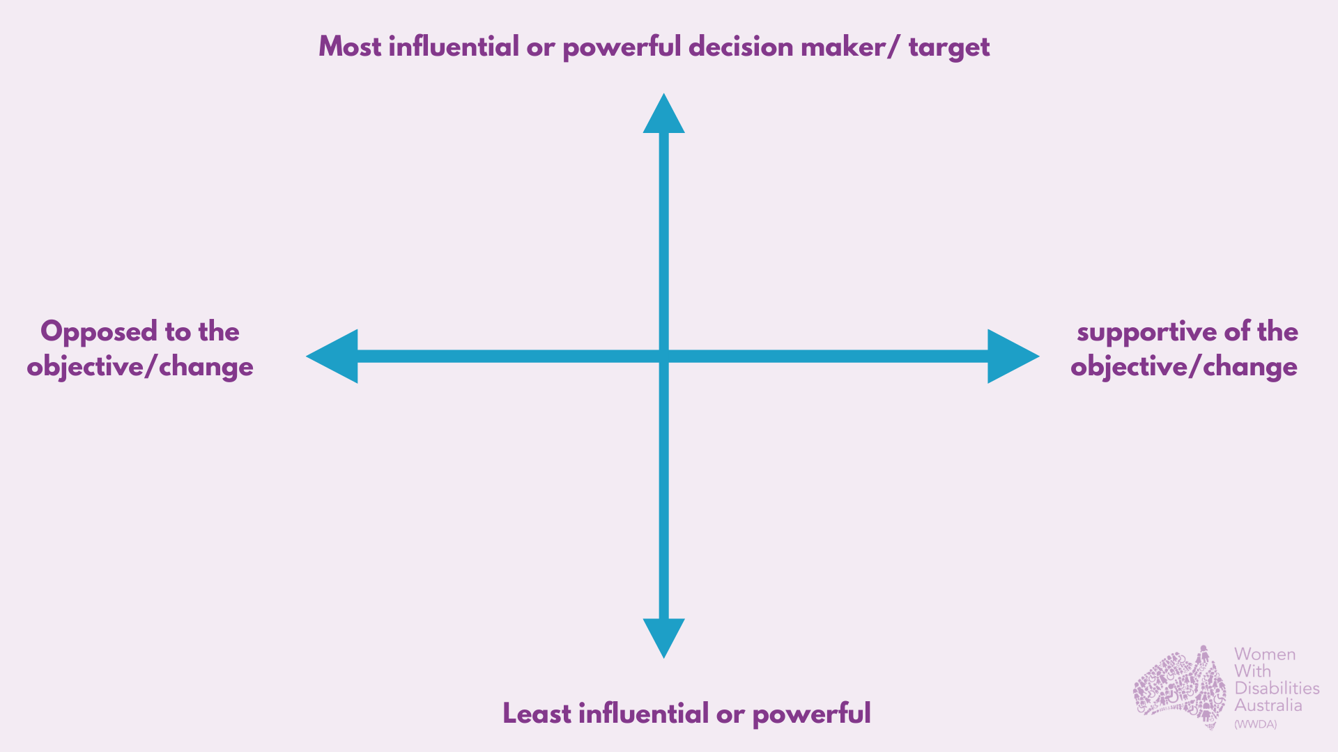
Image: Power Mapping Tool

Power Mapping Tool
It is hard to pinpoint the exact origins of power mapping, but the tool has been used widely in advocacy and campaigning since the 1980s varying in words but used for the same purpose; mapping out stakeholders and where they are positioned on the issue currently. When making public decisions or launching a campaign about a new decision that has been made, you need to correctly identify who has the power to fix the problem you want fixed. Then you need to pressure them to make the right decision.

Power mapping is a tool to not only identify who holds that power, but, crucially, who holds influence over that person, and, therefore, who to target with your direct actions and campaign activities.

A power map, properly done, can reveal these relationships and power dynamics and help you design a winning strategy for your campaign. By placing your stakeholder in this quadrant spectrum, you are placing them in their current position towards the issue, or past positions on similar issues. The top reads “most influential or powerful decision-maker/target” and the bottom is the “least influential or powerful”. If a stakeholder has lots of influence, we would place them in the top half of the map, as this is where they fall on that scale of measurement. The lower someone is on the map, the less power they hold. The left is “opposed to the objective/change” and the right is “supportive of the objective/change”. Where they are in reference to the right or left determines where they stand on the issue. If someone is in the bottom left, they have resistance to the issue and little influence; if they were in the top right, they have lots of influence and are in favour of the change.

This will allow you to have a tangible map of where stakeholders stand in order to help you prioritise who to reach out to whether it be for support of the idea or to persuade someone who is resistant. Let’s use the example from the last workshop to map out the stakeholders.
- Example: We are trying to make public spaces such as parks and streets, more accessible and inclusive. Where would we be placed on the map?

Stakeholder importance
Stakeholders play a vital role in the decision-making process. They include anyone who is impacted by the decision, those who have vested interest, and those who may be opposed. If a decision is being considered, it is important to know who will support your decision and who will be opposed, as this will directly affect the outcome and decision made. By using tools, such as the power mapping tool above and the matrix table below, we can focus on who to target and persuade them to support the decision or know who is already on board and can help us to promote and endorse the decision.

Good policy decisions require rigorous consultation and engagement with stakeholders, including those who are experts in relevant fields. Experts include academics and professionals who can supply knowledge and advice on certain issues and topics, which helps to create effective law and policy. So, who are our stakeholders and where can we place them in the power map tool?

Open Google Jamboard Here

Influence and Impact Matrix

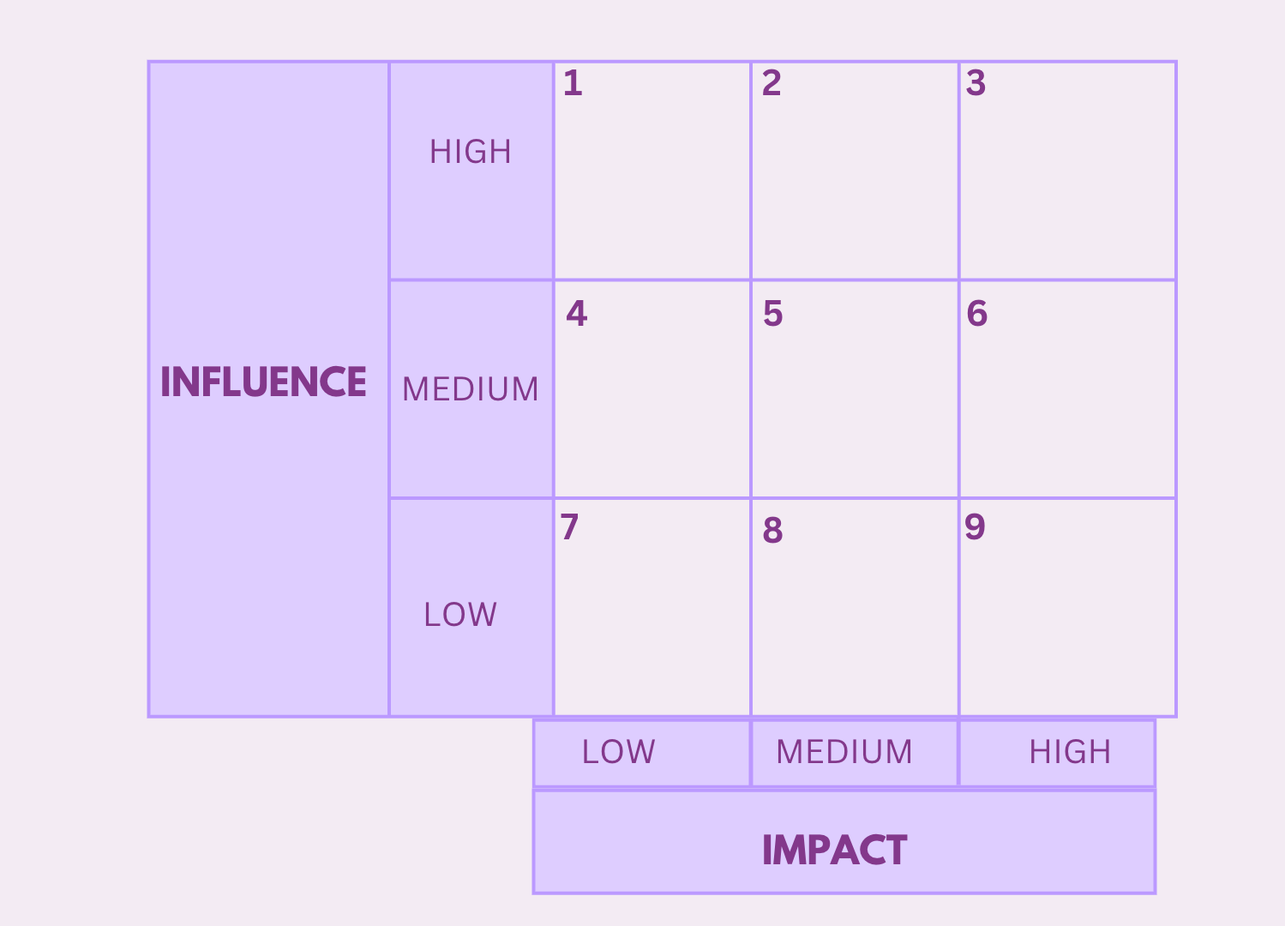
Image: Influence and Impact Matrix

How to use the matrix
Influence is the level of involvement the person has in decision-making. Impact is the ability of the stakeholder to bring out a desired change. For example, your Minister or Secretary would be in quadrant 3, as they have both high influence and a high capacity to have a significant impact on a project’s outcome – including cancelling funding, shifting a project’s focus, replacing the working team, or even cancelling the project itself.

To help you determine the level of influence and impact your various stakeholders have on your project outcomes, you can ask yourself these following questions:
- What responsibilities does this stakeholder have?
- What does this stakeholder expect from this project?
- How will this stakeholder benefit from the project?
- Does this stakeholder have any conflicts of interests regarding this project?
- How committed is this stakeholder to the project?
- Can/will the stakeholder commit tangible resources to this project?
- What will be the consequences if I don’t manage this stakeholder well?
- How much influence does this stakeholder have with other stakeholders?
- Does this stakeholder pose any threats?
Now, using these questions and the background you have on the stakeholders, try to organise them numerically by the way they were set out on the power mapping tool. You can use either tool alone or both in conjunction with another.

How can we be active citizens?

There are many ways we can be active citizens in our community and country. You can:

Write to or email members of parliament,

Sign a petition,

Attend rallies and meetings,

Use your personal and professional relationships to raise awareness, and

Ask others to spread the message.

The internet can be an important tool towards becoming an active citizen, as it serves a great purpose for research and connecting like-minded individuals. This can be through social media, online groups, forums, and meetings.

Writing to your local MP (federal or state level representative) can be extremely influential to public decision-making. You can organise a meeting with them to let them know what you care about, and they can also refer you to groups within the area. To organise a meeting with your representative or Senator, see the government’s official guidelines here: https://www.aph.gov.au/senators_and_members/guidelines_for_contacting_senators_and_members

Parliamentary committees encourage people to give their opinion on bills, proposed laws, and issues of importance. You can also attend a meeting or protest to let government representatives know that you are concerned about an issue. There are useful links to contact representatives, such as write a letter to the Prime Minister: https://www.pm.gov.au/contact-your-pm

Another way to get involved and use your voice is by joining a community group that is focused on issue/s you are passionate about. This can include joining an advisory group, lobbying group or online forum, or becoming a member of certain organisations. Always keep an eye out for event and meetings hosted by your preferred political party.

Advisory Group Examples
Advisory committees are a structured way for individual citizens to share their opinions and perspectives, study issues, and develop recommendations in a focused, small group structure. Working collaboratively together to create outputs and outcomes with advice and insight offered from each advisory member. Advisory groups vary on their work depending on the committee’s purpose, industry, and role description. Advisory member positions can be volunteer or paid depending on the group. These groups are a direct action to help provide advice and consultation on a certain change, new policy, or events.

Many local councils have their own disability advisory group. Reaching out to your local council, library, member, or similar entities may be helpful to begin searching for groups and organisations in your area. There are also Civil Society Organisations (CSOs) in many communities for surrounding issues - the internet is a great tool for finding those in your local area.

Here are some examples which are also shown in the image handout.
- https://wisdm.org/
- https://quizlet.com/303272190/public-admin-quiz-2-public-decision-making-flash-cards/
- https://www.dss.gov.au/groups-councils-and-committees
- https://strongercivilsociety.org/get-involved/

