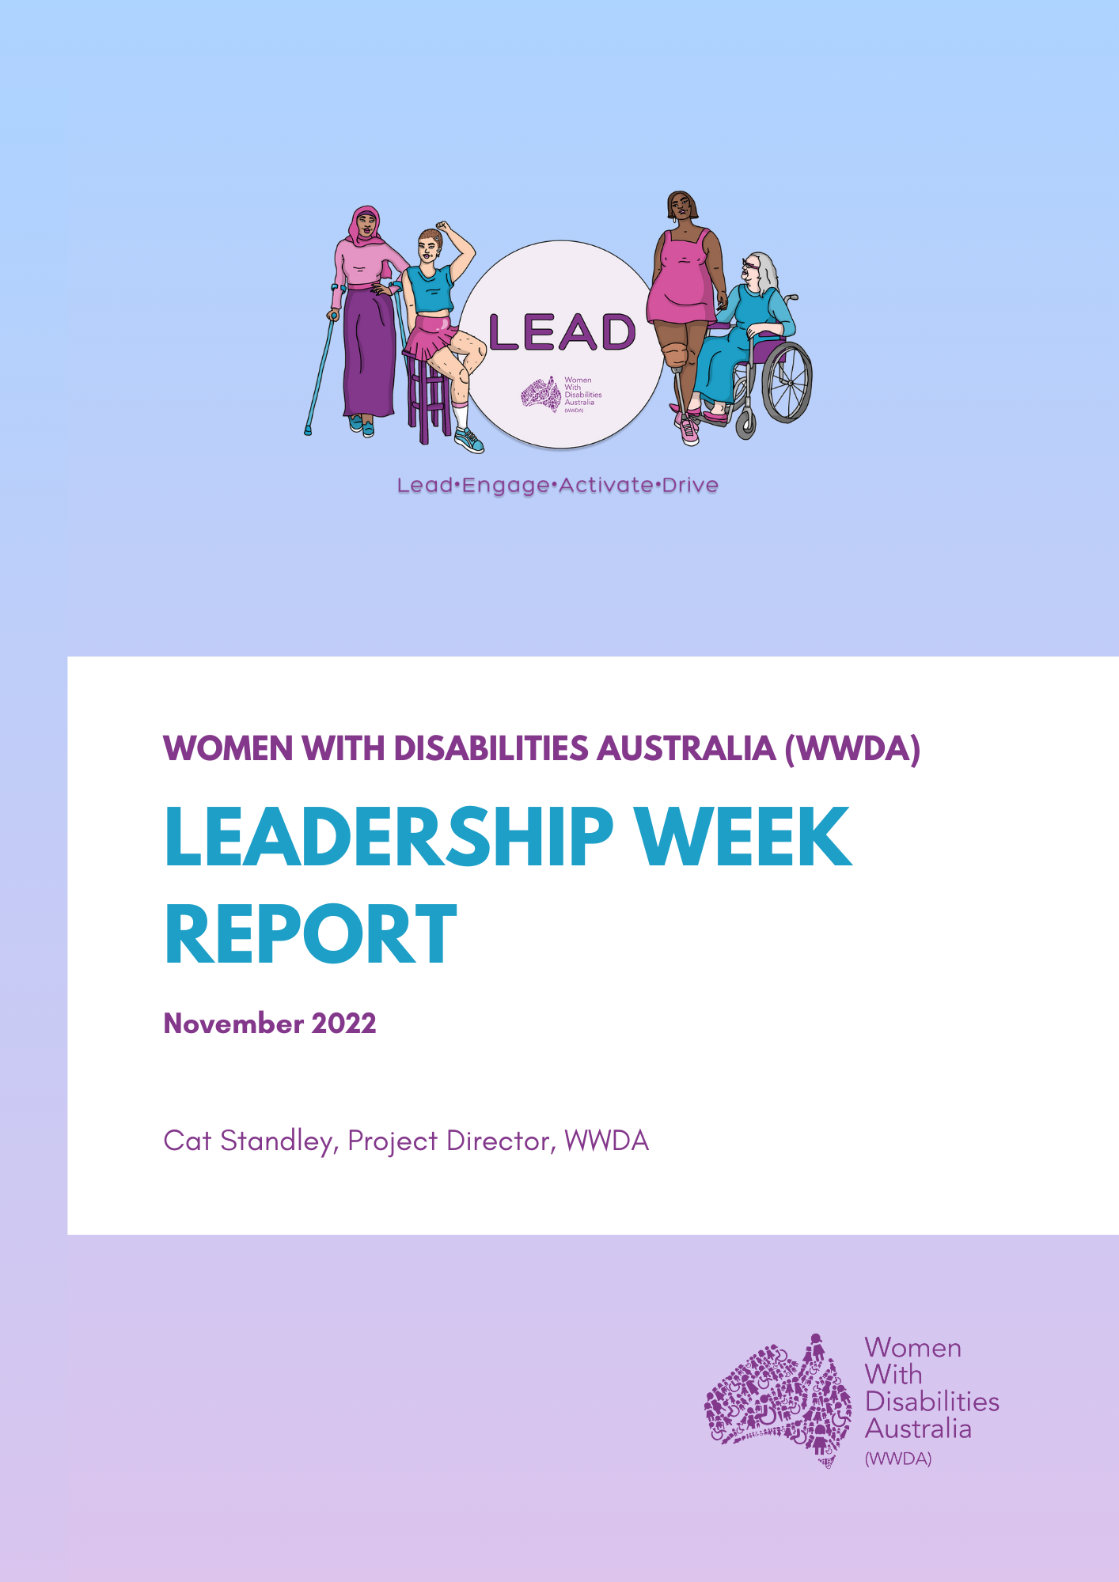

About Women With Disabilities Australia (WWDA)

Women With Disabilities Australia (WWDA) Inc is the national Disabled People’s Organisation (DPO) and National Women’s Alliance (NWA) for women, girls, feminine identifying and non-binary people with disability in Australia. As a DPO and a NWA, WWDA is governed, run, and staffed by and for women, girls, feminine identifying and non-binary people with disability.

WWDA uses the term ‘women and girls with disability’, on the understanding that this term is inclusive and supportive of, women and girls with disability along with feminine identifying and non-binary people with disability in Australia.

WWDA represents more than 2 million women and girls with disability in Australia, has affiliate organisations and networks of women with disability in most States and Territories, and is recognised nationally and internationally for our leadership in advancing the rights and freedoms of all women and girls with disability. Our organisation operates as a transnational human rights organisation - meaning that our work, and the impact of our work, extends much further than Australia. WWDA’s work is grounded in a human-rights based framework which links gender and disability issues to a full range of civil, political, economic, social and cultural rights. All WWDA’s work is based on co-design with and participation of our members. WWDA projects are all designed, governed, and implemented by women and girls with disability.

Table of Contents
Executive Summary 3
Summary of key learnings from Leadership Week 5
Part 1: Context 7
1.1 Background 7
1.2 Event Logistics 8
1.3 Empowering Leadership 8
Part 2: Reflections and Outcomes 14
Conclusion 15
Acknowledgement and thank you 16
Appendix 1: Welcome to Hobart Guide 18
Appendix 2: Illustrations from one of the WWDA Committee Members, Kay Barnard. 33
Appendix 3: Leadership Week Program 34
Appendix 4: Photo and Media Consent forms 36
Appendix 5: Infographic of survey results 38
Appendix 6: Biography Recipe 39

Executive Summary

In November 2022, the WWDA LEAD team hosted a four-day workshop for the LEAD Project, called Leadership Week, for diverse women with disability (WWD), to help build the confidence, skills, and individual leadership capacity of key members of WWDA. WWDA invited the LEAD Project Steering Committee, Co-design Committees, and the WWDA Youth Advisory Group to participate at various activities and events during Leadership Week.

The workshops were facilitated by various WWDA staff with a combination of online and in-person activities. Since the event was a hybrid of online and in-person interaction, the activities were tailored according to the specific audiences, except when both the in-person workshop and online attendees could be part of the same activity.

Some of the activities included getting professional headshots, learning to write a professional bio, meeting the Anti-discrimination Commissioner for Tasmania, and learning about online safety as a diverse disabled woman and leader in their communities and/or workplaces.

Leadership Week was held at the RACV in Hobart over three days of interactive events, plus an additional day of reflections.
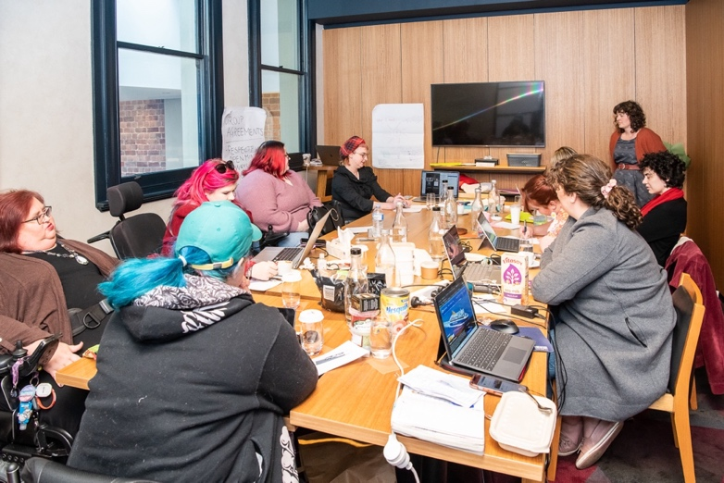
[Image: picture above features participants and staff engaging in reflections.]

Summary of key learnings from Leadership Week

In November 2022, Leadership Week organised by Women With Disabilities Australia proved to be a progressive event that allowed for the growth, empowerment and development of diverse women with disabilities. Key learnings from this event include:

Skill building: Participants had the opportunity to build upon existing skills or learn new skills that enhance their leadership capacity. This included the development of practical skills and knowledge that can be applied to leadership roles in our community and workplaces.

Networking: Leadership Week allowed participants to network with one another and other’s’ own professional and personal networks. Building a strong network can be valuable for personal and professional growth.

Knowledge sharing/Capacity exchange: Capacity exchange was a key component of Leadership Week. Participants learned from each other but had the opportunity to share their own skills and knowledge with the group.

Professional development: Activities such as professional bio writing, headshots, and capturing participants’ lived experiences and expertise through video footage shows that the WWDA LEAD team emphasised personal and professional development.

Social media and online safety: Participants engaged in a facilitated discussion with the WWDA Director of Media and Communications on how to use social media for advocacy and activism effectively, whilst ensuring personal safety.

Leadership skills building and empowerment: Events such as Leadership Week demonstrate that WWDA is committed to building leadership skills in diverse women with disabilities. This event and other events like it, suggest that leadership skills building is part of an ongoing strategy at WWDA to support and empower diverse women with disabilities.

Impact on committee members: The ongoing impacts felt by the committee members from Leadership Week show that WWDA is dedicated to the continued growth and success of all diverse women with disability.

Part 1: Context

1.1 Background

In November 2022, Women With Disabilities Australia (WWDA) organised an event for its committee members called Leadership Week. The event took place in Hobart and aimed to enhance the leadership skills and confidence of women, non-binary and feminine-identifying people with disabilities. WWDA facilitated various activities and engaged participants in discussions related to advocacy, professional development, and online safety. This report provides an overview of the Leadership Week and highlights the key events and outcomes.

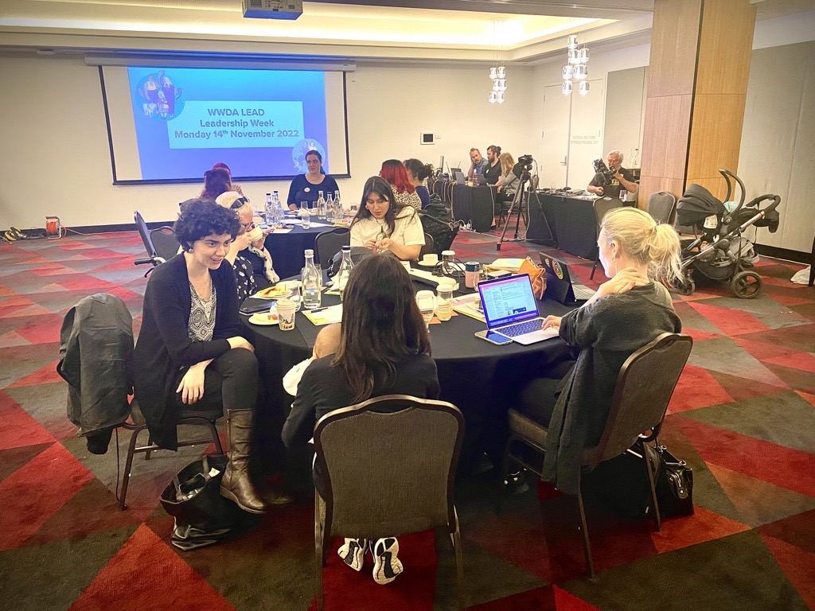
[Image: Picture above is a photo of WWDA committee members and WWDA staff on the first day of Leadership Week.]

1.2 Event Logistics

WWDA ensured the participation of committee members from all over Australia by arranging flights to Hobart and covering the costs of accommodation and catering. This inclusive approach allowed individuals with disabilities to attend the event without financial barriers. The four-day program provided ample time for networking, learning, skill-building activities, as well as participant reflections.

1.3 Empowering Leadership

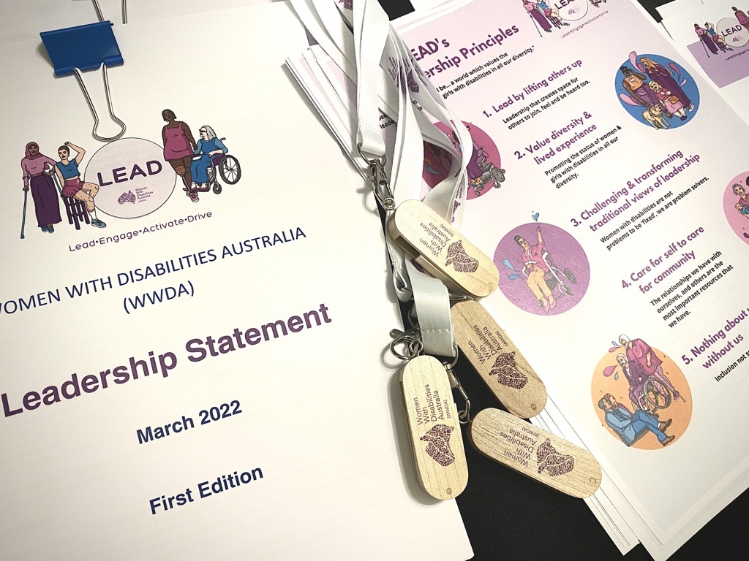
[Image: Picture above shows printed versions of the WWDA LEAD Leadership Statement and WWDA LEAD’s five Leadership Principles. There are also WWDA branded lanyards and USBs in the picture.]

One of the primary objectives of the Leadership Week was to empower women and gender diverse individuals with disabilities to strengthen their leadership capabilities. The WWDA LEAD team conducted sessions on various topics to achieve this goal. These included:
Professional Bio Writing: Participants were taught how to create effective professional biographies that showcase their skills, achievements, and experiences. This skill is valuable for establishing credibility and professional networking.

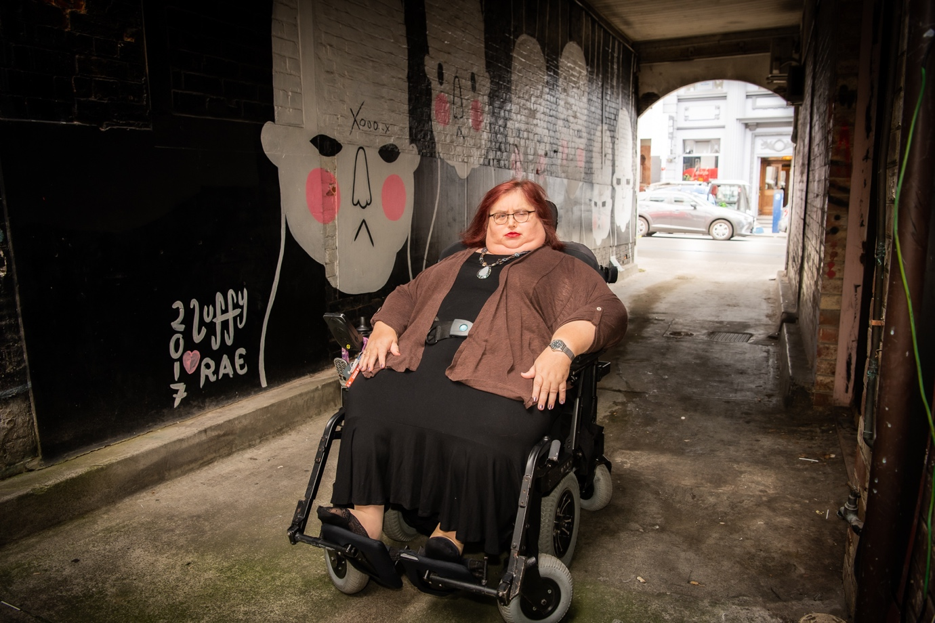
[Image: Picture above shows WWDA Board President and Committee member, Karin Swift. Photo by Amy Brown.]

Head Shots and Footage: To enhance their online presence, committee members had the opportunity to have professional headshots taken by Amy Brown, who is a professional photographer based locally in Hobart. Additionally, Amy Brown and her colleague Mike Gissing (AV technician) captured footage of women with disabilities speaking about the WWDA LEAD Mentoring Program and their personal experiences of leadership.

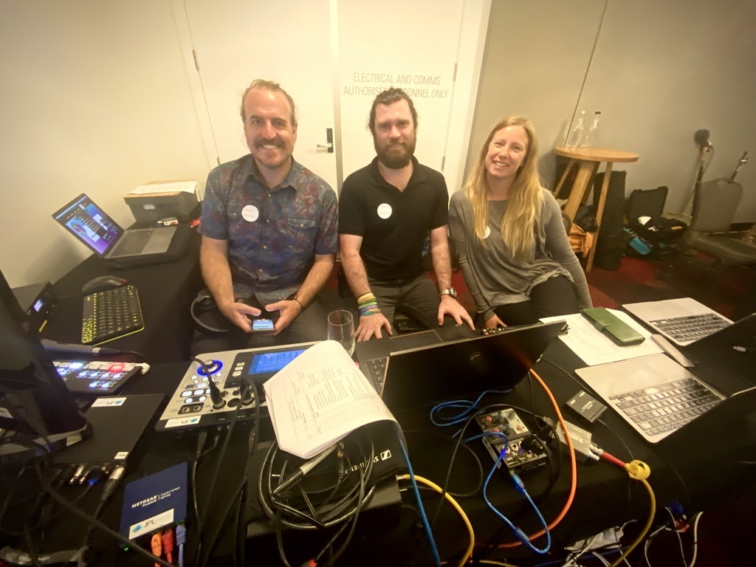
[Image: Picture above shows the team from the audio-visual external providers that were contracted to capture the footage of Leadership Week, November 2022. From left to right: Jamie Meakin, Pete Alexander, and Gabriella Fry.]

JPL Media (AV team) – Zoom presenter training: JPL Media was contracted for the audio-visual needs of Leadership Week. Their team was flown to Hobart to assist the in-person event attendees in connecting with the online participants of the event. The JPL Media team also put together a session for all attendees to show them best practices when delivering content online such as framing of themselves in a webcam, lighting, sound, tech checks, and more.

Guest Speaker: Sarah Bolt, the Anti-Discrimination Commissioner based in Tasmania, delivered a thought-provoking speech on the topic of discrimination against women with disabilities in the workplace. Her insights and expertise provided valuable perspective to the participants. Sarah also facilitated a follow-up Q&A session with the participant group to allow further discussion of the rights of women with disabilities.

Youth Leadership discussion: Margherita Dall’Occo Vaccaro (WWDA Youth Development Officer) facilitated the discussion of youth involvement in disability leadership for girls, young women and non-binary people with disability.

Co-design presentation: Libbi Cunnington (WWDA Project Director) gave a presentation on co-design in all project materials for diverse women with disabilities and its importance in ensuring that women with disabilities are consulted on and encouraged to be part of the creation of resources for women with disabilities.

Social media and online safety: WWDA staff played a crucial role in guiding committee members on the appropriate use of social media for advocacy and activism. In collaboration with event participants, Jacinta Carlton (WWDA Director of Media and Communications) facilitated an engaging session on how to use social media safely and effectively. Recognising the power of online platforms, participants learned strategies to leverage social media effectively while maintaining personal safety. Key lessons included:

- Strategic Posting: Participants were encouraged to be thoughtful about the timing and content of their social media posts. By not posting in real time, individuals have the opportunity to review and refine their messages, ensuring they align with their goals and values.
- Selective Commenting: Responding to comments on social media platforms can be overwhelming. WWDA staff emphasised the importance of selectively engaging with comments, encouraging committee members to focus on the discussions they deemed most relevant and impactful.

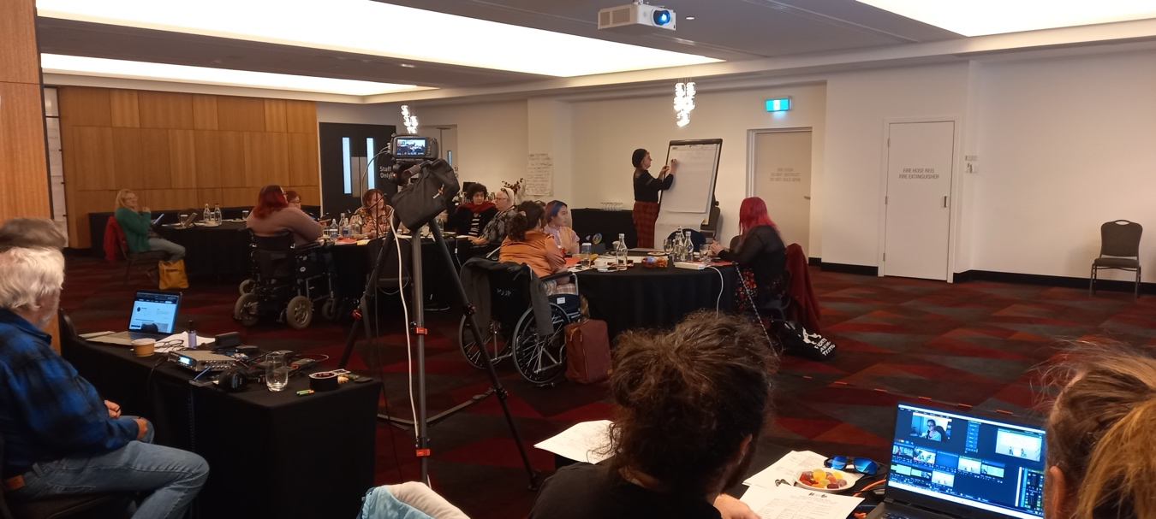
[Image: Picture above features the participants, staff, and AV teams in the conference space.]

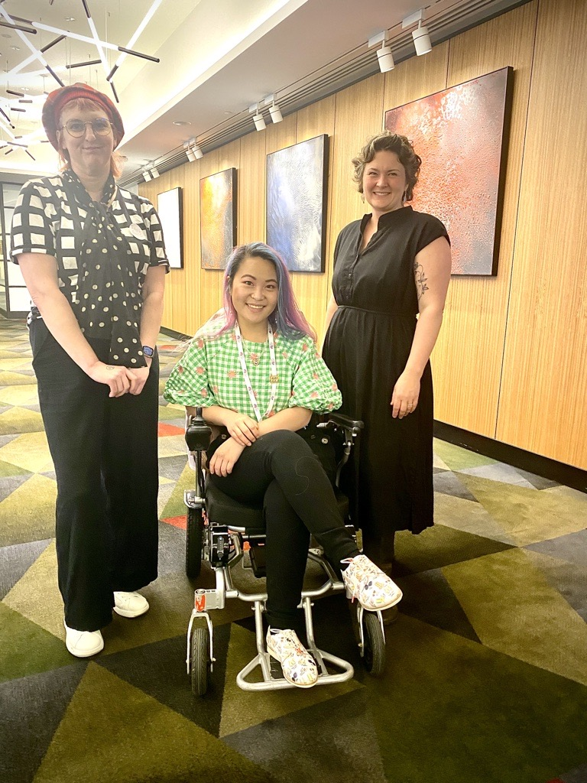
[Image: Picture above shows WWDA staff members with WWDA committee member. From left to right: Saphia Grant (WWDA staff member), Akii Ngo (WWDA committee member), and Zoe Houstein (WWDA staff member).]

Part 2: Reflections and Outcomes

Leadership Week in November 2022 served as a pivotal event that brought together women, non-binary and feminine identifying individuals with disability to explore their leadership potential, build upon existing and new leadership qualities, and advocate for change. This event left a deep-seated and long-lasting impression on its participants and WWDA staff alike, yielding impactful outcomes for the LEAD Project through profound capacity exchange and reflections. Insights and lessons learned from the event participants are demonstrated below:

“The WWDA LEAD Leadership Week enabled me to learn new things, network with like-minded women with disability and energise and enjoy some time away. As a long-term member of WWDA, it also filled me with hope that there were many younger women ready and able to take up the fight. On another note, we all had the opportunity to have professional photos taken of ourselves. I feel proud to have nice photos of myself that I can use on social media and help build my professional identity.”
- Karin Swift, WWDA member and Board President.

“WWDA was the catalyst for me to see myself as a leader. I didn’t see myself as a woman with disability. Everyone here is a role model to everyone around them.”

- Stevie Russell-Farnham, WWDA Member and WWDA LEAD Co-design Committee Member

The empowerment, skill development and sense of community fostered amongst the diverse women with disabilities and project staff can be quantifiably traced back to the events and activities held throughout Leadership Week. Through these reflections WWDA has learned that Leadership Week and the LEAD Project has inspired personal, professional and collective growth in leadership development amongst a number of influential women with disability in our community.

Conclusion

The Leadership Week organised by Women With Disabilities Australia (WWDA) in November 2022 proved to be a life-changing experience for committee members and project staff alike. WWDA provided a platform for skill-building, networking, and knowledge-sharing. WWDA LEAD Project staff successfully empowered women, girls, non-binary and feminine-identifying individuals with disabilities to enhance their leadership capacity. The event's emphasis on professional bio writing, headshots, and capturing personal experiences through video footage allowed participants to strengthen their professional and personal profiles. Additionally, the guidance on social media usage and online safety ensured that committee members could effectively engage in advocacy and activism while maintaining personal security. WWDA maintains commitment to fostering leadership skills among women and gender diverse people with disabilities, and the impact of this Leadership Week will undoubtedly be felt in the continued growth and success of its committee members.

Acknowledgement and thank you

Women With Disabilities Australia (WWDA) acknowledges the traditional owners of the land on which participants and Project staff resided throughout this event. We acknowledge First Nations people’s deep spiritual connection to this land. We extend our respects to community members and Elders past, present and emerging.

This document was written by Cat Standley (WWDA Project Director), for and on behalf of Women With Disabilities Australia (WWDA), with support from Zoe Houstein (WWDA Project Director).

Funding acknowledgement
Women With Disabilities Australia receives part of its funding from the Australian Government, Department of Social Services (DSS). WWDA acknowledges with thanks, the department for providing funding to enable WWDA to contribute to the work of the Information, Linkages and Capacity Building Programs.

Project Staff acknowledgement
Women With Disabilities Australia acknowledges all the staff that helped to put together this event and the subsequent work that followed to ensure that women with disabilities could continue to engage with the LEAD Project.

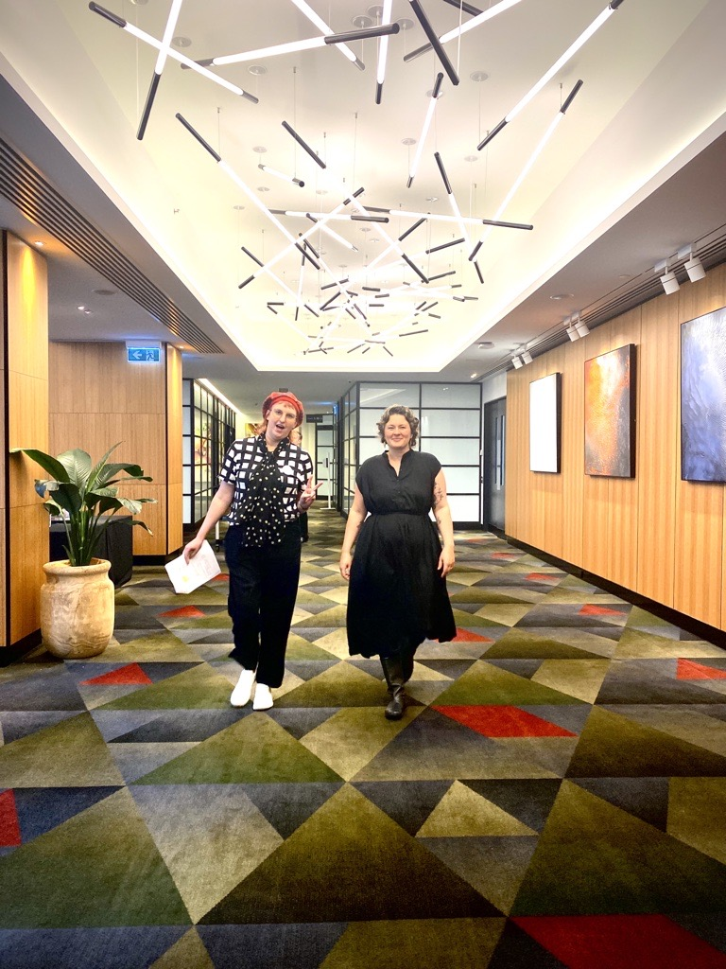
[Image: Picture above shows WWDA staff members, from left to right: Saphia Grant and Zoe Houstein.]

Appendix 1: Welcome to Hobart Guide

Women With Disabilities Australia (WWDA) welcomes you to Hobart.

We are excited to host the WWDA LEAD Leadership Week 2022.

We have 3 days packed with fun, interesting, and engaging activities for you including workshops, discussions, and peer-to-peer networking opportunities.

WWDA LEAD will also be launching our mentoring partnership with Brancher where you will be able to sign up as a mentor or a mentee, or both!

We have created an event program, which you will find below. You will have this emailed to you and printed for you at your hotel when you arrive.

If you need any help in the lead up to or during the week, please do not hesitate to contact Zoe on zoeh@wwda.org.au or Saphia on lead@wwda.org.au

We hope you have a great time, and we can’t wait to hear about your experiences.

Yours,

The WWDA LEAD team.

What to bring

Your devices

If you are bringing any of the following: iPad, tablet, laptop, smart phone, remember to also pack all the chargers you need to power and charge each item.

Wheelchair details

Airlines are aware of your specifications, but make sure you have them printed or available on your device if the airline asks for them.

Medical clearance

If you have medical clearance documents, make sure you have them printed or available on your device if the airline asks for them.

Weather

It is the end of Spring in Hobart, which means any weather is possible! If you are arriving on Sunday 13th Nov the temperature will be in the low 20s with a fair amount of rain. The next few days the temperature will be in the mid-teens and rain easing. At this time of year it’s all about layering as the weather changes throughout the day and week. Wet weather clothing or an umbrella would be useful.

Dress code

Casual. Keep in mind that if you wish to be filmed or have photos taken you might want to dress in clothes that make you feel special. Overall, your comfort is the most important thing and that you dress for you.

Emergency numbers

If you, or someone you are with, are in danger or it is an emergency, call 000 immediately.

Local hospital

Royal Hobart Hospital
Address: 48 Liverpool St, Hobart TAS 7000
A short distance from the Vibe Hotel Hobart
Phone: (03) 6166 8308
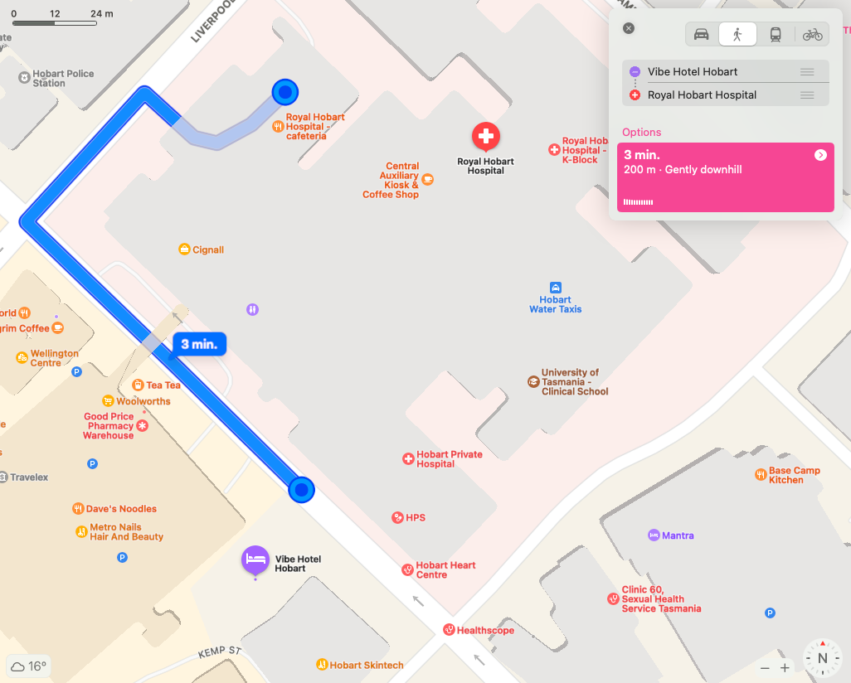

Local police station

Hobart Police Station
Address: 37 – 43 Liverpool St, Hobart TAS 7000
Phone: (03) 6169 4411
A short distance from the Vibe Hotel Hobart
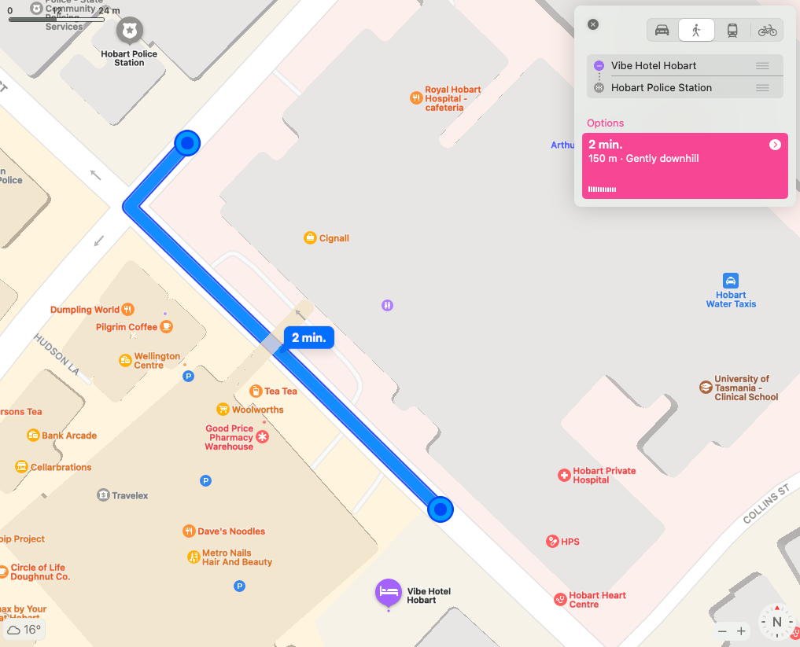

Hotel information

Vibe Hotel Hobart
Address: 36 Argyle St, Hobart TAS 7000
Phone number: (03) 6240 5600
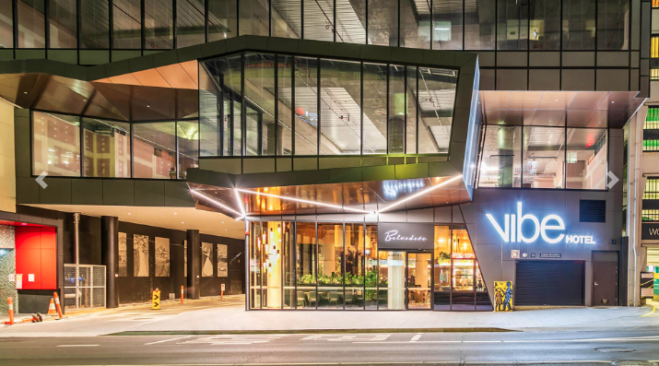
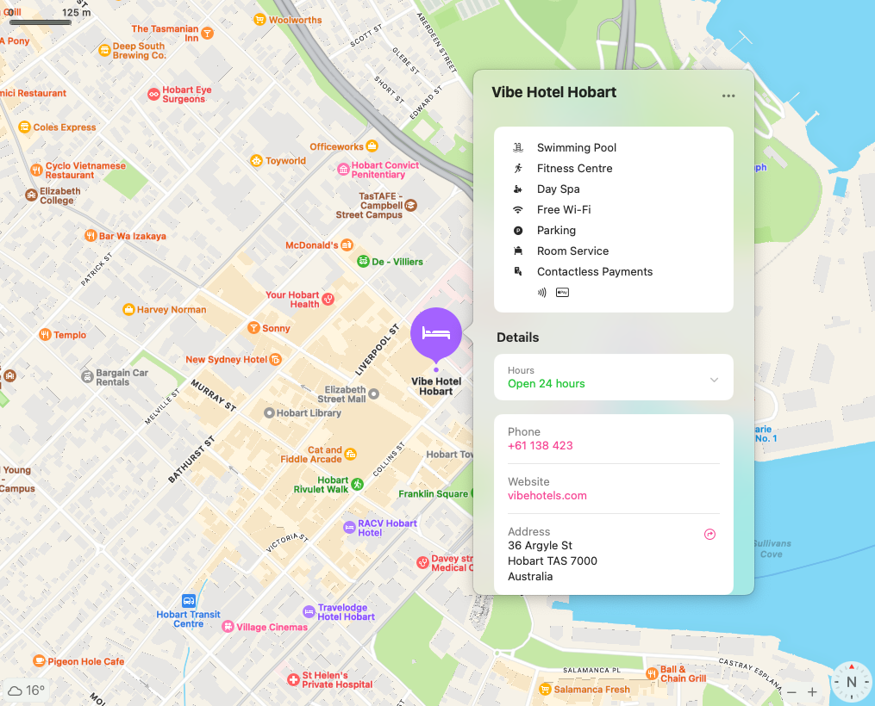
Hotel opening hours: 24 hours
There is a restaurant just behind the main foyer of the hotel called Belvedere.
Opening hours for Belvedere
Breakfast:
6:30am – 10:30am (Weekdays)
7am – 10:30am (Weekend & Public Holiday)
Lunch:
11:30am – 2:30pm (Monday - Saturday)
Closed on Sunday & Public Holiday
Dinner:
5:30pm - 9pm (Daily)
In-room dining is also available during restaurant opening hours.
Menus for the restaurant will be available in your hotel room.
Leadership Week

Monday 14th to Friday 18th November
Monday/ Tuesday/ Wednesday - RACV Hotel Hobart: Collins Room
Thursday - Rest/Personal Day
Friday - RACV Hotel Hobart: Executive Lounge Room

Program

We have scheduled breaks throughout each of our days together, including an hour long shared lunch. We will also frequently ask you if you need a break and also check in with you at around the 40 minute mark of each session to accommodate breaks when needed.

Day 1 Monday 14th Collins Room:
12 pm – Welcome & Leadership Week Opening
1 pm – Shared Lunch
2 pm – What is Leadership and How do we Lead?
3 pm – Workshop with Afternoon Tea: The Value of Strengthening Your Leadership through Bios, Headshots, Zoom
4:30 pm – Break for Personal or Social Time
6 pm – Create Your Leadership by Writing Bios and Presenter Training

Day 2 Tuesday 15th Collins Room:
10 am – Workshop on Knowing Our Human Rights
11:30 am – Break
12 pm – Exploring Leadership Skills Part 1
12:40 pm – Our Site and Codesign in Developing Websites
1 pm – Shared Lunch
2 pm – Exploring Leadership Skills Part 2
3 pm – Workshop with Afternoon Tea: Exploring the Social and Medical Model of Disability
4:30 pm – Break for Personal or Social Time
6 pm – Creative Activity and Open Peer Networking

Day 3 Wednesday 16th Collins Room:
11 am – Using Language in Gender & Disability Advocacy
12 pm – Using Social Media for Advocacy
1 pm – Shared Lunch
2 pm – Mentoring Q & A
3 pm – Summit Planning Brainstorm with Afternoon Tea
4 pm – Break for Personal or Social Time

Thursday 17th Nov – Rest/personal day
Friday 18th Nov: Executive Lounge Room (a program for this day will be provided via email before you depart and will also be available when you arrive.

Event space

RACV Hotel Hobart
Collins Room, first floor – signage will say ‘WWDA LEAD Leadership Week’ for Mon 14th – Wed 16th Nov
Address: 154-156 Collins St, Hobart, TAS 7000
Phone number: 03 6270 8600
Email: hobart@resorts.racv.com.au
Wifi access: Please ask on arrival for the Wifi log in details.
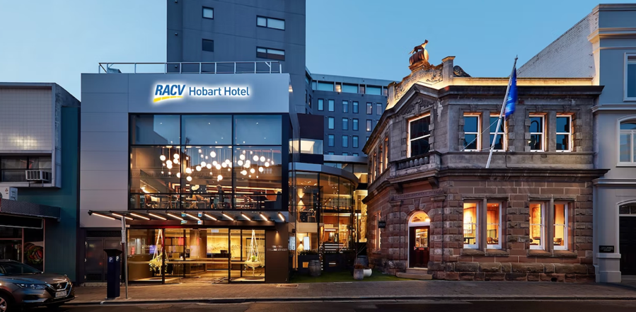
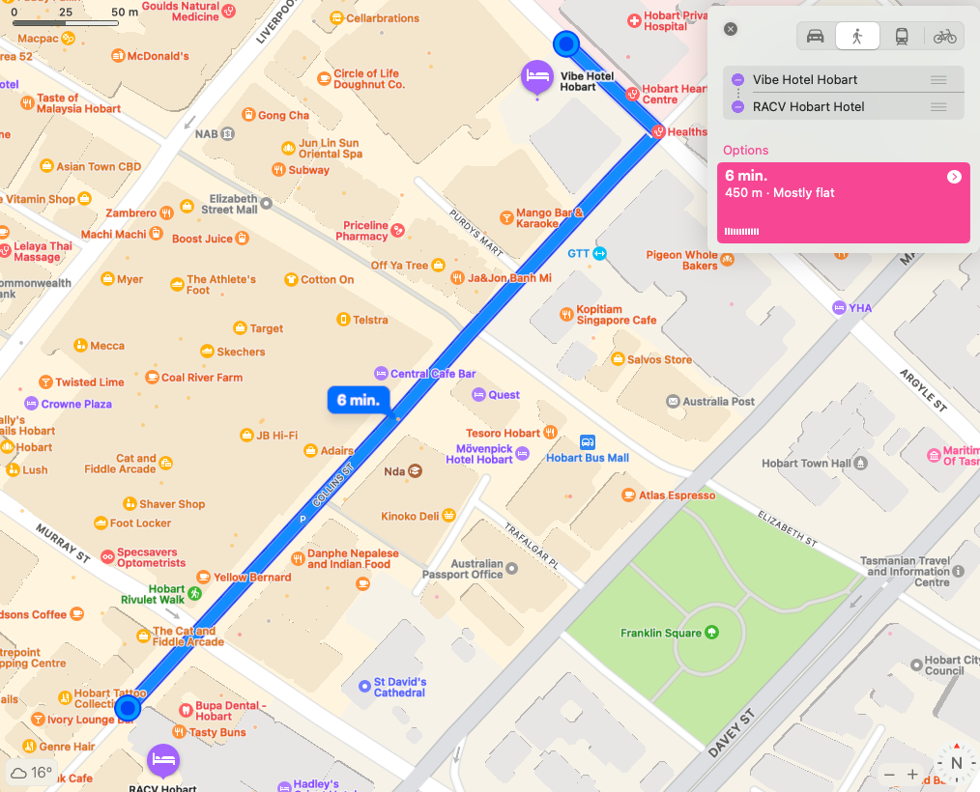

Event accessibility

Enter from main street on ground level access through the main sliding doors, straight into reception foyer, elevator is to the right of reception, 900mm in width, two-way entry and exit – so you would enter in one door and whatever floor you go to you will exit facing the right way.
We also have private access to The Boardroom, which is on the same floor as the Collins Room.

Toilets

Fully accessible toilets are available on the same floor as The Collins Room and The Boardroom. For a list of accessible toilets in the Hobart CBD, see below.

As you are staying at the Vibe Hotel Hobart you are situated in the central business district of Hobart and are therefore surrounded by food options including a Woolworths supermarket (details below).

Catering information

Monday 14th, Tuesday 15th, Wednesday 16th November
Your lunch and afternoon tea will be catered in the Collins Room.
Thursday is a rest/personal day.
Friday 18th November
Your morning tea and lunch will be catered in our event space called the Executive Lounge.

Local supermarket

Woolworths Hobart
Opening Hours: 7am- 10pm
Address: 44 Argyle Street, Hobart 7000 (if you are accessing with your wheelchair you will need to use the lifts inside the Wellington Centre next to Cellarbrations Wellington Centre).
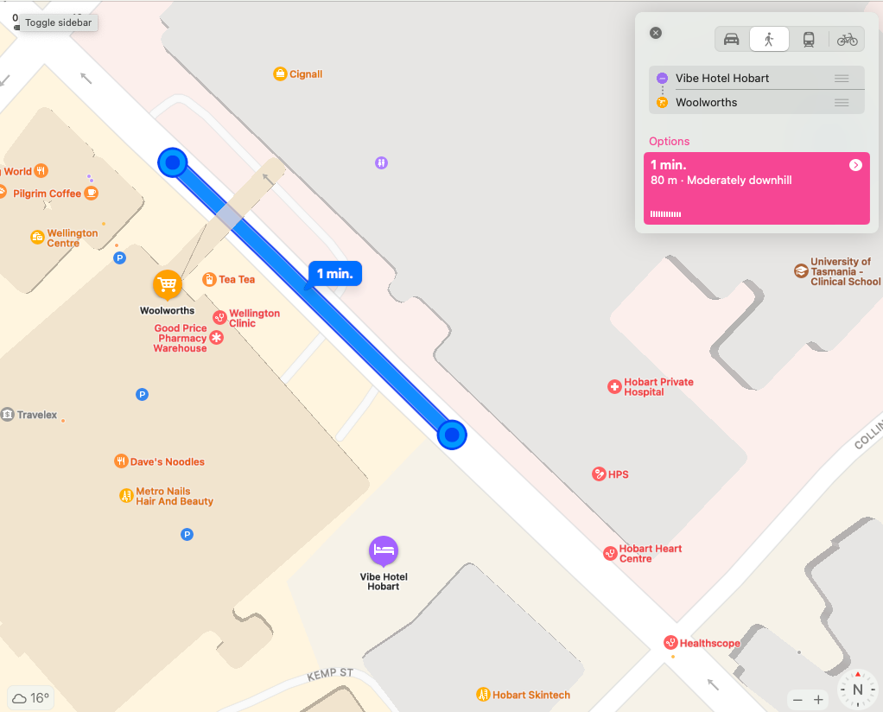

Café

Close to Vibe Hotel Hobart
Pigeon Whole Bakers (great tea, coffee and pastries): 32 Argyle St, Hobart 7000
Opening hours:
Mon-Fri 7:30am-3pm
Sat-Sun 7:30am-1pm
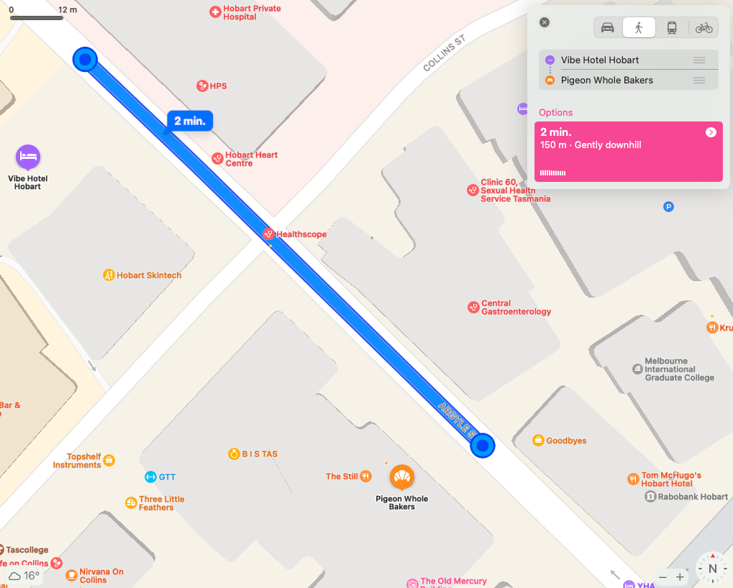

Food stop

Close to Vibe Hotel
Sush Sushi – Wellington Court, Hobart
Mon-Fri: 7am–7pm
Saturday: 9am–4pm

Close to RACV Hobart Hotel
Urban Greek
www.urbangreekhobart.com
103 Murray Street, Hobart TAS 7000
Mon closed
Tue-Sun lunch 11:30am-3pm
Tue-Sun dinner 5pm-10pm

Picnic Café Hobart
https://www.picniccafehobart.com
6a Mathers Lane, Liverpool Street, Hobart TAS 7000
Mon-Tue closed
Wed-Fri 8am-4pm
Sat-Sun 8am-3pm
Last kitchen orders 1 hour prior to closing.

Local pharmacy

Good Price Pharmacy Hobart
Wellington Centre, 42/44 Argyle St, Hobart TAS 7000
Opening hours:
Mon-Fri | 8am–6pm
Saturday | 9am–5pm

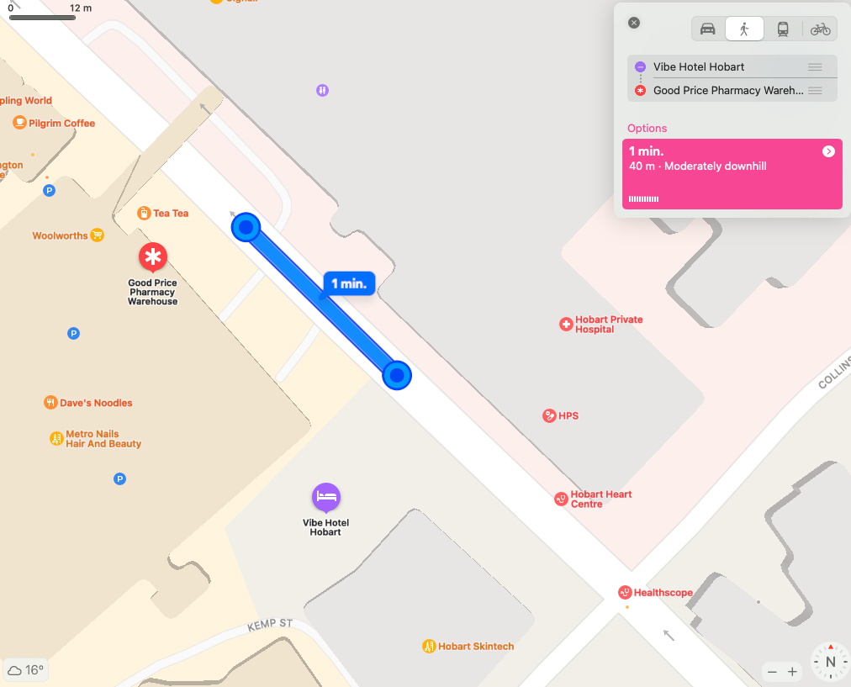

Accessible toilets in CBD

Argyle Street Car Park (near Vibe Hotel Hobart): open 7am-10pm
Centrepoint Shopping Centre 51 Murray Street: open Mon-Fri 9am-5:30pm, Sat 9am-4pm
Franklin Square, Elizabeth Street near the bus mall: open 24 hours
Salamanca Square, Battery Point: open 6am-9pm

Cab charge details

In discussion with Zoe Houstein (WWDA) you were sent 2 cab charges. You need to ask for a receipt from the cab driver and hand it to Zoe. Please ask for cab charge cards for your return trip. You will need to ask the cab driver for receipts and email them to Zoe on your return.

COVID19 Care

The RACV Hobart Hotel provides hand sanitiser at the entrance to the Hotel as well as at the entrance to the Collins Room. We will supply hand sanitiser in each of the events spaces also. Please let us know if you have any additional needs with regard to COVID19.

Who will be in the room with us
WWDA LEAD Team

Saphia Grant – Project Manager LEAD
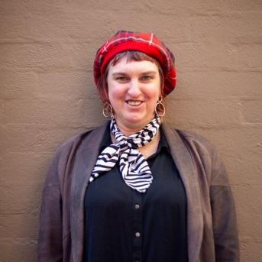

Zoe Houstein – Project Officer LEAD
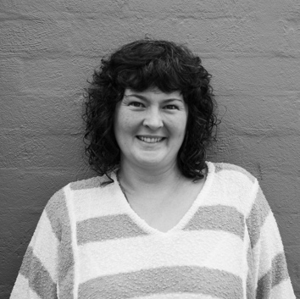

Margherita Dall’Occo-Vaccaro – Youth Development Officer
Jacinta Carlton – Media and Comms Officer
Cat Standley – Content Development Officer LEAD (joining us via online)

JPL Media Team
Jamie Meakin – Project Manager JPL Media

Gabrielle Fry – Project Manager JPL Media
Peter Alexander – Technical Director JPL Media
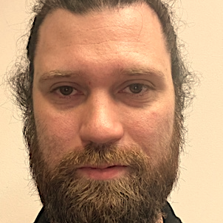
Amy Brown Media Team
Amy Brown – Audio Visual Producer

Mike Gissing – Audio Visual Technician

Appendix 2: Illustrations from one of the WWDA Committee Members, Kay Barnard.
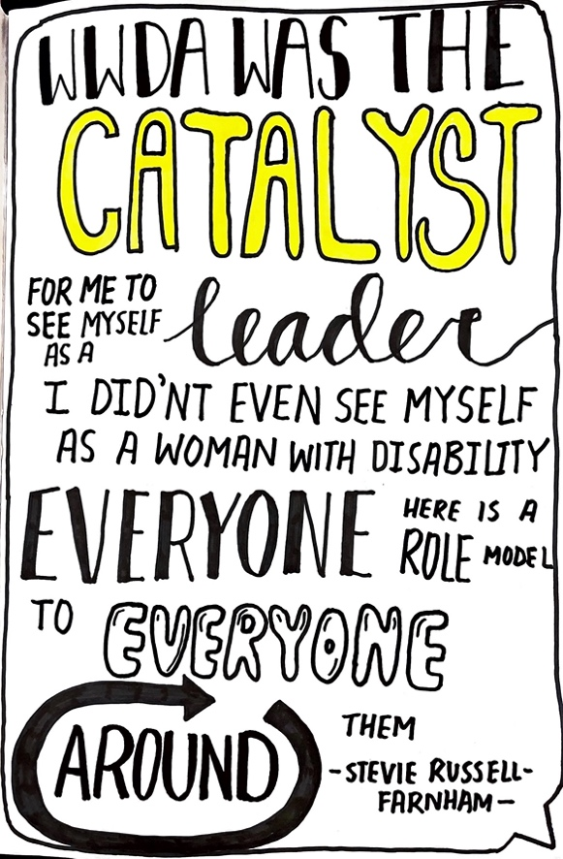
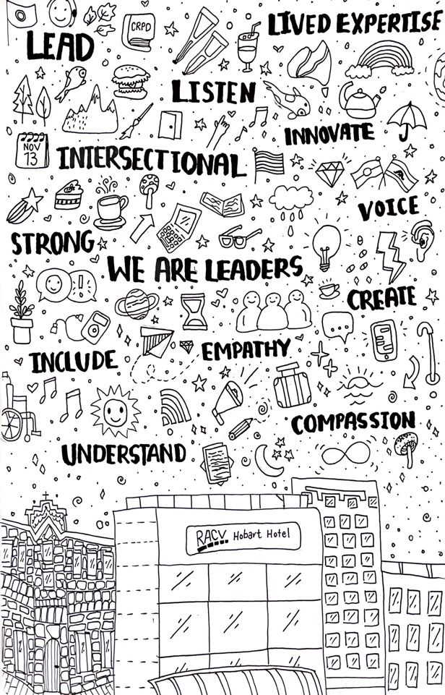
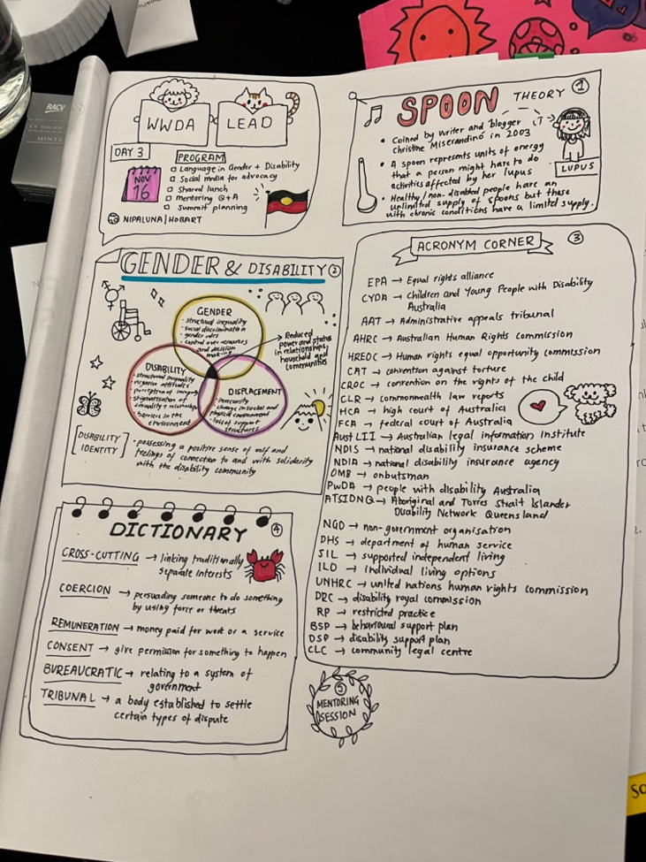

Appendix 3: Leadership Week Program
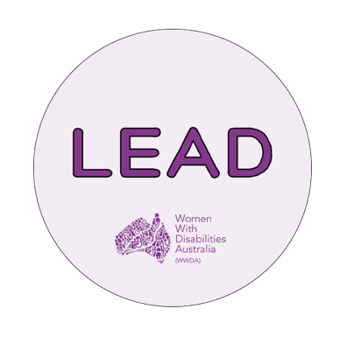
WWDA LEAD Leadership Week
Program
Mon 14th, Tues 15th, Wed 16th November 2022
RACV Hotel Hobart: 154-156 Collins St, Hobart

We will have break times each day, including an hour-long shared lunch, and will also check in each session to provide breaks when requested.

Day 1:
12 pm – Welcome & Leadership Week Opening
1 pm – Shared Lunch
2 pm – What is Leadership and How do we Lead?
3 pm – Workshop with Afternoon Tea: The Value of Strengthening Your Leadership through Bios, Headshots, Zoom
4:30 pm – Break for Personal or Social Time
6 pm – Create Your Leadership by Writing Bios and Presenter Training

Day 2:
10 am – Workshop on Knowing Our Human Rights
11:30 am – Break
12 pm – Exploring Leadership Skills Part 1
12:40 pm – Our Site and Codesign in Developing Websites
1 pm – Shared Lunch
2 pm – Exploring Leadership Skills Part 2
3 pm – Workshop with Afternoon Tea: Exploring the Social and Medical Model of Disability
4:30 pm – Break for Personal or Social Time
6 pm – Creative Activity and Open Peer Networking

Day 3:
11 am – Using Language in Gender & Disability Advocacy
12 pm – Using Social Media for Advocacy
1 pm – Shared Lunch
2 pm – Mentoring Q & A
3 pm – Summit Planning Brainstorm with Afternoon Tea
4 pm – Break for Personal or Social Time
Please contact:
Zoe Houstein (WWDA Project Officer LEAD): 0400 101 354
Saphia Grant (WWDA LEAD Manager): 0457 527 016

Appendix 4: Photo and Media Consent forms
__________________________________________________________________

The ‘Leadership Week’ is being conducted by Women With Disabilities Australia (WWDA) on Monday 14th, Tuesday 15th, Wednesday 16th and Friday 18th November 2022 in Hobart, Tasmania.

At the ‘Leadership Week’ we will be taking photographs and video footage of the proceedings of our activities. The information that comes from the ‘Leadership Week’ will be documented and recorded and used in planning and evaluation.

We would like your permission to use your photograph and video footage to promote the LEAD projects and activities. Your photo and/or video footage may be used in our newsletters, reports, publications on our websites and our social media sites (Facebook, Instagram, LinkedIn, Tiktok and Twitter).

If you agree to us taking and using your photographs and/or video footage please sign here.

I agree to having my photo and/or video footage taken and reproduced for the purposes of the ‘Leadership Week’.

Signature: ______________________________________________

Name: _________________________________________________

Date: __________________________________________________

If you disagree to us taking and using your photographs and/or video footage please sign here.

I disagree to having my photo and/or video footage taken and reproduced for the purposes of the ‘Leadership Week’.

Signature: ______________________________________________

Name: _________________________________________________

Date: __________________________________________________

NB: If you require assistance to complete this ‘Photo/Video Consent and Release Form’ please contact:
Zoe Houstein (WWDA)
Mobile 0400 101 354
Email: zoeh@wwda.org.au

Appendix 5: Infographic of survey results
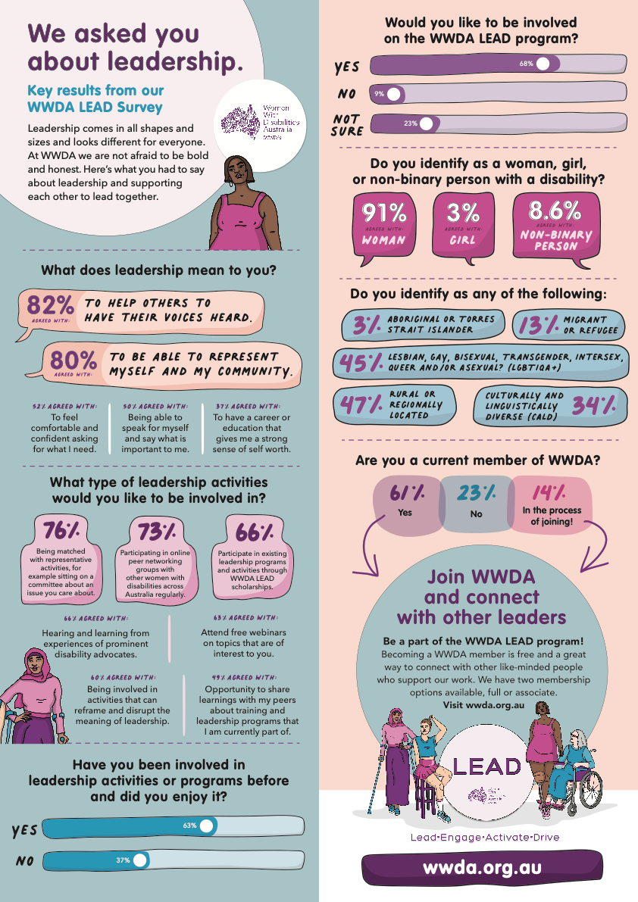

Appendix 6: Biography Recipe

Writing a ‘Bio’ is not easy for everyone.

Here is a short framework to help you get started with ideas.

- Who are you: Start by writing your name and where you live? Or you can just write your name.

- What you do or where you work: Are you an advocate, a volunteer, student, have your own consultancy business, small business owner, work for a company/organisation?

- Your current role: What do you do for work (paid or unpaid roles? You can either list your current title e.g., community leader, lived experience expert, project officer, or a short, descriptive phrase about your role here.

- Your shining light: People reading your bio will also want to get a sense of who you are. Listing your overall goal, values, or a statement that describes your ethics will help them get to know you, even in short bios. E.g., I aim to work on boards to represent and further the human rights of women with disability.

