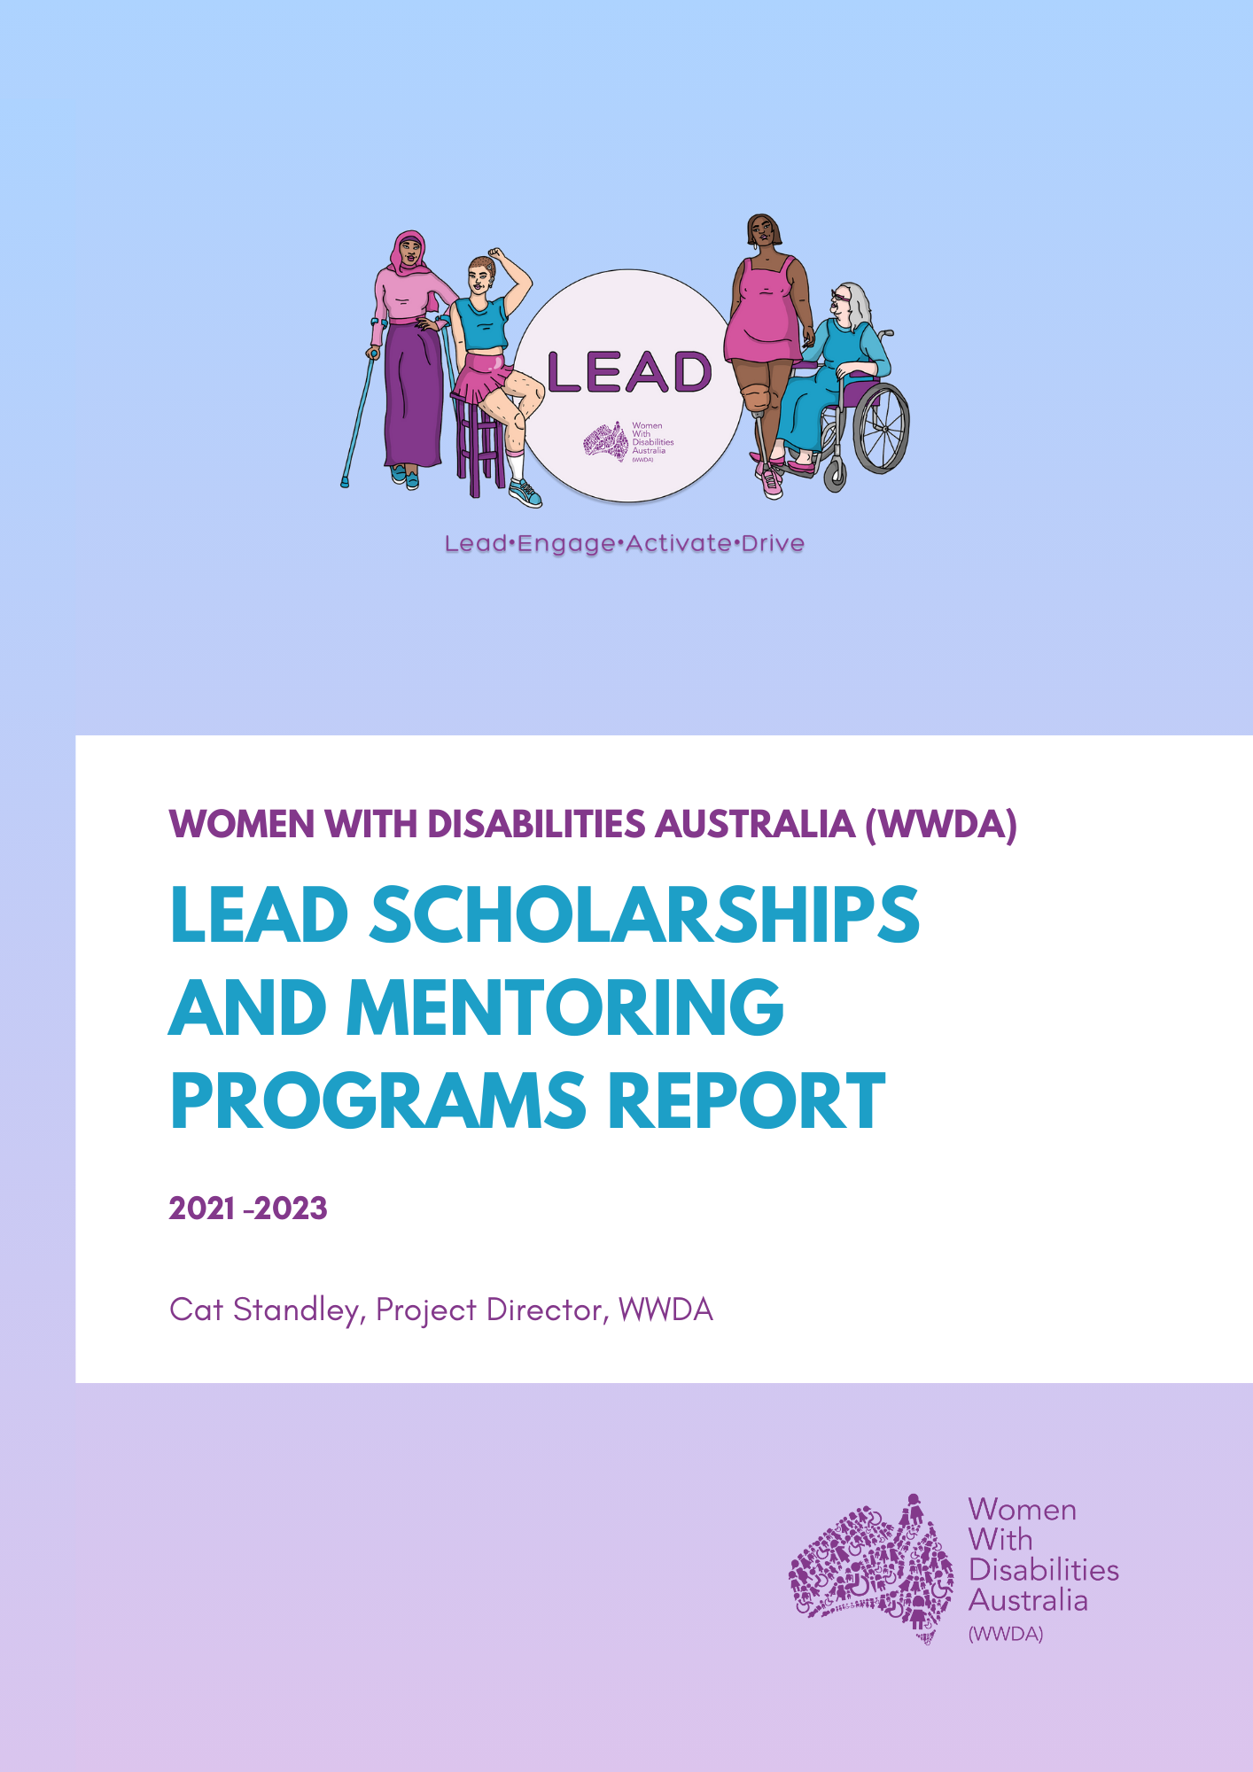

About Women With Disabilities Australia (WWDA)

Women With Disabilities Australia (WWDA) Inc is the national Disabled People’s Organisation (DPO) and National Women’s Alliance (NWA) for women, girls, feminine identifying and non-binary people with disability in Australia. As a DPO and a NWA, WWDA is governed, run, and staffed by and for women, girls, feminine identifying and non-binary people with disability.

WWDA uses the term ‘women and girls with disability’, on the understanding that this term is inclusive and supportive of, women and girls with disability along with feminine identifying and non-binary people with disability in Australia.

WWDA represents more than 2 million women and girls with disability in Australia, has affiliate organisations and networks of women with disability in most States and Territories, and is recognised nationally and internationally for our leadership in advancing the rights and freedoms of all women and girls with disability. Our organisation operates as a transnational human rights organisation - meaning that our work, and the impact of our work, extends much further than Australia. WWDA’s work is grounded in a human-rights based framework which links gender and disability issues to a full range of civil, political, economic, social and cultural rights. All WWDA’s work is based on co-design with and participation of our members. WWDA projects are all designed, governed, and implemented by women and girls with disability.

Table of Contents
Executive Summary 3
Part 1: Context for the WWDA LEAD Scholarships Program 4
Background for the WWDA LEAD Scholarships Program 4
Objectives 4
Program Implementation 4
Part 2: Reflections and Outcomes for the LEAD Scholarships Program 5
2.1 Program Outcomes 5
2.2 Lessons Learned 6
2.3 Reflections from participants 7
Part 3: Context for the LEAD Mentoring Program 9
3.1 Background for the LEAD Mentoring Program 9
3.2 Program Structure and Objectives 10
Part 4: Reflections and Outcomes for the LEAD Mentoring Program 11
4.1 Achievements and Impact 11
4.2 Future Considerations 13
4.2.1 Expansion and Outreach 15
4.2.2 Evaluation and Feedback 15
4.2.3 Continued Accessibility Focus 15
4.2.4 Sustainability and Funding 16
4.3 Participant Reflections 16
Conclusion for the WWDA LEAD Scholarships Program 18
Conclusion for the WWDA LEAD Mentoring Program 18
Acknowledgement and thank you 19
Appendix 1: WWDA LEAD Scholarship information 20
Appendix 2: Leaderships Courses Register 26
Appendix 3: WWDA LEAD Scholarship Application Form 33
Appendix 4: WWDA LEAD Mentoring Program Application Form 35

Executive Summary

From 2021 through to 2023, the WWDA LEAD Project facilitated two separate programs for women, girls, feminine identifying and non-binary people with disability designed to build individual leadership capacity within the community. These programs were known as the WWDA LEAD Scholarships Program and the WWDA LEAD Mentoring Program.

The WWDA LEAD Scholarships Program was initially implemented by WWDA LEAD Project staff that had collated leadership courses that were either specifically designed for women and gender diverse people, and/or people with disability. The Program selected its first round of applicants in May 2021 and the second round of applicants were selected in April 2022. Overall, the program successfully paired over 20 women, girls, feminine identifying and non-binary people with disability to leadership courses that were funded by the Scholarships Program of the WWDA LEAD Project.

The first round of the WWDA LEAD Mentoring Program opened to all WWDA members in June 2021, with the second round of the program opening in October 2022. WWDA LEAD Project staff worked closely with Brancher (the mentoring platform) to ensure that the platform and the program were accessible to women, girls, feminine identifying people non-binary with disability. The WWDA LEAD Mentoring Program recruited approximately 270 women, girls, nonbinary and feminine-identifying people with disabilities during 2021 and 2022. Throughout both intake years, the WWDA LEAD Mentoring Program successfully matched around 60 participants into mentoring relationships who found that the platform and the program helped to build their personal and professional leadership capacity. This program was also funded by the WWDA LEAD Project and made freely available to all participants.

Part 1: Context for the WWDA LEAD Scholarships Program

Background for the WWDA LEAD Scholarships Program
This report provides an overview of the WWDA LEAD Scholarships Program, an initiative implemented by Women With Disabilities Australia (WWDA) in 2021 and 2022. The program aimed to enhance the individual capacity building skills of women, girls, and gender diverse people with disabilities. The primary focus was on empowering participants to develop and strengthen their leadership abilities through educational opportunities.

Objectives
The WWDA LEAD Scholarships Program had the following key objectives:
1. Increase leadership skills: The program aimed to provide women, girls, feminine identifying and non-binary people with disabilities the opportunity to enhance their leadership abilities through targeted educational programs.
2. Promote inclusivity: By offering scholarships, the program aimed to support individuals who face barriers to accessing leadership development opportunities due to disability-related challenges and/or financial barriers.
3. Foster empowerment: The program intended to empower participants by equipping them with the skills and knowledge needed to actively engage in decision-making processes, advocate for their rights, and increase participation and contribution to the community.

Program Implementation
1. Selection of Participants: WWDA advertised the program nationally and invited women, girls, feminine identifying and non-binary people with disabilities to apply for the scholarships. The selection process involved a comprehensive review of applications, considering factors such as leadership potential, commitment to disability rights, and the impact the program would have on the individual's personal and professional growth and how this could improve WWDA’s work.
2. Scholarship Benefits: The WWDA LEAD Scholarships Program covered the expenses associated with enrolment in leadership development programs or courses of the recipients' choice or from the Leadership Courses Register that the WWDA LEAD Project staff had collated. This financial support allowed participants to pursue educational opportunities that aligned with their specific needs and goals. Certain terms and conditions had to be met for the course to be approved such as cost (courses valued at or below $2500 + GST) and leadership development specific courses.
3. Ongoing Support: WWDA provided ongoing support to the scholarship recipients throughout their program duration. This involved regular check-ins, guidance, and assistance tailored to the individual needs of each participant. Project staff made themselves available via email when participants requested assistance. The aim was to ensure their success and address any challenges encountered along the way.

Part 2: Reflections and Outcomes for the LEAD Scholarships Program

2.1 Program Outcomes

The WWDA LEAD Scholarships Program has made remarkable impact on women, girls, feminine identifying and non-binary people with disabilities by achieving the following program outcomes:
1. Enrolment: The WWDA LEAD Scholarships Program successfully facilitated the enrolment of more than 20 women with disabilities in leadership development programs. The participants had the opportunity to explore various areas such as increasing accessibility in the workplace, public speaking, policy advocacy, community engagement, and organisational management.
2. Skill enhancement: Through their chosen programs, the recipients were able to enhance their leadership skills, gaining valuable knowledge and practical tools. They acquired expertise in areas such as increasing disability accessibility, strategic planning, effective communication, negotiation, and conflict resolution.
3. Networking opportunities: The program also facilitated networking opportunities among the participants, enabling them to build networks, and connect with other professionals and organisations working in the disability rights sector. These networks will continue to support their personal and professional growth beyond the program. For example, all participants had the opportunity to be a part of the WWDA Facebook Community Group, where they could connect with other professionals and people in our community. Participants of the Scholarships Program also connected with WWDA staff professionally, either virtually or face-to-face through other opportunities of the WWDA LEAD Project such as Committees and Expert Panels.
4. Empowerment and confidence: The WWDA LEAD Scholarships Program significantly contributed to the empowerment and self-confidence of the participants. They reported increased self-belief, assertiveness, and motivation to pursue leadership roles and actively contribute to disability advocacy.

2.2 Lessons Learned

The WWDA LEAD Scholarships Program clearly shows the demand that women, girls, feminine identifying and non-binary people with disabilities are seeking professional and personal development through education and upskilling. The development of leadership skills, networking opportunities and increased confidence that the program provided for participants has built upon already existing frameworks of their leadership capacity.

WWDA LEAD Project staff can confidently state that the WWDA LEAD Scholarships Program met its objectives of increasing leadership skills, promoting inclusivity, and fostering empowerment, as is evidence by the participant reflections below.

2.3 Reflections from participants

Featured below are two de-identified Stories of Change, submitted by participants of the LEAD Scholarships Program.

“My name is Jane* and I participated in the WWDA Lead Scholarships project. I live in Narrm (Melbourne) in Victoria.

I’ve been a WWDA member since I got involved with Women with Disabilities Victoria. A friend of mine encouraged me to apply for WWDA scholarships, as I was currently looking for opportunities to learn some new skills in making documents more accessible, such as in Easy English formats. I applied and was very appreciated to have been given this opportunity. I have done both Easy English and policy and advocacy training through the project.

By being involved in this project I can much more confidently say I know what’s involved and what it takes to make documents more accessible to people with low literacy in our communities. I also understand much better what it’s like for people with low literacy. I know the steps to take, what to look for, and have the resources. I can also confidently say I understand the policy cycle much better.

I see myself as being able to use what I’ve learned, using myself as a resource for my communities. I also take what I’ve learned and pass it onto others as a way of up-skilling them.”

*Name has been changed to protect confidentiality.
- WWDA LEAD Scholarships participant #1

“My name is Jesse* (they/them). I live in Canberra, ACT (currently contested country of Ngunnawal across Canberra, Gundungurra to the north, and Ngarigo to the south). I have participated in the 2022 WWDA LEAD Scholarship program round.

I first heard about the program through a friend who shared the opportunity with me and thought it would be great for me to consider applying. This was my first interaction with WWDA. I looked at the WWDA website and information on program and something that attracted me to the program was the language around the program addressed the intersections and nuance of queer and disability cross-over and decided I would apply.

When I first looked at doing a course, I looked across advocacy and the arts and as I saw individual advocates using social media to communicate their stories. As a writer and creative, I have created content and felt that doing a course in communications may help expand my reach and audience so initially identified courses in digital media area. However, at the same time opportunities were coming up in high-level systemic advocacy, which I felt would be a better use of my time, focus and a fun thing, as I do have a background in comms, but not in talking to politicians.

I decided to apply for a short course through Melbourne University, ‘Persuasion for Policymakers: How to persuade and influence government decision-makers and stakeholders’. When I started this course, I was very grateful to learn that Maria Katsonis who was leading the course was also a lived-experience expert. And found that the course leant itself well to the lived experience aspect, while not necessarily being built for that aspect, which I found interesting.

One of the most significant changes of being involved in the LEAD project was: A) realising that there is support out there for developing leadership, and B) Realizing oh, crap I’m a leader! It’s kind of a bit sad, that you work that out while sitting in a Senate room with a bunch of politicians.

A number of things came together while completing this course that made me realise that although I have had interrupted academic journeys with three different undergraduate degrees due to health reasons, that I am skilled and that I do not need to complete these degrees to belong in leadership spaces and that I need to have faith in myself.

The beautiful part of the LEAD scholarship program was the acknowledgement that I was worth the cost involved to do a course, that the organization saw potential in me and to that I am grateful and want to be accountable to that. Being a part of this project now informs what I do, not only the way I talk to politicians, but also what I already knew and continue to know is that leadership is in all of us. Just because many of us have these interrupted journeys it doesn’t mean we can’t lead. Because many of us already are whether they be leading chat groups in community centres or at high-level positions with Government.

The confidence this project has given me led me into applying for the 2022 Sync Leadership Program for disabled artists through Access Arts. It’s building further confidence and what I’ve bought to this program and now chasing is building an online community of disabled advocates and artists (mostly online), taking people through the process of creating art from concept to completion through coaching, mentoring, supporting and guiding artists. Creating greater buy-in from society and targeted support for disabled artist leadership for more equitable inclusion in community.

I am very grateful to have received this scholarship. I don’t have a lot of capacity, but I would love to be involved in future WWDA LEAD work in any way I can.”

*Name has been changed to protect confidentiality.
- WWDA LEAD Scholarships participant #2

Part 3: Context for the LEAD Mentoring Program

3.1 Background for the LEAD Mentoring Program

From 2021 - 2023, Women With Disabilities Australia (WWDA) successfully ran two intakes of the WWDA LEAD Mentoring Program in collaboration with Brancher, an external partner. The Mentoring Program aims to empower women, girls, feminine identifying people and non-binary people with disabilities by providing them with opportunities to engage in mentoring relationships. These relationships foster skills exchange and help participants build leadership skills in both their personal and professional lives. The first intake of the Program had more structure in terms of when the mentoring relationship would begin and who people were matched with. Applicants were matched with each other based on Brancher’s algorithm, which sought data from everyone’s intake form and the latest research from behavioural sciences. Based on feedback from participants of the first round of the Program, the second intake of was designed to be more flexible, allowing participants to enter and participate in mentoring relationships at their own pace. There were benefits and lessons learned from both approaches, which will be discussed further. Additionally, WWDA has taken great care to ensure that the program's platform and trainings are accessible to individuals with various disabilities, including those with low to no vision, intellectual and cognitive disabilities, and others.

3.2 Program Structure and Objectives

The Mentoring Program implemented by WWDA follows a structured framework that facilitates meaningful interactions between mentors and mentees. The program has three primary objectives:

- Skills Exchange: The program encourages mentors and mentees to engage in a reciprocal exchange of skills, knowledge, and experiences. Mentees can learn from the expertise of their mentors, while mentors can also gain fresh perspectives and insights from their mentees.

- Leadership Development: The program aims to support the individual leadership development of participants, both in their professional and personal lives. By providing guidance and support, mentors help mentees enhance their leadership skills, confidence, and decision-making abilities. Conversely, mentors are also able to build their own leadership capacity through developing the leadership skills of their mentees.
- “My mentee has been wonderful. I love learning through the mentoring program.”
- WWDA LEAD Mentoring Program Participant (Mentor) 2022

- Flexibility and Accessibility: One of the key strengths of WWDA's Mentoring Program is its flexibility. The program recognises that individuals with disabilities may have unique circumstances and support and access needs, and therefore allows participants to enter mentoring relationships and engage in activities at their own pace. This flexibility allowed participants to overcome potential barriers and fully benefit from the program.

In addition to being flexible, WWDA has prioritised accessibility in the design and implementation of the program. The mentoring platform and training materials have been carefully developed with inclusive design principles to accommodate a range of disabilities. The program materials have considered factors such as screen reader compatibility, alternative formats, captioning, and Easy Read formats.

Being a platform where mentoring partners largely met online, this further increased the flexibility of the program allowing those with psychosocial disabilities and chronic illnesses to meet in an online capacity and continue to be part of the program with minimal risk to their health and/or their psychological wellbeing.

Part 4: Reflections and Outcomes for the LEAD Mentoring Program

4.1 Achievements and Impact

The Mentoring Program has achieved significant positive outcomes for participants. Some of the notable achievements and impacts include:

- Enhanced skills and knowledge: Mentees have reported gaining new skills, knowledge, and perspectives through their interactions with mentors. This has helped them grow both personally and professionally, enabling them to overcome challenges and pursue their goals. Mentors have also reported that they have learnt from their mentees through facilitation of skills exchange throughout their mentoring relationship.

“I achieved my goal – building my leadership skills.”
– WWDA LEAD Mentoring Program Participant 2021

“I achieved my goal – sending a novel to a publishing house.”
– WWDA LEAD Mentoring Program Participant 2021

- Increased confidence and empowerment: Participants have experienced an increase in self-confidence and empowerment because of their participation in the program. The guidance and support provided by mentors have enabled mentees to believe in their abilities and take on leadership roles in various aspects of their lives.

“I know the difference it makes knowing someone is always there when needed. Helps ease or prevent anxiety.”
– WWDA LEAD Mentoring Program Participant 2021

“I have gained confidence in my mentoring ability”
– WWDA LEAD Mentoring Program Participant 2022

- Expanded networks and support systems: Mentoring relationships have facilitated the establishment of valuable connections and networks for participants. These networks provide ongoing support, guidance, and opportunities beyond the duration of the program, strengthening the mentees' support systems. Participants of the program also had regular check-ins from WWDA LEAD Project staff as well as the option of connecting and networking with people in the closed community Facebook group. To wrap up two years of this program, LEAD Project staff held a virtual event via Zoom and invited all participants of the Mentoring Program to attend and learn about they could contribute to the final evaluations of the LEAD Project by sharing their experience of the Mentoring Program and how this contributed to their Stories of Change from a leadership perspective.

“Very good opportunity to meet inspiring mentors who share a common ground being a woman and having a disability together. It’s not every day that I get the opportunity to interact with this common ground.”
– WWDA LEAD Mentoring Program Participant 2021

- Promoting disability-inclusive leadership: The program contributes to the promotion of disability-inclusive leadership by empowering women, girls, feminine identifying and non-binary people with disabilities. Through their increased leadership capacity, program participants can actively contribute to decision-making processes and advocate for the rights and needs of themselves and people with disabilities.

“The opportunity to help someone else grow, and along the way grow in my own way.”
– WWDA LEAD Mentoring Program Participant 2021

4.2 Future Considerations

Having run the WWDA LEAD Mentoring Program for two years means that WWDA has learned valuable insights and lessons from the feedback of all participants and the platform partner, Brancher. As the Mentoring Program continued to evolve throughout its duration, WWDA should consider the following aspects to improve future mentoring programs:
- Recruit the role for Mentoring Program Coordinator. This will provide participants with a touch point staff member to access when they need information or help with the program. This will also ensure the ongoing safety of participants should they encounter any issues along the way.
- Requiring Police and Working With Children/Vulnerable People’s Checks as a compulsory part of the application process. This will ensure that the program is protective of all participants.
- More lead-in planning time to shorten the recruitment process for participants of the program, subsequently leaving more time for Project staff to engage with the people enrolled. The role of the Mentoring Program Coordinator could be involved in strategic planning for the program given its duration and high number of applicants.
- Additional virtual trainings for mentors to complement the online interactive training modules. This will help maximise the mentor’s capacity building. The Mentoring Program Coordinator would also help to facilitate these sessions alongside a team member from Brancher.
- Additional virtual trainings for all participants to complement the online trainings to improve participant safety online. Making these training modules essential to complete to take part in the program will help to improve participant safety and wellbeing online.
- Regular virtual group meetings for all participants throughout the program to ensure people are on track, feel supported and know how to glean the most out of the program. The Mentoring Program Coordinator would keep regular contact with all participants to ensure they are getting the most out of the program. The coordinator could then organise group sessions with those who would benefit most.
- Regular prompts to all participants to reach out to the program coordinator when more personalised assistance is required. This is another reason the role of Mentoring Program Coordinator would be beneficial to participants that required tailored assistance.
- Although feedback from the first round indicated that participants would prefer a more flexible approach to the program, feedback and data from the second round was conflicting and indicated that participants desired more structure from the program. A future recommendation would be to move back to a cohort-based program with admin pairing as opposed to unrestricted timeframes and user driven pairing.

4.2.1 Expansion and Outreach
WWDA LEAD Project staff regularly used outreach campaigns such as targeted email newsletters and announcements, virtual networking events, online information sessions, and online forums through the WWDA Community Facebook Group. Other outreach opportunities to increase the expansion of the program that WWDA should consider for the future include:
- Committing to local outreach by hosting events through community centres
- Showcasing testimonials and case studies from previous rounds of the program
- Encouraging participants to leave reviews through targeted surveys
- Increasing our media coverage of the program and its benefits
- Holding webinars with guest speakers from professional networks
- Collaborating with other organisations or professional networks to promote the program.

4.2.2 Evaluation and Feedback

Regular evaluation of the program's effectiveness and impact has been crucial for ongoing improvement. WWDA is collecting feedback and data from participants, to assess the program's outcomes and identify areas for enhancement. Some of the general feedback of people engaged with the program have provided initial comments on their experience and this includes sentiments such as:
- Gaining more confidence in their mentoring ability.
- Learning the difference between encouraging and directing someone.
- Using it as a time where they [mentors] can learn how to keep a mentee focussed.

4.2.3 Continued Accessibility Focus

WWDA has maintained its commitment to accessibility by regularly reviewing and updating the program materials throughout the duration of the program. WWDA LEAD Project staff have worked with the platform to ensure they remain inclusive and accommodate evolving accessibility standards and guidelines.

4.2.4 Sustainability and Funding

To ensure the long-term sustainability of the program, WWDA should explore funding opportunities and partnerships with relevant stakeholders. This will help secure resources for program maintenance, expansion, and continuous improvement.

Should WWDA consider holding another round of the Mentoring Program, WWDA should take into account the lessons learned from the evaluation, feedback and data of participants and previous rounds of the program. These lessons should inform the strategic planning, coordination, and engaging ongoing participation from applicants to ensure the continued sustainability of the program.

4.3 Participant Reflections

Some de-identified initial reflections from the Mentoring Program participants is featured below:

- “The ability to pair me with someone I didn’t know I needed in my life.”
- WWDA LEAD Mentoring Program Participant 2022

- “This platform is a great communicative and collaborative platform.”
- WWDA LEAD Mentoring Program Participant 2022

- “I really enjoyed our monthly mentoring sessions which were practical and focussed.”
- WWDA LEAD Mentoring Program Participant (Mentee) 2022

- “LEAD Program overall is very good.”
- WWDA LEAD Mentoring Program Participant 2022

Conclusion for the WWDA LEAD Scholarships Program

The WWDA LEAD Scholarships Program was conceptualised by WWDA LEAD Project staff to enhance and build upon existing leadership skills and capacity in women, girls, feminine identifying and non-binary people with disabilities. This program was proven successful with over 20 participants over two years that completed their training with additional skillsets and knowledge to add to their portfolios. The WWDA LEAD Scholarships Program was pivotal in designing and developing future WWDA LEAD activities and events for the remainder of the LEAD Project.

Conclusion for the WWDA LEAD Mentoring Program

The WWDA LEAD Mentoring Program established by Women with Disabilities Australia, in collaboration with Brancher, has been successful in empowering women, girls, and gender diverse individuals with disabilities. By providing a flexible and accessible platform for skills exchange and leadership development, the program has made a positive impact on the lives of its participants. WWDA's commitment to flexibility, inclusivity and accessibility has been a key factor in the program's success. As the program continues to grow, it is important to consider expansion, evaluation, accessibility, and sustainability to further enhance its impact and reach.

Acknowledgement and thank you

Women With Disabilities Australia (WWDA) acknowledges the traditional owners of the land on which participants and Project staff resided throughout these programs. We acknowledge First Nations people’s deep spiritual connection to this land. We extend our respects to community members and Elders past, present and emerging.

This document was written by Cat Standley (LEAD Project Director), for and on behalf of Women With Disabilities Australia (WWDA), with the assistance of Justine Roberts (LEAD Senior Project Officer).

Funding acknowledgement
Women With Disabilities Australia receives its funding for the LEAD Project from the Australian Government, Department of Social Services (DSS). WWDA acknowledges with thanks, the department for providing funding to enable WWDA to contribute to the work of the Information, Linkages and Capacity Building Programs.

Project Staff acknowledgement
Women With Disabilities Australia acknowledges, with thanks, all the Project staff that have contributed to the LEAD Project to date.

Appendix 1: WWDA LEAD Scholarship information

About the WWDA LEAD Scholarship Program

Women With Disabilities Australia (WWDA) is the national Disabled People’s Organisation (DPO) for women, girls, feminine identifying and non-binary people with disability in Australia.
WWDA uses the term ‘women and girls with disability’, on the understanding that this term is inclusive and supportive of, women and girls with disability along with feminine identifying and non-binary people with disability in Australia.
In 2020 WWDA received funding to develop the leadership and capacity of women and girls with disability. WWDA called the project “LEAD”, which stands for Lead, Engage, Activate, Drive.
As part of WWDA LEAD we will be opening up one scholarship round in 2021 and a scholarship round in 2022.
These WWDA LEAD scholarships will be open to existing and new members to apply for a range of leadership and/or training courses that will create a strong network of women and girls with disability to help us:

- deliver the WWDA LEAD National Leadership Summit in 2023,
- participate in mentoring and supporting other women and girls with disability,
- develop the WWDA LEAD Leadership and Mentoring toolkit to both National and International audiences,
- support more WWDA members to become actively involved in the work of WWDA.

One WWDA scholarships will be available in 2021 and 2022 to ensure that WWDA can deliver multiple leadership opportunities to our members, and to encourage graduates to mentor new participants, establish networks and increase participation and representation in all areas of life, both as individuals and as a community.

Important dates

Date | Activity
24 March | Information session on WWDA LEAD Scholarships
24 March | Applications open
29 March | Call in WWDA LEAD Information day  9am-8pm
9 April | Call in WWDA LEAD Information day  9am-8pm
16 April | Applications close
16 April-29 April | Applications reviewed
3 May | Successful applicants announced

About the courses that you can apply for through WWDA LEAD | Scholarships Round 1

We would like to encourage individuals to apply for courses that take place in 2021. If the course you are interested takes place after this date, you can apply in the second round in 2022.
Travel and associated costs will not be funded as part of the scholarship program and will be at the own expense of the applicants.
Applicants will need to have a reliable internet connection, in order to participate as much as possible in their nominated program (if the program includes virtual participation).
WWDA LEAD Scholarships can be funded up to the value of $2000 GST and 10 scholarships will be available.
WWDA LEAD staff will be available to help you identify courses. Staff will be available on:
9am-8pm Monday 29th March 2021 (Aus Eastern Standard time)
9am-8pm Friday 9th April 2021 (Aus Eastern Standard time)
Staff will be available to answer any questions you may have, and assist you in finding a course and/or training opportunity that suits you. You can also identify your own course that you are interested in. We will be available by telephone, email and NRS. If you have additional communication requirements please contact us to arrange for you beforehand.
Unfortunately, we cannot help you complete your application. However, if it is easier for you to tell us your answers over the phone, or in a different way, please let us know.
Some courses cannot be applied for because of our funding agreement with the Australian Government. If you are unsure whether a course is eligible, please contact us on the following days
9am-8pm Monday 29th March 2021 (Aus Eastern Standard time)
9am-8pm Friday 9th April 2021 (Aus Eastern Standard time)
If you don’t think you will be unable to attend the course dates, please think about a different course, or perhaps consider applying in a later WWDA LEAD Scholarship Round.

WWDA LEAD Scholarship Eligibility Criteria

To participate in the WWDA LEAD Scholarships program, applicants must:
Be a current WWDA member. If you are not a member please Click here to become one.

- Identify as a woman, girl, feminine identifying or non-binary person with disability.
- Be aged 15 years or above.
- Be currently living in Australia.
- Have an interest in disability rights advocacy, leadership and pursuing that work that WWDA does.
- Applicants must attend one of the information sessions on offer.
- Applicants must have a computer and access to reliable internet.

Additional Information
- Applicants can apply for a leadership course, or a course that they think will help them to develop their leadership skills.
- Applicants will need access to a computer and reliable internet to be able to participate in sessions and classes (particularly if the course is an ‘on-line’ course).
- Applicants must complete and submit the application form by Friday 16th APRIL 2021
- WWDA LEAD Scholarships can be funded up to the value of $2500 GST and 10 scholarships will be available.
- Travel and associated costs will not be funded as part of the scholarship program and will be at the expense of the applicants.
- Please contact WWDA LEAD staff to discuss courses that may be suitable or please contact us with a course that you are interested in.
- There are some courses that we cannot fund due to our funding arrangement, please contact us on call in days if you are unsure. Dates below:
9am-8pm Monday 29th March 2021 (Aus Eastern Standard time)
9am-8pm Friday 9th April 2021 (Aus Eastern Standard time)
- Please check the eligibility and selection criteria for the course you want to apply for, as these are external processes that WWDA has no control over.
- Applicants will be selected on their responses to the questions on the application form and will be selected by an internal staff team at WWDA, with final approval made by the WWDA CEO.
- Applicants must be committed and prepared to participate fully in the program.
- Successful Scholarship participants are required to complete a report after the completion of the scholarship opportunity to share with the WWDA community on what they have learnt and what they would like to do with their learnings. Reports can be in many formats, video story, written report, podcast and artwork. Please let us know if there is another way that you would like to share your learnings with others by contacting us.
- We will also encourage successful scholarship participants to be part of future WWDA LEAD activities, including:
- Taking part in the codesign committee for the WWDA LEAD National Summit 2022

- Mentoring future scholarship participants.

- Taking part in WWDA LEAD peer networking activities and webinars.
Contact Us

If you require any further information you can contact us in the following ways.
- Email Libbi Cunnington at SPO@wwda.org.au
- Call or text Libbi on 0488 758 539
- You can use the National Relay service To call us Call 1800 555 677 Ask for 0488 758 539
- Need a translator? Call 131 450 Ask for 0488 758 539.
- Send a letter to PO Box 407, Lenah Valley, Tasmania 7008, Australia

Appendix 2: Leaderships Courses Register
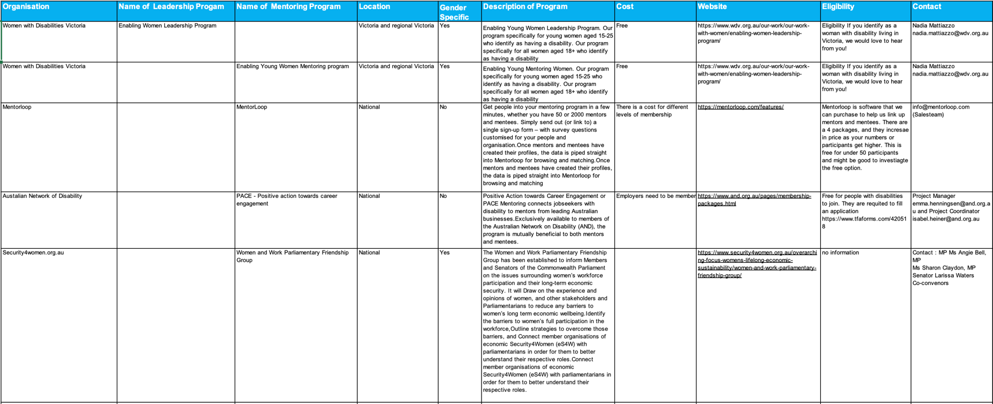

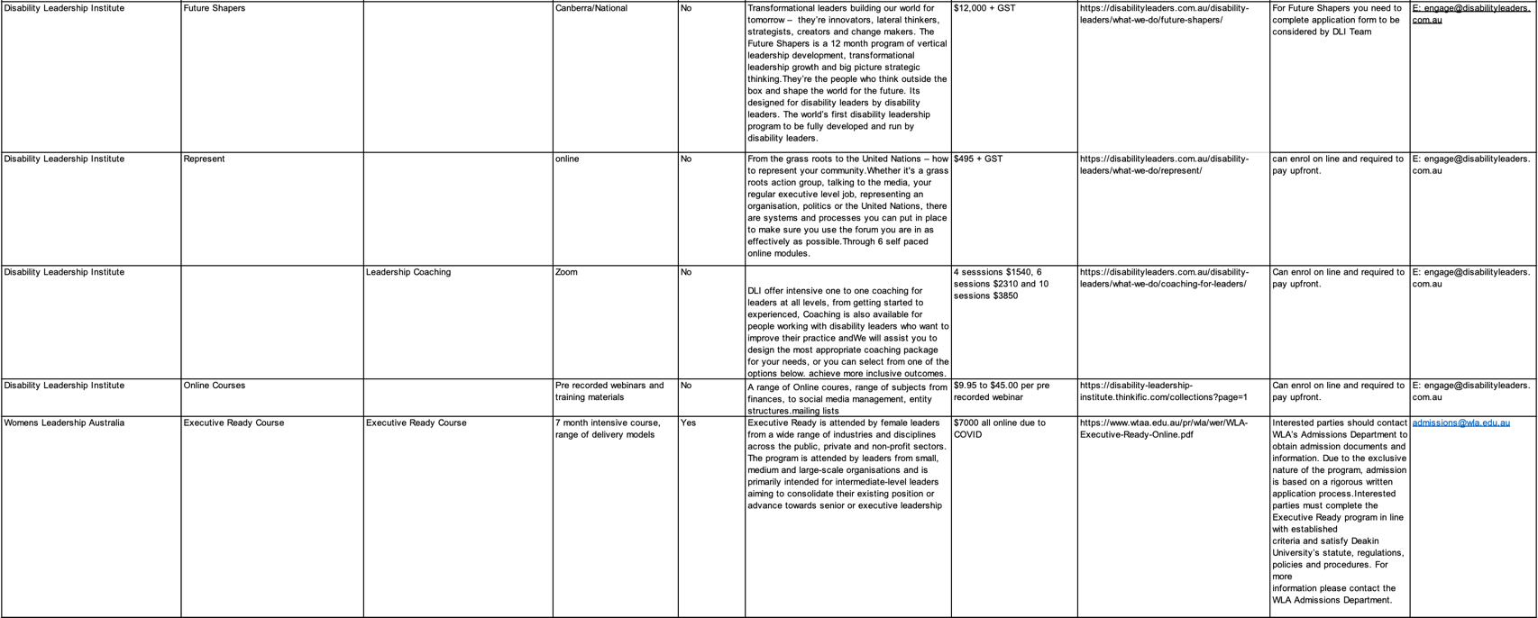
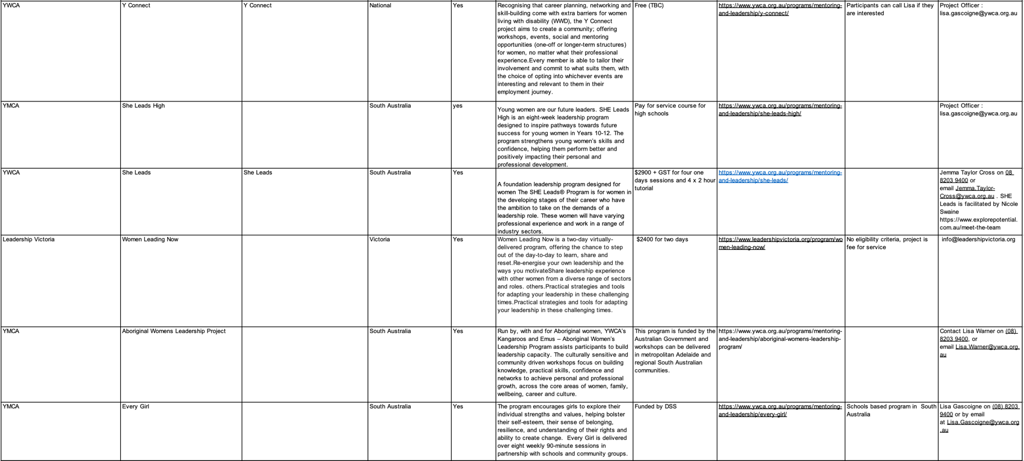

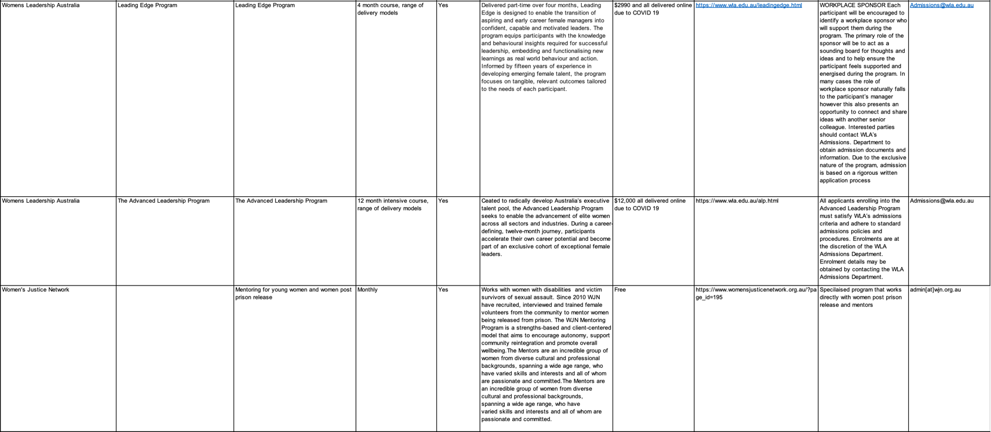
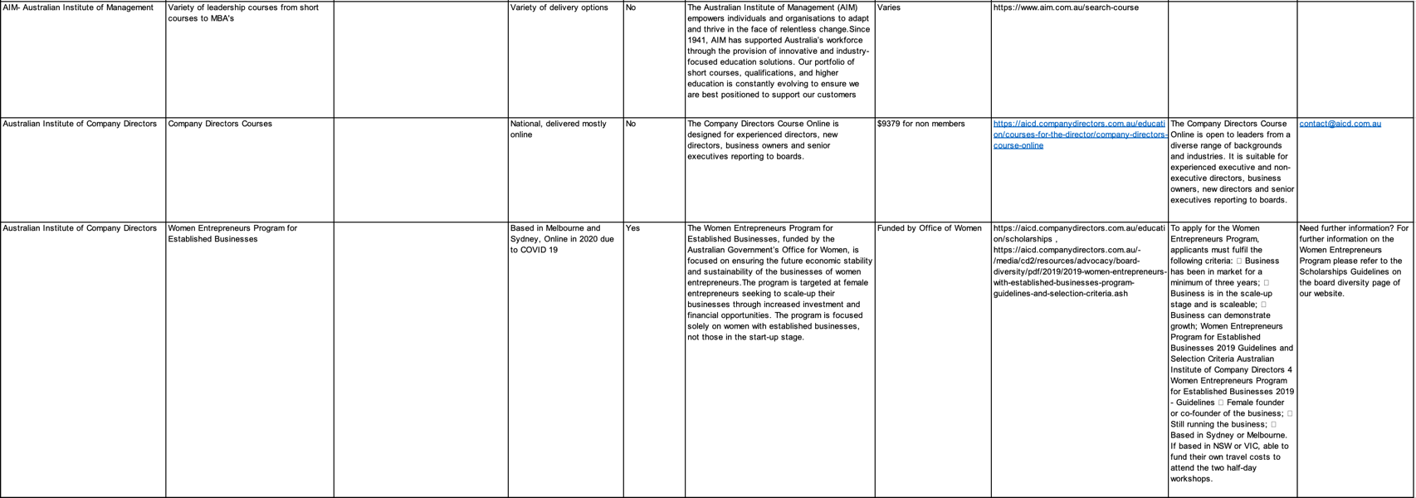
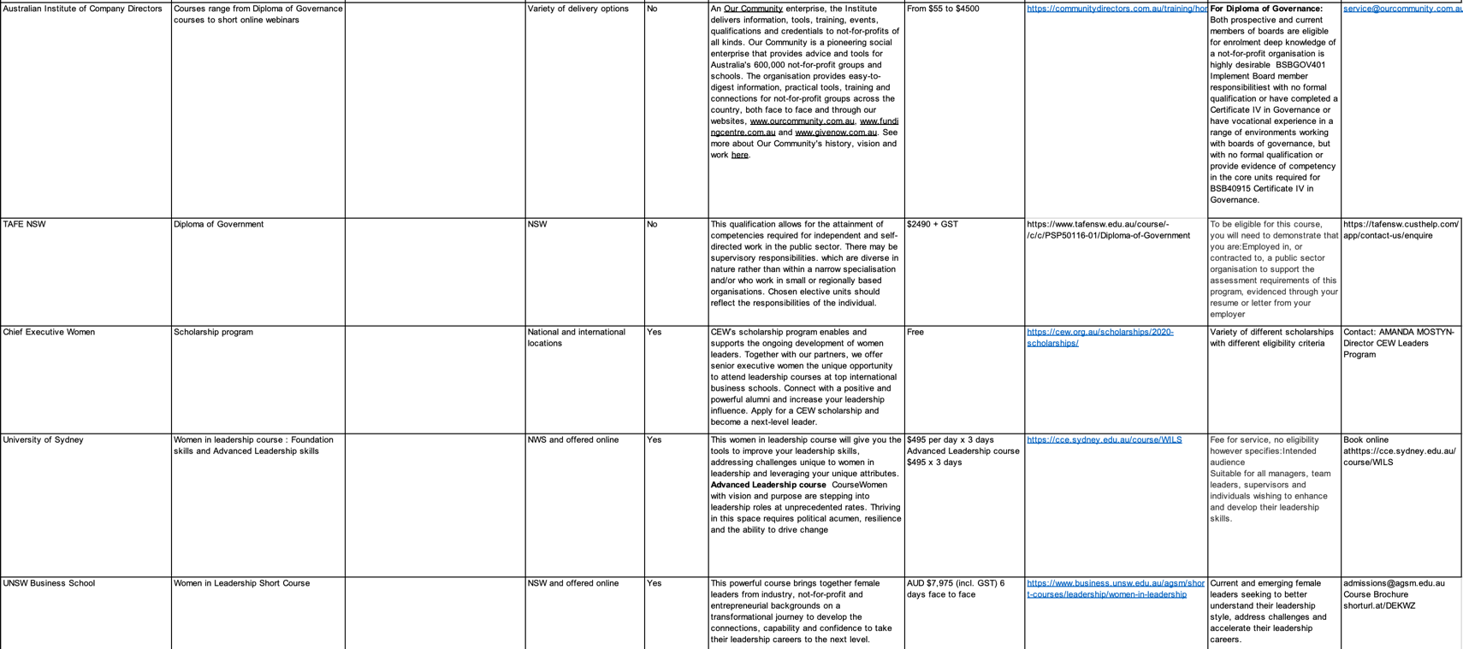
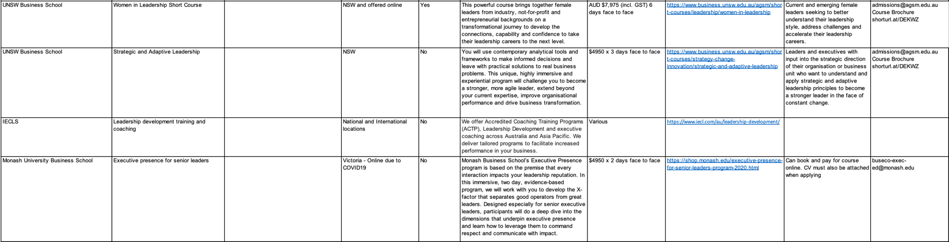

Appendix 3: WWDA LEAD Scholarship Application Form

WWDA LEAD Scholarships Application Form

- Consent: I consent to sharing my personal details with WWDA. I am aware that I can stop filling in this form at any time. I am answering these questions as a woman, girl, feminine identifying or nonbinary person with disability who is over the age of 15 years and a WWDA Member.
  - Yes
  - No
- What is your name?
  - __________________________________________________________
- What is your email address?
  - __________________________________________________________
- What is your address?
  - __________________________________________________________
- What is your postcode?
  - __________________________________________________________
- Can you tell us why you would like to be involved in the WWDA LEAD Scholarship program?
  - __________________________________________________________
__________________________________________________________
__________________________________________________________
__________________________________________________________
- What is the most important issue/s that you would like to learn about or take action on that affects women, girls, feminine identifying and non-binary people with disabilities?
  - __________________________________________________________
__________________________________________________________
__________________________________________________________
__________________________________________________________
- What is the name of the training provider and course that you would like to take part in?
  - __________________________________________________________
__________________________________________________________
__________________________________________________________
__________________________________________________________

- How do you think taking part in a leadership or training course would help you to do this?
  - __________________________________________________________
__________________________________________________________
__________________________________________________________
__________________________________________________________
- What is the cost of course (Up to $3000 including GST)?
  - __________________________________________________________
- What are the dates of course? (Start and Finish)
  - __________________________________________________________
- By the end of the WWDA LEAD Scholarship opportunity what do you want to have achieved?
  - __________________________________________________________
__________________________________________________________
__________________________________________________________
__________________________________________________________
- How do you think this course may help WWDA or the work that WWDA does?
  - __________________________________________________________
__________________________________________________________
__________________________________________________________
__________________________________________________________
- Do you have access and support needs?
  - Yes
  - No
  - I don’t know, can I speak with someone?
- If yes, what are your access and support needs?
  - __________________________________________________________
__________________________________________________________
__________________________________________________________
__________________________________________________________
- Thank you for your interest. Are there any other comments you would like to add?
  - __________________________________________________________
__________________________________________________________
__________________________________________________________
__________________________________________________________

Appendix 4: WWDA LEAD Mentoring Program Application Form

WWDA Lead application form

Thank you for showing interest in the WWDA LEAD program

Name:__________________________________________________
Organisation (if applicable):___________________________________
Postal Address:____________________________________________
_________________________________________________________Postcode:_______________________State:_____________________
Phone:_________________________
Email:____________________________________________________

Are you a current WWDA Member: ı Yes ı No

**Please note you will need to sign up to be a WWDA member to take part in the LEAD program**
**Please note that you will need to identify as having a disability to participate**

To sign up please click here WWDA Membership form

Access & Support Details

To enable us to ensure your access and support needs will be met, please fill out the details below.

Communication

I will require an Auslan interpreter: | Yes | No
I will require other communication support (please specify)
__________________________________________________________________________________________________________________

I have no specific communication requirements

Selection Criteria

Selection of participants will be based on the answers to these questions.

If you require more space, please attach further sheets.

- What are your personal objectives for wanting to do the WWDA Leadership & Mentoring Workshop?

- Are you a member of any State/Territory WWDA Group or other State/Territory disability organisations? If so, which groups/organisations are they?

- By the end of the WWDA Leadership & Mentoring program, what do you want to have achieved?

- What would you like to get from a mentoring relationship?

- What area would you like to be mentored in? (eg: running support groups; doing representation work; writing submissions, etc)

- In what ways might you be able to further the work of WWDA after the leadership program

- What current resources do you have to further the work of WWDA? (eg: willingness, commitment, time, particular skills etc)

- What additional resources would you need in order to further the work of WWDA? (eg: training skills, policy writing skills, administration skills etc).

- Do you have any other comments you wish to make?

Contact Us

If you require any further information you can contact us in the following ways.
- Email us at Libbi
- Call us on Libbi
- Use TTY to contact us/or NRS
- Send a letter to PO Box 407, Lenah Valley, Tasmania 7008, Australia

