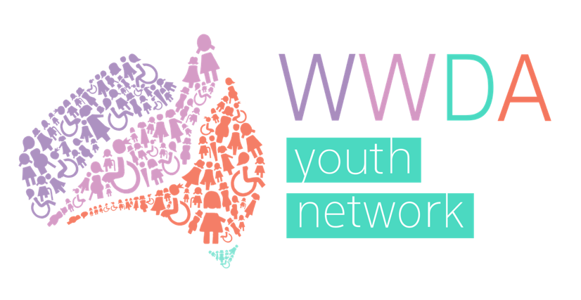

Women With Disabilities Australia

Youth Advisory Group

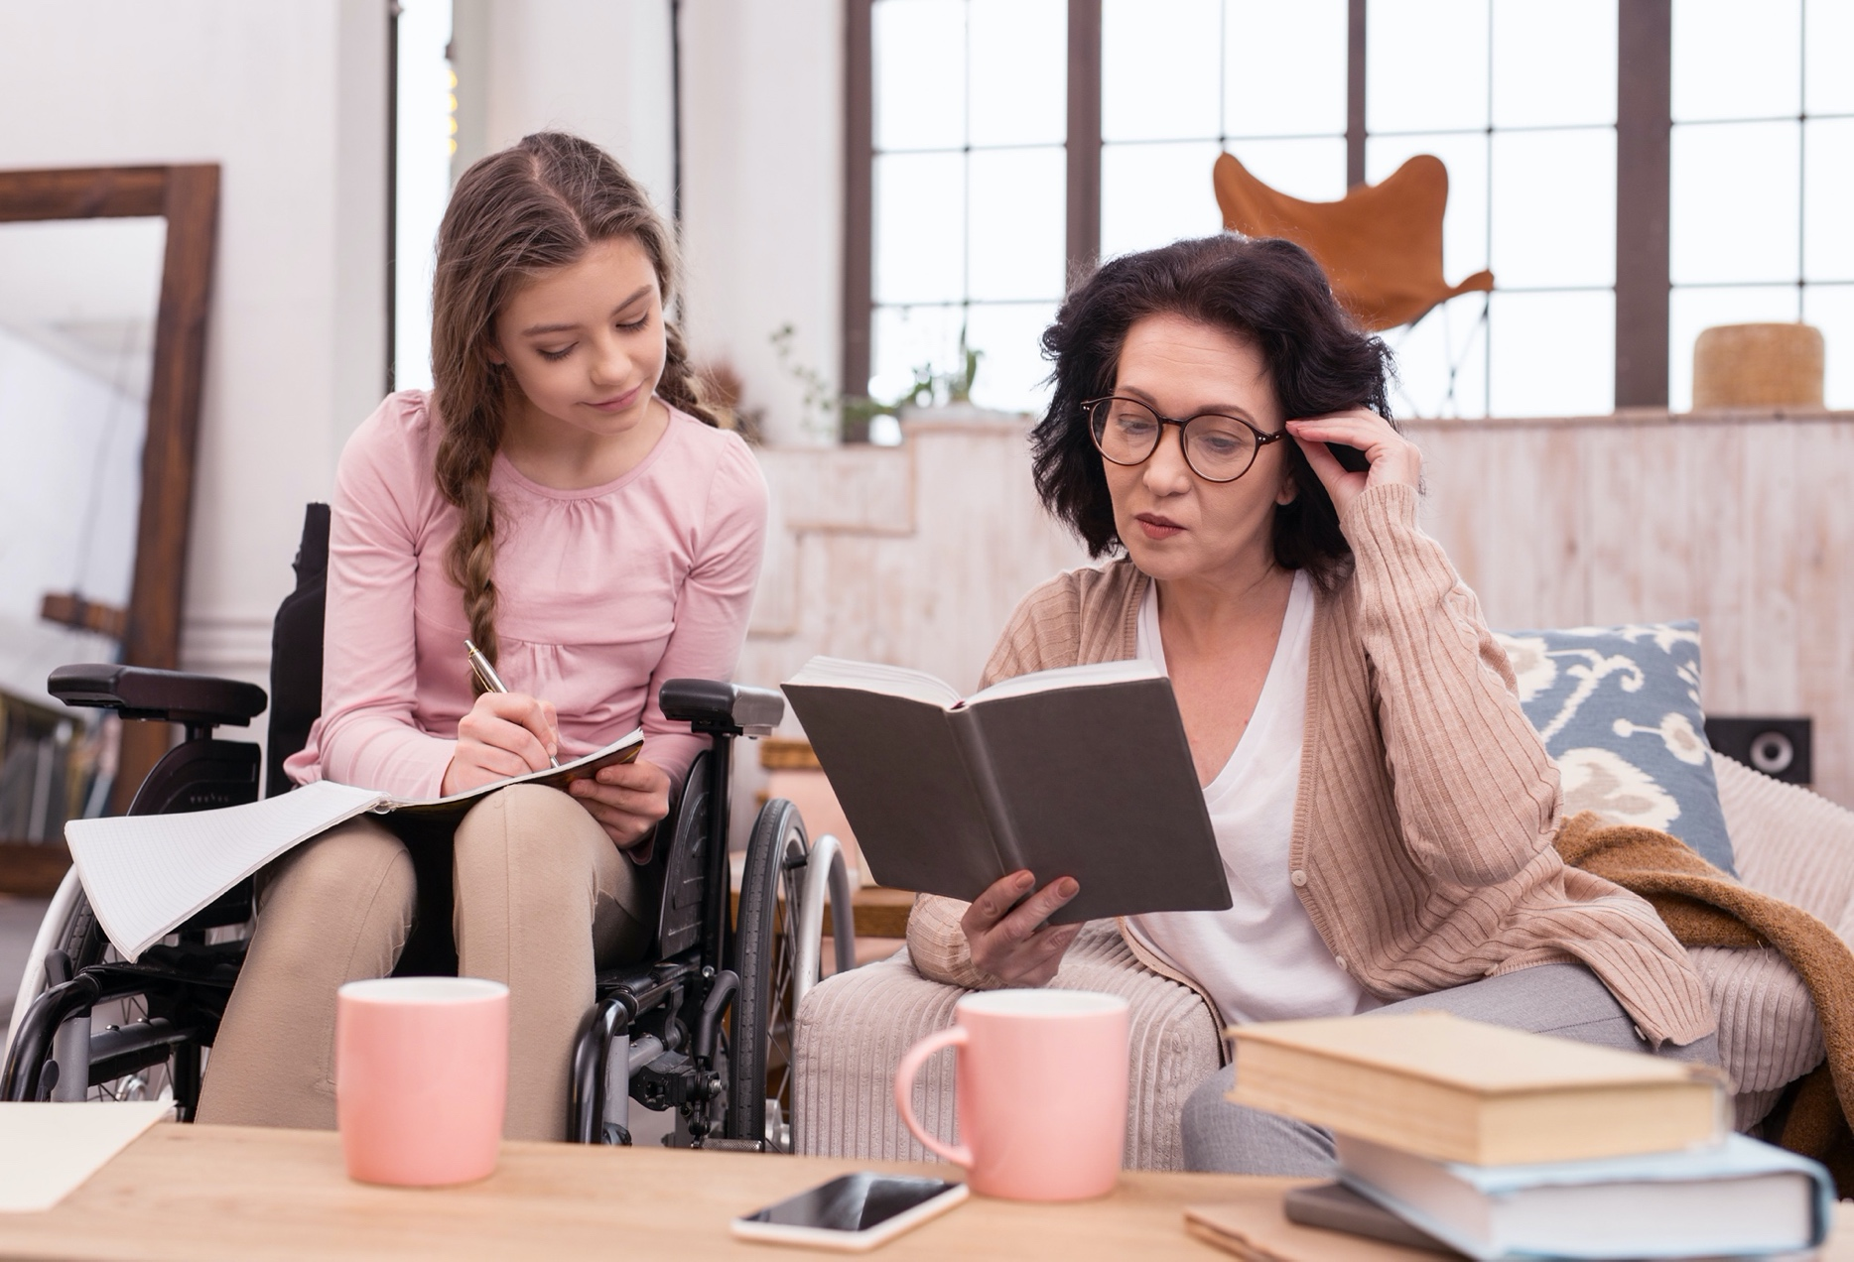
Terms of Reference 2024

Introduction and Background
The WWDA Youth Network is an initiative of Women With Disabilities Australia (WWDA) aimed at providing a voice to young women, girls, feminine identifying and non-binary young people with disability aged of 15-30.

The objectives of the WWDA Youth Network are to:
- Actively promote the inclusion and empowerment of young women, girls, feminine identifying and non-binary young people in all areas of life;
- To advocate for the issues and needs of young women, girls, feminine identifying and non-binary young people with disability in Australia while engaging with people outside of the Network;
- To educate and build the capacity of young women, girls, feminine identifying and non-binary young people with disability on their rights and options by:
a. Creating accessible resources that empower young women, girls, feminine identifying and non-binary young people with disability to learn about and stand up for their rights
b. Keeping the community up to date with relevant news, events and opportunities in the disability and women’s sectors nationally and internationally;
c. Supporting young women, girls, feminine identifying and non-binary young people with disability to participate in leadership opportunities, public consultations and education.
d. Promoting the representation of young women, girls, feminine identifying and non-binary young people in disability, gender and other equality platforms.

The WWDA Youth Network was originally launched by WWDA in conjunction with the Minister Assisting the Prime Minister for Women, Senator the Hon. Michaelia Cash on 30 July 2015 at an event at the Australian Human Rights Commission (AHRC) in Sydney.

Cashelle Dunn was the founder of the WWDA Youth Network and managed the WWDA Youth Network between 2015 and 2018. With support from Federal Government grants, Cashelle ran a number of initiatives under the WWDA Youth Network, including developing a human rights toolkit for young women and girls with disability and launching the WWDA Youth Network website, Facebook page, Instagram and Twitter. Since 2018, the WWDA Youth Network had largely been stagnant due to a lack of resourcing and staff members. However, in 2020, WWDA has decided to re-activate the WWDA Youth Network, with the support of new grant funding and staff. The Youth Network has been operating steadily since 2020 with continuing support from the Department of Social Services and the Office for Women.

The role of the WWDA Youth Advisory Group
To drive the continued invigoration of the WWDA Youth network, WWDA assembles the WWDA Youth Advisory Group made up of a diverse cohort of young women, girls, feminine identifying and non-binary young people with disability aged 15-30 inclusive.
across Australia.
The role of the WWDA Youth Advisory Group is to provide advice to WWDA on the issues facing young women, girls, feminine identifying, and non-binary young people with disability across Australia.

Broadly, the WWDA Youth Network will work with WWDA staff to:
- identify issues facing young women, girls, feminine identifying, and non-binary young people with disability aged 15 to 30 inclusive.
- promote membership of the WWDA Youth Network to young women, girls, feminine identifying, and non-binary young people with disability between the ages of 15-30
- identify information and resources that are needed among young women, girls, feminine identifying and non-binary young people with disability and develop these resources for the wider WWDA community.
- participate in relevant government and non-government consultations and forums.
- contribute to the maintenance of WWDA Youth Networks social media pages, including Facebook, Twitter, and Instagram
- identify, plan, and implement other activities in which the WWDA Youth Network could be involved.

The role of WWDA
Activities of the WWDA Youth Advisory Group will be managed by WWDA’s part-time Youth Development Officer, Claire Bertholli. The group is also supported by WWDA’s full-time Policy Officer, Sophie Cusworth and WWDA’s other project staff.

When the Advisory Group is operating; WWDA staff will provide the administrative support and resourcing required to support the group to:
- take part in bi-monthly formal meetings.
- run broader online consultations on issues impacting young women, girls, feminine identifying, and non-binary young people with disability aged 15 to 30 inclusive.
- take part in training courses and opportunities that build leadership and advocacy skills
- take part in relevant government and non-government consultations and inquiries.
- develop information and resources for the for the WWDA website , the WWDA Youth Network social media and WWDA Our Site, and other WWDA Projects being developed.
- take part in other activities which support the rights and empowerment of women, girls, feminine identifying and non-binary young people with disability between the ages of 15-30.

WYAG members will be expected to attend all formal meetings. If a member misses THREE consecutive Bi-monthly meetings without communicating their absence to the WWDA staff team, the WWDA team reserves the right to determine these members position on the WYAG as vacant.
- When an WYAG member misses TWO Bi- monthly meetings in a row without offering an apology, the youth development officer will send the member a wellbeing check -in email to gauge their capacity to continue in WYAG.
- When an WYAG member misses THREE bi monthly meetings in a row without offering an apology, They will be sent an email alerting them that their position in the WYAG Has become vacant due to non-attendance.

Structure and Membership
The WWDA Youth Advisory Group will consist of up to 15 young women with disability, who will meet once every two months via video conference for at least one year from April/ May 2024 to April/May 2025. An advisory group member will have their membership automatically extended every year without reapplying under the following conditions.

- until they turn 31 years of age.
- After they miss 3 consecutive bi- monthly WYAG meetings with no apology/explanation.
- If they resign at any time from the advisory group in writing/verbally/by their preferred communication style to Claire Bertholli WWDA Youth Development Officer.

Meetings will be coordinated and chaired by WWDA’s Youth Development Officer, Claire Bertholli. With the permission of members, meeting will also be recorded for the purpose of minute taking / notes.

WWDA commits to circulating a meeting agenda and all required reading for the meeting one week prior to the meeting date. Meeting dates will be set at least one month in advance. Meeting minutes will be circulated no later than two weeks after the meeting takes place.

Outside of meetings, WWDA Youth Advisory Group may be asked to take part in discussions over email, or another agreed upon platform. Members will also be given opportunities to take part in additional events and forums as representatives of the WWDA Youth Advisory Group.

Membership Criteria
The WWDA Youth Advisory Group will consist of up to 15 young women, girls, feminine identifying and non-binary young people with disability aged 15-30.

Expressions of interest to join the WWDA Youth Advisory Group are open to all young people with disability aged 15 to 30 years who identify as female, non-binary, gender fluid or transgender.
All WWDA’s work is grounded in a human rights framework. WWDA practices intersectional feminism and will aim to ensure WWDA Youth Advisory Group members are representative of the needs and views of a diverse range of young women and girls with disability in Australia. For this reason, WWDA will be reserving 3 of the 15 positions on the advisory group for young women with disability who identify as Aboriginal or Torres Strait Islander individuals. WWDA also strongly encourages young women with disability are who from culturally and linguistically diverse, migrant and refugee backgrounds, living in remote, rural or regional areas and /or identify as LGBTIQA+ to apply.
Remuneration
As a feminist disability organisation, WWDA values the time and contributions of all individuals. In recognition of this, WWDA will remunerate all WWDA Youth Advisory Group members, or the organisations they represent for their participation at a rate of $50 per hour per meeting. This may be in the form of gift vouchers or via the payment of an
invoice.

Any Questions or Feedback
Contact Claire Bertholli WWDA Youth Development Officer ydo@wwda.org.au

