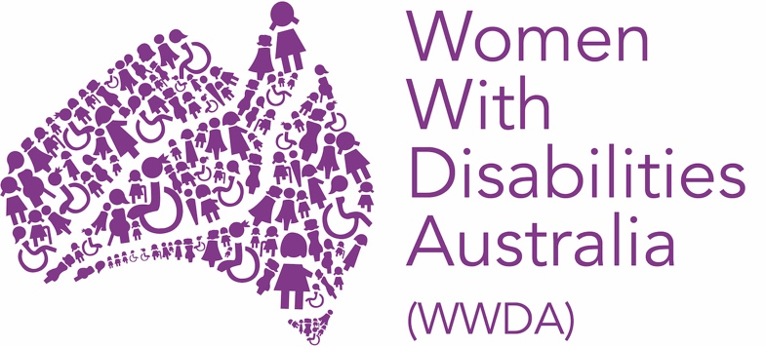

Expression Of Interest (EOI) for Board Director Position

Women With Disabilities Australia (WWDA) is the national Disabled People’s Organisation (DPO) and National Women’s Alliance (NWA) for women, girls, feminine-identifying, and non-binary people with disabilities in Australia. As a DPO, WWDA is run by and for women, girls, feminine identifying, and non-binary people with disability.
Representing over 2 million women and girls with disabilities in Australia, WWDA is recognised nationally and internationally for its leadership in advancing the rights and freedoms of all WGwD in Australia. Operating as a transnational human rights organisation, WWDA's work impacts beyond Australia, grounded in a framework linking gender and disability to civil, political, economic, social, and cultural rights.
WWDA seeks new members to join its Management Committee (Board). This is a volunteer position where you can help to shape the future of WWDA. The role of the WWDA Management Committee is to set the strategic direction of WWDA and to govern the organisation. This opportunity is perfect if you are a WWDA Member, are passionate about promoting the rights of women, girls and gender-diverse people with disabilities, have leadership or financial experience, and want to use your voice to help WWDA continue its work.

This is the Expression of Interest form. It will ask for information about you and your experience. You can submit your expression of interest by completing the online form, or sending this completed form by email to officeadmin@wwda.org.au.

First name:

Last name:

Email address:

Contact number:

Are you a woman or non-binary person with disability? Please answer yes or no:

Do you live in Australia? Please answer yes or no:
Have you been a Full Member of WWDA for at least 12 months? Please answer yes or no:
Under the provisions of the Corporations Act 2001, there are requirements on who can be appointed as a Member of the Management Committee.

Are you willing to obtain and maintain a National Police Check? Please answer yes or no:

Are you willing to obtain and maintain a Director ID? Please answer yes or no:

Can you confirm that you have not been declared bankrupt or insolvent? Please answer yes or no:

Why are you interested in being a member of the WWDA Committee of Management?

Can you share your experience as a woman or non-binary person with a disability, and how this has shaped your understanding of the barriers faced by women and girls with disabilities in Australia?

What is your understanding of WWDA’s mission and the services it provides to its members?

Please describe any previous experience you have serving on a Board or Committee. What key governance skills did you develop, and how would you apply them to the Management Committee at WWDA?

Can you please detail your specific finance related qualifications or experience? OR What skills or experience will you bring to the Management Committee?

Nominations must be endorsed by another WWDA Member. Who has endorsed your nomination?
Please include the first name and last name of the endorsing WWDA member.

Have you read the Board Member Position Description and do you understand the requirements, time commitment and responsibilities? Please answer yes or no:

--

A copy of your resume is required in support of your EOI. Please email a copy of this nomination form and your resume to: officeadmin@wwda.org.au to submit your expression of interest.

Thank you for completing this expression of interest for the Board Director positions with WWDA.

