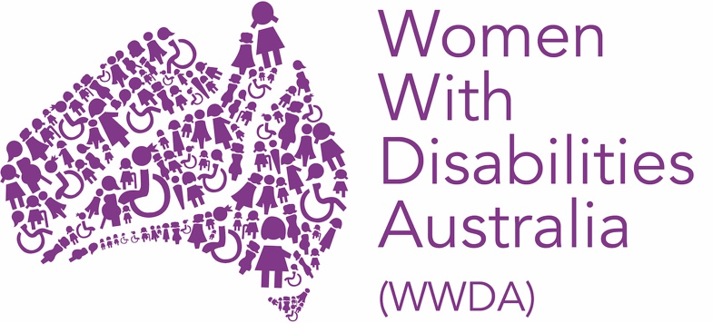

POSITION DESCRIPTION

POSITION DETAILS

Position title: | WWDA Management Committee Member (Volunteer Position)
Location of Meetings: | Management Committee (MC) meetings are held via Zoom.
Time Commitment: | Attendance at MC meetings held every month plus reading the meeting papers.  Attendance at the Annual General Meeting, held online in November each year.
Tenure: | Up to 9 years as per current Constitution
Current as at: | October 2024

The following position description may be updated periodically to reflect the evolving needs and priorities of WWDA. Where possible, changes will be made in consultation with the Board Member to ensure mutual understanding and agreement.

Women With Disabilities Australia (WWDA) is the national Disabled People’s Organisation (DPO) and National Women’s Alliance (NWA) for women, girls, feminine-identifying, and non-binary people with disabilities in Australia. As a DPO, WWDA is run by and for women, girls, feminine identifying, and non-binary people with disability. WWDA uses the term ‘women and girls with disability’ (WGwD) on the understanding that it is inclusive of women and girls with disability along with feminine identifying and non-binary people with disability.

Representing over 2 million women and girls with disabilities in Australia, WWDA is recognised nationally and internationally for its leadership in advancing the rights and freedoms of all WGwD in Australia. Operating as a transnational human rights organisation, WWDA's work impacts beyond Australia, grounded in a framework linking gender and disability to civil, political, economic, social, and cultural rights.

As such a member of the Management Committee must practice intersectional feminism, understand the human rights model of disability, and ensure WWDA's strategic direction reflects diverse WGwD voices in Australia. WWDA is membership-based, with work founded on co-design and consultation with its members.

SUMMARY AND BROAD PURPOSE OF THE POSITION

The role of a Management Committee Member for Women With Disabilities Australia (WWDA) is to contribute strategically to the governance and direction of the organisation, ensuring it adheres to its mission of advancing the rights of women and girls with disabilities (WGwD) across Australia.

This involves participating in the development and oversight of compliance, risk management and financial sustainability. Management Committee Members will support the recruitment, performance monitoring and development of the Chief Executive Officer (CEO), ensuring effective leadership.

By drawing on high-level communication, governance, and leadership skills, Management Committee Members will enhance WWDA’s national advocacy efforts and ensure alignment with its human rights-based framework and strategic objectives.

BOARD RESPONSIBILITIES AND DUTIES

On behalf of the members, the Management Committee of Women With Disabilities Australia (WWDA) is entrusted with the stewardship and long-term well-being of the organisation. The Management Committee holds ultimate responsibility for ensuring WWDA achieves its mission of advancing the rights and freedoms of women and girls with disabilities (WGwD).

In providing leadership and strategic governance, the Management Committee must:

- Establish and uphold the organisation’s purpose, values, goals and objectives.
- Identify and monitor the management of corporate risks.
- Develop, oversee, and regularly review WWDA's strategic direction, including the approval of strategic plans, annual budgets, financial objectives, significant capital allocations, and major initiatives.
- Monitor WWDA’s performance against established policies and criteria.
- Ensure adequate resources are available to achieve WWDA’s purpose, values, goals, and objectives, while effectively managing these through reliable financial systems.
- Recruit and support the Chief Executive Officer, providing constructive oversight of their performance.
- Ensure robust processes are in place for identifying, managing, and monitoring risks.
- Guarantee WWDA’s compliance with relevant laws and regulations, ensuring the organisation can meet its financial obligations as they arise.
- Facilitate mechanisms for consultation with members, ensuring ongoing accountability to them.

NON-EXECUTIVE DIRECTOR RESPONSIBILITIES

The Non-Executive Director Responsibilities for this role include but are not limited to the following:

- Understanding of Committee Member Responsibilities: Committee Members must possess a comprehensive understanding of their role, encompassing legal, ethical, fiduciary and financial responsibilities.

- Strategic Expertise: Committee Members should demonstrate the ability to critically assess the organisation’s strategy through constructive questioning and insightful suggestions, thereby contributing to the Management Committee’s effective decision-making processes.

- Financial Acumen: Committee Members must be capable of reading and interpreting WWDA’s financial statements and reports presented to the Management Committee, ensuring informed oversight of the company’s financial health.

- Legal Compliance: The Management Committee is tasked with overseeing compliance with various laws and regulations, necessitating a clear understanding of each Committee Member’s legal duties and responsibilities.

- Risk Management: Committee Members should have experience in identifying and managing significant risks that may impact the organisation.

- People Management and Change Implementation: Committee Members must be knowledgeable about contemporary management practices related to employment, branding, stakeholder engagement, strategic vision and communication, as well as having experience in executive remuneration and compensation strategies.

- Industry Knowledge: Committee Members are expected to have experience in similar organisations or sectors, enhancing their ability to provide relevant insights and guidance.

KEY RELATIONSHIPS

The expected key relationships for this role include but are not limited to the following:

- Management Committee Chair/President
- Other Management Committee Members
- Chief Executive Officer
- Chief Operating Officer and/or applicable Senior Management
- Members of Women With Disabilities Australia

EXPECTED COMPENTICIES

The expected competencies and/or personal attributes for this role include but are not limited to the following:

- Integrity: Committee Members are committed to fulfilling their duties and responsibilities with the highest ethical standards, prioritising the interests of members over personal gain.

- Collaborative, Curious and Courageous: Effective Committee Members function well within a team environment while demonstrating the curiosity to ask probing questions and the courage to engage in meaningful discussions with management and fellow Committee members when necessary. Committee members must demonstrate strong interpersonal skills, and are expected to actively listen and communicate tactfully, presenting their viewpoints clearly and honestly.

- Active Contribution: Committee Members are expected to actively engage with a genuine interest in WWDA and its mission, consistently contributing to the organisation's strategic objectives and initiatives.

REQUIREMENTS AND SELECTION CRITERIA

In order to be eligible, nominees must:

- Be a woman or non-binary person with disability;
- Live in Australia;
- Have been a Full Member of WWDA for at least 12 months; and
- Meet the requirements of relevant laws, including the Corporations Act.

Under the provisions of the Corporations Act 2001 there are requirements on who can be appointed as a Member of the Management Committee. Requirements for this role include but are not limited to the following:

- Obtain and maintain National Police check
- Obtain and maintain a Director ID
- Not have been declared bankrupt or insolvent

Ensuring that we have a skillset that is representative of not only the mission of WWDA, but the skills required to strategically move WWDA forward, we are specifically looking for Directors that have governance and finance experience.

Successful candidates will be required to sign a Committee of Management Code of Conduct.

