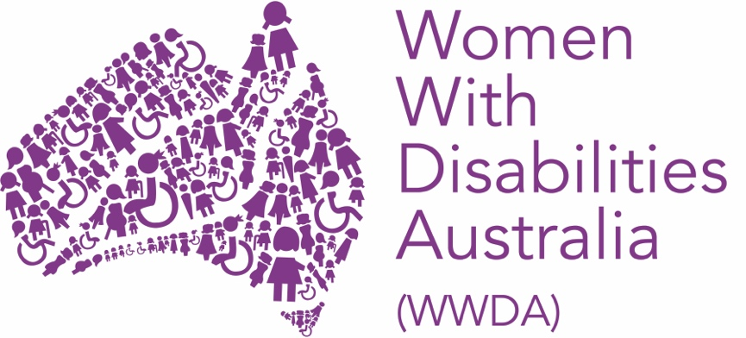

WOMEN WITH DISABILITIES AUSTRALIA (WWDA)

Asia Pacific Feminist Forum

Post-Event Report

September 2024

PUBLISHING INFORMATION

Women With Disabilities Australia (WWDA) (2024). ‘Asia Pacific Feminist Forum Post Event Report’ September 2024. WWDA: Hobart, Tasmania.

Acknowledgments

WWDA acknowledges the traditional owners of the land on which this publication was produced. We acknowledge Aboriginal and Torres Strait Islander people’s deep spiritual connection to this land. We extend our respects to community members and Elders past, present and emerging.

This document was written by Clare Gibellini, for and on behalf of Women With Disabilities Australia (WWDA).

Women with Disabilities Australia (WWDA) receives part of its funding from the Australian Government, Department of Social Services (DSS) and the Office for Women (OFW). WWDA acknowledges and thanks DSS and the OFW for its support.

Contact

Women with Disabilities Australia (WWDA)
PO Box 407, Lenah Valley, 7008 Tasmania, Australia
Phone: +61 438 535 123
Email: officeadmin@wwda.org.au
Web: www.wwda.org.au
Facebook: www.facebook.com/WWDA.Australia
Twitter: www.twitter.com/WWDA_AU

Disclaimer
The views and opinions expressed in this publication are those of Women with Disabilities Australia (WWDA) and not necessarily those of our funding bodies or the Australian Government.

CONTENTS
WOMEN WITH DISABILITIES AUSTRALIA (WWDA) 1
PUBLISHING INFORMATION 2
Acknowledgments 2
Contact 2
Disclaimer 2
INTRODUCTION 4
KEY ACTIVITIES 6
1. Preparatory activities, meetings, and webinar 7
2. Official program and related activities 8
3. Attendance at parallel and side events 12
5. Other Activities 16
Conclusion: Key Outcomes and Benefits 18

INTRODUCTION

In September 2024, Women with Disabilities Australia (WWDA) staff member Clare Gibellini attended the 4th Asia Pacific Feminist Forum (APFF) held in Chiang Mai, Thailand from the 11th to 14th, as a delegate on behalf of WWDA.

The Asia Pacific Feminist Forum (APFF) first came into being in 2011, as an outcome of different conversations between APWLD and their members regarding the scarcity and near non-existence of feminist organising spaces in Asia and the Pacific. This meant that outside of international spaces, feminists in the regions lacked the kind of convening space which would allow them to exchange knowledge and skills, learn about various movements and resistances, and build feminist solidarities and friendships with each other. The first APFF took place in Chiang Mai, Thailand in September 2011.

Since then, the APFF has been organised by APWLD as a tri-annual event which brings together feminists, activists, and women’s human rights defenders (WHRDs) from all regions of Asia and the Pacific, to participate in a three-day feminist convening. In those three days, feminists come together to celebrate collective achievements, deepen feminist knowledge, and strengthen linkages and solidarities with each other. The APFF does not take place in a vacuum, and each APFF theme is defined by the context of the world we are living in, a structural analysis of the issues we face, and the systemic forms of oppression which are the driving force behind these issues.

Each APFF has an overarching theme, with a framework that guides the opening plenary for each day. APFF4 used the Anger-Hope-Action framework, with Day 1 guided by ‘Where We Are’ (Anger), Day 2 by ‘Where We Want Be’ (Hope), and Day 3 by ‘How We Get There’ (Action). Each day’s opening plenary sets the tone for the rest of the day, which is filled with different workshops, as well as side-events. The APFF seeks to bring to life feminist ways of work and play, and side-events include the Solidarity Space where participants can come together to plan and organise solidarity actions like protests and strikes; the Wellness Space which runs workshops and activities focused on sustaining our own energies, as well as sustaining a movement, through feminist wellness; the Feminist Bazaar where indigenous women’s crafts are brought in by members to promote women artisans, and the Really Free Market which supports exchanging unwanted items for other goods, to counter the consumerist ways of living promoted by capitalism; and a childcare space for participants with children. Art, music, dance, performance, and literature are an essential part of the APFF

Clare joined advocates from Pakistan and Nepal to develop and deliver a workshop entitled “Nothing About Us Without Us: Feminist Ways of Knowing and Being Included” on day one of the conference.

This was Clare’s first attendance at APFF, and her participation allowed her both to solidify her international and Australian connections, broaden her networks, gain new skills, and solidify her existing expertise.

KEY ACTIVITIES

Clare participated in APFF through multiple avenues, including in person workshops, adding to collective exhibitions, as well as attending the official program of meetings and events. These activities are outlined below.

1. Preparatory activities, meetings, and networking.

Prior to attending the conference, WWDA delegate Clare participated in several meetings organised by the National Forum for Women with Disabilities (NFWWD), to discuss the collective attendance at APFF of representatives, and development of the workshop. These sessions included information on the conference, who would be attending, internationalising our issues and unpacking the themes of the conference.

Prior to the start of the Conference, Clare attended a Welcome Dinner hosted by the Asia Pacific Forum on Women, Law and Development. It was a fantastic event attended by many delegates and provided an excellent opportunity for discussions and networking.

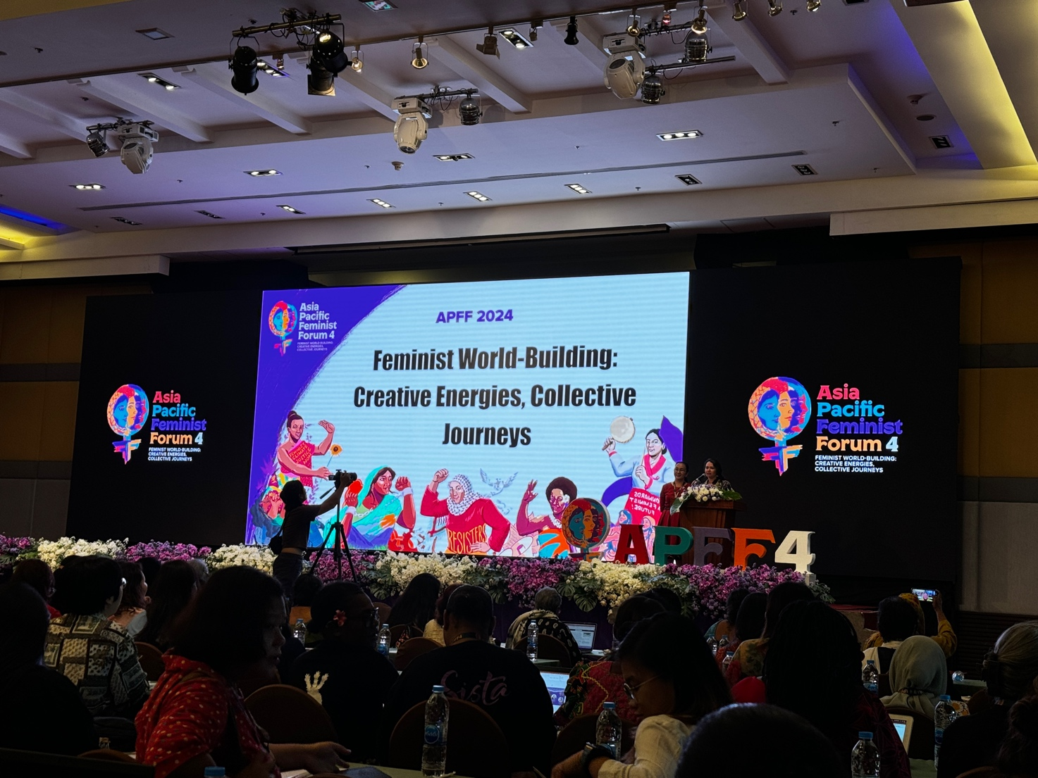
Photo: Opening of the Asia Pacific Feminist Forum 4

2. Official program and related activities

Day One – Plenary “Where We Are”

Thursday the 12th of September saw the commencement of the full conference, and there were many fantastic speakers in the opening plenary. This session looked at “Where We Are”, and discussed the impact of political crises, systems of oppression, and rising fundamentalisms. Key speakers highlighted the role of corporate capture, militarism, and imperialism in exploiting resources and undermining social justice.

Azra Talat Sayeed emphasized the need to address militarism and its impact on children and communities. Sarala Emmanuel discussed the IMF's austerity measures in Sri Lanka, affecting women's economic rights. Theresa Arriola from the Northern Mariana Islands highlighted US militarization's impact on local communities. Kyungjin Oh from South Korea addressed the backlash against women's rights, and Zainah Anwar from Malaysia stressed the importance of challenging religious fundamentalism in women's rights advocacy.

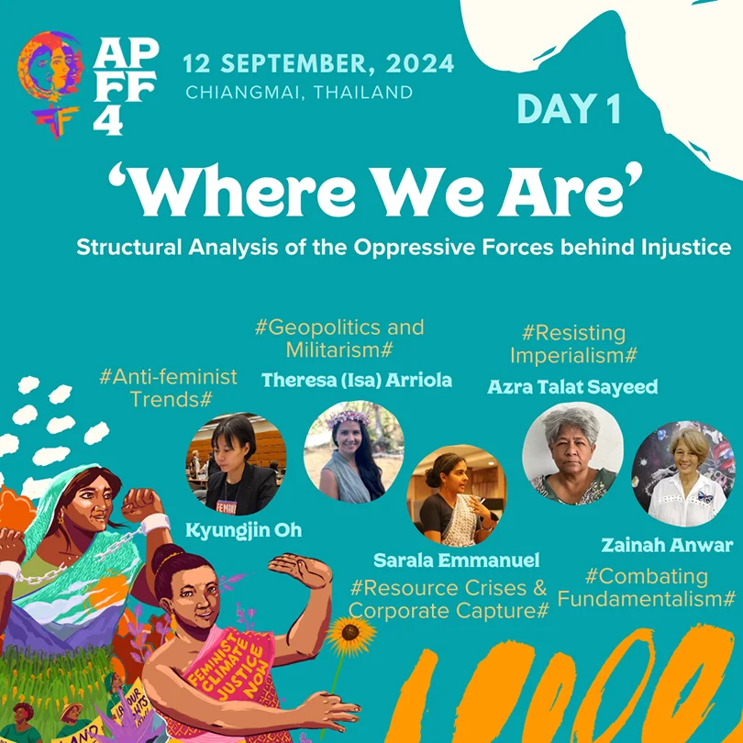
Photo: Plenary Speakers from Day 1 “Where We Are”

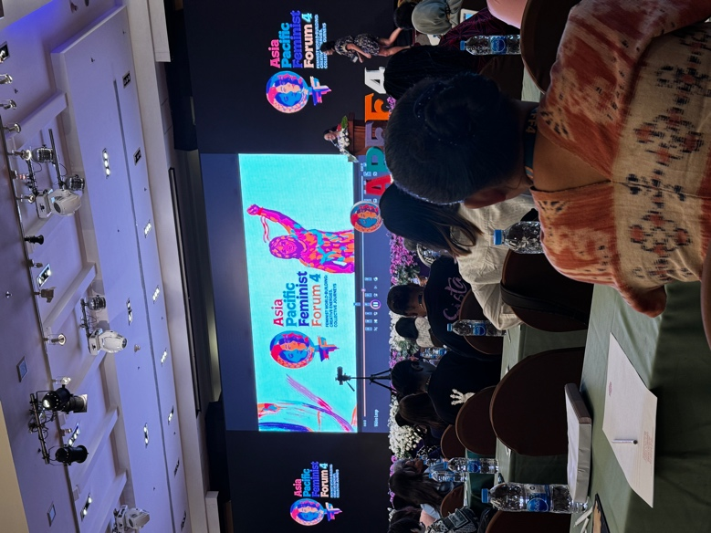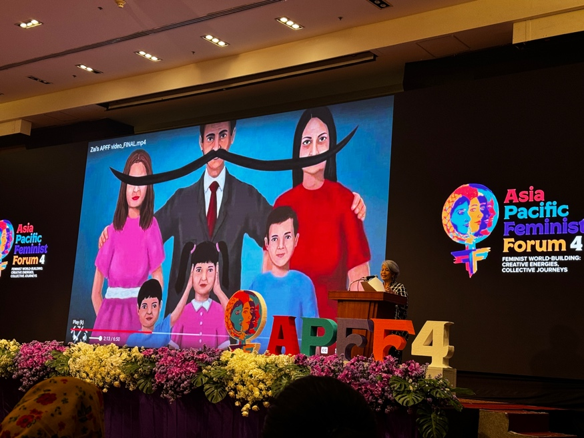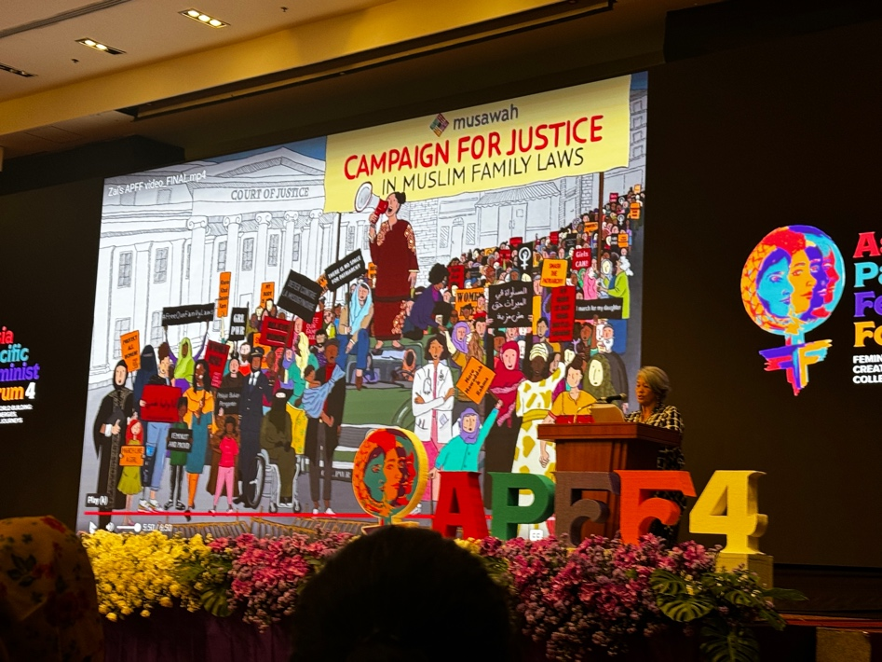
Photos: Opening Plenary Speakers Day One

Day One - Workshops
Reconfiguring Perceptions: Women’s Bodies as Enraged/ing Sites of Resistance
In this workshop, attendees learnt about reclaiming rage as a complex social, physiological, psychological, and emotional phenomenon. The main objective of the workshop was to convene a space to create an ideological impetus to disrupt the day-to-day representation of ‘feminine’ rage, and to use it effectively towards a path of solidarity. We discussed accessing rage and working with it rather than against it; to de-stigmatise, decolonise, and reclaim the severed emotion, thereby designing a collective imagination of feminist futures.
From the Abstract:
Rage is primarily seen as a destructive or negative emotion. For the lack of available research on experiences of rage by non-binary/gender fluid individuals, we will try to mostly articulate rage in its gendered relations. Reception of expression of rage by men is usually seen as powerful, whereas, for women, it is regarded as selfish and destabilising. The gendered reception of rage makes anger a taboo.
Through a series of questions and exchanges, we seek to open up conversations on how one perceives their rage, and how one experiences it in relation to the larger social expectations of the neo-liberal economy that define how women must present their emotions. This would be a meaning-making exercise, one that encompasses questions of civility, sanity, and normality as framed in a heteronormative, phallocentric society that describes the global neoliberal order.
How does one become (or rather is made) civil, sane, and normal versus insane, uncivil, and abnormal with fearless expression of rage, discomfort, and pain that is one’s own and at the same time, of generations of women? What is the significance of such rage in stirring great movements and building cross-regional solidarity?
The workshop takes up these questions, narrowing them down to localised expressions and interpretations of female rage, thus, challenging the participants to think outside the colonial categories of ‘civility’ and ‘sanity’. These questions can open up a gamut of conversations and self-reflective exercises on the stigma that is imposed upon and thereby reproduced on the bodies of women in cultures with a history of colonial influence.
Clare was able to share ways in which women with disability have been further marginalised when expressing their anger. Like many multiply-marginalized communities, we have been historically chastised when we react to oppression with fury. Much like trans people fought against police brutality at Stonewall, it was seen as a riot rather than a protest; when women with disability fight for the right to regulate their own bodies, they are accused of behaving irrationally.

People are most comfortable with us when we are not talking about the injustices that we face within a world that is not built around the needs of the disabled community. Society prefers we talk about how we overcome our obstacles and how they, too, can be resilient like us! When we are smiling and happy, we are the perfect role model, the disabled women they allow to participate out of the goodness of their hearts, as a way to give back to the less fortunate.

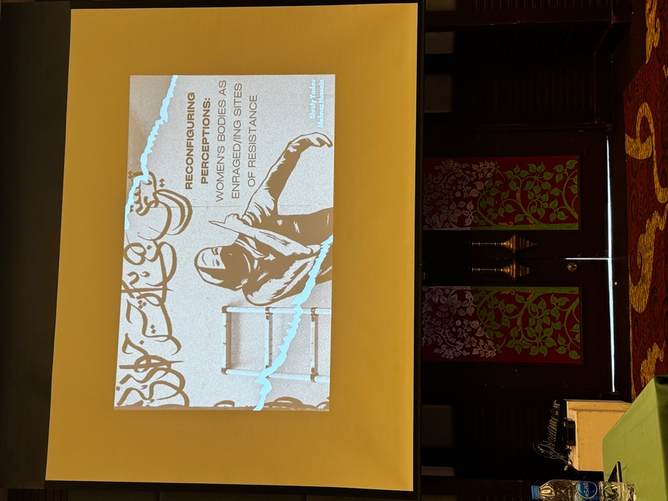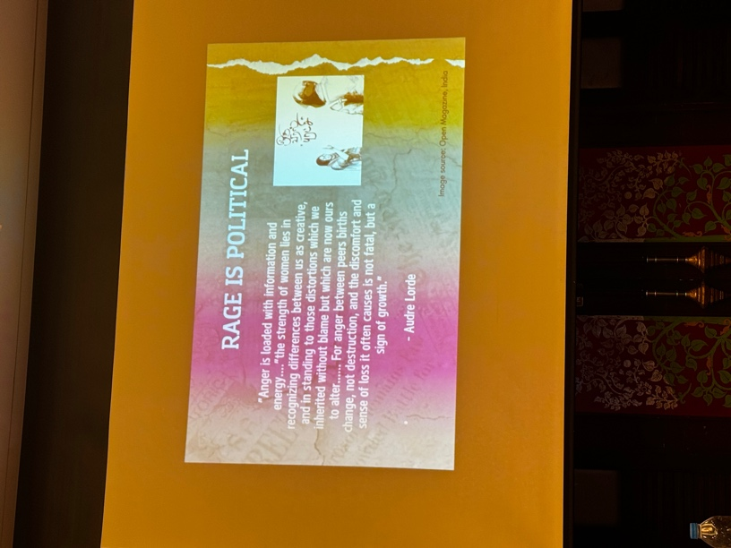
Photos: Workshop “Reconfiguring Perceptions”

Nothing About Us Without Us: Feminist Ways of Knowing and Being Included

This joint side event with the National Forum of Women With Disability (NFWWD), Federation of Women with Disability Nepal (FWDN) and Women with Disabilities Australia (WWDA) looked at the
integration of a gender perspective into institutional frameworks. We discussed how the global agenda depends on diverse self-advocate leadership, how gender equality and empowerment of women (GEEW) needs a disability perspective, and disability rights need a gender perspective. Finally, we discussed how sustainable development must prioritize intersectionality and real inclusion, including accessibility and reasonable accommodation for women with disabilities.

Key questions:
1. What accountability mechanisms can women self-advocates with disabilities use to promote their rights to participation in political life and accessibility to signatory governments of the CRPD and CEDAW?
2. How can resource mobilization and institutional reform lead to more comprehensive data collection on gender and disability? What are effective ways to include/consult women with disabilities in monitoring and evaluation processes?
3. In recent years, the frequency and intensity of humanitarian emergencies, including natural disasters and conflict situations, have increased. How can inclusive decision-making and self-advocate leadership help mainstream the rights and needs of women and girls with disabilities in times of crisis?

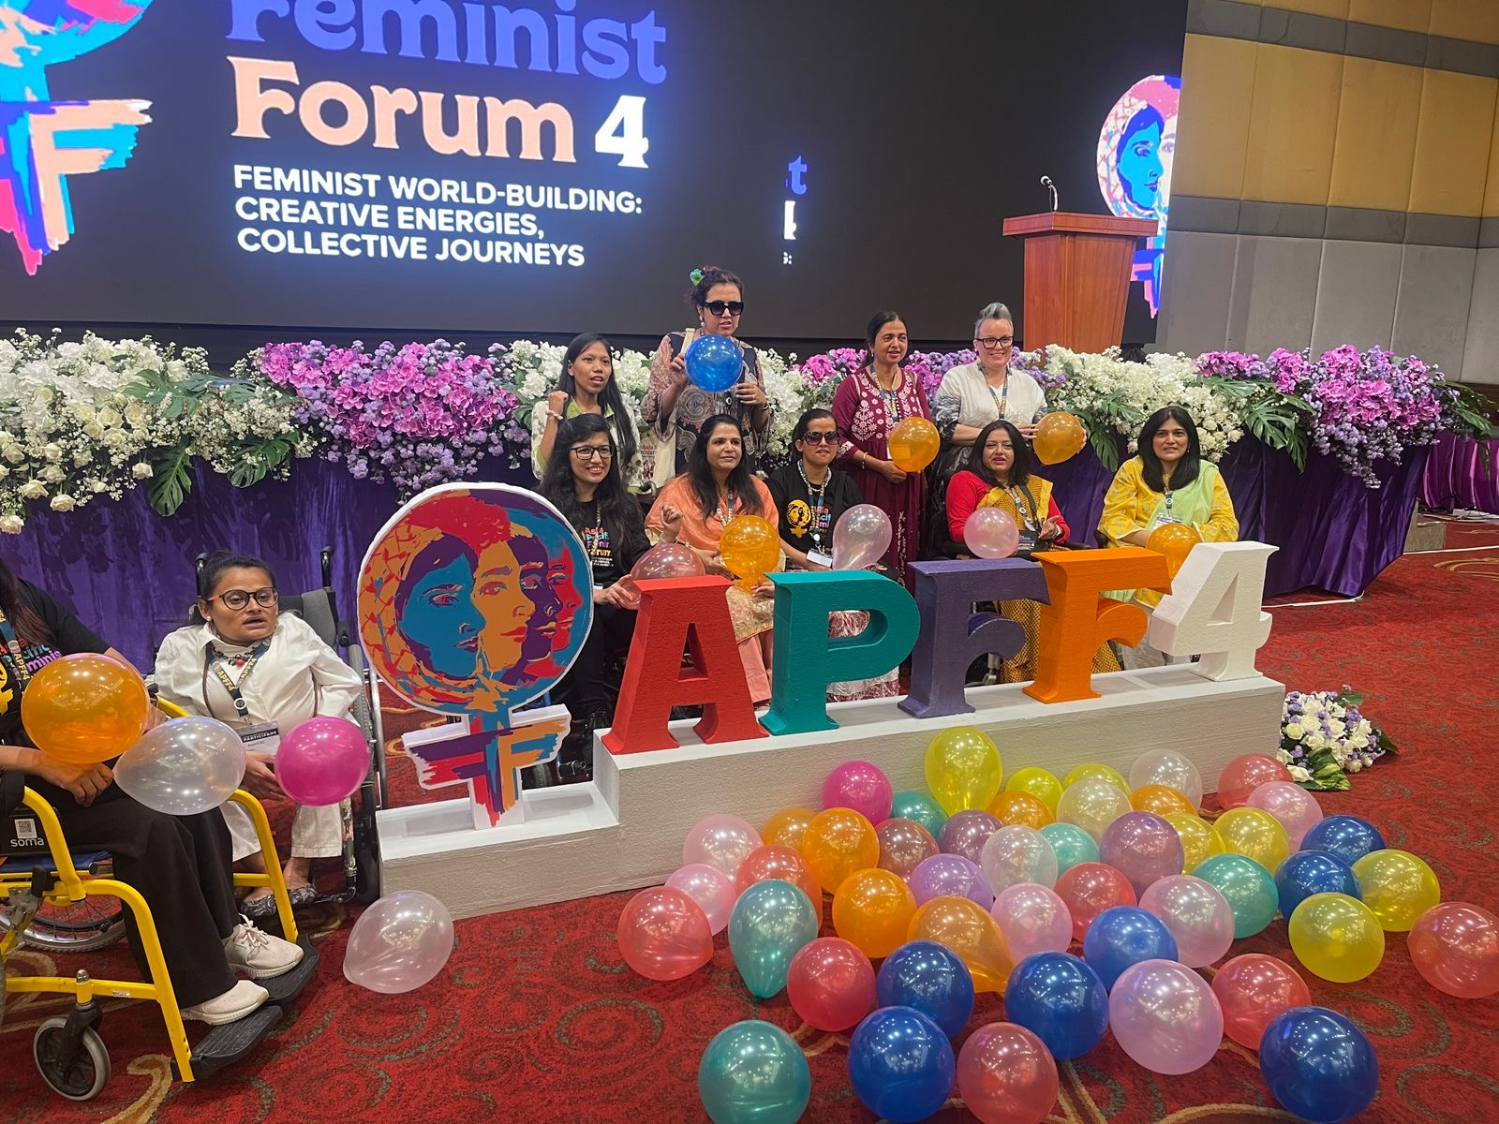

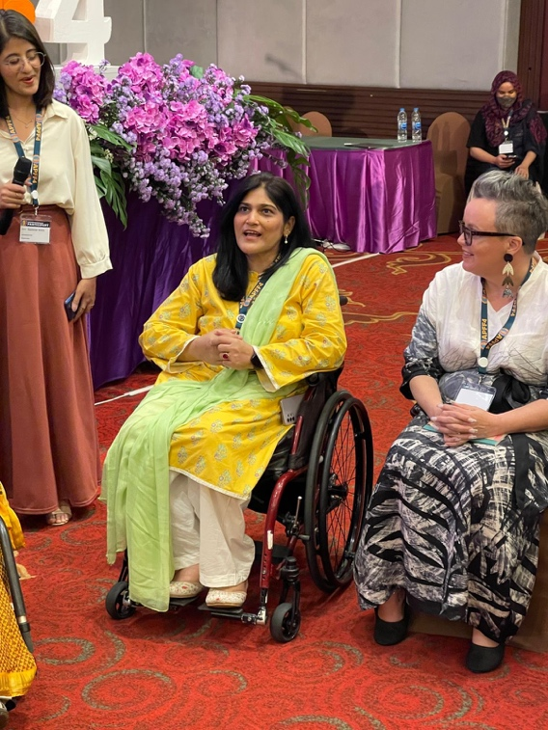
Photos: Workshop “Nothing About Us Without Us”

Day One - Networking Events

Immediately after the side event, the three organisations hosted a networking meeting to discuss the revival of the Asia Pacific Network of Women with Disabilities. There was strong interest in continuing to work together and ensuring greater visibility of women and girls with disability in mainstream spaces.

The key outcomes from the meeting were:
- Drafting a statement to the organisers of APFF to improve accessibility measures
- Drafting of a brief shadow report or video for Beijing +30, led by women with disability from the Asia Pacific
- Commitment to work together to develop a knowledge exchange between women with disabilities in Australia and Pakistan, with a possible in person event in 2025.

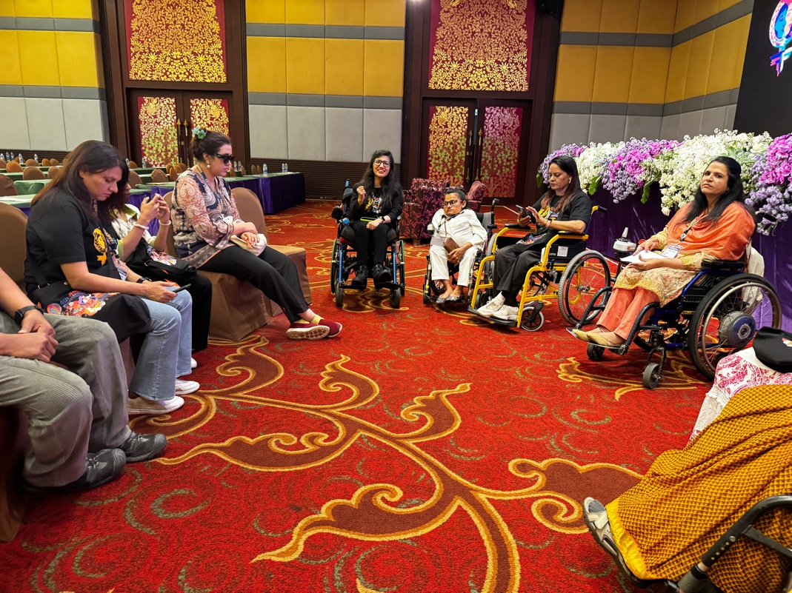
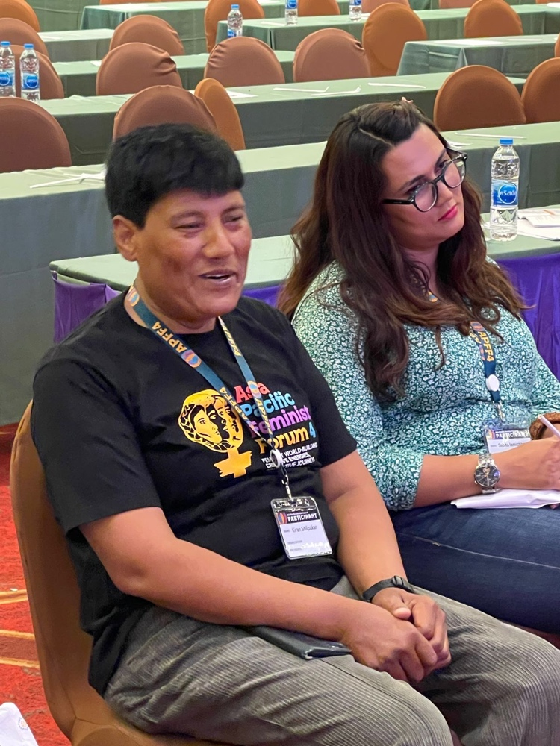
Photo: Asia Pacific Women with Disabilities Networking Event

Day Two – Plenary “Where We Want To Be”

The second plenary focused on the hopes and aspirations for the future, emphasizing the need for systemic change and accountability. This time there was greater representation of marginalised groups such and First Nations communities and women with disability. There were presentations about the importance of digital accessibility, and the need for inclusive funding criteria for people with disabilities. Highlighted were the challenges faced by the Pacific region, including low female representation in politics and high rates of gender-based violence. There was strong emphasis on the importance of climate resilience strategies and menstrual hygiene education in advancing gender justice.

Key speakers included Beverly Litdong Longid from the Philippines, advocating for indigenous rights and accountability; Sarita Lamichhane from Nepal, highlighting the need for disability respect, inclusion and representation; Doris Tulifau from Samoa, stressing the importance of feminist leadership and climate resilience; and Zebunisso Sharikova from Tajikistan, calling for gender justice and economic equity. The session concluded with participants sharing their dreams for a future free from violence, patriarchy, and inequality, emphasizing the need for inclusive governance and proactive interventions.

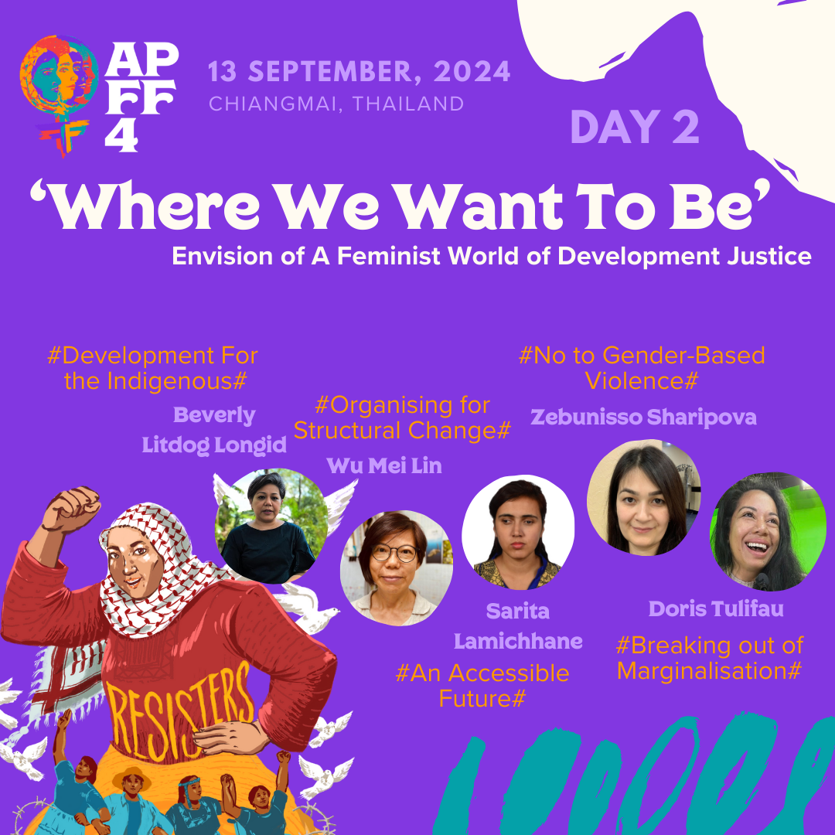
Photo: Plenary Day Two – “Where We Want to Be”

Day Two – Workshops

From Bystander to Response: A workshop on Imagining Feminist Solidarities in South Asia (and beyond)

This workshop looked at how feminist organisers and collectives in South Asia and beyond, have been forced to be bystanders or have found themselves as bystanders in a multitude of contexts and situations. There is either inaction because of issues of power or privilege (or the lack thereof), and this could lead to situations of trauma (both individual and collective) as a result of this witnessing.

Delivered by Kadak, a collective of women, non-binary and queer folk from South Asia who work with graphic storytelling across a range of mediums, the workshop facilitated a sharing, co-creation and challenging of the concept of ‘the bystander’ in the context of imagining feminist solidarities in South Asia (and beyond). Facilitators also shared the journey to developing the “Bystander Anthology”, a graphic novel exploring the experiences of some 50 South Asian artists and creatives.

Key questions and issues discussed were:
- What makes or unmakes a bystander? What does it mean to be, or not be one?
- How can we co-create and build collective and individual responses to situations that are rooted in feminist solidarities?
- How can we mobilise through cross-border, cross movement, trans-national solidarities, to move from bystanders to response?
- How can we work towards ensuring that these narratives are resourced to come to life, through art and creative expression?

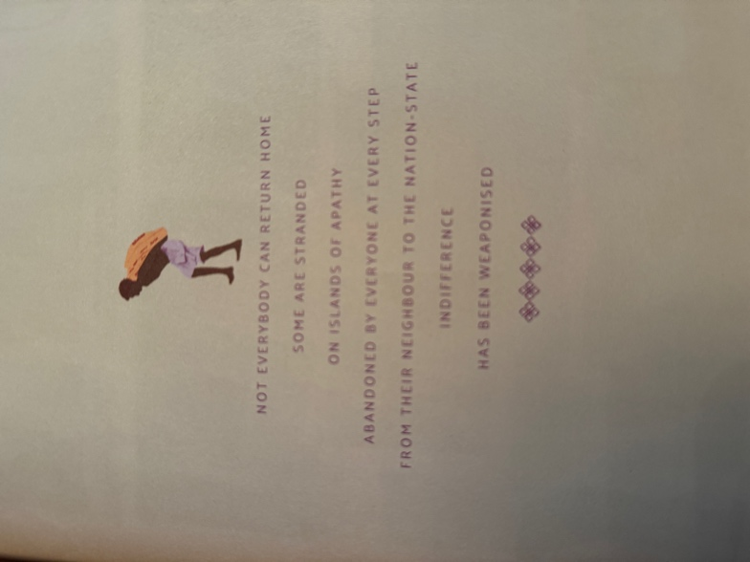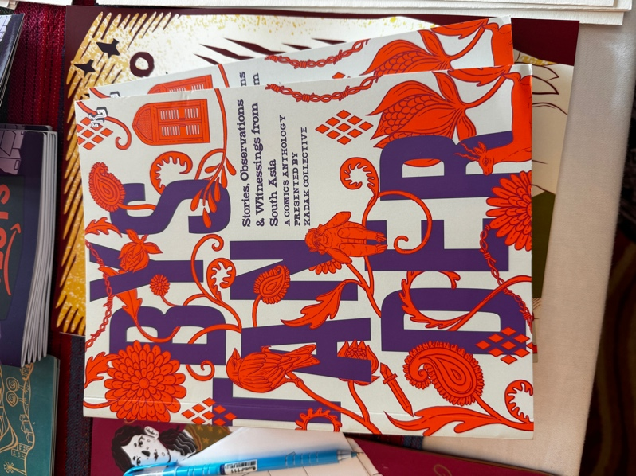
Photo: An excerpt and the cover of the Bystander book by Kadak Collective

Cripping Care : A Strategy Cafe for Co-Designing Disability Justice in Sexual and Reproductive Health Care

The workshop looked at “cripping” or centering disability justice in sexual and reproductive healthcare. Starting with a focus on India, facilitators discussed current models of care systems and how they either wilfully exclude disabled body-minds or consider them to be worthy of only sub-par care.
Attendees then looked at the global discourse of SRHR, disability – and its intersections with other marginalities – identifying that these intersections are easily forgotten. Facilitators posed the question: What will it take for global feminist movements to not just include, but centre disability justice in SRHR for people across intersections such as queerness, class, caste, and religion?

Over the two hours we learned about the similarities experienced in various nations in the Asia Pacific region (Nepal, Myanmar, India, Pakistan, Sri Lanka, Bangladesh, Australia, West Papua and Korea), and collaboratively worked on advocacy plans to bring the unique experiences of women and girls with disability to the conversation in mainstream feminist spaces. We also shared stories of success in our various countries to build capacity of workshop attendees.

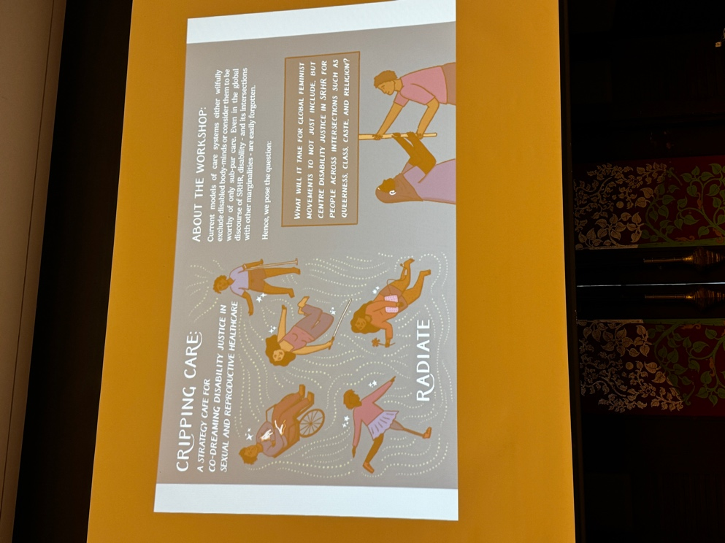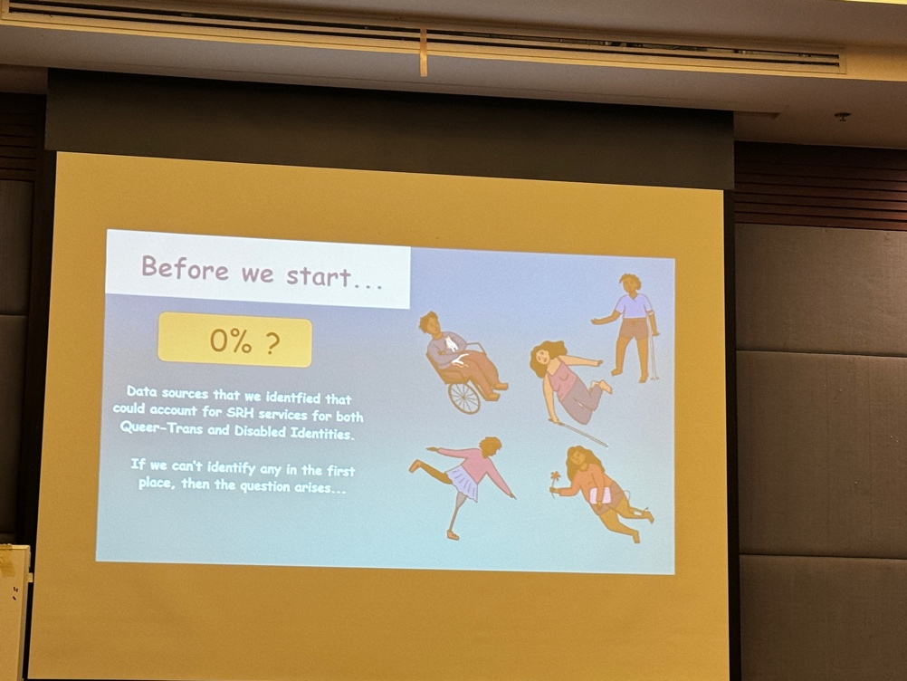

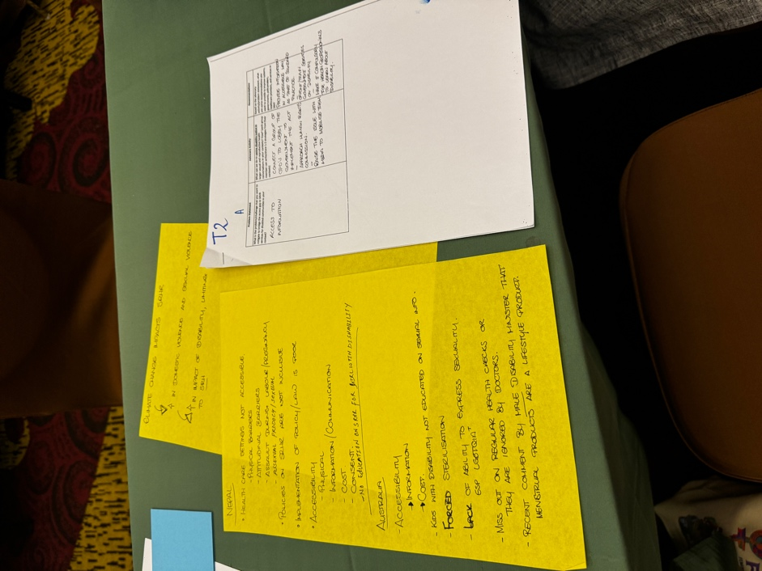
Photos: Slides and Activity Sheets from The Cripping Care Workshop

Day Three - Plenary “How We Get There”

The third and final plenary focused on the ways we can all work together to achieve the future we are hoping for. Speakers discussed the impact of patriarchy, globalization, and other systems on women in the Asia Pacific region, emphasizing the need for feminist movements to resist and dismantle barriers. The session highlighted strategies for creating a just and supportive world, including trauma healing and story documentation in Timor Leste, and the challenges faced by migrant domestic workers in Hong Kong. The importance of solidarity, self-care, and capacity building across generations was stressed, with a focus on sustainable funding and inclusive perspectives. The session concluded with a call to action for continued activism and collaboration.

Key speakers included Jovianna Guterres from Timor Leste,who discussed the peacebuiliding and recovery process, and the importance of building feminist care and safety into the process; Sring Sringatin from Hong Kong, highlighted the structural challenges and exclusion from labour protection and the need for recognition and protection of migrant workers' work as essential work. Mehrub Moiz Awan performed a poem about her experiences as a trans woman in Pakistan, and spoke about the need for strong self reflection and resilience.

Laisa Bulatale from Fiji talked about the need to provide sustainable funding, and education for women to increase representation in decision making spaces. Finally, Jac sm Kee from Malaysia spoke about improving sustainability and inclusion of women in emerging sectors such as tech and AI.

. 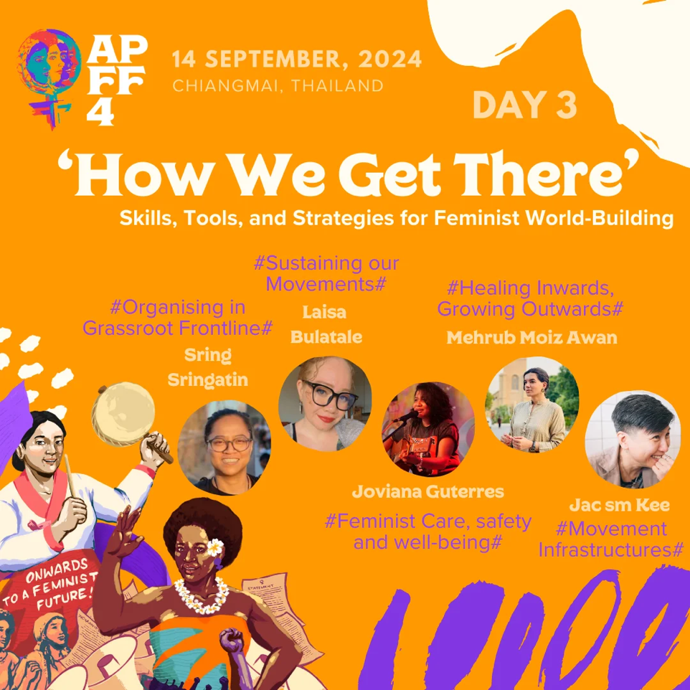

Day 3 – Workshops

Workshop on the United Nations Universal Periodic Review (UN UPR) Mechanism

This workshop focused on the technical aspects of the preparation of reports by NGO’s when their country is reviewed by the Human Rights Council UPR Working Group. Attendees were provided with knowledge about the language used by the UN, processes for reporting and ways to stay connected throughout the process.

Facilitators shared an overview of what reviews are based on:
- The National Report by the State under Review
- The Compilation of UN information (containing information in reports by treaty bodies, special procedures as well as submissions by UN Country Teams and UN entities)
- The Summary of Stakeholders’ Submissions (containing information in submissions by national human rights institutions, civil society organisations and regional human rights mechanisms)
- The Charter of the United Nations;
- The Universal Declaration of Human Rights;
- Human rights instruments to which a State is party
- Voluntary pledges and commitments made by States, including those undertaken when presenting their candidatures for election to the Human Rights Council;
- Applicable international humanitarian law.

They then shared information about the technical aspects of generating and submitting a report to the review.

- Side Events and Exhibitions

Over the conference there were a number of side events and exhibitions that provided opportunities for connection and education.

- The Feminist Bazaar – where groups could showcase and sell artisanal goods made by women from their communities
- The Really Really Free Market - a booth where you could bring items you no longer need, and leave them at the booth for someone else to take for free.
- The Solidarity Space and Artivism Corner – a space where to gather to create posters, slogans, and brainstorm different ideas for taking solidarity actions to support women in all countries and regions.
- The Feminist Library Corner - a space to showcase organisational promotional materials; this included not just pamphlets, reports, or books, but other promotional material ranging from bookmarks to t-shirts, flags and posters.
- The Memorial Corner - a space to share photos, descriptions, stories, or any other form of commemoration of feminists and allies across our regions who have passed away.

Feminist Accountability Map - A map that consolidates and tracks the progress / lack of progress of countries in the Asia Pacific against its commitments to human rights and Development Justice.

This is Sheila - Sheila the mannequin is a social experiment aimed at raising awareness on sexual and gender-based violence against women and girls. The mannequin was named Sheila because the name is often used as a derogatory slang to refer to women and girls.

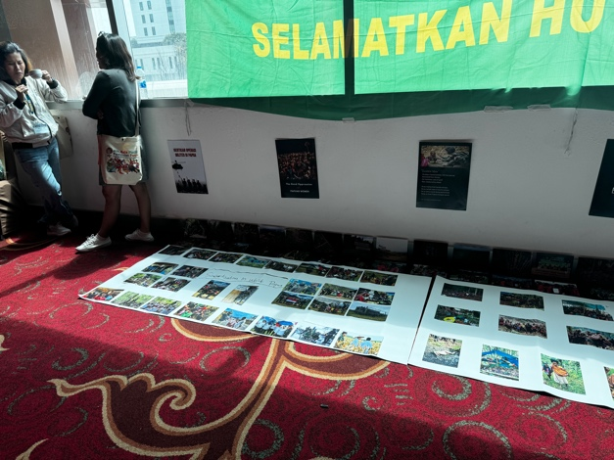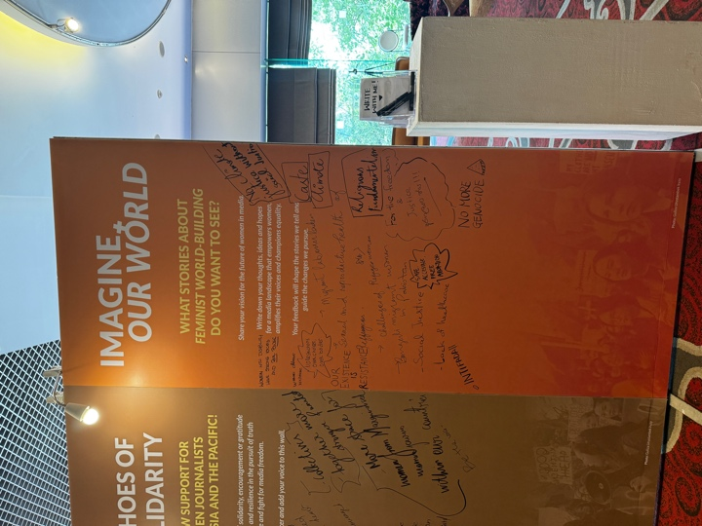
Photos – West Papua and Storytelling exhibition

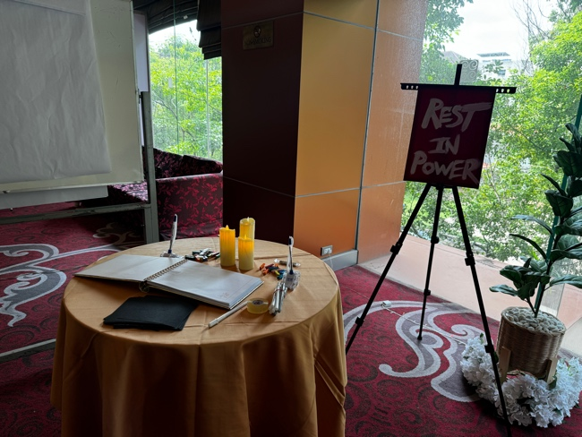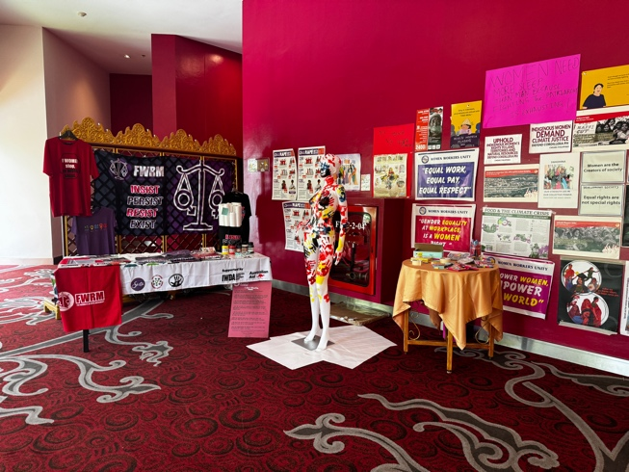
Photos – Memorial Corner and I am Sheila exhibition

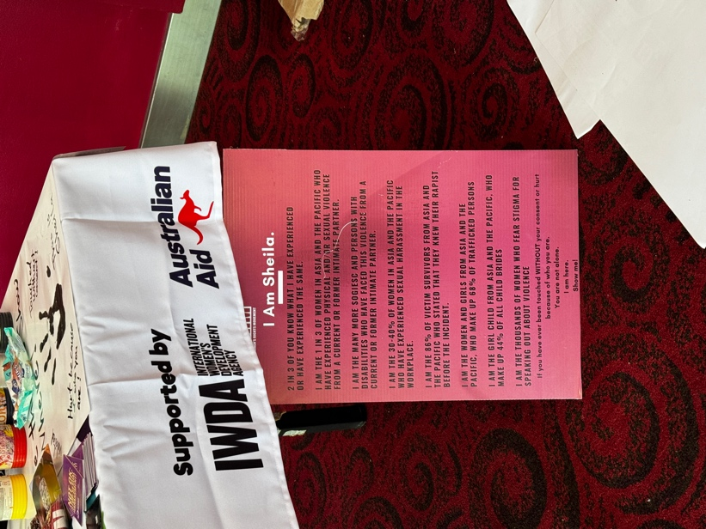
Photo – I am Sheila exhibition

4. Conclusion: Key Outcomes and Benefits from APFF

Individual Outcomes

Attending APFF gave Clare the opportunity to gain a deeper understanding of the issues and challenges faced by women across the Asia Pacific. It also showcased the need for women with disabilities to be present and visible in these spaces so that they can continue to be included and have a voice in mainstream feminist work . The mutual exchange of knowledge between delegates from different nations proved beneficial in helping understand how to effectively implement strategies within our own national contexts. Many delegates spoke to their experience with comprehensive policy development and community engagement, which provided concrete examples of how to navigate governmental advocacy.

Additionally, Clare organised and participated in networking events where she was introduced by colleagues to influential stakeholders and representatives from international organisations such as APWLD, Korea Center for United Nations Human Rights Policy (KOCUN), and the National Forum for Women with Disabilities (NFWWD). These introductions helped build critical connections that can support ongoing advocacy efforts. This collaborative spirit ensures that the benefits of APFF extend beyond the conference itself, creating a lasting impact on global disability advocacy efforts.

Finally, attending APFF provided Clare with a profound understanding of global efforts and contexts in the realm of disability rights and inclusion. Immersed in a diverse environment, she was exposed to a myriad of international initiatives, policies, and best practices, which broadened her perspective beyond the Australian context. Engaging with global leaders, policymakers, and advocates allowed her to grasp the varied challenges and innovative solutions being implemented worldwide. This enriched understanding equips her with the ability to contribute more effectively to national and international forums, bringing a nuanced and informed perspective that bridges local experiences with global strategies, ultimately enhancing the collaborative efforts towards achieving disability inclusion and human rights on an international scale.

Outcomes for WWDA

Engagement in APFF built upon WWDA's connections with global partners, fostering new relationships and strengthening existing ones. By participating in various sessions, panels, and networking events, the WWDA delegate had the opportunity to interact with a wide range of international stakeholders, including representatives from prominent organisations, policymakers, and fellow advocates. These interactions facilitated the exchange of ideas, best practices, and collaborative strategies, enabling WWDA to build upon its robust network of allies and supporters. The connections formed at APFF are instrumental in creating opportunities for joint initiatives and partnerships, furthering WWDA's mission to promote the rights and inclusion of women with disabilities on a global scale.

WWDA's active participation at APFF supported its visibility within the international community. By sharing her expertise and experiences in various forums and discussions, the WWDA delegate showcased the organisation's ongoing leadership and commitment to advancing disability rights. This visibility promoted WWDA’s role as a key player in the global disability advocacy landscape and attracted attention from potential partners and supporters. The exposure gained at APFF has opened doors for increased collaboration and influence, enabling WWDA to amplify its impact and continue its contribution to international efforts aimed at achieving equity and inclusion for women with disabilities.

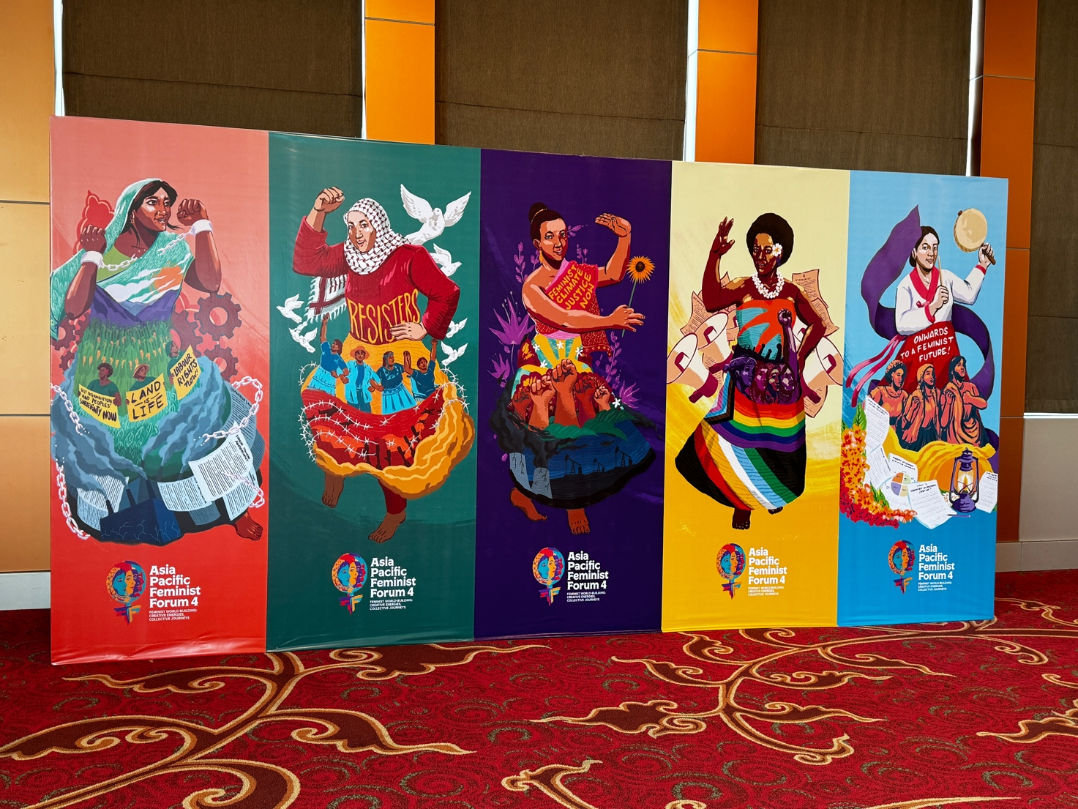
Photo – Five posters depicting paintings of diverse women, and the issues they face around the globe.

