
WWDA LEAD Final Project Report

Image: The photo above is of the LEAD team. From left to right is Sarah Hamilton, Justine Roberts, Cat Standley, Annette Maurer, and Jessica O’Sullivan. This photo was taken in Melbourne when the LEAD team were recording the launch for the Leadership and Mentoring Toolkit on the 9th of October 2024.
Table of Contents
WWDA LEAD Final Project Report 0
Publishing Information 3
About WWDA 5
Section 1: Executive Summary 6
Summary of project 7
Key achievements 7
Impact 8
Key recommendations 8
Section 2: Introduction 10
Purpose of the report 11
Background information 11
Scope of the project 11
Section 3: A reflection on the outputs and outcomes of the Individual Capacity Building (ICB) stream of the WWDA LEAD Project 13
Promote peer learning opportunities for women, girls and gender-diverse people with disabilities 14
Foster the development of leadership and mentoring knowledge and skills of women, girls and gender-diverse people with disabilities 25
Provide direct support for women, girls and gender-diverse people with disabilities to undertake individual leadership training and/or coaching. 33
Increase opportunities for women, girls and gender-diverse people with disabilities to participate in public decision-making and representation. 38
Increase the engagement of women, girls and gender-diverse people with disabilities in WWDA through outreach initiatives. 41
Implement initiatives to address the gender disparity in NDIS participants. 51
Provide access to information resources developed by and for women, girls and gender-diverse people with disabilities. 53
Section 4: A reflection on the outputs and outcomes of the Organisational Capacity Building (OCB) stream of the WWDA LEAD Project 58
Develop and implement strategies to upskill the organisation 59
Improve organisational systems and process to deliver efficiency and effectiveness 61
Strengthen the quality of organisational activities 64
Section 5: A reflection on the outputs and outcomes of the overall project management deliverables of the WWDA LEAD Project 68
Recruit project staff/personnel 69
Establish project management process and project governance structure 70
Develop internal and external financial reporting requirements and processes 72
Develop project reporting framework and processes 73
Establish project liaison and update meetings with the NDIA and DSS 74
Map and identify key project stakeholders 75
Develop project communications strategy 77
Develop project monitoring, evaluation and learning (MEL) processes 78
Undertake project evaluation and review processes 82
Consolidate and finalise outputs and outcomes of the project into a Final Project Report 85
Section 6: What we’ve learnt about the leadership of women, girls and gender-diverse people with disabilities and how to support its growth 87
Analysis on qualitative data 88
Reflections 100
Evaluation findings 101
Recommendations 117
Conclusion 118
Section 7: Appendices 120
Appendix 1 – ‘Empower Meet’ presentation 121
Appendix 2 – Likert Scale Survey 122
Appendix 3 – Annual Member Survey 126
Appendix 4 – Peer Networking Survey 127
Appendix 5 – Leadership and Mentoring Toolkit – Post-launch survey 129
129
Appendix 6 – Member Skills and Interest Survey 131
Appendix 7 – Membership Engagement Strategy 132
Appendix 8 – Monitoring, Evaluation and Learning 134
Section 8: Endnotes 135

Publishing Information
Women With Disabilities Australia (WWDA) (2024). WWDA LEAD Final Project Report. Women With Disabilities Australia (WWDA): Hobart, Tasmania.

Acknowledgments
Women With Disabilities Australia (WWDA) acknowledges the traditional owners of the
land on which participants and Project staff resided throughout these programs. We
acknowledge First Nations people’s deep spiritual connection to this land. We extend
our respects to community members and Elders past, present and emerging.

This document was written by Cat Standley, Justine Roberts and Jessica O’Sullivan for and on behalf of Women With Disabilities Australia (WWDA).

Funding acknowledgement
Women With Disabilities Australia receives its funding for the LEAD Project from the
Australian Government, Department of Social Services (DSS). WWDA acknowledges
with thanks, the Department for providing funding to enable WWDA to contribute to
the work of the Information, Linkages and Capacity Building Programs.

Project Staff acknowledgement
Women With Disabilities Australia acknowledges, with thanks, all the project staff that
have contributed to the LEAD Project to date.

Co-design Committee and Expert Co-production Panel members acknowledgement
Women With Disabilities Australia acknowledges, with thanks, all the Project Steering Committee members, Co-design Committee members and Expert Panel members that have contributed to the LEAD Project to date.

For a full list of acknowledgements, please visit our website: https://wwda.org.au/toolkit-acknowledgements/

Contact
Women With Disabilities Australia (WWDA)
PO Box 407, Lenah Valley, 7008 Tasmania, Australia
Email: officeadmin@wwda.org.au
Web: https://wwda.org.au
Facebook: www.facebook.com/WWDA.Australia
X: https://x.com/WWDA_AU

Women With Disabilities Australia (WWDA) has Special Consultative Status with
the Economic and Social Council of the United Nations.

Disclaimer
The views and opinions expressed in this publication are those of Women With Disabilities Australia (WWDA) and not necessarily those of our funding bodies. All possible care has been taken in the preparation of the information contained in this document. WWDA disclaims any liability for the accuracy and sufficiency of the information and under no circumstances shall be liable in negligence or otherwise in or arising out of the preparation or supply of any of the information aforesaid. This work is copyright. Apart from any use as permitted under the Copyright Act 1968, no part may be reproduced without written permission from Women With Disabilities Australia (WWDA).

© 2024 Women With Disabilities Australia (WWDA).
ABN: 23 627 650 121
ARBN: 621 534 307

About WWDA
Women With Disabilities Australia (WWDA) Inc. is the national Disabled People’s
Organisation (DPO) and National Women’s Alliance (NWA) for women, girls, and gender-diverse people with disability in Australia. As a DPO and a NWA, WWDA is governed, run, and staffed by and for women, girls, and gender-diverse people with disability.

WWDA uses the term ‘women and girls with disabilities’ on the understanding that
this term is inclusive and supportive of women, girls and gender-diverse people with disabilities.

WWDA represents more than 2 million women, girls and gender-diverse people with disability in Australia. WWDA has affiliate organisations and networks of women with disability in most States and Territories and is recognised nationally and internationally for our leadership in advancing the rights and freedoms of all women, girls and gender-diverse people with disability. Our organisation operates as a transnational human rights organisation - meaning that our work, and the impact of our work, extends much further than Australia. WWDA’s work is grounded in a human-rights based framework which links gender and disability issues to a full range of civil, political, economic, social and cultural rights. All WWDA’s work is based on co-design with and participation of our members. WWDA projects are all designed, governed, and implemented by women, girls and gender-diverse people with disability.

Section 1: Executive Summary

Summary of project
The WWDA LEAD – Lead, Engage, Activate and Drive Project was funded in 2019, with support from the National Disability Insurance Scheme’s Information, Linkages and Capacity Building (ILC) Program. Funded until the end of 2024 by the Australian Department of Social Services (DSS), to promote and advance the leadership, agency, autonomy, human rights and freedoms of women, girls and gender-diverse people with disabilities, both individually and collectively.

The LEAD Project delivered two streams of capacity building for women, girls and gender-diverse people with disabilities: individual capacity building (ICB) and organisational capacity building (OCB). The ICB stream of the project sought to deliver outreach initiatives, programs, events, and activities to the community to help build the leadership capacity of women, girls and gender-diverse people with disabilities. This was seen through programs such as WWDA LEAD Scholarships and WWDA LEAD Mentoring; invitations to women, girls and gender-diverse people with disabilities to provide subject matter expertise through co-design and co-production of key assets for the project; outreach initiatives and events such as Peer Networking and the launch of the Leadership and Mentoring Toolkit. The OCB stream of the project helped to build organisational capacity of WWDA through various deliverables such as recruiting women and gender-diverse people with disabilities to deliver the project, developing and implementing strategies to upskill staff through training opportunities, and developing and implementing organisational frameworks that help improve operational efficiency.

Key achievements
The most notable achievements of the LEAD Project included leadership-building programs such as mentoring and scholarships provided to the community. The launch of the Leadership and Mentoring Toolkit is also a significant achievement, as this resource was in intensive co-development for nearly four years with experts from the WWDA membership. The quality of organisational activities has been strengthened through the delivery of key outputs such as the Member Survey, and organisational systems and processes have been developed that help to improve WWDA’s efficiency and effectiveness.

Impact
As reported through the project outcomes, the LEAD Project has had an extraordinary impact on leadership development for women, girls and gender-diverse people with disabilities through several programs, activities and events. A significant percentage (86.7%) of evaluation survey participants agreed that taking part in the WWDA LEAD Project improved their self-esteem, which contributed to strengthening their leadership skills. Many (93.3%) evaluation participants agree that being able to share their experiences with their community also contributes to strengthening their leadership.

It should be acknowledged that the resource development made through co-design and co-production has had a significant impact on the WWDA community. The project will continue to provide women, girls, and gender-diverse people with disabilities with ongoing benefits for leadership capacity building. This includes providing WWDA members with the opportunity to continue to build their leadership skills and knowledge through resources such as the Leadership and Mentoring Toolkit.

Key recommendations
The LEAD team has made several key recommendations to WWDA after the delivery of the project. This includes:
- Prioritise opportunities for women, girls and gender-diverse people with disabilities to connect and build relationships that foster a sense of community and belonging.
- Provide leadership development spaces for women, girls and gender-diverse people with disabilities to enhance self-esteem.
- Continue to implement strategies that challenge societal stereotypes through advocacy and promoting the human rights of women, girls and gender-diverse people with disabilities.
- Explore participants’ perspectives on how social connections impact their leadership experiences.
- Continue engagement of the WWDA community to better understand the issues that are important to women, girls and gender-diverse people with disabilities.
- Provide opportunities for participation in activities such as workshops, resource development, and leadership-building programs.
- Engage a Salesforce expert to streamline the use of Salesforce to improve its efficiency and effectiveness.
- Conduct thorough reviews of grants in planning phases to ensure that projects are being completed in a systematic order that has ongoing benefit to WWDA and its members.

Section 2: Introduction

Purpose of the report
The purpose of this report is to thoroughly document the outputs and outcomes of each of the deliverables in the WWDA LEAD Project. This report reflects on the impact of each of these outcomes, evaluates participant feedback and examines the effect the LEAD Project has had on women, girls and gender-diverse people with disabilities in developing their leadership capacity and provides key recommendations to WWDA based on the lessons learned from the project.

Background information
The WWDA LEAD Project recognised a community need to increase the engagement and participation of women, girls and gender-diverse people with disabilities in leadership spaces in a safe, inclusive and supportive environment. The project has amplified the voices of women, girls and gender-diverse people with disabilities and provided leadership opportunities where women, girls and gender-diverse people with disabilities are often overlooked.

Throughout the delivery of the project, the LEAD team has been committed to WWDA’s co-design and co-production principles. Ensuring the contributions of women, girls and gender-diverse people with disabilities has been a mainstay of the project and is consistent with the Leadership Statement principles that have underpinned the outputs of the project. Through frequent consultation and collaboration of the Co-design Committee members and Expert Co-production Panel members, the LEAD team was able to deliver high-quality, impactful outcomes to the WWDA community.

Scope of the project
The WWDA LEAD Project had two primary objectives:
- Increase the leadership capacity in women, girls and gender-diverse people with disabilities.
- Increase the organisational capacity through delivery of project outputs to improve operational effectiveness.

The WWDA LEAD team sought to achieve these goals through various activities, events, programs, and the development of systems and frameworks. Part of the project was to collect qualitative and quantitative data to help demonstrate the impact of the project on the community and help inform WWDA where future funding could be focused.

In 2019, the WWDA LEAD Project was initially given a two-year delivery timeline. However, towards the end of 2022, WWDA was granted its first extension to complete the project by June 2024, and then another extension to complete the final deliverables by October 2024.

Section 3: A reflection on the outputs and outcomes of the Individual Capacity Building (ICB) stream of the WWDA LEAD Project

Promote peer learning opportunities for women, girls and gender-diverse people with disabilities

This deliverable was designed to enhance support for women, girls and gender-diverse people with disabilities by developing and implementing online platforms for peer learning and support. The intention was to create accessible mechanisms where women, girls and gender-diverse people with disabilities could exchange experiences, gain valuable insights, and provide mutual encouragement, while building their leadership capacity. The planned feedback and evaluation process aimed to ensure these platforms effectively met their needs and facilitated meaningful peer connections. This initiative sought to empower women, girls and gender-diverse people with disabilities by fostering a collaborative environment that supports their personal growth and strengthens our community.

Outputs and Outcomes

Peer Networking Events
The LEAD Project held several national Peer Networking Sessions for women, girls, and gender-diverse people to attend, explore and learn about different themes for each session. The themes discussed during Peer Networking ranged from LGBTIQA+ and disability, disability pride month, women’s health month, and general discussion sessions. These freely and publicly available Peer Networking events ran monthly from February 2021 – November 2021, February 2022 – November 2022, February 2023 – November 2023. The virtual events provided a consistent and safe space for women, girls and gender-diverse people with disabilities to meet and connect with peers in a supportive group. Peer Networking was available for all women, girls and gender-diverse people with disabilities to join, not just WWDA members.

In addition to the monthly Peer Networking, the LEAD Project ran other peer learning virtual events such as webinars, public decision-making workshops, and a virtual side-event for CSW67, which has had over 130 views since its upload to the WWDA YouTube channel.

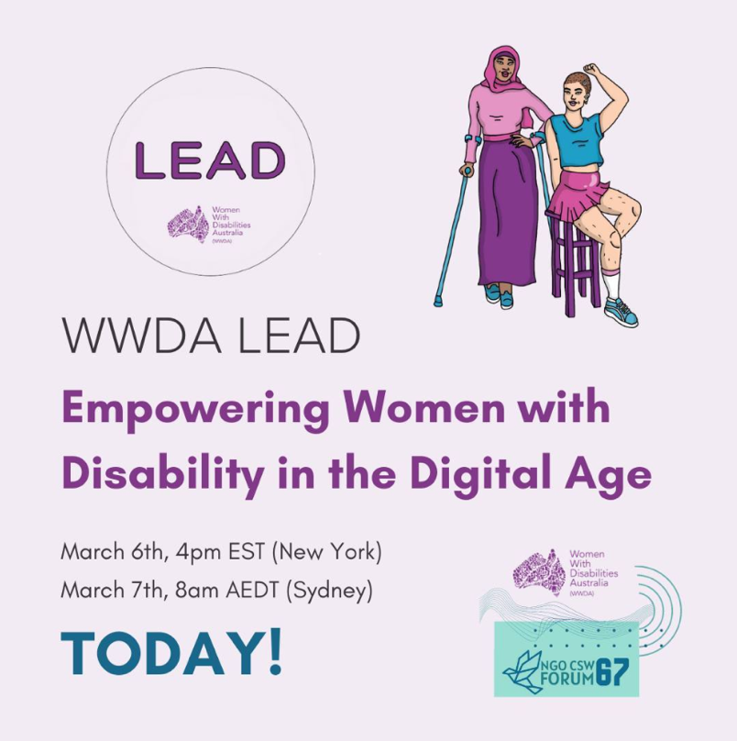

Image: image above shows the social media tile WWDA used to promote the WWDA LEAD parallel event for the CSW67.
A lack of opportunities exist for women, girls and gender-diverse people with disabilities to come together, network and take part in capacity exchange. The LEAD Project provided a consistent and reliable space for the WWDA community to share their lived experience of their intersecting identities in a safe and supportive online forum, facilitated by the project team and co-facilitated by members of the WWDA Youth Advisory Group, LEAD Co-design Committee, and LEAD Expert Co-production Panel. Feedback from participants of the Peer Networking sessions has highlighted the value of this space and why it is important to them:
“The opportunity to talk online with other LGBTIQA+ women with disability. Also to connect with others who are neurodivergent.”
- Peer Networking Survey respondent, 2023
“I spend a lot of time working with women in my local community and in my state, and I have not had the opportunity to meet disabled women from around the country outside of WWDA Peer Networking.”
- Peer Networking Survey respondent, 2023

In celebration of International Women’s Day (IWD) 2024, the LEAD team facilitated a Peer Networking event called ‘Empower Meet’ combining the United Nation’s theme for 2024 ‘Investing in women: Accelerate progress’ and the LEAD Project’s theme of investing in workplaces and leadership for women, girls and gender-diverse people with disabilities. Fifteen women, girls and gender-diverse people with disabilities attended an interactive online Peer Networking event and centred discussions around three primary questions:
- How would you like to see companies and governments invest in women?
- How do you want to see progress accelerated in your community?
- As disabled women and gender-diverse people, we face a lot of barriers. How do you take time for yourself?

The full presentation is available in Appendix 1.

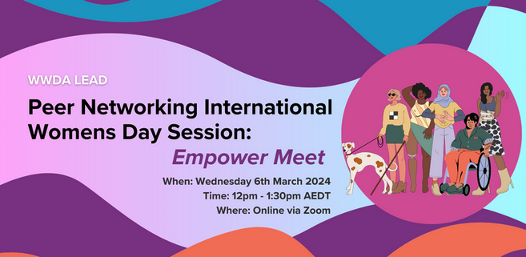

Image: image above shows the event banner that was presented on the Humanitix event WWDA promoted for this Peer Networking session for IWD 2024.

WWDA Youth Podcast
Women, girls and gender-diverse people with disability are often underrepresented in the media. As such, the WWDA Youth Advisory Group (WYAG) worked with WWDA staff over a six-month period to create a new podcast featuring women, girls and gender-diverse people with disability talking about leadership. After a long lead-up, involving many discussions with podcast producers and tech companies about accessibility, WWDA partnered with 2PHR to produce a monthly podcast. Former WYAG members, Jade Taylor and Amy James, helped to produce the podcast. Many young women, girls and gender-diverse people were interviewed and spoke to different topics about youth leadership. All ten episodes of the WWDA Youth ‘We can all be leaders’ Podcast can be listened to here.

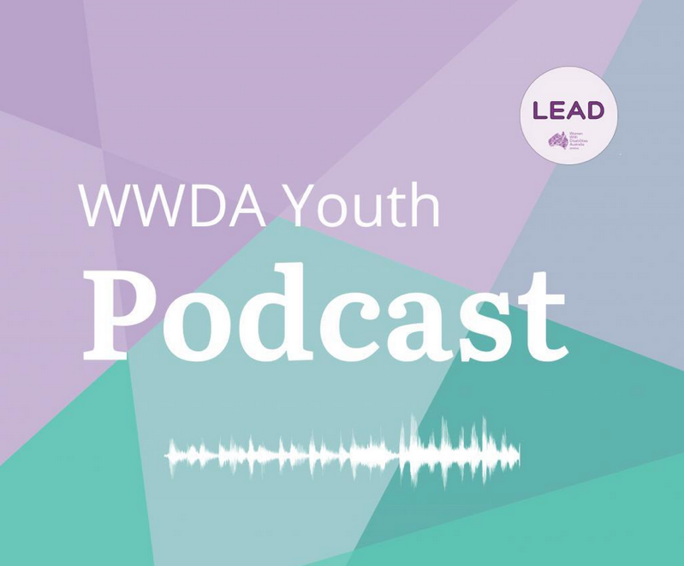

Image: image above shows the tile that WWDA promoted across their social media platforms announcing the beginning of the WWDA Youth Podcast as part of the LEAD Project.

WWDA LEAD Mentoring Program
From 2021 to 2023, WWDA engaged an Australian Software as a Service (SaaS) mentoring company called Brancher (meaning “to connect” in French). The Brancher platform enabled people to connect with like-mentors and mentees and participate in a safe mentoring relationship, whilst building their leadership capacity and taking part in capacity exchange. Brancher worked closely with LEAD Project staff to ensure that its platform was accessible and functional for WWDA’s members. Through this work, Brancher engaged Access Easy English to design Easy English resources for the platform. This meant that all the mentoring training modules available through the Brancher platform were available in Easy English, therefore increasing accessibility to the program.

In the first round of the WWDA LEAD Mentoring Program during 2021/2022, the LEAD team worked with Brancher to identify 37 well-matched pairs of mentors and mentees out of a total of 90 applications for the mentee positions and 52 for mentor positions. The second round of the WWDA LEAD Mentoring Program during 2022/2023 saw 124 women and gender-diverse people with disabilities apply for the program, and WWDA worked with Brancher to try and match every one as closely as possible to similar or related skills and knowledge sets. Even though the program had a much higher number of applicants, there were only 18 well-matched pairs of mentors and mentees. However, 83% of the pairs successfully wrapped up their mentoring relationship by the end of the program. To read the full report of the WWDA LEAD Mentoring Program, visit the WWDA website.

WWDA members and constituents can provide feedback and evaluation processes implemented.
Towards the end of 2020, WWDA engaged an external consultant, Caroline Lambert, who was experienced in creating Monitoring, Evaluation, and Learning (MEL) Frameworks from diverse feminist perspectives. Part of Caroline’s feminist MEL Framework consisted of a feedback survey (see Appendix 2) that was designed to be sent to all participants of LEAD activities and events. This survey ensured the project captured the thoughts and reflections of those participants and how the event or activity influenced their leadership capacity, skills and knowledge. Feedback and evaluations of LEAD activities and events have been collected by the LEAD team on an ongoing basis for several years. Feedback was collected through survey responses and Stories of Change from participants of the LEAD Project. More participant feedback has been presented in Section 6 of this report. Below are some quotes provided to the LEAD team through LEAD participants’ Stories of Change.
“When organisations talk about disability leadership, even disabled people’s organisations, often they mean a disabled person who can just fit into the mold of doing the same work of an abled person. The far greater challenge is to broaden the scope of leadership to include everyone’s strengths, skills and challenges. The staff who led groups like peer networking brought their own unique approach to the group while allowing individuals to shine. Meeting so many disabled women who are so diverse taught me a great deal about my community and myself. Sometimes I came to WWDA LEAD peer mentoring knowing nothing and learned so much from multiple perspectives.”
- Nadia – WWDA Member
“Human interaction and connections are all prone to vulnerability but in that vulnerability, there is always an opportunity for growth- psychological safety occurs and that was really pronounced in the project. The ability to contribute and feel that sense of value in self and learn.”
- Tess – WWDA LEAD Expert Co-production Panel Member
“LEAD taught me I’m of value. I have a voice worth hearing and it is worth being heard. Now I will speak up. I have the tools now to navigate how to approach difficult conversations.”
- Janel Manns – WWDA LEAD Co-design Committee Member
“Working through the WWDA LEAD Mentoring Program has supported me to set myself tangible goals to work towards practicing my leadership in my professional and personal life and has helped me to keep myself accountable in working towards achieving these goals. I have become more confident in building on and actively practicing my advocacy skills. I think that observing other women, girls and gender-diverse people with disabilities fiercely and skillfully advocating for their needs has supported me to learn from my peers and develop my confidence slowly.”
- Lisa Mabin – WWDA Member
“Being around other women with disability and observing how they act, engage, and interact has shown me a different perspective and given me confidence to begin presenting a more authentic version of myself at work; not the one that is constrained by beliefs around what a ‘professional woman’ does/acts like.”
- Sally – WWDA Member

Sarah Heta (LEAD Expert Co-production Panel member) shared a Story of Change through art to show how the LEAD Project has impacted her:

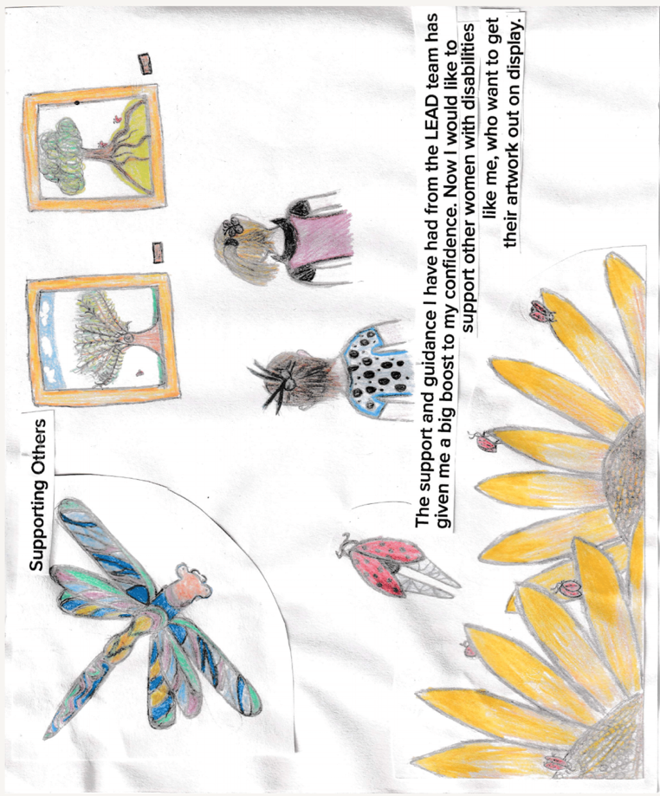
Image: image below is a hand drawn picture by a WWDA member and illustrator for the toolkit. It has drawings of flowers, a dragonfly, people, and a quote that reads “The support and guidance I have had from the LEAD team has given me a big boost to my confidence. Now I would like to support other women with disabilities like me, who want to get their artwork out on display.”

Online mechanisms for peer support are developed and implemented.
When asked whether the peer learning approach of WWDA LEAD strengthened their leadership skills, overall, 86.6% of participants from the Likert Scale Survey agreed. A further 73.3% of survey participants agreed that understanding the agency and autonomy of diverse women, girls and gender-diverse people with disabilities as a group contributed to strengthening their leadership. An overwhelming 93.3% of survey participants agreed that WWDA LEAD helped to develop a stronger sense of solidarity, purpose and shared strength of diverse women, girls and gender-diverse people with disabilities. With 80% of respondents agreeing that this sense of solidarity, purpose and shared strength contributes to strengthening their leadership skills. Of the survey participants, 93.4% agree that the LEAD Project has strengthened their perception of how their leadership contribution is valued.

Overall feedback from participants of Peer Networking events indicated that their experience was positive with particular attention to the value that these events provided for our community being:
- connection to peers and
- the ability to discuss a wide array of topics.

Many participants noted that these sessions provided a safe and inclusive space to explore issues free from judgement, where they felt heard and respected. Peer Networking events were held over a three-year period and participants of these events informed project staff that there were no other consistent events such as the WWDA LEAD Peer Networking that were run as frequently or reliably as this event.

Another online mechanism for peer support was the WWDA LEAD Mentoring Program, which achieved significant positive outcomes for participants. Some of the notable achievements and impacts include:

Enhanced skills and knowledge
Mentees have reported gaining new skills, knowledge, and perspectives through their interactions with mentors. This has helped them grow both personally and professionally, enabling them to pursue their goals. Mentors also reported that they experienced capacity exchange taking place throughout their mentoring relationship.

Increased confidence and empowerment
Participants have experienced an increase in self-confidence and empowerment because of their participation in the program. The guidance and support provided by mentors have enabled mentees to believe in their abilities and take on leadership roles in various aspects of their lives.

Expanded networks and support systems
Mentoring relationships have facilitated the establishment of valuable connections and networks for participants. These networks provide ongoing support, guidance, and opportunities beyond the duration of the program, strengthening the mentees' support systems. Participants of the program also had regular check-ins from WWDA LEAD Project staff as well as the option of connecting and networking with people in the closed community Facebook group.

To wrap up two years of this program, LEAD Project staff held a virtual event via Zoom and invited all participants of the Mentoring Program to attend and learn about how they could contribute to the final evaluations of the LEAD Project by sharing their Stories of Change and how their experience of the Mentoring Program influenced their leadership.

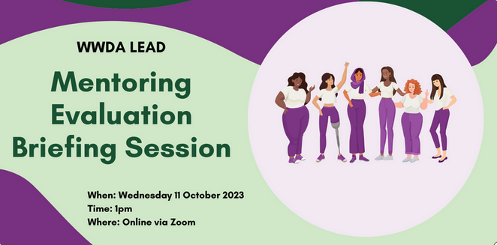

Image: image above shows the Humanitix banner that WWDA used to promote the evaluation briefing session.

Other considerations
The most important reflection on the opportunities the LEAD Project offered for Peer Networking were that many women and gender-diverse people with disabilities felt there were limited other Peer Networking opportunities offered in the unique and accessible way in which the LEAD team delivered Peer Networking. Many asked if the sessions could continue and be based on the outcomes of the LEAD Project. As such, it has been recommended that WWDA consider how this may be explored again in future, considering the enormous benefit to the community.

While some participants from our committees and advisory groups were invited to facilitate Peer Networking sessions, notable feedback from the LEAD Peer Networking Survey demonstrated that more participants would have liked the opportunity to facilitate events as well. Provided WWDA has the opportunity and funding in the future, WWDA members interested in this opportunity would feel heard and supported if they were to be invited to host Peer Networking events. This also reflects WWDA’s commitment to acting on feedback from its members as evidenced by the actioned feedback provided through the annual Member Survey (Appendix 3).

Other reflections from participants of the Peer Networking Survey (Appendix 4) included:

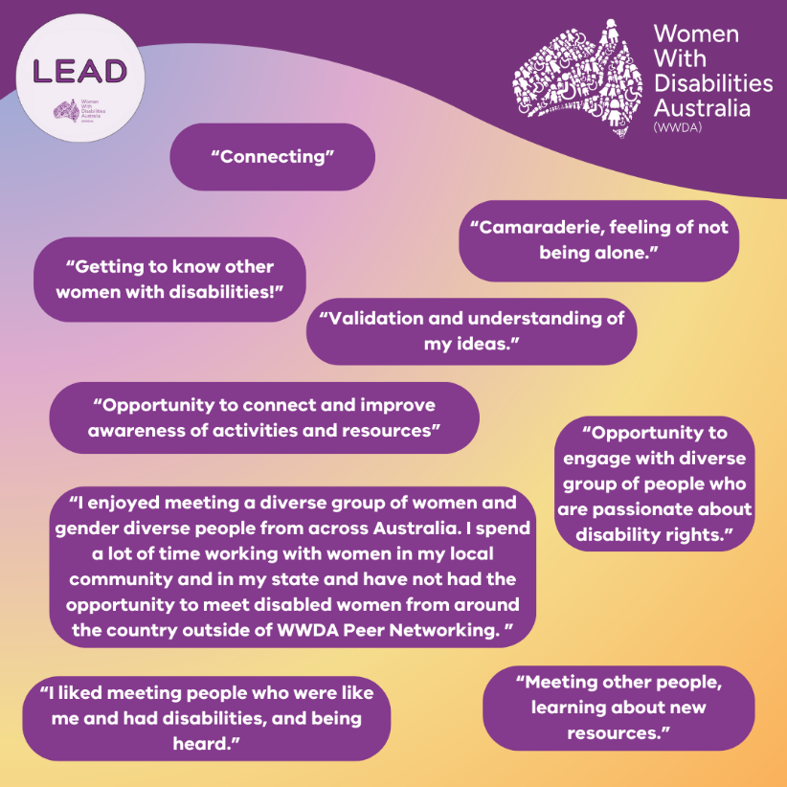

Image: image above shows feedback from participants of the Peer Networking Survey that was conducted. Quotes read:

“Connecting.”
“Getting to know other women with disabilities!”
“Camaraderie, feeling of not being alone.”
“Validation and understanding of my ideas.”
“Opportunity to connect and improve awareness of activities and resources.”
“Opportunity to engage with diverse group of people who are passionate about disability rights.”
“I enjoyed meeting a diverse group of gender-diverse people from across Australia. I spend a lot of time working with women in my local community and in my state and have not had the opportunity to meet disabled women from around the country outside of Peer Networking.”
“I liked meeting people who were like me and had disabilities, and being heard.”
“Meeting other people, learning about new resources.”

“Meeting so many disabled women who are so diverse taught me a great deal about my community and myself. Sometimes I came to WWDA LEAD peer mentoring knowing nothing and learned so much from multiple perspectives. Other times I thought I already knew everything about a topic and then I just had to sit back and listen because I found out there were so many people who actually knew stuff I hadn’t considered. It was an opportunity to meet and talk to leaders from across Australia.”
- Nadia – WWDA Member

Challenges around the use of technology, access to stable internet, and ability to attend during work hours were barriers that were noted by the LEAD team based on feedback from some participants of online events. Additional feedback included other ways for people to attend events held by WWDA such as some in-person sessions, outside of work hours sessions, and having sessions at different times during the day for those with regular appointments or who needed support workers to assist with participation.

Some participants shared that having generic sessions for events, such as Peer Networking, felt like a barrier to their ability and willingness to attend, as the sessions were unpredictable in nature and did not allow an adequate amount of time for participants to prepare themselves for the event. This was also the experience of the LEAD team who reinstated a theme for each month of Peer Networking after a significant drop in attendance was noted for generic sessions when compared to the themed sessions. Participants felt more comfortable with the structure of a Peer Networking event when a topic was provided in advance as it provided a safe space for what to expect and gave the attendee the choice of whether to attend or not.

Foster the development of leadership and mentoring knowledge and skills of women, girls and gender-diverse people with disabilities

This deliverable aimed to assist women, girls and gender-diverse people with disabilities by developing leadership and mentoring resources, designed to enhance their leadership skills. The resources were developed through a co-design and co-production process. They offer accessible, practical tools and guidance tailored to the needs and wants of the WWDA community. By including plain English and Easy Read formats, different language translations including Auslan, and ensuring wide accessibility through the WWDA website, the project sought to empower and build the leadership capacity of women, girls and gender-diverse people with disabilities with the knowledge and skills needed to excel in leadership roles and advocacy spaces.

Outputs and Outcomes

A Leadership and Mentoring Resource Toolkit for women, girls and gender-diverse people with disabilities is developed in a wide range of accessible formats by October 2024.
The LEAD team engaged a human rights expert to ensure that WWDA’s human rights-based framework was embedded throughout the content. Through co-design and co-production, the LEAD team worked extensively with the LEAD Co-design Committee (CDC) and Expert Co-production Panel (ECP) members to design and develop key materials for the toolkit. Everything from the colour palette, merchandise, illustrations, content and case studies to the social media communications was done in tandem with members of the LEAD CDC and ECP. LEAD staff prioritised feedback and input from the CDC and ECP members, ensuring it remained consistent with WWDA’s co-design and co-production frameworks to best meet the needs of the WWDA community. Part of this meant that the LEAD team engaged various subject matter and lived experience experts from the ECP to ensure that the toolkit had been user-tested through several lenses including a First Nations lens, a youth lens, and an intellectual and learning disability lens. The entire toolkit was then passed through two different plain English experts, ensuring that all content was accessible for plain English audiences. This ensured the content of the toolkit was successfully written in a way that was simple and engaging as well as informative.

Publishing the toolkit in a wide range of accessible formats was always a priority for the LEAD team. The LEAD team sought advice and consultation from multiple providers on how to present the toolkit information in the most universally accessible way, that reflected WWDA’s standards for accessibility and met the community’s need. External providers from Ethnolink and Information Access Group both expressed that the best way to meet these needs was to provide conversions of key information in Easy Read formats and then have the Easy Read format translated into multiple languages. To ensure accessibility remained for the Deaf community, the LEAD team also had the Easy Read English version translated into Auslan, which is available on the WWDA YouTube account.

A Leadership and Mentoring Toolkit for women, girls and gender-diverse people with disabilities is promoted nationally and internationally.
In early 2024, a second extension of the LEAD Project was granted for the team to continue the delivery of activities until the 31st October 2024. The additional time ensured that project staff could achieve the best possible outcomes for project activities, including the toolkit, in line with WWDA’s co-design and co-production processes. Working alongside the LEAD CDC and ECP, and external consultants, the LEAD team delivered the Leadership and Mentoring Toolkit on time, within scope and budget, whilst ensuring accessibility for the toolkit was provided on multiple fronts. The toolkit was officially launched on the 16th October 2024 via YouTube, which can be watched here. In its first 24 hours of launching, the event had over 180 views, which is substantially more than WWDA’s subscriber base of 124 subscribers (as at 17th October 2024). Since the launch of the toolkit, WWDA’s YouTube subscribers have increased by 9.7%. Since its upload date to the 27th October 2024, 79.6% of viewers have been based in Australia, meaning that 20.4% of viewers were based outside of Australia demonstrating the far-reaching promotion of the toolkit globally.
Image: image below shows a Google Analytic graph of the number of viewers for the toolkit launch from the time it was uploaded to the 27th October 2024.

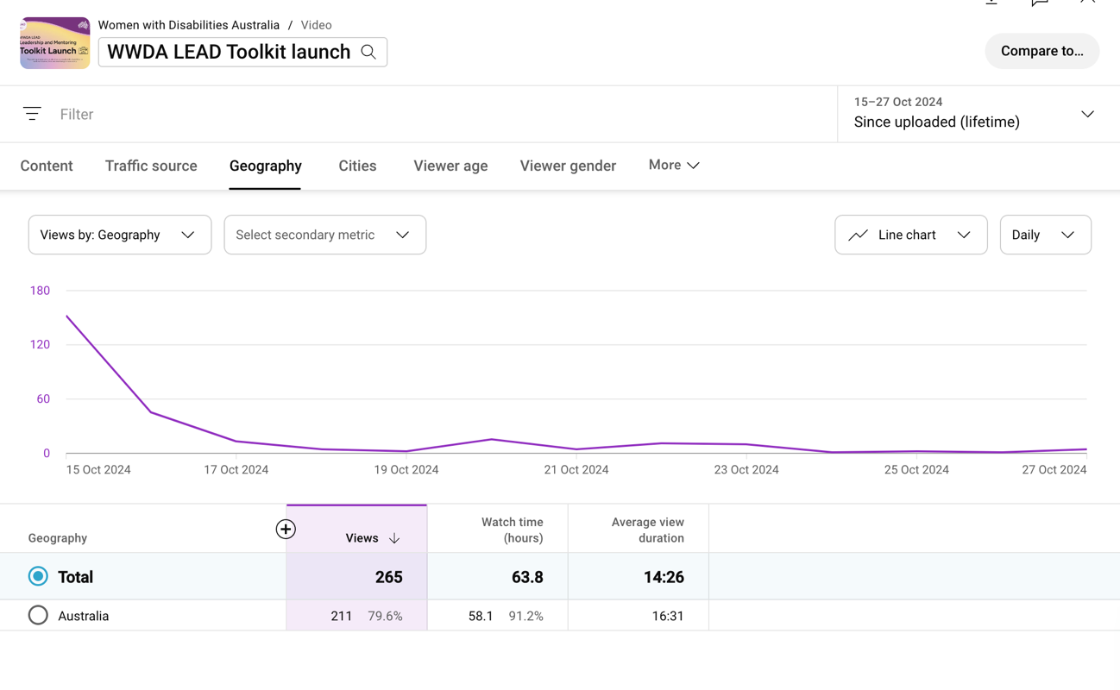

The LEAD team worked with members from the ECP to help create content as part of the pre-launch, post-launch, and ongoing promotion strategies for the Leadership and Mentoring Toolkit. As a national Disabled People’s Organisation (DPO) and National Women’s Alliance (NWA), WWDA’s audience is far reaching both nation-wide and internationally. WWDA is recognised for its leadership in advancing the rights and freedoms of all women, girls and gender-diverse people with disabilities.

The LEAD team engaged Ethnolink to provide translations in multiple languages to assist in promoting the reach of the toolkit to women and gender-diverse people with disabilities across Australia and internationally. The First Nations languages that were recommended to the LEAD team based on 2021 census data were Northern Territory Kriol and Pitjantjatjara. Ethnolink emphasised that both languages were the most spoken First Nations languages across the widest geographical area of Australia. Pitjantjatjara was also highlighted as a mutually intelligible language from the Anangu Pitjantjatjara Yankunytjatjara Lands, meaning selecting this language would reach a wider audience. Part of Ethnolink’s recommendations to increase reach to First Nations populations was to provide the written text resources in audio due to written language limitations and low literacy rates. The international languages that were recommended by Ethnolink were Chinese (Simplified), Chinese (Traditional), Vietnamese, Turkish, and Arabic. These recommendations were also based on 2021 census data for languages spoken by women between 18-65 years old, in Australia, with low English proficiency and who need assistance with core activities. Having these language translations will also assist the Leadership and Mentoring Toolkit being promoted internationally.

Feedback from participants of the LEAD Project, including contributors to the toolkit, show that a significant number (86.7%) of survey participants agreed that participating in WWDA LEAD improved their self-esteem, and the same 86.7% agreeing that this boost in self-esteem contributed to strengthening their leadership skills. Additionally, 80% of participants agreed that feeling more equal enhanced their leadership capacity, while 86.6% agreed that the peer learning approach of WWDA LEAD played a vital role in strengthening their leadership. This feedback demonstrates the importance of having accessible leadership capacity building resources available to women, girls and gender-diverse people with disabilities.

Feedback received from participants Stories of Change further reinforces the positive impact the LEAD Project has had on improving self-esteem and strengthening leadership skills:
“By writing for WWDA LEAD blog, I was able to find a safe space to share my struggles and find a new sense of confidence in this. Not only did this help develop my self-esteem by writing, but I was also able to read about other women who live with disability.”
- Anon WWDA member
“Getting paid to do my drawings was so good and it was nice to have a job and be able to show people what I was doing. I am excited about what might come next for the first time in a long time which makes me feel much happier about my future. Hopefully one day I can work with other women with disabilities to help them find the artist in themselves. I also was asked by WWDA to look at the Toolkit and see if I could understand the ideas in it. For the first time I felt like my disability was useful to someone. I can’t wait to see the drawings in the Toolkit. I will really be an actual artist then!!! Thank you for giving me a chance to support the LEAD Project. I have learnt much more about what I can do.”
- Anon WWDA member

Sarah Heta has also shared several Stories of Change through art to illustrate the impact the LEAD Project has had:

Image: image below is a ‘collage of hope’ that Sarah Heta created. There is a picture of a sun emerging from clouds. There is a quote within the collage that read “Being part of the LEAD Project has given me hope. I was in a dark place, and it now feels like the sun is coming out from behind the clouds. I am so grateful to have had this opportunity and mostly to have people believe in me and help me every step of the way.”

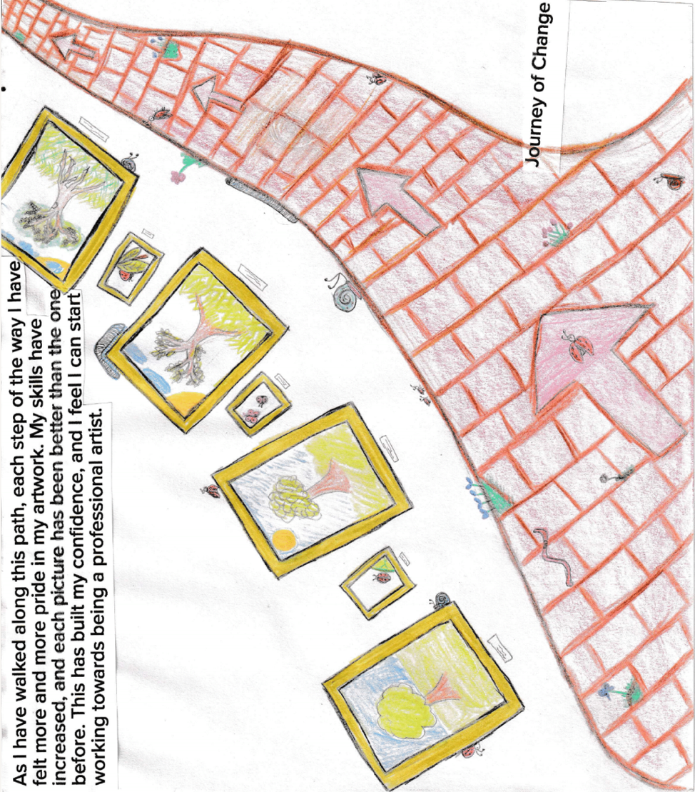

Image: image above is a drawing done by Sarah Heta called ‘Journey of Change’. It is a picture of a path with arrows and drawings of trees and how they change over time. There is a quote that reads “As I have walked along this path, each step of the way I have felt more and more pride in my artwork. My skills have increased, and each picture has been better than the one before. This has built my confidence, and I feel I can start working towards being a professional artist.”

These findings suggest that enhancing self-esteem and promoting equality are important components for leadership development, highlighting that a supportive environment can empower individuals to take on leadership roles confidently.

Other considerations
The development of the Leadership and Mentoring Toolkit provided many opportunities for reflection for the co-design and co-production contributors, and the LEAD team. In exploring the information that would be most useful, the tone of the content, the design elements and the accessibility, the following reflections have emerged.

Sarah who finds it challenging to access written text expressed this eloquently in her Story of Change:
“I was asked by WWDA to look at the toolkit and see if I could understand the ideas in it. For the first time I felt like my disability was useful to someone. The person I spoke to from WWDA made me feel like what I had to say was really important and would help other women with disabilities to be able to understand the information. I feel really proud that my experiences that are sometimes very hard, could help other women who might find reading and understanding hard too.”
Highlighting leadership across many everyday contexts has been well received in co-design and after the launch. Sophie also spoke about how her thoughts about her disability had changed with her involvement in co-production of the toolkit:
“The toolkit was a valuable tool to learn about leadership. It has been useful to see leadership in a more casual light that is accessible to everyone. Living with a disability often makes it feel like there are so many pathways in life that are not available to you. The world around us does not often show or support people with disabilities in leadership roles which makes those roles feel completely unattainable. However, this toolkit made leadership seem accessible and open to everyone. The section with everyday examples of leadership really reinforced the idea that leadership is more than what we get to see in the media, that it’s not only men in suits but also can be people with disabilities. Growing up without examples of people with disabilities in a wide range of careers and achieving their goals really limited my ideas of what I could achieve. I always felt like many positions in society were not accessible for people with disabilities. It makes leadership sound manageable and no longer out of reach. The focus on exploring new pathways to leadership has received positive feedback. I will take the skills I learnt in the toolkit to be open to leadership roles within my job and I also think the skills will improve my ability to advocate for myself, which is such an important and difficult skill as someone living with a disability. At work and school, I have felt nervous about asking for help when I need it. The toolkit has been helpful by providing important language and ideas about leadership that help you to be able to advocate for yourself. The toolkit was empowering.”
A barrier that has arisen for some women and gender-diverse people with disabilities involved in developing the Leadership and Mentoring Toolkit is sustainability of their experience after the completion of the project. The LEAD team recognise the need for further support for women who face significant barriers to participation. This is something to be considered for WWDA moving forward. Many women and gender-diverse people with disabilities who participate in WWDA projects have experience working in this space and have networks to draw on. Whilst one of the strengths of the LEAD Project was engaging women and gender-diverse people with disabilities who had few networks or experiences in this sector, it is important to ensure they have access to other opportunities, so the gains made in their confidence are maintained and continue to grow.
“The drawings I have done for the WWDA Leadership Toolkit has made me feel better in myself and more confident to show my artwork to other women. I didn’t really think of my art as something I could do as a job. Now, I am feeling like that is something I can work towards. The WWDA Lead team have given me so much support to do my drawings and have given me a feeling that I actually am an artist. I have a disability that makes it hard for me to read and write and to understand instructions if I get too many at once. That has made it really hard for me to find a job. Getting paid to do my drawings was so good and it was nice to have a job and be able to show people what I was doing.”
- Sarah Heta – LEAD Expert Co-production Panel member

Following the launch of the Leadership and Mentoring Toolkit, the LEAD team released a post-launch survey to capture feedback from participants. The purpose of this survey is to help inform the delivery of future events from WWDA, ensuring accessibility and engagement for women, girls and gender-diverse people with disabilities. A copy of this survey can be found in Appendix 5.

Provide direct support for women, girls and gender-diverse people with disabilities to undertake individual leadership training and/or coaching.

This deliverable aimed to provide support for women, girls and gender-diverse people with disabilities to engage in individual leadership training and coaching. This involved identifying recognised leadership institutes and programs, and developing and implementing expression of interest, application, and selection processes. The goal was to empower women and gender-diverse people with disabilities by supporting access to leadership development opportunities, and by enhancing their skills and confidence to participate in leadership roles. This support is important for fostering personal growth and enhancing their leadership capabilities, ultimately contributing to greater representation of women and gender-diverse people with disabilities in leadership roles.

Outputs and Outcomes

Recognised leadership institutes and programs are identified.
The WWDA LEAD Scholarships Program was initially implemented by LEAD staff that had collated leadership courses that were either specifically designed for women and gender-diverse people, and/or women and gender-diverse people with disability.

After an extensive expression of interest campaign, applicants to the program were carefully chosen based on meeting the needs of key selection criteria. Eligibility criteria included requirements such as: must be over the age of 15, must identify as having a disability, must have a computer and reliable internet to participate, and more. In May 2021, the LEAD team announced confirmed applicants to round one of the WWDA LEAD Scholarships Program. Round two of the WWDA LEAD Scholarships Program was announced in April 2022.

To read the full report about the WWDA LEAD Scholarships Program, visit the WWDA website.

Expression of interest, application and selection processes are developed and implemented.
An expression of interest (EOI) framework wasn’t developed at the start of the project, however as the project progressed the LEAD team developed a framework based on what previous team members had implemented. This framework was then implemented as part of the Project Management Framework. More can be read about this framework here.

Women with disabilities are supported to undertake individual leadership training and/or coaching.
All applicants to the WWDA LEAD Scholarships Program were offered ongoing support from LEAD staff. This entailed various support methods such as information sheets converted into Easy English, introductory information sessions, assistance in enrolling, and regular check-ins.

Leadership Week
Leadership Week, was hosted in Hobart by the LEAD team. In November 2022, the LEAD team invited the LEAD Project Steering Committee and Co-design Committee members to attend an in-person event where workshops, activities and leadership building exercises were provided. To increase accessibility to the event, the LEAD team designed this as a hybrid event that would allow the WWDA Youth Advisory Group members and other committee members to participate if they were not able to come to Hobart.
To read the full report about Leadership Week, visit the WWDA website.

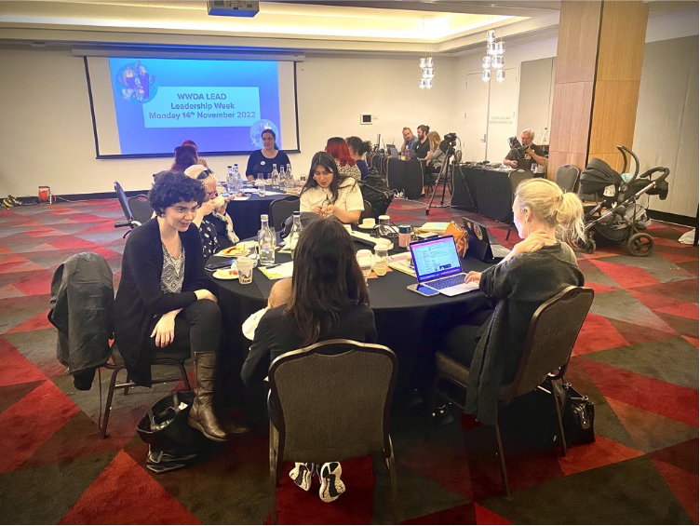

Image: image above is a photo of participants and staff that attended the in-person event for Leadership Week 2022.

Number of women with disabilities undertaking individual leadership training and/or coaching.
Over 20 women and gender-diverse people with disabilities were enrolled in the WWDA LEAD Scholarships Program over two rounds from 2021 to 2022. All successful participants were given the opportunity to enrol in leadership capacity building courses, exploring areas such as increasing accessibility in the workplace, public speaking and policy advocacy valued at or below $2500 + GST.

The recipients were able to enhance their leadership skills; gaining valuable knowledge and practical tools. The program also facilitated networking opportunities among the participants, enabling them to build networks, and connect with other professionals and organisations working in the disability rights sector. These networks will continue to support their personal and professional growth beyond the program. For example, all participants had the opportunity to be a part of the WWDA Facebook Community Group, where they could connect with other professionals and people in the WWDA community. The participants reported increased self-belief, assertiveness, and motivation to pursue leadership roles and actively contribute to disability advocacy.
“My name is Jane* and I participated in the WWDA LEAD Scholarships project. I live in Naarm (Melbourne) in Victoria. I’ve been a WWDA member since I got involved with Women with Disabilities Victoria. A friend of mine encouraged me to apply for WWDA scholarships, as I was currently looking for opportunities to learn some new skills in making documents more accessible, such as in Easy English formats. I applied and was very appreciated to have been given this opportunity. I have done both Easy English and policy and advocacy training through the project. By being involved in this project I can much more confidently say I know what’s involved and what it takes to make documents more accessible to people with low literacy in our communities. I also understand much better what it’s like for people with low literacy. I know the steps to take, what to look for, and have the resources. I can also confidently say I understand the policy cycle much better. I see myself as being able to use what I’ve learned, using myself as a resource for my communities. I also take what I’ve learned and pass it onto others as a way of up-skilling them.”
*Name has been changed to protect confidentiality.
- WWDA LEAD Scholarships participant #1

Other considerations
The most notable accomplishment for this deliverable were the WWDA LEAD Scholarships Programs that were run over a two-year period. These programs were able to directly impact several women and gender-diverse people with disabilities by providing them with the opportunity to participate in leadership training that helped to develop their leadership capacity and empower them to be leaders for the WWDA community. The Scholarships Programs helped more than 20 women and gender-diverse people with disabilities access individual leadership capacity building courses. Participants were able to develop their leadership skills, improve accessibility in the workplace, and network with other leaders.

Another significant success of the deliverable was that the Scholarships Programs also helped the LEAD team to develop essential processes that would build WWDA’s organisational capacity. Through the Scholarships Program, the LEAD team was able to utilise information collected across the lifespan of the project and tailor a refined expression of interest (EOI), application and selection process that was then built into the Project Management Framework. This will assist WWDA in the future should the organisation needed a structured method for collecting expressions of interest for another project. To read more about the EOI process, application and selection processes, and Project Management Framework click on the links provided.

As mentioned previously, a barrier for women, girls and gender-diverse people with disabilities in leadership participation, may be maintaining the new skills and knowledge they have developed and the continued use of those skills in the future. The LEAD Project addressed this through the resources that have been developed such as the Leadership and Mentoring Toolkit, webinars and podcasts.

Below, a WWDA member describes through her Story of Change how she is hopeful that future WWDA projects may be helpful for other women, girls and gender-diverse people with disabilities in developing their skills and knowledge, like the way she was able to build her skills and knowledge about leadership by participating in the LEAD Project. The activities, events, and programs that have been a part of the LEAD Project have had a positive impact on women, girls and gender-diverse people with disabilities and it is important for WWDA to be mindful of how projects like this can provide continued benefit to the community and ongoing connections to members.
“I am excited about what might come next for the first time in a long time which makes me feel much happier about my future. Hopefully one day I can work with other women with disabilities to help them find the artist in themselves. Maybe I can even be a leader one day and find ways to support someone else who feels like life is stressful. I didn’t think I could ever do that before being in the LEAD Project.”
- Anon – WWDA member

Increase opportunities for women, girls and gender-diverse people with disabilities to participate in public decision-making and representation.

This deliverable focused on expanding opportunities for women, girls and gender-diverse people with disabilities to engage in public decision-making and representation. It involved developing tools to increase the participation of women and gender-diverse people with disabilities in public decision-making. This included creating a member skills and interest audit to align their abilities and interests with appropriate representation roles, as well as essential documents like a Representatives Register, Representation Policy and Procedure, and structured processes for expression of interest, application, and selection. The development of these tools was important for ensuring women, girls, and gender-diverse people with disabilities had fair and structured access to public decision-making roles, enabling them to effectively influence public decision-making and policies that positively impact their lives. By providing clear processes and support, these tools helped to break down barriers that prevented women, girls and gender-diverse people with disabilities from participating in public decision-making, promote equity, and enhance the representation and visibility of women, girls and gender-diverse people with disabilities in public forums.

Outputs and Outcomes

A WWDA member skills and interest audit is developed.
In September 2024, the LEAD team created a Member Skills and Interest Survey that would be sent out to all WWDA members to collect details about their skills and interests. The purpose of the survey was to collate a catalogue of members that consent to being contacted and are interested in participating in opportunities through WWDA. Opportunities that may arise include taking part in a co-design committee, attending events, co-facilitating webinars, providing subject matter expertise and technical skills. A copy of this survey can be viewed in Appendix 6.

After the improvements and standardisations were made to Salesforce (the customer relationship management system WWDA uses to house member data), the LEAD team discussed with the wider organisation whether the ongoing maintenance of the database could be managed by operational staff due to limited funding. However, an opportunity for WWDA to directly integrate this survey within Salesforce and have it directly linked to member profiles exists and the LEAD team have made recommendations to explore this further. The potential value of including this survey as part of the membership form would mean that all new members of WWDA will automatically have this information as part of their profile. With this in mind, the LEAD team made recommendations to WWDA to consider engaging a Salesforce expert in the future should the organisation need updates to the membership form. Another option for WWDA to explore in the future would be to allow members to update this information themselves when they login to their member portal.

A WWDA Representatives Register, Representation Policy and Procedure are developed.
In 2024, the LEAD team developed a Representative Register considering where WWDA is most often represented and the best way to capture this information. Ensuring simplicity was fundamental to the planning and development process of the register, enabling staff and other representatives of WWDA to use the register as needed. An external human resources consultant created a policy and procedure detailing the use of the register and employees can view this policy in Employment Hero. Maintaining the use of the register will be the responsibility of WWDA staff, WWDA Committee Members, and other WWDA Representatives. This will allow WWDA to accurately maintain records and information about representation in the sector.

A WWDA representatives expression of interest, application and selection processes are developed.
From May to October 2024, the LEAD team developed a generic WWDA expression of interest, application and selection process designed to be used across the organisation. The frameworks, processes and policies related to these structures can be found in WWDA’s SharePoint and Employment Hero for staff.

Opportunities for women, girls and gender-diverse people with disabilities to participate in public decision-making and representation are increased.
The WWDA Youth Advisory Group (WYAG) had specifically requested more information from the LEAD Project about how they could increase their capacity for public decision-making and become more involved in shadow policy writing. In response, and in collaboration with the LEAD Co-design Committee (CDC) and the WWDA Senior Policy Officer, LEAD staff developed a series of workshops. These workshops focused on public decision-making, shadow policy writing, and ways for women, girls, and gender-diverse people with disabilities to enhance their involvement in representing other women, girls, and gender-diverse people with disabilities. The workshops were created through a co-design process in 2023 with the LEAD CDC. A series of three different workshops were created to encapsulate the CDC’s feedback as to what should be included. To watch these workshops, visit the WWDA YouTube channel:
- Public Decision-Making Workshop 1: What is Public Decision-Making?
- Public Decision-making Workshop 2: Influence in Decision-Making as a Citizen
- Public Decision-Making Workshop 3: The Public Participation Process
For more information about these workshops and to use the resources created for women, girls and gender-diverse people with disabilities, visit the WWDA website.

Another opportunity that arose for women, girls, and gender-diverse people with disabilities to participate in representation for the WWDA community was through the monthly Peer Networking events. Several WYAG members were invited to co-facilitate sessions and speak to their expertise and skills, whilst networking with other women and gender-diverse people with disabilities during the event. All WYAG members and WWDA members that co-facilitated remunerated for their time and contributions.

Other considerations
A major success for this deliverable can be attributed to Public Decision-Making Workshops that were created in co-design with the LEAD CDC. These workshops provided useful and accessible information to women, girls and gender-diverse people with disabilities on public decision-making and shadow policy writing. These workshops also provided another point of engagement between the LEAD team, the WYAG and the co-design committee to take part in asset creation for the community.
Another successful outcome of this deliverable that is useful to WWDA was the deployment of the Member Skills and Interest Survey. The results from this survey have provided invaluable information to WWDA on member preferences about who would like to be contacted for representation opportunities in the future.

A noted barrier to the completion of this deliverable was the limited ability to streamline the Member Skills and Interest Survey and integrate this effectively into the customer relationship management system, Salesforce. Setting up automation on member data collection would provide WWDA with a better opportunity to engage with members on specific topics. Consequently, once survey results came in, the LEAD Membership and Communications Officer was responsible for inputting member information into Salesforce. Automation would remove the potential for any inadvertent errors to occur. For example, if two members had the same name (Jane Smith), the incorrect information could be added to the wrong member profile. Further recommendations have been made to WWDA by the LEAD team, which can be read here.

Increase the engagement of women, girls and gender-diverse people with disabilities in WWDA through outreach initiatives.

This deliverable aimed to enhance engagement among women, girls and gender-diverse people with disabilities through several initiatives. This included establishing a membership database and an accessible membership structure, creating branded communication templates, and increasing membership and social media subscribers. Additionally, introducing a dedicated Facebook group, webinars and live streaming has improved engagement of WWDA’s audience. These actions are important for building a stronger, more inclusive community, improving connectivity, and providing essential support. The goal was to increase participation, representation, and engagement by making outreach efforts more effective and accessible.

Outputs and Outcomes

A WWDA membership database is sourced and implemented by December 2021.
In April 2021, WWDA implemented the use of Salesforce, a customer relationship management (CRM) system to be the sole database that would collect and store membership details. Using Salesforce increased security to member data as Salesforce is committed to complying with global privacy laws.

During 2023 and 2024, WWDA engaged Deloitte to assist the organisation in making improvements to the Salesforce environment. Deloitte worked closely with various WWDA staff to streamline the communication between WWDA’s electronic direct mailing service and the membership database.

An accessible WWDA membership structure and strategy is developed and implemented by December 2021.
As mentioned above, the WWDA membership structure was revised and implemented by April 2021. In May 2023, the LEAD team recruited a Membership and Communications Officer, and part of their role was to field member enquiries, respond to comments on WWDA social media, and increase member engagement to WWDA through surveys, email newsletters, and opportunities for participation in WWDA events. In September 2023 the Membership and Communications Officer wrote the first Membership Engagement Strategy for the LEAD Project, and then further revised and implemented this strategy in October 2024 ensuring WWDA has a strategy in place for membership engagement beyond the LEAD Project. The Membership Engagement Strategy for 2024-2025 can be found in Appendix 7.

Branded WWDA and project communications templates are developed and implemented.
In 2020, WWDA underwent a basic rebrand giving a refreshed look. However, upon feedback from WWDA members to the Membership Satisfaction Survey in 2023 and in consultation with external providers, WWDA undertook a more extensive rebrand in 2024 that was more accessible and contemporary for the wider WWDA audience. Since the Leadership and Mentoring Toolkit was such a large part of the LEAD Project, the development of an isolated branding guide was required to ensure that all communications, designs, and merchandise were created consistent with WWDA’s general branding guidelines.

The LEAD team worked collaboratively with the rest of the organisation to create communications templates in 2020. These templates were able to be implemented immediately and have consistently been used in all campaigns that have been deployed since.
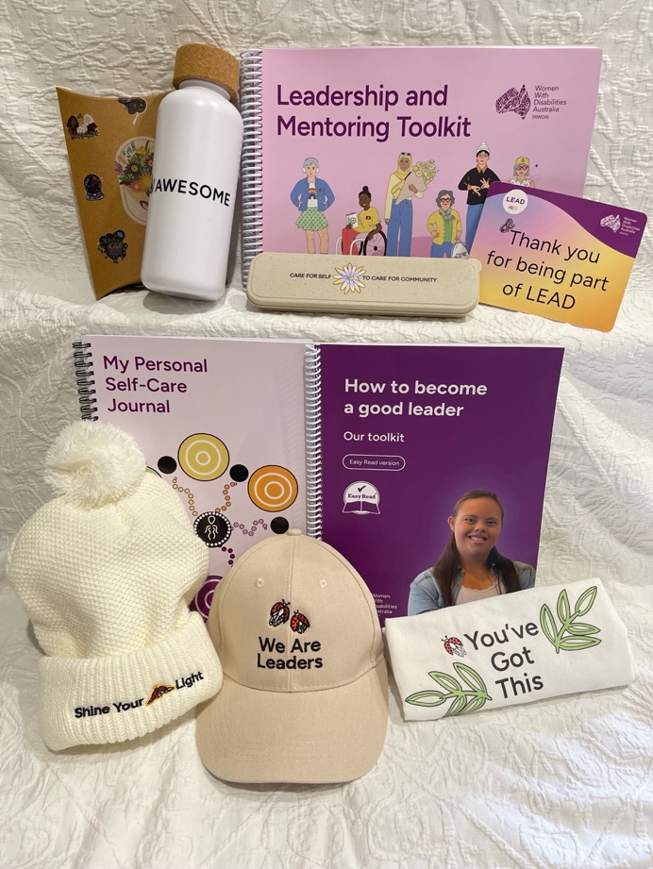

Image: image above shows the different merchandise that the LEAD team developed to launch the Leadership and Mentoring Toolkit. Pictured from left to right in the top row: affirmation cards, a drink bottle, the plain English version of the toolkit, the cutlery set, a thank you card. Pictured from left to right in the bottom row: the self-care journal, the Easy Read version of the toolkit, a beanie, a cap, and a bag. All the merchandise reflects quotes and illustrations from the toolkit.

There is a 10% increase in WWDA membership and Facebook subscribers by project end.
The WWDA membership base has grown substantially and increased over 146% throughout the lifespan of the LEAD Project. The increase of WWDA members throughout the lifecycle of the project has been enormous and has continued to assist the organisation in driving systemic change related to policy and advocacy – one of WWDA’s core strategic goals. The increase in membership is likely attributed to several LEAD Project outputs such as Peer Networking, Scholarships Programs, Mentoring Programs, the Membership Satisfaction Survey (now named the Member Survey). WWDA now has nearly 2000 members engaging with the annual Member Survey, outreach initiatives such as engagement workshops, and increasing social media presence such as the development of the new WWDA TikTok channel. The LEAD Project has also created connections with other women’s, youth, government, health and disability inclusion organisations, creating a media outreach list for future events and partnerships. This was instrumental in the LEAD team achieving the activity deliverables.

There has been an overall increase to Facebook subscribers and community group members throughout the duration of the project. WWDA continues to build its brand and recognition in the sector which further serves to grow WWDA’s audience and reach in the community.

Table 1. Increase in Facebook subscribers and group members throughout the duration of the LEAD Project.

Facebook | % increase
General WWDA Facebook page | 5%
Youth Facebook page | 3.76%
WWDA Facebook Community Group | 15%
Total Facebook subscriber increase | 23.76%

A dedicated women with disabilities community Facebook group is developed by June 2021.
A dedicated community Facebook group was created in 2020 and continues to steadily grow its membership base. The dedicated Facebook group aims to support women, girls and gender-diverse people with disabilities in a safe online space where members can feel supported and validated. WWDA also promotes opportunities for the community to engage in consultation sessions, participate on committees and provide feedback to the organisation within the group. From 2020 to the end of the reporting period (31st October 2024), over 2,100 members have joined the WWDA Facebook Community Group.

Webinars and live Facebook streaming opportunities are researched and implemented.
In the early phases of the project, a WWDA LEAD webinar series was developed and the project team heavily researched, designed and recorded accessible webinars exploring a variety of subjects. Collectively, this webinar series has had over 500 views.
This series is available to watch on the WWDA YouTube channel:
- Intersection: LGBTIQA+ and disability
- Disability and identity
- NDIS and Gender
- We can all be leaders

Throughout the project, the WWDA LEAD team monitored the success of planned events such as webinars and workshops with adequate lead-in time for promotion. This allowed the team to release more targeted content in response to member requests while meeting the activity deliverables for the project. Facebook livestreaming opportunities were explored early in the project, however, due to the spontaneity of livestreams and requests from the WWDA community for sufficient preparation time to attend events, the project team focused on planned events that could be uploaded to the YouTube channel for future viewing by interested parties that may have missed the time of the event.

WWDA LEAD Art Prize
The WWDA LEAD Art Prize competition was an outreach initiative promoted by the LEAD Project to showcase additional ways that women, girls and gender-diverse people with disabilities could demonstrate their leadership. Casey Grey (former WWDA Management Committee member) and Ferris Knight (LEAD Co-design Committee member) were nominated as ‘highly commended entrants across all categories’ for their artworks. In terms of engagement and outreach, the WWDA LEAD Art Prize competition was hugely successful for the LEAD Project and received over 110 artwork submissions to display in the Art Prize Gallery. To increase the engagement of the WWDA community, the LEAD team invited members of the WWDA community to take part as a judge in the ceremony. The award ceremony for the competition was hosted via Zoom and uploaded to the WWDA YouTube channel for registrants to watch post the event.

Information about the WWDA LEAD Art Prize can be found on the WWDA website.
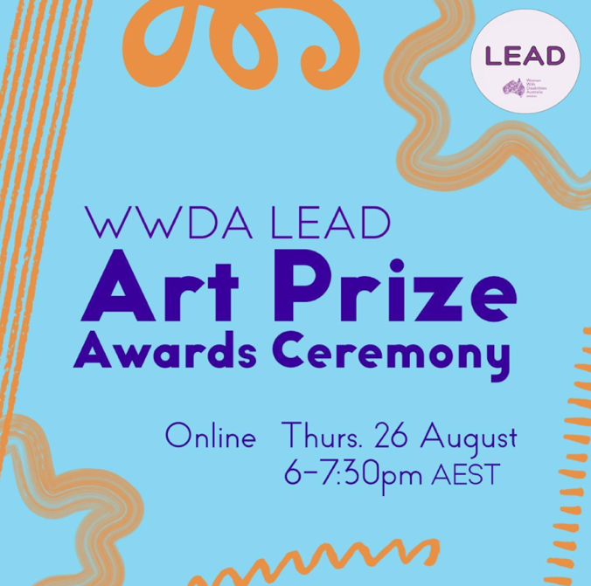

Image: image above shows the social media tile WWDA used to promote the WWDA LEAD Art Prize Awards Ceremony.

WWDA LEAD Blog
In September 2020, the LEAD team initiated a call-out to women, girls and gender-diverse people with disabilities to provide submissions for the new WWDA LEAD Blog that would focus on what leadership means to the community. To ensure accessibility for the WWDA community the LEAD team provided this information in an Easy English version as well. Over the lifespan of the LEAD Project, the team frequently platformed women, girls and gender-diverse people with disability, publishing 58 blogs directly related to leadership and a further 21 blogs on various subjects to the WWDA website. The blogs were also shared through WWDA’s social media channels. When the avenue for publishing blogs was open to the WWDA community, the LEAD team experienced a high volume of submissions leading to an extended waitlist of more than three months, at times, for publication. All contributors to the WWDA LEAD Blog were remunerated for their time, expertise, and creative contributions.

To read the WWDA LEAD Blogs, visit the WWDA website.

Kate, a contributor to the LEAD Blog, provided the following evaluation feedback in her Story of Change:
“I first wrote a blog piece with LEAD to challenge the way I see myself and my disability. I had previously only written about my health from a negative perspective (like the hardship and barriers). Through LEAD, I challenged my writing and leadership by writing two strengths-based pieces that centred the opportunities and empowerment that I have found with my disability and engaging with the disability community. I see this empowerment and optimism as a key component of myself and my leadership.”
When asked if WWDA LEAD has contributed to how Kate practices leadership Kate said:
“My process of writing and engaging with other women with disabilities has shifted my broader work to advocate for the inclusion and elevation of women with disabilities and people with lived experience of chronic illness. I am now more confident to call out ableism and propose better solutions.”
Additional feedback from the Likert Scale Survey revealed 93.3% of survey participants agreed that sharing stories with other diverse women, girls and gender-diverse people with disabilities contributed to strengthening their leadership. While 93.4% of participants agreed that dispelling myths about women, girls and gender-diverse people with disabilities contributed to strengthening their leadership. Feedback from Stories and Change submissions shows that the peer learning approach of the LEAD Project and sharing stories with other women, girls and gender-diverse people with disabilities contributed to strengthening leadership:
“By engaging with the work of women with disabilities and see others like me lead and shine, it makes it easier for me to do the same.”
- Kate, WWDA member
“Made me feel pretty good about my ability to be a leader and talk to girls about women’s health.”
- Anon WWDA member
“I think it is inspiring to create a platform for women with disability to express their concerns and goals about daily life, and possible difficulties that prevent them from reaching their full potential. WWDA LEAD programs such as blogging allows women with disability to truthfully express their thoughts without them being filtered to make mainstream media and the general community comfortable. Such a platform allows the truth and struggles of disability to be explored so that positive changes can be made to make the world more accessible for everyone.”
- Anon WWDA member
“Through my participation in WWDA LEAD, connecting with other diverse women, girls and gender-diverse people with disabilities and discovering others have experienced these same or similar limiting self-beliefs, I have tried to work on accepting myself as who I am and actively partaking in opportunities that take me out of my comfort zone or safety net: my mantra has become “Feel the fear and do it anyway.”
- Lisa Mabin, WWDA Member
“Meeting so many disabled women who are so diverse taught me a great deal about my community and myself. Sometimes I came to WWDA LEAD peer mentoring knowing nothing and learned so much from multiple perspectives. Other times I thought I already knew everything about a topic and then I just had to sit back and listen because I found out there were so many people who actually knew stuff I hadn’t considered. It was an opportunity to meet and talk to leaders from across Australia.”
- Nadia, WWDA Member

These results indicate that fostering supportive networks and challenging societal stereotypes are essential strategies for enhancing leadership capabilities among women and gender-diverse people with disabilities.

When participants were asked whether participating in WWDA LEAD helped reduce their isolation, 73.4% agreed. However, only 60% believed that this reduction contributed to strengthening their leadership skills. This discrepancy suggests that while participants value the reduction in isolation, further exploration is needed to understand how these experiences can be better linked to leadership development.

Other considerations
A major success of the deliverable was the increase in membership for the organisation overall, as well as the increase in subscribers and followers across all social media platforms. This deliverable primarily focused on the increase in WWDA members and in subscriber base to Facebook, however it must be noted that all WWDA’s social media channels experienced an increase to their followership, including the WWDA Tik Tok channel.

Providing multiples platforms and opportunities for women and gender-diverse people with disabilities to engage and participate in the LEAD Project and with WWDA ensured a greater diversity of voices, sharing of ideas and increase in activity. Representing the diversity in WWDA membership is crucial to the primary purpose of WWDA as an organisation. The LEAD Project was an important vehicle to increase this engagement and provided avenues where women and gender-diverse people with disabilities could feel included in a way that notices and builds on their strengths.

As one member wrote in their Story of Change:
“Before writing for WWDA LEAD, I did not consider myself to be a leader: rather the opposite, in fact. I wanted to write for WWDA LEAD to express myself and help me identify better ways of coping with my struggles. However, I now realise that by sharing these struggles, I may have helped other people who haven’t been able to identify how they can better manage their mental health struggles. Being a leader doesn’t mean bossing people around; it can be as simple as showing others ways of doing things differently and allowing them to make decisions that best match their individual circumstances. By writing for WWDA LEAD blog, I was able to find a safe space to share my struggles and find a new sense of confidence in this. Not only did this help develop my self-esteem by writing, but I was also able to read about other women who live with disability. Since participating in WWDA LEAD, I am now employed to write on a regular basis which allows me to continue to develop my craft and better explore ways to help others who struggle with life in the same ways as I do. In my experience, the process of understanding more about leadership was a gradual process and was unexpected. I am grateful to have written for WWDA LEAD multiple times and for this shift in my understanding about leadership.”
A notable barrier the LEAD team identified through the delivery of this activity included the need for a dedicated staff member to be interactive with the WWDA Facebook group. This could include activities such as commenting on posts, driving discussions about leadership development in the community and providing opportunities to engage with the LEAD Project. With the LEAD team often engaged with other deliverables there was, at times, missed connection opportunities for WWDA and members of the Facebook group. Having a dedicated staff member that is prompt to engage with WWDA members could help to reinforce WWDA’s brand, reputation and membership connection.

Implement initiatives to address the gender disparity in NDIS participants.

The deliverable aimed to address gender disparities in NDIS participation by developing accessible, gender-focused information and resources by February 2023 and implementing outreach initiatives. It involved enhancing data collection, hosting an online forum for sharing experiences related to accessing sexual and reproductive services, and advocating for a NDIS Gender Strategy. Additionally, collaboration with government bodies on the National Gender Equality Strategy was part of the plan. These actions were crucial for identifying and addressing gender imbalances within the NDIS, ensuring that all genders receive equitable access and support. The goal was to improve gender equity in NDIS services, influence policy changes, and enhance the overall inclusivity and effectiveness of the scheme.

Outputs and Outcomes

Targeted, gender-focused accessible NDIS information and resources are developed in a wide range of formats by February 2023.
In 2020, WWDA released a ‘Response to employment issues paper’ that addressed the gender disparity amongst NDIS participants. In this paper, WWDA recognised the gaps in the NDIA’s data collection processes:
“The NDIA does not provide gender-disability disaggregated data or information, including in relation to employment, or employment outcomes. Similar to other national disability frameworks, systems, services and programs, the NDIS essentially treats and views people with disability as asexual, genderless human beings.” ^{[1]}

In 2021, in addition to the ‘Response employment issues paper’ released by WWDA, the LEAD team developed an information session exploring why women are not accessing the NDIS at the same rate as men, as part of the WWDA LEAD webinar series. This accessible webinar has been viewed 86 times and is available to watch on the WWDA YouTube channel: NDIS and Gender.

The LEAD team worked extensively and collaboratively with the wider organisation to create several gender-focused accessible NDIS resources. Additional NDIS videos that were created by WWDA include:
- The NDIS: How to Apply
- The NDIS and Gender: Your Right to Supports
- The NDIS: Your Right to Access Services and Supports
- The NDIS: Gender Strategy Now!

During the project, various LEAD team members assisted other WWDA staff in the development of several accessible resources for members and constituents on the NDIS including:
- NDIS Fact Sheet
- National Disability Insurance Scheme (NDIS)
- NDIS: An Easy Read Guide

A LEAD Project team member worked closely with the WWDA Policy Manager and the WWDA President of the Committee of Management to co-facilitate an online forum for women, girls, and gender-diverse people with disabilities to attend and share their experiences of the NDIS when trying to access sexual and reproductive services. This event has been viewed over 260 times and can be watched on the WWDA YouTube channel: Sex and the NDIS. The stories and qualitative data captured from the ‘Sex and the NDIS’ online forum held in August 2023 helped to inform WWDA’s report for the NDIS review.

In April 2024, WWDA finalised its position statement on the need for a NDIS Gender
Strategy and continues to raise this as a priority with the NDIA and the Independent Advisory Council. WWDA continues to work collaboratively with the Department of Prime Minister & Cabinet (and the Office for Women) to assist in all aspects of the development of the Australian Government’s National Gender Equality Strategy.

Other considerations
The LEAD team, in tandem with the rest of the organisation, worked collaboratively on delivering targeted, gender-focused accessible NDIS information for women, girls and gender-diverse people with disabilities. The issues identified in the ‘Response to employment issues paper’ regarding the gender disparity in people who have accessed the NDIS, states that NDIS participants are largely men compared with women and also brings awareness to the fact that the NDIA do not disaggregate their data based on gender. The lack of gender-focused resources available has brought the conversation to the fore and helped WWDA in the identification of other issues when providing recommendations to Government.

While all the resources created by the LEAD team and WWDA were made with accessibility in mind, they were not co-designed resources made by and for women, girls and gender-diverse people with disabilities. Upon reflection of this deliverable, the LEAD team could have engaged WWDA’s advisory committees and co-design committees to help the staff create accessible resources that were meaningful and relevant for the information the community needed. Employing a co-design method through all aspects of the LEAD Project would have increased the engagement and connection between WWDA and its members and intended audiences. This could have had a potential flow on effect in increasing WWDA’s membership base and online engagement.

Provide access to information resources developed by and for women, girls and gender-diverse people with disabilities.

This deliverable aimed to enhance access to information resources developed specifically by and for women, girls and gender-diverse people with disabilities. By the end of the project, a diverse range of online content and resources were created in multiple accessible formats to support autonomy and agency. This initiative was important because it provided tailored information and tools that empower women, girls and gender-diverse people with disabilities, address barriers, and improve their ability to make informed decisions, advocate for themselves, and to build leadership capacity. The varied formats ensured the resources were accessible and effective, meeting the needs and preferences of users.

Outputs and Outcomes

WWDA online content and resources that promote the autonomy and agency of women, girls and gender-diverse people with disabilities are developed in a range of alternative formats by February 2023.
The LEAD team prioritised accessibility in all resource development. This meant accessible formats for several co-designed resources were sought in a range of translations such as First Nations languages, Chinese (Simplified), Chinese (Traditional), Vietnamese, Turkish, Arabic, and Auslan. The LEAD team also engaged community subject matter experts to review co-designed content through specific lenses, ensuring that materials were accessible to the diverse population that makes up WWDA members.

There are a wide range of resources available to women, girls and gender-diverse people with disabilities that focus on promoting autonomy and agency.
Throughout the LEAD Project, a wide range of resources have been co-designed and co-produced with ECP members and co-design committee members alongside project staff. This ensured all resources made by the community are relevant, useful and accessible for the community. WWDA’s human rights-based framework has underpinned all resource development throughout the LEAD Project, ensuring WWDA’s commitment to promoting the autonomy and agency of women, girls and gender-diverse people with disabilities.

The WWDA Our Site portal is further developed by December 2022.
Launched in 2020, the WWDA Our Site website continued to be maintained and updated through to 2023. From November 2022 through to February 2023, the Content and Communications Officer from the LEAD and Our Site team assisted the Our Site Project in the development of an updated version to the ‘Real Stories’ section of the website. This included streamlining the process of story submission from contributors to make it more accessible so that WWDA could continue to platform women and gender-diverse people with disabilities and amplify the voices of the WWDA community. In April 2023, to celebrate the 3-year anniversary of the launch of Our Site, the Content and Communications Officer co-facilitated the Our Site Storytelling Workshop, which helped to celebrate the many contributors to Our Site’s Real Stories and also to encourage new contributions from other women, girls and gender-diverse people with disabilities. The workshop sold out and had an additional waitlist of 30 people. Since its release, the workshop has been viewed 59 times. At the end of the workshop, all participants were provided with a certificate of participation.

The WWDA Our Site portal underwent a thorough review of the "Sex and Your Body", "Safety and Violence" and “Life Choices” sections leading to key updates. Changes were made to ensure the content is current, useful and reflective of the diverse WWDA community. The "Real Stories" section has achieved a milestone of 100 shared stories during the reporting period. Further enhancements to the WWDA Our Site portal include all resources and external links being reviewed and updated to improve website functionality and relevance, to ensure a more effective and user-friendly experience.

Other considerations
The development of accessible information resources through co-design is a key feature that speaks to the success of this deliverable. Throughout the project, the LEAD team worked extensively with co-design committees and an ECP to ensure women, girls and gender-diverse people with disabilities can access information relevant to their needs. Accessibility was increased through multiple language translations and other accessible formats such as Easy Read.

Sarah Heta was a member of the LEAD ECP and has shared some of her experience of what it felt like to be a part of the development of a key resource for the disability community:
“I am doing some drawings for the Change Story too. It is a love heart with insects in it like the drawings I did for the Toolkit. This is to show how much I loved doing the drawings and how good it has made me feel about myself. I can’t wait to see the drawings in the Toolkit. I will really be an actual artist then!!! Thank you for giving me a chance to support the LEAD Project. I have learnt much more about what I can do.”
- Sarah Heta, LEAD Expert Co-production Panel member

Alongside the success of co-design and co-production, was to ensure that all participants of ECP and co-design committees felt empowered and that their involvement promoted the autonomy and agency of women, girls and gender-diverse people with disabilities. A few members of the LEAD CDC and PSC share feedback about their participation in the LEAD Project:
“I just wanted to touch base and say the toolkit looks amazing! … Thank you all so much for all the work you did on this project. I am so proud to have been part of its creation!”
- Janel Manns, LEAD Co-design Committee member
“I was super excited to attend the launch of the Leadership & Mentoring Toolkit…”
- Stevie Russell-Farnham, LEAD Co-design Committee member
“…please give everyone my very warm regards and thanks to all – LEAD experts and past/present staff – for being part of such a fantastic and valuable project.”
- Kerrie Duff, LEAD Project Steering Committee member
“It's been so good to be part of it the whole way through.”
- Karin Swift, LEAD Project Steering Committee member

An important note for this deliverable acknowledges that not all committee members were able to attend every meeting and workshop. This meant, at times, that co-designing phases were limited or delayed due to a lack of participants. Although committee members were always remunerated for their time and expertise, sometimes they couldn’t attend the sessions for a variety of reasons. The LEAD team frequently offered alternative arrangements to ensure inclusion in co-design however these were not always suitable and thus, there were a small number of times that work did not include the involvement of the entire LEAD CDC.

Section 4: A reflection on the outputs and outcomes of the Organisational Capacity Building (OCB) stream of the WWDA LEAD Project

Develop and implement strategies to upskill the organisation

This deliverable focused on developing and implementing strategies to upskill the organisation. This included recruiting women and gender-diverse people with disabilities for project positions, creating and implementing a WWDA Project Management Framework and Policy, and updating the WWDA employee handbook to align with current regulations. These actions ensure that women and gender-diverse people with disabilities have equitable access to meaningful project roles that positively impact the community, while the updated policies and handbook provide a structured, legal, and supportive work environment that promotes inclusivity and compliance with relevant regulations.

Outputs and outcomes

Women with disability are recruited for project positions by end of July 2020.
The LEAD Project experienced some delays throughout the course of the activity, meaning that some project staff were unable to remain on the team for the entirety of the project. There has been staff turnover throughout the lifespan of the project, however continued recruitment activity has allowed the continuation and success of the project. All new staff recruited into WWDA are provided full training to ensure success in their roles as well as additional professional development opportunities to assist in the creation of accessible resources for the LEAD Project. Professional development offered upon onboarding of a new staff member includes:
- Access Easy English
- Creating Accessible Documents in Word and PDF
- Mental Health First Aid

WWDA LEAD Monitoring, Evaluation and Learning (MEL) workshop.
In December 2022, the WWDA LEAD team were invited to Hobart for a three-day team bonding and exploratory MEL workshop. The purpose of the workshop was to introduce the MEL Framework to the LEAD team and help the team to understand how to facilitate the feminist MEL process for participants. A secondary outcome of this staff event meant that organisational capacity building strategies were developed and implemented that would also ultimately help to deliver the MEL for the LEAD Project.

A WWDA Project Management Policy and Framework is developed and implemented by December 2022.
Due to delays experienced within the LEAD Project at times through its lifespan, a WWDA Project Management Framework and Policy wasn’t developed until 2024. The framework developed reflects similar subscription-based SaaS such as ClickUp and monday.com. This framework was then adapted generically so that it could be applied to future projects within WWDA. The framework was developed to be used as an alternative to expensive subscription-based SaaS that limits WWDA’s ability to maintain records beyond funding. However, the framework and policy developed by the LEAD team will provide WWDA with the support and structure it needs to enhance its project management capabilities in the future.

The WWDA Employee Handbook is reviewed and updated to be current and consistent with industrial relations and OHS laws.
The WWDA employee handbook was uploaded to Employment Hero in August 2024 and continues to be updated in line with legislative requirements. To further support organisational staff, a new Employee Assistance Program (EAP) was implemented at the beginning of 2024 providing a more comprehensive service for staff.

Other considerations
The primary success of this deliverable involved upskilling and professional development of the organisation’s staff. Upon onboarding, all staff receive training tailored to their role. This includes one-to-one training with their manager, training from external providers, and ongoing consultation with key stakeholders. The onboarding process equips staff for success in their role. Additional to this, was the development of the Project Management Framework and Policy. The creation of these internal resources means WWDA will be able to implement a structured process when deploying projects in future.
The delayed development of the Project Management Framework and Policy meant that project teams within WWDA currently were unable to benefit from this specific organisational capacity building objective of the LEAD Project. Completing this task at the beginning of the project would have provided structure in the delivery of these projects, evaluation of results and reporting structures. Future recommendations to WWDA would be to conduct thorough reviews of project grants in line with the Project Management Framework and Policy to ensure projects with have ongoing benefit to WWDA and its members.

Improve organisational systems and process to deliver efficiency and effectiveness

This deliverable focused on improving organisational systems and processes to enhance WWDA's efficiency and effectiveness. Clear governance structures and enhanced operational effectiveness have been achieved by implementing key frameworks and policies including a Risk Assessment Framework, a communication and engagement strategy, a financial management system, an organisational policy and procedure manual, and an updated WWDA Constitution. This is crucial for fostering a more responsive and accountable environment, ultimately allowing WWDA to better serve its members and achieve its mission.

Outputs and Outcomes

The WWDA Constitution is updated with legal input by June 2021.
The WWDA Constitution was updated with legal input by 2021. The updates that were made to the Constitution were to clarify details, support governance structures and reflect legislative changes.

An organisational Risk Assessment Framework is developed.
An organisational Risk Assessment Framework was developed in 2024 by the LEAD team. Although this framework is specifically for implementation of projects, it has also been written to be adaptable to ensure its application to other aspects of the organisation. WWDA then engaged an external human resources consultant to develop a policy to cover the use of the framework within the organisation.

A WWDA communication and engagement strategy is developed and implemented.
A WWDA communication and engagement strategy was developed early in the project and continues to be updated regularly as the strategic goals of WWDA evolve. Individual campaigns related to the LEAD Project utilised templates the LEAD team created as part of the communication and engagement strategy to ensure effective communication for all events and activities. By using these templates, LEAD Project communications were accurately targeted at WWDA’s current audience and aimed to broaden this scope to capture people laterally aligned to WWDA including support workers, carers and family members. Use of the templates and strategies demonstrates ongoing organisational capacity building implementing structured processes delivering efficiency and effectiveness to WWDA.

A cloud-based financial management system is established and implemented.
A cloud-based financial management system was established and implemented in 2024. This financial management system has proven effective at accurate and timely reporting of WWDA’s financial responsibilities. Key features of this cloud-based system include enhanced compliance to WWDA’s stakeholders and funding bodies, increased accessibility for staff and improved financial oversight and management of WWDA project and operational budgets.

An organisational Policy and Procedure Manual is developed for the Organisation by October 2024.
WWDA’s current organisational policy and procedure manual continues to be updated by external human resources consultants, ensuring that policies and procedures are updated in line with current regulatory requirements. Staff are informed of updates via the Employment Hero portal ensuring that WWDA remains compliant with current legislation.

Review and update the WWDA Strategic Plan
In 2024, the LEAD team engaged The Alternative Board to assist in the development of a new organisational strategic plan that would help WWDA continue to fulfill its mission in promoting and advancing the human rights of women, girls and gender-diverse people with disabilities.

The WWDA Strategic Plan sets out the strategy for 2025 and outlines three key organisational goals and required objectives. These are:
- Undertake focused systemic advocacy on priority human rights issues identified by women, girls and gender-diverse people with disabilities.
- WWDA will maintain its national and international leadership position in promoting the human rights of women, girls and gender-diverse people with disabilities, contributing to the development, implementation, and monitoring of relevant laws and policies.
- WWDA will establish robust governance mechanisms alongside the development of infrastructure, systems, and financial capacity. This will ensure transparency and accountability, enabling the achievement of WWDA’s purpose, goals, and objectives while ensuring the long-term impact and organisational resilience.

Other considerations
The primary success of this deliverable was to strengthen governance structures for WWDA to ensure sustainability and longevity of the organisation. The Risk Assessment Framework that was developed by the LEAD team will provide WWDA with a strong foundational base to assess, analyse and mitigate risks to the organisation and/or projects, which only serves to further reinforce the governance structures already in place. Another positive result of this deliverable includes the implementation of a cloud-based financial management system leading to increased accountability and transparency of WWDA’s financial management as accurate data can now be provided in real-time.

While organisational policies and procedures were updated throughout the course of the project, WWDA didn’t employ the use of the SaaS program ‘Employment Hero’ until the start of 2024. This meant that prior to this, there was no automated method for tracking and monitoring that staff had read and acknowledged the policies and procedures for the organisation. However, WWDA will now continue to use Employment Hero as one of the primary avenues for communicating organisational compliance with staff.

Strengthen the quality of organisational activities

This deliverable aimed to strengthen the quality of organisational activities through the implementation of an annual Member Survey. The survey measures member satisfaction and gathers valuable feedback that informs improvements in services and governance. Additionally, the WWDA monthly newsletter, WWDA organisational policy and procedure manual, WWDA staff induction manual, and WWDA Management Committee policies and orientation manual provide essential information and resources that enhance communication, ensure compliance, and support staff training. By implementing these resources and regularly updating governance and services based on survey outcomes, the organisation demonstrates its commitment to responsiveness and continuous improvement. This approach ensures that the organisation remains aligned with its members needs while maintaining high satisfaction levels.

Outputs and Outcomes

A WWDA Membership Satisfaction Survey is developed and implemented annually.
From August to October 2023 the LEAD team deployed WWDA’s inaugural Membership Satisfaction Survey that allowed members to provide feedback to WWDA about the organisation. This survey had a response from 10% of WWDA’s membership base at the time. To read more about the results of the Membership Satisfaction Report, visit the WWDA website.

In 2024, the survey was renamed to the ‘Member Survey’ as it was designed to capture more than membership satisfaction and include member experiences of the organisation. This survey is now ready to be deployed annually to ensure that WWDA continues to listen to the needs of its members and make changes accordingly in-line with WWDA’s commitment to continuous improvement. The survey is available in multiple accessible formats including Easy Read language translations.

Of the 149 participants of the survey, WWDA’s communications received an average rating of 4.03 out of 5, with praise for the informative content, the diverse newsletter sources and the member-led community.

“I get so much more out of the membership than I ever expected. And I have brought information into my workplace to share knowledge.”
- WWDA Membership Satisfaction Survey participant 2023
“I like feeling like part of a community, especially when I go through periods of feeling isolated due to disability.”
- WWDA Membership Satisfaction Survey participant 2023

The WWDA Member Survey provided invaluable insights into the perceptions and experiences of WWDA members, offering a comprehensive overview of the organisation’s strengths, areas for improvement, and the impact of communication strategies. The positive feedback reflects the dedication and success of WWDA’s operations. Members expressed satisfaction with WWDA’s informative content, diverse newsletters and the sense of community fostered within the organisation. The high ratings and praise highlighted the effectiveness in keeping members informed and connected. However, the survey has also illuminated areas where improvement is essential. Dissatisfaction with how WWDA identified and engaged with non-binary and gender-diverse people with disabilities prompted the implementation of more inclusive language across all communications strategies and campaigns. Updates to the WWDA website to increase accessibility was also actioned after feedback from members.
“It is really important to me that WWDA address the issue of what they mean by non-binary people being welcome and who they are talking about. There is a real lack of clarity on this and as a non-binary trans person I feel incredibly uncertain as to whether WWDA is for me or not.”
- WWDA Membership Satisfaction Survey participant 2023

Monthly WWDA newsletter is produced and contains up to date information on the activities of the LEAD Project.
Throughout the LEAD Project, WWDA maintained a monthly newsletter ensuring continuous LEAD activity updates were provided to WWDA subscribers. The LEAD Project included relevant information for each month, upcoming information for future activities, opportunities to take part in various activities and events and surveys to capture responses from participants of recent activities. The WWDA newsletter continues to be a primary source of information and communication between WWDA and its members.

WWDA Governance, policies and systems are reviewed, developed, and ratified.
During the project, work commenced on the development of a WWDA organisational policy and procedure manual; a WWDA staff induction manual; and a WWDA Management Committee policies and orientation manual. These systems continue to be reviewed, developed, and ratified on an ongoing basis and are made available in cloud-based spaces where employees and members of the Committee of Management can access them.

Other considerations
The success of this deliverable aligned well with the previous one as its activities helped to strengthen the quality of systems and processes. Like the previous deliverable, the governance structures built for WWDA were further reviewed and updated leading to improved quality of those structures. Additionally, as part of the communications strategy for the project, the LEAD team created a campaign to garner information about the organisation from a member perspective. This provided WWDA with insights into areas for improvement for the organisation and how WWDA can improve its communications methods to the membership base. Overall feedback from the first- and second-Member Surveys was quite positive and constructive, leading to improved accessibility on the WWDA website and more inclusive language when WWDA is engaging with its target audience.

As discussed in the previous deliverable, the main barrier to this activity was the initial lack of infrastructure to overall governance and compliance for the organisation. As the project progressed, these structures continued to be strengthened, which contributed to build the general organisational capacity of WWDA.

Section 5: A reflection on the outputs and outcomes of the overall project management deliverables of the WWDA LEAD Project

Recruit project staff/personnel

This deliverable ensured that the project was staffed appropriately and in-line with project-specific requirements. All staff that were recruited were offered the option of applying for reasonable adjustments through Job Access, or WWDA provided the reasonable adjustments to the staff. Comprehensive orientation to the project and the organisation was provided to all new staff upon onboarding. The outputs of this deliverable ensured that the project team worked in a supportive and inclusive environment working cohesively and effectively to achieve project goals.

Outputs and Outcomes

Project staff are recruited.
Staff with the requisite skills and experience were recruited guaranteeing timely delivery of the desired outcomes for the LEAD Project. Recruitment involved advertising roles through EthicalJobs, interviewing candidates and completing onboarding procedures.

Orientation to the project and the organisation is completed.
Orientation to the project and the organisation was completed as new staff were onboarded. This was conducted using a structured approach that enabled new staff to feel familiar with the needs of the project, the organisation, and feel supported to contribute to the demands of their roles.

Reasonable adjustments are organised.
Throughout the delivery of the project, WWDA provided the JobAccess service to new staff upon onboarding. JobAccess is a government service for employers to offer staff that allows for reasonable adjustments to be made for people with disability in employment settings. Ensuring a person-centred approach, WWDA has encouraged the use of this service to all staff should they require reasonable adjustments to work.

Other considerations
Women and gender-diverse people with disabilities were recruited to the project team to help deliver activities and programs to the community. WWDA also offered the JobAccess service that provided staff with the reasonable adjustments they required to feel supported at work.

A barrier to the completion of this deliverable were the limitations to the retention of project staff throughout the course of the project. Initially, it was difficult to retain staff as the project was experiencing some preliminary setbacks. These setbacks were limited, and the LEAD team mitigated any impact the delays had on the overall delivery of the project.

Establish project management process and project governance structure

This deliverable aimed to establish project management processes to streamline the delivery of activities outlined within the grant for the LEAD Project. A project governance structure was also established to ensure WWDA remained consistent with its constitutional requirements for project delivery.

Outputs and Outcomes

Project management process is established.
While the initial LEAD team employed a hybridised model for project management, a firm structure for WWDA wasn’t developed until 2024. The final LEAD team developed a project management process and continued to refine this process as the project progressed and as needs evolved dependent on the activity requirements.

Project Steering Committee is established.
A Project Steering Committee (PSC) was established at the start of the project to ensure that the project had the necessary governance structures in place for operations and oversight. The PSC was regularly convened throughout the course of the project, which assisted the LEAD team in providing essential updates on the status of the project. All PSC members were remunerated for their time and expertise.

Draft Terms of Reference for the PSC are developed and endorsed.
Draft Terms of Reference for the PSC were developed and endorsed in 2020. The Terms of Reference provided members of the committee with general project information, clear expectations of their role, their relationship to other committees formed for the LEAD Project, and the ways they would be thanked for their time and expertise. Throughout the project, the LEAD team formed additional committees that were essential to delivering material assets to the project. Draft Terms of Reference were developed and endorsed by these committees to ensure their participation was in-line with WWDA’s co-design policies.

Other considerations
From the beginning of the project, the LEAD team established project governance structures that helped to keep the project on track throughout the four years of delivery. Establishing a Project Steering Committee (PSC) meant that the project team was accountable for the ongoing completion of deliverables, ensuring that activities were completed within time, scope and budget. The biggest strength from this deliverable can be attributed to the dedicated PSC members who continued to participate in the project, throughout the many changes within the project and organisation.

A major barrier to the success of this deliverable was the initial lack of formalised procedures relating to project management. Since these processes and frameworks weren’t developed in detail until 2024, this meant that earlier phases of the project weren’t able to benefit from the organisational infrastructure that was later developed by the LEAD team.

Develop internal and external financial reporting requirements and processes

This deliverable aimed to build the organisational capacity of WWDA to ensure that the organisation could meet its financial reporting requirements to funding bodies. Internal and external financial reporting processes and policies were developed as a framework that would allow WWDA to meet these obligations in a timely and accurate manner.

Outputs and Outcomes

Project accounting cost/job code is established.
A project accounting code/job code was established early in the project. The project accounting codes allow for all income and expenses to be appropriately coded, which would facilitate accurate financial reporting. The job codes established have benefited WWDA as they are able to be applied to all aspects of the organisation and continue to be used by external financial consultants.

Quarterly project financial reports prepared by WWDA accountants are provided to the Project Steering Committee (PSC), the WWDA Management Committee and the project funding body as required.
Accurate financial reports are created by WWDA accountants and provided to the funding body and WWDA Management Committee as required. The PSC were provided with frequent budget updates related to project expenditure during their regular committee meetings held with the project team.

Project financial acquittals are provided to the funding body as per the funding contract.
Project financial acquittals were provided to the funding body in a timely manner in accordance with the funding contract. With the implementation of a cloud-based financial management system, financial reporting to key stakeholders and funding bodies is now a straightforward process.

Other considerations
In consultation with external human resources consultants, the LEAD team helped to develop financial reporting processes for the organisation. The achievement of this task has meant that WWDA remains compliant with its financial responsibilities. Establishing accounting codes for all income and expenses means that transparency exists for WWDA’s financial records.

Develop project reporting framework and processes

This deliverable aimed to create project reporting frameworks and processes that would enhance the organisation’s capacity. The LEAD team developed project reporting frameworks and processes that worked in tandem with the Project Management Framework. This deliverable also ensured that the LEAD team met the reporting obligations to the funding body as per the funding contract.

Outputs and Outcomes

Project reporting is undertaken in accordance with the requirements of the project funding contract.
As per the initial funding contract with the National Disability Insurance Agency (NDIA) and then with the Department of Social Services (DSS) from 2022, ongoing project reporting was a key feature for the LEAD team ensuring that all activities and events for the LEAD Project were accurately reported on. This demonstrated a high level of communication between the project team to the funding bodies, and the wider WWDA community. Regular progress reports were submitted to the NDIA and to DSS at six-monthly intervals. The most recent activity work plan progress reports to DSS have been accepted and endorsed by DSS.

LEAD Project contributions to the WWDA Annual Report are submitted.
Each financial year the LEAD team have generated a LEAD Project contribution to the WWDA Annual Report that is presented at the Annual General Meeting. This contribution meets the reporting obligations of the organisation and helps to keep WWDA members updated on the status of projects within WWDA.

Other considerations
The LEAD Project coordinated many activities, events and programs throughout the course of the project. Project reporting to funding bodies was a central focus to the LEAD team and was always completed in a timely fashion. The LEAD team often had many positive aspects and feedback from participants of the project to share with the DSS about the impact of the delivery of the LEAD Project in the community. The LEAD team were diligent at ensuring that LEAD Project contributions were made to the WWDA Annual Report and positively reflected the experiences of women, girls and gender-diverse people with disabilities.

A barrier to consider for this deliverable was the delayed development to the project management framework and reporting processes. The frameworks that the LEAD team built in 2024 will provide WWDA with a clear and consistent structure for reporting processes in the future.

Establish project liaison and update meetings with the NDIA and DSS

This deliverable aimed to ensure a communication line was established between project staff and the funding body. Establishing a project liaison to meet with the NDIA and DSS allowed the project staff to continue to revisit their project planning, ensuring timely delivery of activities, and meeting their contractual obligations to the funding body.

Outputs and Outcomes

Project Manager and staff participate in meetings with the project funding body as required.
The LEAD Project was originally funded by the NDIA; however, the funding agreement was transferred to DSS in November 2022 as the Department became responsible for the management of all Information Linkages and Capacity Building grants. Throughout the lifespan of the project the LEAD team, engaged with the NDIA at regular intervals, including through the progress report updates, the team continued to engage with DSS through the Funding Arrangements Manager when the funding transferred.

Project updates and relevant events are provided to NDIA and/or DSS for inclusion into NDIA and/or DSS newsletters and other relevant publications.
The launch of the Leadership and Mentoring Toolkit saw the development of a communications strategy and media release between the Minister’s Office and the LEAD team to ensure that the Department would provide cross-promotional media that endorsed the use of the toolkit.

Due to the timing of the WWDA newsletters and newsletters from Government bodies, the LEAD team provided project updates through reporting channels and regular updates were released through the WWDA newsletter and WWDA social media platforms.

Other considerations
A primary success to this deliverable was the meaningful relationship the project team made between the organisation and the Department. The project team worked diligently to build and strengthen the connection between the organisation and the funding body through regular communication and reporting opportunities. The LEAD team was able to report on many achievements and successes of the project on a frequent basis.

Map and identify key project stakeholders

The aim of this deliverable was to identify key project stakeholders that could have a massive impact on the delivery of the activities within the grant. At the beginning of the project, the LEAD team formulated a comprehensive list of stakeholders in a register, that was later refined to key stakeholders after a project review at the beginning of 2023. The key stakeholders were identified as those that have the most influence in the project and that could make a significant impression in key project activities.

Outputs and Outcomes

Database of identified project stakeholders is developed.
Early in the project a comprehensive list of stakeholders was developed. This list was then refined to a register of key stakeholders in the project. The database of key stakeholders was then mapped against their involvement and interest in the project, allowing project staff to communicate effectively with the right stakeholders using their preferred method of contact. Using this stakeholder power/interest mapping technique ensured that project staff were monitoring, managing, communicating, and anticipating the needs of all stakeholders throughout all stages of the project. From this database, a communications strategy was then developed, which provided key stakeholders with regular updates to the level of detail they required at their chosen intervals, via their preferred method of contact. All communications with stakeholders were tracked in a communications log, allowing project staff to keep a thorough record of key information shared between the project team and stakeholders.

Other considerations
The development of a database of essential project stakeholders was key to ensuring communications related to project-specific tasks remained on track with everyone involved in the LEAD Project. Mapping the stakeholders according to their level of interest and influence in the project helped the LEAD team develop effective communications strategies with internal and external stakeholders including the CEO, PSC and WWDA members, as well as the funding body and other external providers. Tracking communications between stakeholders and the project team meant that everyone was always up to date with the latest and most relevant information.

Upon reflection, regular review of this database at key milestone points of the project would have provided the LEAD team with a meaningful and contemporary list of stakeholders that still had interest in the project. From here, communications strategies and plans could have been updated in line with stakeholder needs as these changed and evolved over the years.

Develop project communications strategy

The aim of this deliverable was to ensure an effective communications strategy was developed and implemented to support the project and the activities to succeed. The LEAD Project was immensely beneficial for the WWDA community and empowered many women, girls and gender-diverse people with disabilities to build their leadership capacity and take part in capacity exchange. A strong communications strategy for the LEAD Project was central to the successful completion of all major deliverables for this project.

Outputs and Outcomes

Mechanisms, processes and timeframes for project communications are developed and implemented.
As part of the development process for project communications, mechanisms for deployment and timeframes to run campaigns were built into these frameworks. This allowed project staff to plan and execute effective campaign strategies around all LEAD Project-related activities, events and programs.

Project communication templates and branding are developed and implemented.
As part of the ICB deliverable: Increase the engagement of women, girls and gender-diverse people with disabilities in WWDA through outreach initiatives, branded project communications templates were developed early in the LEAD Project to ensure that all events, programs and activities were campaigned effectively and promoted. More information about this output can be read here.

Other considerations
Throughout the LEAD Project, WWDA experienced multiple iterations of rebranding before landing with the most recent design. This final rebrand was the result of many consultations with subject matter experts in accessibility, external technical service providers, and feedback from WWDA members about improving the design and user-friendliness of the website. The rebrand for WWDA encapsulated the desire of WWDA members to increase their engagement with WWDA, while providing WWDA with a consistent and reliable theme for all their communications. The rebrand for the toolkit, whilst maintained under the WWDA brand, was heavily influenced by designs from a WWDA member and spoke to WWDA’s ongoing commitment to platforming women, girls and gender-diverse people with disabilities. The project templates that were created out of this deliverable will continue to prove beneficial to the operational management of WWDA for future projects.

Develop project monitoring, evaluation and learning (MEL) processes

This deliverable aimed to ensure that project monitoring, evaluation and learning processes were in place, which would be effective at capturing essential data from participants at various stages of the project. Monitoring the activities as they ran from initial phases right through to feedback collection stages provided the groundwork for project staff to consider and implement the feedback from LEAD Project participants. This provided all LEAD Project participants with a rounded experience of the activities and confidence that WWDA was listening to feedback to ensure that delivery of the next event met a higher standard.

Outputs and Outcomes

Project Evaluation Framework is developed.
In June 2021, WWDA engaged an external consultant, Caroline Lambert, to assist in the planning, development, and implementation of the monitoring, evaluation and learning (MEL) framework for the LEAD Project. Caroline specialises in feminist leadership, governance and strategy and assisted the project in developing the MEL framework from a feminist perspective to ensure MEL could be delivered with integrity. Caroline worked with the LEAD Project co-design committees extensively to support the MEL framework and to ensure that the National Health and Medical Research Council’s (NHMRC) ethics framework ^{[2]} was applied to the WWDA LEAD MEL. Each of these principles were embedded within the development of the WWDA LEAD MEL framework. This ethical approach to MEL also provided WWDA with growth opportunities to reflect on learned lessons of the project.

The principles that underpin the NHMRC’s ethics framework for MEL are:
- Respect for participants
  - Caring about participants
  - Ensuring privacy and confidentiality
  - Consent processes
- Research merit and integrity
  - Evaluation is necessary
  - Well designed
  - Fills a data gap
  - Does no harm to participants
  - Facilitators are trained
- Justice
  - Selection of participants is fair
  - Fair recruitment processes
  - Participants are not pressured
  - Transparency in findings
- Benefit
  - Designing research to minimise risk or discomfort to participants
  - Ensuring that the benefit of the research justifies any risk or discomfort

Caroline helped facilitate the co-design process to draft the Leadership Statement with the Project Steering and Co-design Committees and created a Desk Review on Feminist MEL for WWDA to further support the development of the WWDA LEAD MEL framework. The combination of these three resources formed the foundations that enabled Caroline and the project team to draft MEL principles for the LEAD Project. These principles were:

- Nothing about us without us: Women, girls and gender-diverse people with disabilities who participate in WWDA LEAD are the best MEL experts available. The lived experience and rich knowledge of the WWDA community is central to WWDA LEAD’s approach to MEL, at every stage: from design, data collection, sense-making and knowledge building. WWDA’s MEL approaches will value both numbers (quantitative) and stories (qualitative) to learn about what has changed for the community. Value will be identified in both individual and collective change, and approaches will be cultivated that support both individual and collective knowledge. Accessible methodologies will challenge and transform traditional approaches to MEL, which frame the MEL practitioner as the expert. The time and energy of the LEAD participants who take part in the MEL will be valued and kindness and caring in the delivery of the MEL from facilitators is essential to the process. The facilitators commit to providing transparency of the MEL.
- Do no harm: WWDA LEAD will ensure that the WWDA LEAD MEL is fair, respectful, and only asks what is necessary. The privacy, confidentiality, and different ways of being and knowing among the WWDA LEAD participants will be respected. The benefits and risks of participating will be clearly explained, and the consent process will be empowering. WWDA will be accountable: there will be clear pathways for participants to raise any concerns about the MEL processes.
- Name the power relationships: Power exists in so many forms in MEL, for example, the power relationship of WWDA with the WWDA LEAD participants. At no time should any WWDA LEAD participant feel coerced into participating in a MEL process and, so long as it is possible, they can withdraw their consent at any time up until the MEL reports are submitted or made public. Another important power relationship is between WWDA and the funder – which influences how the MEL is designed.
- See the Big Picture: WWDA LEAD’s MEL will see the big picture. The LEAD team will capture the contribution made to leadership journeys and change for women, girls and gender-diverse people with disabilities, but will not claim the full credit. The LEAD team will value the progress made as much as the outcome. The LEAD team will recognise that gender equality change is complicated and will need a sensitive and respectful approach to responses. Pragmatism will be practiced, not everything can be measured, and attention will be focused on indicators of impact and stories of change. Lastly, the insights from the WWDA LEAD MEL will help to inform WWDA’s work for transformational and systemic change.

Data collection methodologies are identified and implemented.
The LEAD Project undertook many different types of data collection methodologies including feedback surveys, Likert Scale Surveys, Stories of Change, focus groups, one-on-one emails and phone calls, evaluation briefing sessions for the Mentoring Program and Peer Networking, qualitative and quantitative data analysis, website analytics, and social media commentary monitoring. These methods for data collection provided real-time feedback to project staff about the success of the events or programs. This allowed for project staff to consider areas for improvement and any lessons learned for future funding considerations.

Other considerations
Engaging Caroline Lambert was of great benefit to the project and to WWDA. Caroline helped develop an ethical MEL structure for a complex project in an accessible format that could be applied to all facets of the LEAD Project, whilst respecting and empowering participants of the MEL. The tailored MEL framework that was created captured the feedback of all participants that took part in various events, activities and programs, and framed the MEL participants as the experts of the MEL – a significant reversal to the notion of how MEL is usually delivered. The findings and learnings from the MEL process have provided WWDA with the necessary data on how the community engages with the organisation and activities of specific projects, valuing both quantitative and qualitative information from MEL participants. More information on the tools used to collect qualitative data from participants can be found in Appendix 8.

A barrier of note to the MEL process was that some participants felt the surveys and other communication methods were onerous and therefore did not want to complete them. A future consideration for WWDA to encourage engagement amongst its membership base would be to provide shorter surveys and more opportunities to respond in other ways. One WWDA member from the 2023 Membership Satisfaction Survey notes:
“I had to wait for a good day to fill in this questionnaire - on days that are full of brain fog and fatigue even reading the newsletters is difficult, I wish there were 2-line summaries and less pressure to participate on days like these.”
- Anon WWDA member, 2023 Membership Satisfaction Survey participant

Undertake project evaluation and review processes

The aim of this deliverable was to undertake project evaluation consistent with the MEL framework that had been developed for the project. Analysing the data and measuring the success of the outcomes will provide WWDA and the funding body with a greater understanding of the detail involved in essential programs and activities for women, girls and gender-diverse people with disabilities. Conducting regular reviews to assess project management processes including evaluation will allow WWDA to improve project workflow efficiency and help to identify issues or concerns that may negatively impact the delivery of the project. The overall goal of this deliverable was to ensure project deliverables were achieved on time and within scope, apply learnings from the MEL process, and enhance planning for future projects.

Outputs and Outcomes

Seek participant reviews and evaluations of events or activities
Feedback on events or activities through surveys, focus groups, and Stories of Change helped to provide direct insight into participant experiences of the LEAD Project and their overall engagement in those activities or events. By actively seeking feedback from participants, the project was able to tailor future events to better meet the needs of the community, which increased satisfaction levels.

Analyse participant evaluations for qualitative data
Responses from participants have helped the project team to compile analysis reports on qualitative data. This data has identified recurring themes and areas for improvement for WWDA and the project. The qualitative data collected provided the project team with a greater understanding of how the WWDA community and LEAD Project participants engaged with the project. The use of this data helps to show demonstrable impact of the project on the community, particularly in terms of individual capacity building skills and strengthening community connections.

The learnings from the analysis of the qualitative data have allowed WWDA to promote a culture of continuous improvement, through meaningful consideration and implementation of feedback from its constituents. This means that the overall impact of the LEAD Project will continue to influence the community, long after the project has finished.

Amongst the resources created by Caroline Lambert for the WWDA LEAD MEL process, Caroline also developed a series of questions for the LEAD Project team to help guide the analysis of qualitative data and learn from the outcomes of the deliverables related to the individual capacity building (ICB) stream of the project. Using the guiding questions (listed below), the project team were able to discern valuable data from MEL participants.

Learning Questions for the ICB area of work:

- How has the LEAD Project strengthened the knowledge, skills, confidence, and motivation of women, girls and gender-diverse people with disabilities in leadership?
- How has the LEAD Project strengthened the participation and contribution of women, girls and gender-diverse people with disabilities to lead, shape and influence their community and protect their rights?
- How has the LEAD Project’s peer learning supported women, girls and gender-diverse people with disabilities to strengthen their leadership by developing personal identities (recognising the need for personal autonomy and developing a sense of self-esteem) by sharing stories, dispelling myths, connecting and reducing isolation, and naming the costs of this work?
- How has the LEAD Project’s peer learning supported women, girls and gender-diverse people with disabilities to strengthen their leadership by building collective identities which create a sense of agency and autonomy, and build solidarity, purpose and shared strength?

More information on these guiding questions and how they have informed the WWDA LEAD MEL can be found in Section 6: What we’ve learnt about the leadership of women, girls and gender-diverse people with disabilities and how to support its growth.

Other considerations
A notable facilitator to the project evaluation and review process can be credited to the MEL framework that was developed by Caroline Lambert, where the use of several resources informed the development of an ethical framework that empowered women, girls and gender-diverse people with disabilities to take part in the project and the evaluation process. Without this ethical MEL framework, participant reviews and evaluations of their experience with the LEAD Project would have been limited. The WWDA LEAD MEL framework helped the project team to seek evaluations from participants of events, activities and programs in a variety of accessible formats such as through Stories of Change (reflections on leadership, artwork, focus groups) or through feedback surveys, using a process that centralised the participant as the expert to the MEL, rather than the traditional method of the facilitator being the expert. More information on this framework has been provided in the previous deliverable.

A barrier to consider for future projects of WWDA is ensuring that members are aware of different ways to participate in activities and projects for WWDA. Some member feedback the LEAD team received from the 2023- and 2024-Member Survey reflects this experience.
“I’m not really sure how to get involved. Maybe more active posting on the community group? Sharing opportunities for disabled people?”
- Anon WWDA member, 2023 Membership Satisfaction Survey
“I joined thinking I would find people with similar experiences and build connections, but I really don't know how to do that.”
- Anon WWDA member, 2024 Member Survey

Consolidate and finalise outputs and outcomes of the project into a Final Project Report

The final deliverable for the LEAD Project was aimed at ensuring that consolidation of all project outputs and outcomes have been compiled into this final project report. Throughout the delivery of the project, the LEAD team had actively engaged in collecting feedback from participants of events, programs and activities. From October 2023 to October 2024, the LEAD team started organising participant feedback and key achievements, milestones, evaluation results, and identifying the impact of the LEAD Project in line with the MEL framework. Quantitative and qualitative data was analysed to track the project, identify themes in how women, girls and gender-diverse people with disabilities view and practice leadership, and provide insight into lessons learned from delivering the project. This data collection and analysis provided the project team with an understanding of the impact the LEAD Project had on the community and ensured that all deliverables were completed as per the funding agreement.

Outputs and Outcomes

Write a public facing Final Project Report and End of Project Report to funding body to complete status update for final outputs.
The development of the MEL framework included the creation of the structure of this report. This report has methodically gone through each deliverable in a high level of detail ensuring that accurate reporting on each output and outcome has been recorded. Maintaining effective and transparent reporting with funding bodies and the public aims to assist in reinforcing the reputation and confidence the public has in WWDA, which may allow the organisation to consider future funding opportunities.

The WWDA LEAD Final Project Report can be found on the WWDA website.

Other considerations
The main objective to the completion of this deliverable was to analyse evaluation data from participants of the project to provide a public-facing report that describes the outcomes of the project and the effect it has had on the community. Being able to provide a report to stakeholders in a structured format detailing the impact of the project’s deliverables could lead WWDA to explore potential funding opportunities in the future. This report could help inform a gap analysis for WWDA on possible areas to explore regarding leadership capacity building of women, girls and gender-diverse people with disabilities. Reflecting on the main activities, events and programs of the LEAD Project, feedback from participants have noted that Peer Networking events, the Scholarships Programs and Mentoring Programs to be of huge benefit to the development of their leadership capacity. Below is some feedback we received from participants of these activities:
“I loved being able to connect with other disabled peoples, especially as I've only just begun my journey since diagnosis. The facilitator made it really easy to engage and I wish peer networking was still running! I only found it as it was ending.”
- Peer Networking participant 2023
“I am so grateful to WWDA.”
- Pan Karanikolas, Scholarships Program participant 2021
“I have gained confidence in my mentoring ability.”
- Mentoring Program participant 2023

A barrier noted in the delivery of this output is the volume of reporting required alongside all the deliverables. A future consideration for WWDA would be to complete projects using a more systematic approach, reporting on major deliverables as they are completed. This could help ensure that WWDA collects data relevant to the activity and it is reported on in a timely manner. This would provide stakeholders with more meaningful contextual understanding of the project as it was being delivered.

Section 6: What we’ve learnt about the leadership of women, girls and gender-diverse people with disabilities and how to support its growth

Analysis on qualitative data

Lessons learned from the LEAD Project about the leadership of women, girls and gender-diverse people with disabilities is expansive. Supporting leadership capacity growth in women, girls and gender-diverse people with disabilities has proven ongoing benefits to the community. This is seen through increased motivation, confidence and participation of women, girls and gender-diverse people with disabilities in leadership roles.

Listening to participant feedback for the LEAD Project, the LEAD team have identified a series of themes that have emerged from the evaluation data.

- What is leadership?

Leadership is so much more than common definitions as seen through media channels or even in workplaces.

Through diverse mediums and across multiple forums and platforms, members of WWDA shared that a significant learning for them, as women, girls, and gender-diverse people with disabilities, was the realisation that there are many ways to be a leader.
They discovered that they possess strengths, skills, and abilities unique to their identities, which make them leaders in their own right. This understanding empowered them to explore broader options for leadership in their existing lives, as well as envision what might be possible for them in the future. By expanding their view of leadership beyond traditional models, they recognised that leadership is not a one-size-fits-all concept – it can be as diverse and multifaceted as their experiences.
“As I reflect on my journey with WWDA LEAD, I’m amazed at how much it has reshaped my understanding of leadership and my role as a leader. This experience has been truly eye-opening. Before joining WWDA LEAD, I viewed leadership primarily as holding a position of authority, making decisions, and guiding a team towards goals. My approach was focused on directing from the front and less on collaboration. Through WWDA LEAD, I learned that leadership is about much more than making decisions. It involves listening, understanding others' needs, and working together. This shift has significantly changed how I lead. I now prioritise inclusivity and support, rather than just directing others. I've realised that a key part of leadership is creating an environment where everyone feels valued and involved. This newfound perspective has made me appreciate how leadership is not confined to traditional roles. I now see that leaders are everywhere, including in everyday situations at home. This realisation has motivated me to apply these leadership principles more broadly and genuinely in all areas of my life. WWDA LEAD has been so helpful in my leadership journey. It has broadened my view of what leadership can be, increased my confidence, and helped me lead in a more authentic and effective way. I’m excited to use what I’ve learned as I continue to lead and make a positive impact both personally and professionally. Thank you WWDA LEAD for the incredible opportunity and for all the ways it has helped me grow as a leader.”
- Anon WWDA member
“For the way I view myself in leadership, engaging with LEAD has shown me that I have a place in it – and that place doesn’t have to be at the top of a corporate ladder. It helped me to identify the leadership that was already a part of how I interacted, which gave me more confidence around thinking of Leadership and myself – rather than considering them two mutually exclusive ideas.”
- Anon WWDA member
“I never knew that a leader could be more then someone that has authority until they explained it.”
- Anon WWDA member

- We are already leaders!

One of the most powerful themes that emerged was the realisation that women, girls, and gender-diverse people with disabilities are already leading in so many ways and in so many different contexts every single day. For some participants, this meant reflecting on how significant and powerful leadership can be in the context of caring for children. It became clear that, in countless small and big ways, they lead every day – whether it’s guiding children, making decisions that impact their families, or being a steady presence in their communities.

What stood out to the LEAD team is that these everyday acts of leadership often go unrecognised. People don’t always see how they are leading when they help a friend in need, support a neighbour, or make choices that benefit their family’s wellbeing. Yet, in all these actions, they are demonstrating leadership, even if it's not formally acknowledged. This realisation was incredibly empowering. It offered a new foundation to build upon – a reminder that leadership doesn't always have to look like a title or formal role. Leadership is also about the choices they make, the way they show up for others, and the impact they have on those around them.

This newfound understanding has opened new possibilities for taking on more formal leadership roles. Recognition of these everyday acts of leadership is an important step towards empowering women, girls and gender-diverse people with disabilities who already have the skills, resilience, and experience. This a powerful reminder that leadership isn’t something distant or reserved for a select few. It is something women, girls and gender-diverse people with disabilities practice in big and small ways.

“One personal revelation from WWDA LEAD is how being a mother demonstrates leadership. Initially, I hadn’t considered parenting as a form of leadership. However, WWDA LEAD helped me see that leadership can be present in many aspects of life. For example, when guiding my children through their challenges, I provide support and encouragement, much like leading a team. Whether it's helping with school projects or navigating personal struggles, I use skills like empathy, patience, and resilience – qualities essential to effective leadership.”
- Anon WWDA member
“’The way that I thought about leadership before LEAD was very linear and one-sided. Now, I am more open to different styles of leadership that embrace our different identities. I now see it as far more than just decision making. I now see it as about listening, understanding and collaborating. It is about inclusivity and support, ensuring that everyone feels valued and involved.”
- Anon WWDA member

- Taking our power

Participant feedback has reinforced that women, girls and gender-diverse people with disabilities have the power to make a difference and change the way leaders are perceived and valued.

For too long, women, girls, and gender-diverse people with disabilities have had to work harder to find their power in a leadership context. Through the LEAD Project, participants were given the space to explore leadership in a way that truly reflects their unique experiences and strengths.

The LEAD Project did not simply create a platform for leadership; it allowed women, girls, and gender-diverse people with disabilities to celebrate and share their leadership as it is. It showed them that their power is not something separate from who they are but is deeply rooted in their identities. They are leaders because of their identities, not despite them. Women, girls, and gender-diverse people with disabilities can stand proud in their disability, knowing that it doesn’t limit their potential – it amplifies it. They no longer need to fit into a preconceived mould of leadership. Their leadership is valid, powerful, and deserving of recognition.

This message is one women, girls, and gender-diverse people with disabilities continue to carry forward: leadership doesn’t require conformity to others' expectations. It shines brightest when individuals embrace and honour all aspects of themselves – disability included. They are leaders because they have always been, and they will continue to pave the way for a future where all kinds of leadership is seen, valued, and celebrated.
“Needing to shift the culture. Having grown up in a culture where women with disabilities are disempowered this opportunity with WWDA has been an opportunity to action a lot of that change. I’ve sat on advisory committees and made recommendations but to live it is completely different which the project allowed me to do. It allowed me to taste it rather than just speak it. What surprises me is that I have made connections with a few other people from WWDA and they saw me as a leader whereas I didn’t inherently feel that way. The way I see myself is very different to the ways other see me. I am grateful for the opportunity to put that into practice, contribute and feel that sense of ownership and empowerment.”
- Anon WWDA member

- Embracing diversity and lived experience

Embracing and celebrating diversity in leadership leads to far better outcomes in workplaces and in life.

Feedback from LEAD Project participants clearly highlights how traditional leadership models have often been limiting, failing to recognise the full scope of what leadership can look like. However, when diverse perspectives, experiences, and identities are integrated into leadership roles, they bring a wealth of insights that can lead to more innovative, empathetic, and effective decision-making.

The LEAD Project demonstrated how fostering diverse leadership in workplaces and communities can tap into a broader range of ideas, approaches, and problem-solving strategies. This diversity allows for more inclusive approaches that better reflect the needs and realities of all people.
“It was surprising, and interesting, to take in the many views other people had, and the way those different views could really enrich conversation when given a safe space to discuss and understand each other.”
- Anon WWDA member
“My most noticeable change has been my ability to actively input my ideas, share my thoughts and do so with confidence, rather than holding back due to my own lack of confidence in my place in important conversations. Engaging with the activities of LEAD gave me practice in doing this and helped me to understand that my voice was beneficial when added.”
- Anon WWDA member

- Change is happening!

Societies definition of leaders is in transition from traditional to transformational leadership.

Learning from the evaluation feedback, LEAD Project participants were excited by the noticeable shift from traditional leadership to transformational leadership. Participants were eager to learn more about this change and explore the influence of transformational leadership on traditional leadership styles. For many participants, this shift represented a change in how leadership is understood and a chance to redefine what leadership can look like within their own lives and communities. The participants recognised that transformational leadership is more inclusive and reflective of the diverse strengths and experiences that people bring to the table.

The chance to explore transformational leadership allowed LEAD Project participants to reflect on how they could apply these concepts in their own lives, whether in their roles as caregivers, community leaders, or advocates for change. Reflecting on the Stories of Change, participants described how empowering it was to think about leadership differently. This exploration reinforced the idea that leadership is not about holding power over others but leading by lifting others up and creating space for their voices to be heard.
Delving deeper into this concept, participants began to see transformational leadership as a powerful tool for breaking down barriers and shifting power dynamics in their communities and beyond. They recognised that this approach could help them challenge traditional structures that have often limited their participation in decision-making and leadership processes. With transformational leadership, women, girls and gender-diverse people with disabilities could create environments where everyone’s contributions are valued and where people are encouraged to bring their whole selves to their roles.
“I now view myself as a leader, which I didn’t before because I used to think leaders had to be in positions of power or authority.”
- Anon WWDA member

- Increased confidence and self-esteem

Increased confidence and self-esteem were recurring themes among women, girls and gender-diverse people with disabilities participating in the LEAD Project. Many participants had previously navigated environments where their abilities and potential were overlooked or underestimated due to their disabilities. As a result, feelings of self-doubt and insecurity were common. The LEAD Project provided a transformational space where participants could reclaim and strengthen their confidence, fostering a greater sense of self-belief and empowerment.

For many participants, the process of taking part in LEAD activities involved stepping outside of their comfort zones and confronting the internalised doubts they held about their own leadership potential. As they began to recognise their own leadership capacity and the unique perspectives they brought to leadership, their confidence began to grow. Many participants shared that they no longer saw their disability as a limitation, but as a defining aspect of their identity that contributed to their resilience and capacity to lead. They began to feel more assured in their voices, whether speaking in group settings, advocating for themselves, or taking on leadership roles. For some participants, this newfound confidence was the result of seeing other women, girls and gender-diverse people with disabilities, like them, step into their own power and share their stories.

Increased confidence and self-esteem were not just about individual growth; they also had broader implications for the communities and organisations in which women and gender-diverse people with disabilities operated. As participants embraced their leadership potential, they became powerful role models for others, demonstrating that confidence and self-belief can break down barriers and effect positive change.

“A big change for me is how much more confidence I have become in supporting other women with disabilities and, actually, all women, to have confidence in themselves. I have always been able to lift others and see their strengths, but I felt like a bit of a fraud as I really struggled to see my own strengths. It didn’t take much to derail my confidence and my self-belief was way too dependent on judgments or even perceived judgments of others. Recently I applied for a new job. In my application, I explained my disability and articulated all the ways it makes me a far more competent and effective leader. I have never done this before, and even if the person at the other end doesn’t see this value, I am so proud of myself for presenting the whole of me and especially such a important and formative part of who I am to the world. It is a work in progress, and I have days I still need to remind myself of my value but overall, I am so glad I have had the opportunity to know myself and better and value myself more.”
- Anon WWDA member
“Before I connected with the LEAD Project, I was quite unsure of myself and thought that only professional roles where I have held leadership positions counted as leadership. I do believe that after more than a year of being part of the Project that I can see measurable changes in how I practice my leadership every day. Such as being able to ask for what I need to complete tasks without feeling as if I am imposing on someone’s time. This change means a lot to me because it shows that I have developed confidence as a result of this Project, and it also shows that I am not afraid to ask for what I need.”
- Anon WWDA member

- Increased pride and self-worth

Many women, girls and gender-diverse people with disabilities reported increased self-worth and pride after participating in LEAD activities and programs. Participants of the project found a supportive space where they could embrace all aspects of their identity and celebrate their unique strengths. They spoke about standing up for themselves and sharing their disability with others for the first time after participating in LEAD activities and programs.

The impact of this newfound pride went beyond individual feelings of empowerment. For many participants, it became a catalyst for broader changes in their personal and professional lives. With increased self-worth, participants of the LEAD Project reported advocating for themselves more assertively in different contexts, whether at work, in social circles, or in their families. They also spoke about feeling more confident in taking on leadership roles, no longer seeing their disability as a barrier, but rather as a source of strength and resilience that added to their practice of leadership.

“The LEAD Project has given me the opportunity and the language to consider my disability in a different way. I feel pride at all I have achieved when there were barriers to my participation. I can now clearly see how my disability and chronic illness has been of great importance to how my leadership style has developed. I have mentored many other women with disability and health challenges in a way that has increased their confidence and self-worth. I knew how to do this because I had experiences and understanding regarding what had and hadn’t worked for me. I knew how to focus on strengths and create teams where everyone was valued for their unique contributions.”
- Anon WWDA member
“In recent conversations, discussions, consultations and other events I have found that I am more confident to disclose my multiple disabilities instead of just disclosing the one I thought was most relevant to me being there. I have had multiple disability since birth so can’t separate which one has informed my understanding, experience, or beliefs – they are all relevant and I am not ‘too much’ because I was born the way I am.”
- Anon WWDA member

- Changing perceptions of self

One of the most profound outcomes of the LEAD Project was how it helped women, girls and gender-diverse people with disabilities change their perceptions of how they viewed their leadership, particularly in relation to their disability. Many participants shared personal "Stories of Change," reflecting on how the activities and experiences within the project had reshaped their feelings about their disability and the contributions it made to increasing leadership capacity.

Through participation in LEAD activities and programs, many participants reported changes in how they see their disability and how it forms an integral and powerful part of who they are. Through workshops, group discussions, and peer support, participants were able to reflect on the strengths and unique perspectives their disabilities had afforded them. They recognised the resilience, adaptability, and problem-solving skills that often arise from navigating a world that wasn’t designed with accessibility in mind. They saw that their disability enriched their ability to connect with others, think creatively, and approach challenges in innovative ways.
“I have been working in the Not-for-Profit space for 25 years and until I became involved in the LEAD Project I rarely spoke about my disability and chronic illness in the workplace. I had definitely never seen my experiences as a disabled woman as an asset that an employer would and should value.”
- Anon WWDA member
“Through participating in Peer Networking, exploring and developing content in co-design with other women and gender diverse people with disabilities for the Leadership and Mentoring Toolkit and reading their experiences across a range of contexts I have gained the courage to share my whole self in all areas of my life.”
- Anon WWDA member

- What women, girls and gender-diverse people with disabilities bring to leadership.

Another common theme was recognising the strength, resilience and unique perspectives disability can bring to leadership.
For many women, girls and gender-diverse people with disabilities, engaging in the project offered an opportunity to reflect on the distinct qualities they possess due to their lived experiences. Through the activities and discussions, participants reported that their disability was not a limitation in leadership, but a source of strength that enriched their ability to lead in profound and meaningful ways.
“I can now clearly see how my disability and chronic illness has been of great importance to how my leadership style has developed. I have mentored many other women with disability and health challenges in a way that has increased their confidence and self-worth. I knew how to do this because I had experiences and understanding regarding what had and hadn’t worked for me. I knew how to focus on strengths and create teams where everyone was valued for their unique contributions.”
- Anon WWDA member
“I can articulate my strengths and all I have brought to my work and in all other aspects of my life not, despite my disability and illness, but because of it.”
- Anon WWDA member

- Taking it [disability leadership] to the world.

One of the most exciting outcomes of the LEAD Project has been the ripple effect it has created, as many participants have gone on to share the knowledge, skills, and insights they gained with their communities. The enthusiasm and empowerment fostered within the project have led to participants taking what they learned and applying it beyond the boundaries of the LEAD space – spreading a message of empowerment, inclusivity, and leadership to those around them.

Many participants spoke about how they were already putting the lessons learned in the project into action by supporting their peers, advocating for more inclusive spaces, and sharing tools for leadership within their families, workplaces, and communities. For example, some participants began to organise or facilitate their own workshops and discussions, helping others to recognise their own leadership strengths and providing a platform for shared learning. Other participants became more vocal in advocating for accessibility and inclusivity in their professional environments, ensuring that the lessons of LEAD were applied to create a more welcoming and supportive atmosphere for everyone.
“The language and ideas to ensure accessibility I have learnt through the LEAD Project will influence all areas of my work into the future. I consider accessibility in a different way in everything I write and have new skills to ensure as many people as possible have access to the work I am involved in.”
- Anon WWDA member
“I am grateful to the LEAD Project for so many learnings and I am excited to share all I have been lucky enough to learn with other leaders in all areas of leadership.”
- Anon WWDA member
“Maybe I can even be a leader one day and find ways to support someone else who feels like life is stressful. I didn’t think I could ever do that before being in the LEAD Project.”
- Anon WWDA member
“Being around other women with disability and observing how they act, engage, and interact has shown me a different perspective and given me confidence to begin presenting a more authentic version of myself at work; not the one that is constrained by beliefs around what a ‘professional women’ does/acts like. By leading through example I hope that I will help others that I lead to feel confident to bring their authentic self to work also.”
- Anon WWDA member

Reflections

To evaluate the impact of the LEAD Project, the LEAD Project team used a mixed-methods approach that combined both qualitative and quantitative data. After the project activities were completed, the team conducted a post-evaluation survey to assess changes in participants' knowledge regarding their leadership development due to their participation in the LEAD Project.

Additionally, the LEAD team collected Stories of Change from participants in various forms, including written self-reflections, poems, artwork, collages, and group discussions. This allowed project staff to obtain comprehensive qualitative feedback on the impact of the LEAD Project on the WWDA community.

Evaluation findings
A total of 15 respondents completed the survey and 20 respondents completed Stories of Change providing both qualitative and quantitative data.

Overall, 86.7% of survey participants agreed, 26.7% of those strongly agreeing, that participating in WWDA LEAD improved their self-esteem (see graph below).

The following feedback was provided by project participants further reinforcing that the LEAD Project improved their self-esteem:
“By writing for WWDA LEAD blog, I was able to find a safe space to share my struggles and find a new sense of confidence in this. Not only did this help develop my self-esteem by writing, but I was also able to read about other women who live with disability.”
- Anon WWDA member
“Being part of the LEAD Project has given me hope. I was in a dark place, and it now feels like the sun is coming out from behind the clouds. I am so grateful to have had this opportunity and mostly to have people believe in me and help me every step of the way.”
- Sarah, WWDA member

The same 86.7% agreed that this boost in self-esteem contributed to strengthening their leadership skills.

Additionally, 80% of participants agreed that feeling more equal enhanced their leadership capacity. Overall, 86.6% agreed, with 33.3% strongly agreeing, that the peer learning approach of WWDA LEAD played a vital role in strengthening their leadership (see graph below).

An overwhelming 93.3% of survey participants agreed, of those (with 53.3% strongly agreeing), that sharing stories with other diverse women, girls and gender-diverse people with disabilities contributed to strengthening their leadership (see graph below).

Feedback from Stories of Change shows that the peer learning approach of the LEAD Project and sharing stories with other women, girls and gender-diverse people with disabilities contributed to strengthening participants’ leadership:
“By engaging with the work of women with disabilities and see others like me lead and shine, it makes it easier for me to do the same.”
- Kate, WWDA member
“Made me feel pretty good about my ability to be a leader and talk to girls about women’s health.”
- Anon WWDA member
“I think it is inspiring to create a platform for women with disability to express their concerns and goals about daily life, and possible difficulties that prevent them from reaching their full potential. WWDA LEAD programs such as blogging allows women with disability to truthfully express their thoughts without them being filtered to make mainstream media and the general community comfortable. Such a platform allows the truth and struggles of disability to be explored so that positive changes can be made to make the world more accessible for everyone.”
- Anon WWDA member
“Through my participation in WWDA LEAD, connecting with other diverse women, girls and gender-diverse people with disabilities and discovering others have experienced these same or similar limiting self-beliefs, I have tried to work on accepting myself as who I am and actively partaking in opportunities that take me out of my comfort zone or safety net: my mantra has become “Feel the fear and do it anyway.””
- Lisa Mabin, WWDA member
“Meeting so many disabled women who are so diverse taught me a great deal about my community and myself. Sometimes I came to WWDA LEAD peer mentoring knowing nothing and learned so much from multiple perspectives. Other times I thought I already knew everything about a topic and then I just had to sit back and listen because I found out there were so many people who actually knew stuff I hadn’t considered. It was an opportunity to meet and talk to leaders from across Australia”.
- Nadia, WWDA member
93.4% of participants agreed, with 46.7% strongly agreeing, that dispelling myths about women, girls and gender-diverse people with disabilities contributed to strengthening their leadership (see graph below).

These results indicate that fostering supportive networks and challenging stereotypes are essential strategies for enhancing leadership capabilities among women, girls and gender-diverse people with disabilities.

When participants were asked whether participating in WWDA LEAD helped reduce their isolation, 73.4% agreed. However, only 60% believed that this reduction contributed to strengthening their leadership skills. This discrepancy suggests that while participants value the reduction in isolation, further exploration is needed to understand how these experiences can be better linked to leadership development.

Feedback indicates that program participants appreciated the social aspect of the LEAD Project, suggesting that future initiatives connecting women and gender-diverse people with disabilities who feel isolated may be essential:
“To be able to chat and meet people across the country has been good”.
- Anon WWDA member
“Appreciated being part of women projects and wished there was more like it”.
- Zoe, WWDA member

When participants were asked whether naming the costs of leadership work contributed to strengthening their leadership, only 40% agreed. This result suggests mixed perceptions of this concept, suggesting that many may not recognise its value. This indicates the need for further exploration into participants' experiences and perceptions.

There was a strong 80% agreement, including 40% strongly agreeing, from participants that building a collective identity with other diverse women, girls and gender-diverse people with disabilities contributed to strengthening their leadership (see graph below).

Feedback from participants in Stories of Change further highlights the positive impact of the LEAD Project in enhancing their leadership skills by fostering a sense of collective identity:
“Through the WWDA LEAD Project we have built a sense of belonging and community: mutually supporting our own and each other’s leadership journeys. I have become more confident actively practicing my advocacy skills. I think that observing other diverse women, girls and gender-diverse people with disabilities fiercely and skilfully advocating for their needs has supported me to learn from my peers and develop my confidence slowly.”
- Anon WWDA member
“I first wrote a blog piece with LEAD to challenge the way I see myself and my disability. I had previously only written about my health from a negative perspective (like the hardship and barriers). Through LEAD, I challenged my writing and leadership by writing two strengths-based pieces that centred the opportunities and empowerment that I have found with my disability and engaging with the disability community. I see this empowerment and optimism as a key component of myself and my leadership.”
- Kate, WWDA member
“By writing for WWDA LEAD blog, I was able to find a safe space to share my struggles and find a new sense of confidence in this. Not only did this help develop my self-esteem by writing, but I was also able to read about other women who live with disability. Since participating in WWDA LEAD, I am now employed to write on a regular basis which allows me to continue to develop my craft and better explore ways to help others who struggle with life in the same ways as I do”
- Anon WWDA member
“Collaboration helped see the way people handle situations differently. It has given me that likeminded community.”
- Janel, WWDA member
“It helped with my sense of belonging and connection and real validation and understanding. All those attributes go towards that sense of leadership.”
- Tess, WWDA member

A further 86.7% of survey participants agreed, including 26.7% strongly agreeing, that WWDA LEAD helped them to develop a stronger sense of the agency and autonomy of diverse women, girls and gender-diverse people with disabilities (see graph below).

A further 73.3% of survey participants agreed, including 33.3% strongly agreeing, that understanding the agency and autonomy of diverse women, girls and gender-diverse people with disabilities as a group contributed to strengthening their leadership.

An overwhelming 93.3% of survey participants agreed, including 33.3% strongly agreeing, that WWDA LEAD helped to develop a stronger sense of solidarity, purpose and shared strength of diverse women, girls and gender-diverse people with disabilities (see graph below).

80% of respondents agreed, including 33.3% strongly agreeing, that this sense of solidarity, purpose and shared strength contributes to strengthening their leadership skills.

A breakdown of the graph above:
- Every survey participant agreed that participating in the LEAD Project improved their knowledge. Of all participants, 46.7% strongly agreed.
- 93.4% of survey participants agreed that participating in the LEAD Project improved their skills. This includes 46.7% who strongly agreed. 6.7% were neutral.
- 92.8% of survey participants agreed that participating in the LEAD Project improved their motivation. This includes 57.1% who strongly agreed. 7.1% were neutral.
- 73.4% of survey participants agreed that participating in the LEAD Project improved their confidence. This includes 46.7% who strongly agreed. 26.7%were neutral.
- 73.4% of survey participants agreed that participating in the LEAD Project increased their leadership and influencing opportunities. This includes 26.7% who strongly agreed. 20% were neutral.
- 86.7% of survey participants agreed that participating in the LEAD Project increased opportunities to have their say on issues that are important to them. This includes 46.7% who strongly agreed. 13.3% were neutral.

Feedback received from participants further reinforces the improvements found in the survey results since participating in the LEAD Project:
Improving knowledge of leadership/improving skills
“Before joining WWDA LEAD, I viewed leadership primarily as holding a position of authority, making decisions, and guiding a team towards goals. My approach was focused on directing from the front and less on collaboration. Through WWDA LEAD, I learned that leadership is about much more than making decisions. It involves listening, understanding others' needs, and working together. This shift has significantly changed how I lead. I now prioritise inclusivity and support, rather than just directing others. I've realised that a key part of leadership is creating an environment where everyone feels valued and involved.”
- Anon WWDA member
“I never knew that a leader could be more then someone that has authority until they explained it.”
- Zoe, WWDA member
“The LEAD Project has broadened my understanding of leadership to emphasise inclusion, empathy and the power of voices and it’s shown the importance of advocacy, unrepresented groups and valuing diversity. It has made me think about leadership in a more holistic and collaborative way.”
- Karin, WWDA member
“Being a leader doesn’t mean bossing people around; it can be as simple as showing others ways of doing things differently and allowing them to make decisions that best match their individual circumstances.”
- Sally, WWDA member
“In my experience, the process of understanding more about leadership was a gradual process and was unexpected. I am grateful to have written for WWDA LEAD multiple times and for this shift in my understanding about leadership.”
- Anon WWDA member
“I believe that the LEAD Project has helped me to see that there are so many ways to be a leader. It doesn’t need to be in a very specific, narrow box of what “traditional” leadership is generally sold to us as”.
- Anon WWDA member
“The toolkit was a valuable tool to learn about leadership. It has been useful to see leadership in a more casual light that is accessible to everyone. The section with everyday examples of leadership really reinforced the idea that leadership is more than what we get to see in the media, that it’s not only men in suits but also can be people with disabilities.”
- Sophie, WWDA member
“The WWDA LEAD Program has made me understand that in a broader context we need to change our social understanding of leadership rather than mould ourselves to fit traditional and outdated forms of leadership.”
- Lisa Mabin, WWDA member
“I’ve grown to see women with disabilities as key leaders, policy makers, and social influencers – NOT as a ticked box, seat at the table or an afterthought. Participating in LEAD has contributed to this empowerment and growth.”
- Kate, WWDA member
“As I have walked along this path each step of the way, I have felt more and more pride in my artwork. My skills have increased, and each picture has been better than the one before. This has built my confidence, and I feel I can start working towards being a professional artist.”
- Sarah, WWDA member

Increase in confidence, motivation, say on issues important to me & leadership opportunities
“Before I connected with the LEAD Project, I was quite unsure of myself and thought that only professional roles where I have held leadership positions counted as leadership. I do believe that after more than a year of being part of the Project that I can see measurable changes in how I practice my leadership every day. Such as being able to ask for what I need to complete tasks without feeling as if I am imposing on someone’s time. This change means a lot to me because it shows that I have developed confidence as a result of this Project, and it also shows that I am not afraid to ask for what I need.”
- Anon WWDA member
“Working with my mentor, I set the goal to get more comfortable with sharing my lived experience as a woman with dynamic and invisible disability. I believe that this has contributed to me feeling more aligned in my work and more confident in presenting myself as a leader.”
- Lisa Mabin, WWDA member
“Being around other women with disability and observing how they act, engage, and interact has shown me a different perspective and given me confidence to begin presenting a more authentic version of myself at work; not the one that is constrained by beliefs around what a ‘professional woman’ does/acts like.”
- Sally, WWDA member
“Helped me be confident and be strong.”
- Anon WWDA member
“The drawings I have done for the WWDA Leadership Toolkit has made me feel better in myself and more confident to show my artwork to other women. I didn’t really think of my art as something I could do as a job. Now, I am feeling like that is something I can work towards. The WWDA Lead team have given me so much support to do my drawings and have given me a feeling that I actually am an artist.”
- Sarah, WWDA member
“I have become more confident in my skills as a leader and also, I love helping to build others up and develop their leadership potential to”.
- Anon WWDA member
“I will take the skills I learnt in the toolkit to be open to leadership roles within my job and I also think the skills will improve my ability to advocate for myself, which is such an important and difficult skill as someone living with a disability.”
- Sophie, WWDA member
“The language and ideas to ensure accessibility I have learnt through the LEAD Project will influence all areas of my work into the future. I consider accessibility in a different way in everything I write and have new skills to ensure as many people as possible have access to the work I am involved in.”
- Anon WWDA member
“My process of writing and engaging with other women with disabilities has shifted my broader work to advocate for the inclusion and elevation of women with disabilities and people with lived experience of chronic illness. I am now more confident to call out ableism and propose better solutions. For example, I sit on a Consumer Advisory Committee and have become more vocal in my leadership and able to articulate why and how the health service can better engage with lived expertise and ensure it is not just a ‘ticked box’.”
- Anon WWDA member
“Maybe I can even be a leader one day and find ways to support someone else who feels like life is stressful. I didn’t think I could ever do that before being in the LEAD Project.”
- Anon WWDA member
“Now I can speak up and speak out. I have always been able to advocate for others but never for me. Now I can. I value myself and I am happy to walk away if I am not being treated well.”
- Janel, WWDA member

Of the survey participants, 93.4% agree that the LEAD Project has strengthened their perception of how their leadership contribution is valued. This includes 46.7% who strongly agreed.

The following feedback was provided from participants in their Stories of Change, which further reinforces the positive impact the LEAD Project has had:
“LEAD taught me I’m of value. I have a voice worth hearing and it is worth being heard. Now I will speak up.”
- Janel, WWDA member
“I also was asked by WWDA to look at the Toolkit and see if I could understand the ideas in it. For the first time I felt like my disability was useful to someone. The person I spoke to from WWDA made me feel like what I had to say was really important and would help other women with disabilities to be able to understand the information. I feel really proud that my experiences that are sometimes very hard, could help other women who might find reading and understanding hard too.”
- Sarah, WWDA member
“Able to contribute and feel that sense of value in self and learn. Safety to learn and evolve and develop skills.”
- Tess, WWDA member

Recommendations
Based on the findings, several recommendations could enhance the effectiveness of similar projects. First, future initiatives should prioritise opportunities for women, girls and gender-diverse people with disabilities to connect and build relationships that foster a sense of community and belonging. Additionally, workshops focused on enhancing self-esteem and promoting gender equality as important components of leadership development will create a supportive environment that encourage participants to view themselves as capable leaders. It is also crucial to continue implementing strategies that challenge societal stereotypes, through advocacy and promoting the human rights of women, girls and gender-diverse people with disabilities. The LEAD Project played a key role in breaking down barriers faced by women, girls and gender-diverse people with disabilities through creative and innovative leadership building activities, events and programs.

Another key recommendation based on the evaluation of participant feedback and the outcomes of the ICB deliverables, is to continue engagement with the WWDA community. This includes to better understand the issues that are important to women, girls and gender-diverse people with disabilities and provide opportunities for participation in activities such as workshops, resource development, and leadership building programs. Reflecting on the evaluation feedback from the Stories of Change, participants reported that opportunities to take part in WWDA projects have increased their leadership confidence and have encouraged them to share their skills with more people in the community, serving to strengthen the individual and collective leadership of women, girls and gender-diverse people with disabilities.

To better understand the link between reduced isolation and strengthened leadership skills, there should be further exploration of participants perspectives on how social connections impact their leadership experiences. By implementing these recommendations, future programs can better support the leadership development of women and gender-diverse people with disabilities, ensuring they are supported to take on leadership roles with confidence.

Conclusion
The evaluation results demonstrate that the project has significantly enhanced participants' knowledge, skills, confidence, motivation, and leadership opportunities. Feedback revealed that the peer networking and social aspects of the project were particularly valued, as they helped reduce the isolation often experienced by women, girls and gender-diverse people with disabilities. Many participants reported feeling less alone, which fostered a sense of empowerment and validation. The ability to connect with others who share similar experiences allowed them to build a collective identity, enhancing their sense of agency and autonomy while strengthening their leadership skills.

The project's focus on leadership skills development through workshops, webinars, and mentorship has been effective in building confidence and expertise. Additionally, the emphasis on community connections has facilitated lasting relationships and shared experiences among participants. By amplifying their voices and providing ongoing support through resources like the Leadership and Mentoring Toolkit and leadership building programs such as scholarships, the project has created a platform for participants to advocate for their rights and actively shape conversations around disability.

Over the last four years, the LEAD team have been dedicated in ensuring that each of the activity outputs have been accessible resulting in meaningful and impactful outcomes for women, girls and gender-diverse people with disabilities in leadership spaces. Accessibility, a mainstay of WWDA, was prioritised for all events, programs and activities. This was achieved through co-design and co-production of key materials and communications for the project, which is consistent with WWDA’s processes for inclusive design. Members of the co-design committees and ECP frequently reported increases in motivation, confidence and empowerment in their ability to be an effective leader for other women, girls and gender-diverse people with disabilities.

Throughout the project, membership to WWDA has increased over 146%, speaking to the direct and meaningful relationship that the activity has had with the community. Ensuring ongoing member engagement in the project, the LEAD team were committed to providing opportunities for members to co-facilitate events such as Peer Networking. Many LEAD programs and events helped women, girls and gender-diverse people with disabilities to expand their networks, which strengthened community connections and associated support systems. Participants of the LEAD Project describe newfound, enhanced skills and knowledge in the leadership space, and feel more empowered to advocate for themselves and continue to promote opportunities for the community to take part in leadership roles. By promoting opportunities for decision-making, such as participating in committees, the LEAD Project helped to further the influence of women, girls and gender-diverse people with disabilities in key decision-making processes.

The integration of the feminist MEL ensured that the project and its findings were ethical, inclusive, reflective, and meaningful for the community. This will continue to benefit WWDA’s organisational capacity growth for future projects as the framework for the feminist MEL can be easily adapted to similar projects.

Together, these outcomes represent significant achievements for women, girls and gender-diverse people with disabilities. The LEAD Project has highlighted how supportive and inclusive environments can foster meaningful participation in leadership, promote decision-making, build resilience individually and collectively, and empower and motivate all women, girls and gender-diverse people with disabilities to become the capable leaders they are.

Section 7: Appendices

Appendix 1 – ‘Empower Meet’ presentation
Below are the slides that were used to deliver the International Women’s Day 2024 Peer Networking event.
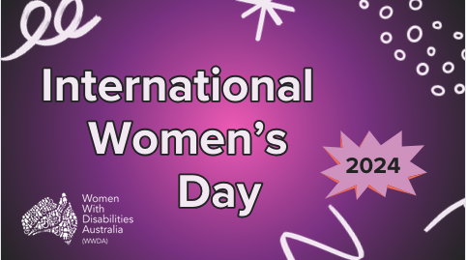
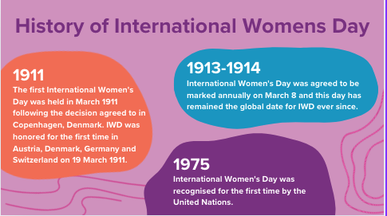
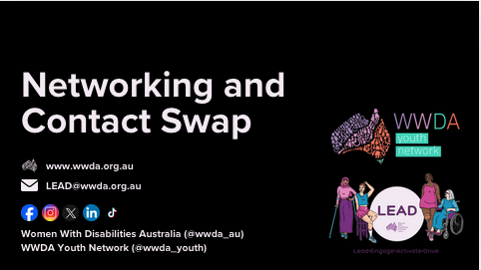
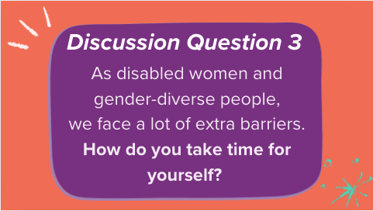
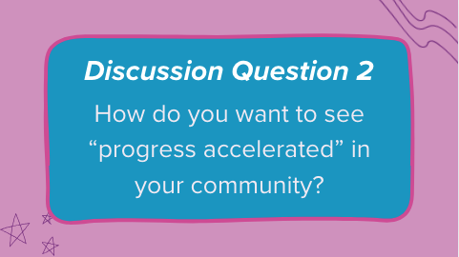
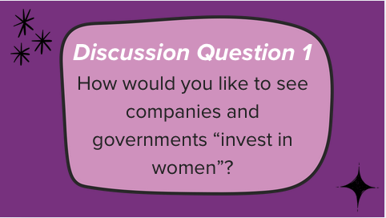
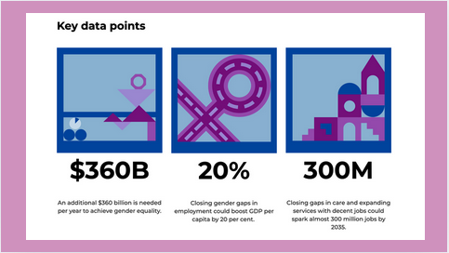
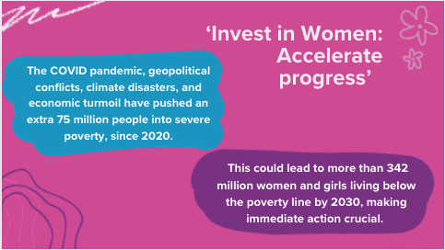

Appendix 2 – Likert Scale Survey
The Likert Scale Survey was sent out to participants of the LEAD Project after an event, activity or program had taken place. This survey gathered essential data on participant experiences of the individual outputs of the project and how those events had now changed or influenced their perception of leadership. Below is the form that was sent out to participants.
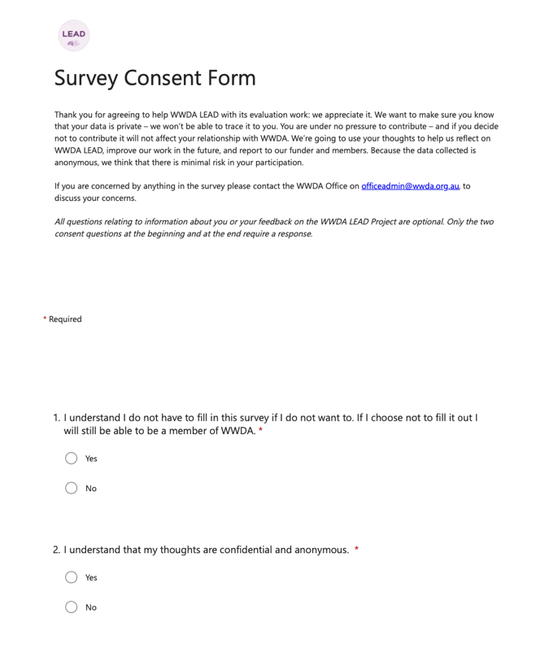
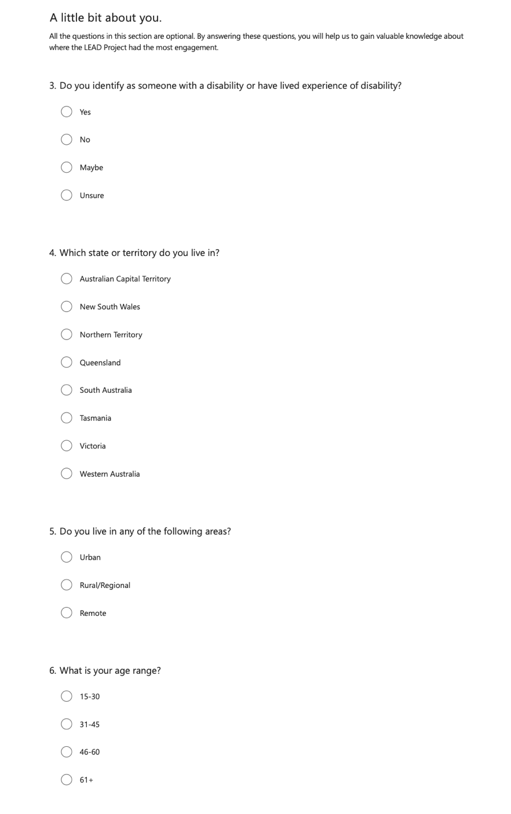
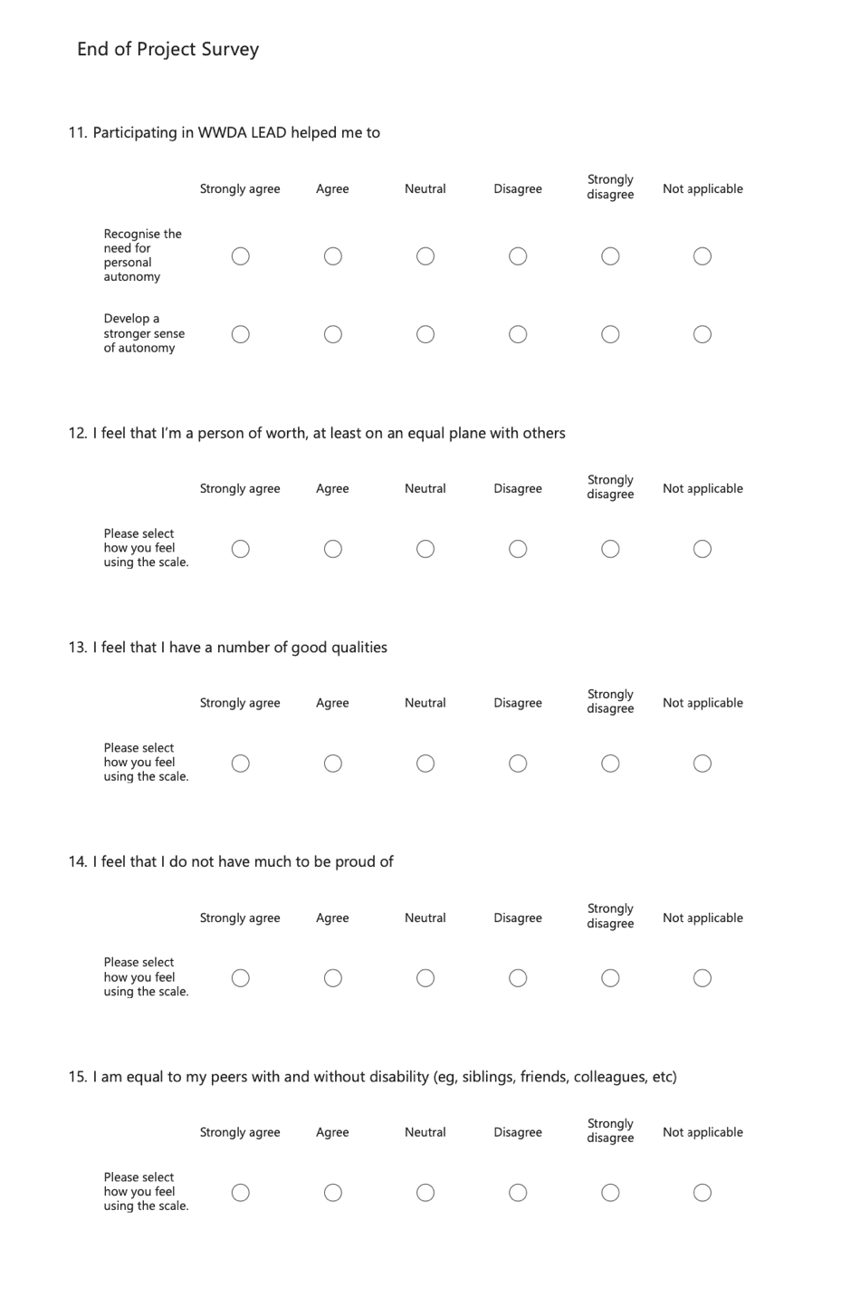
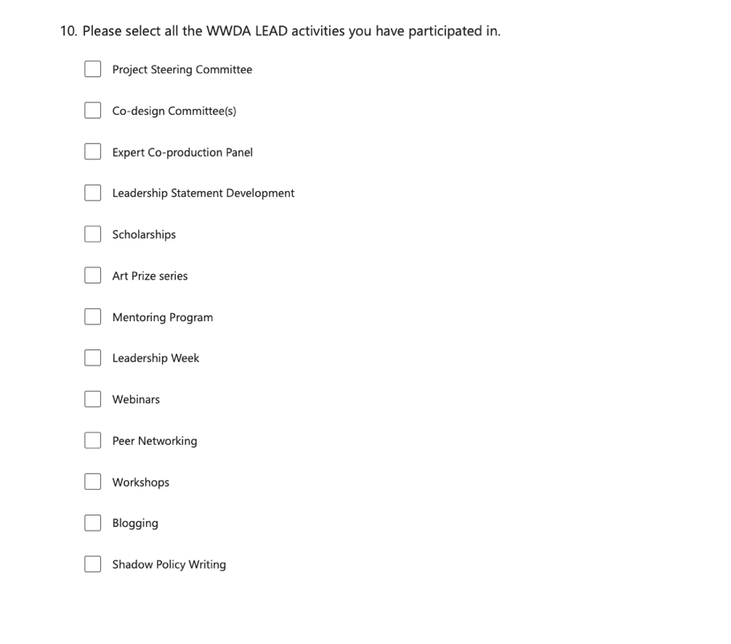
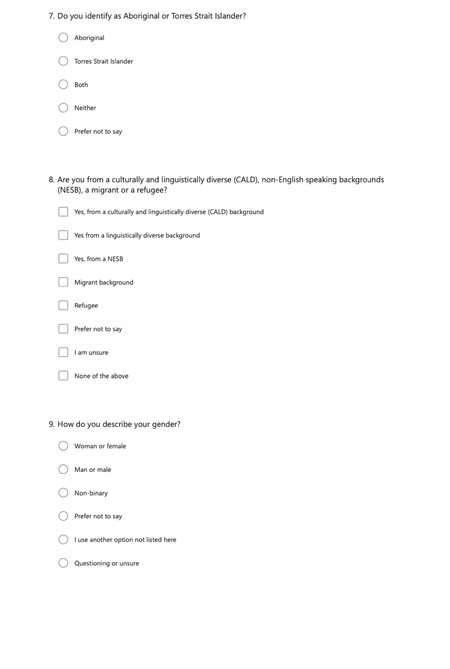
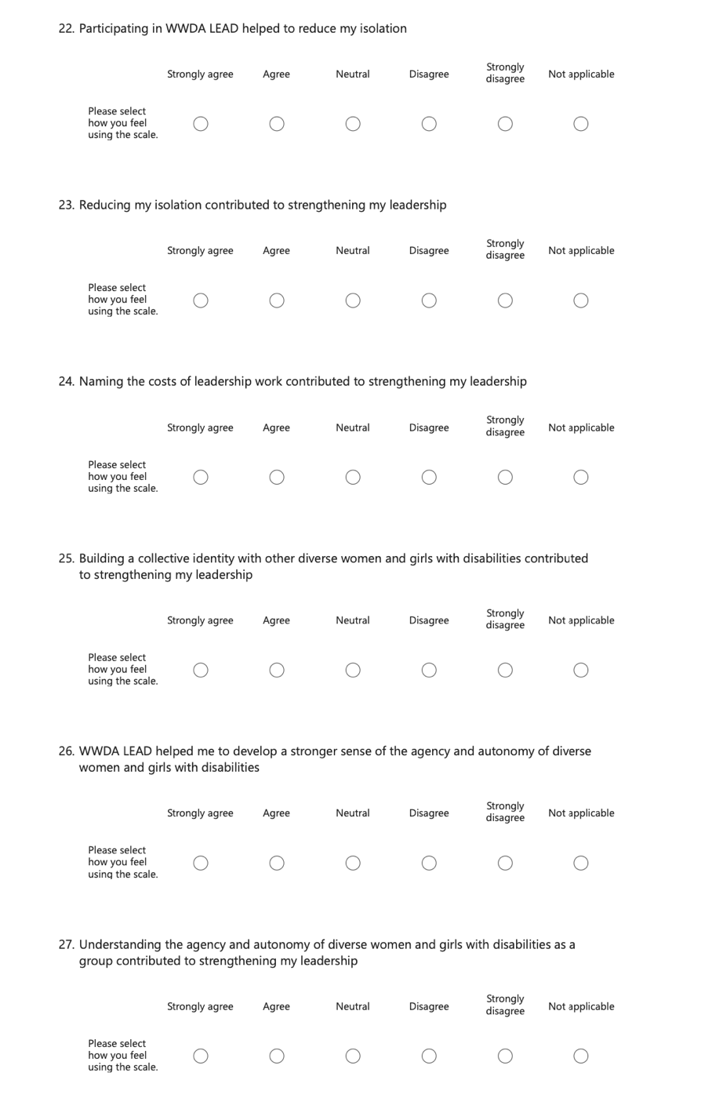
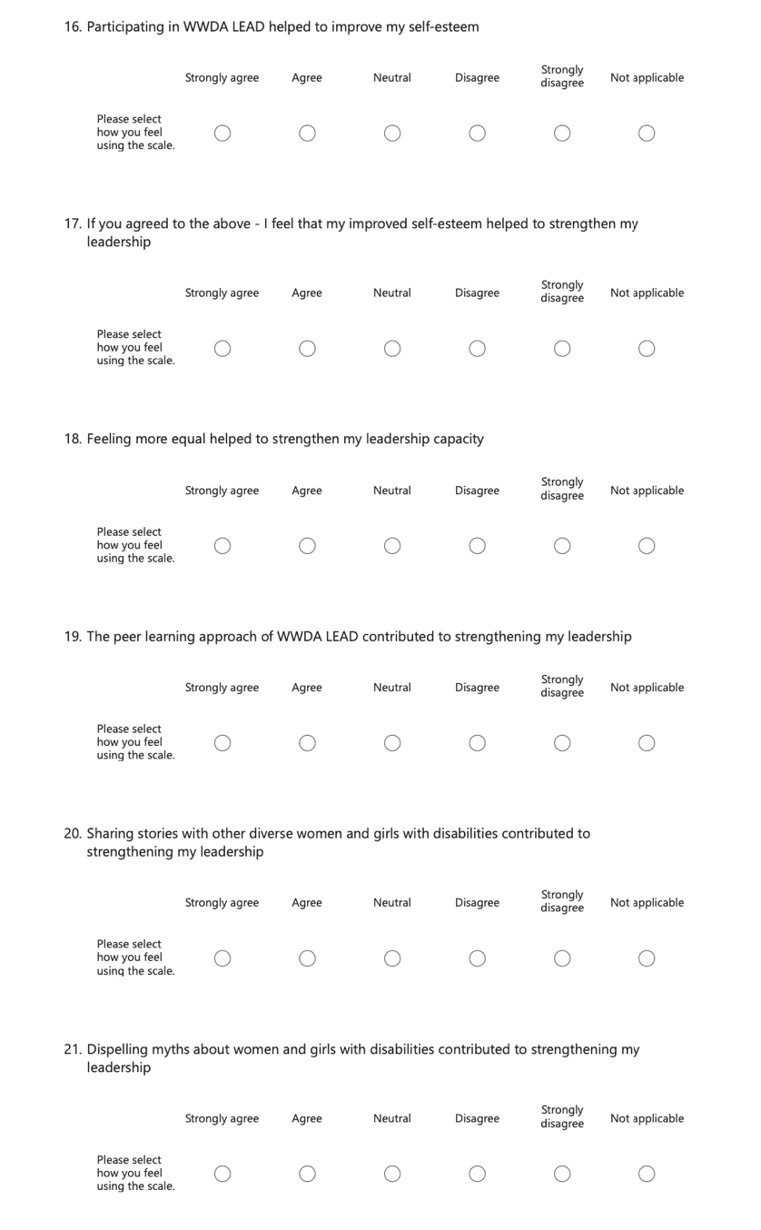
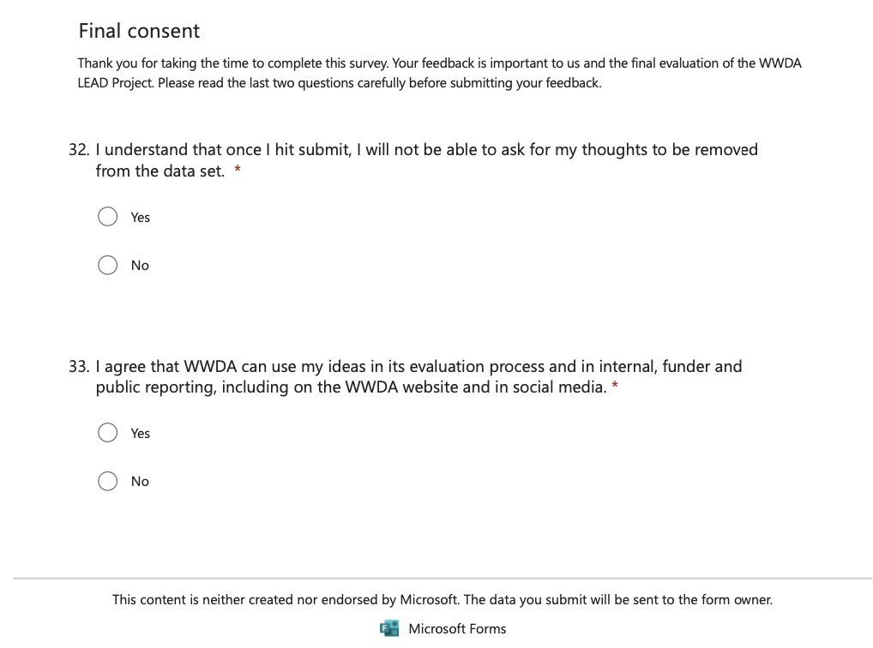
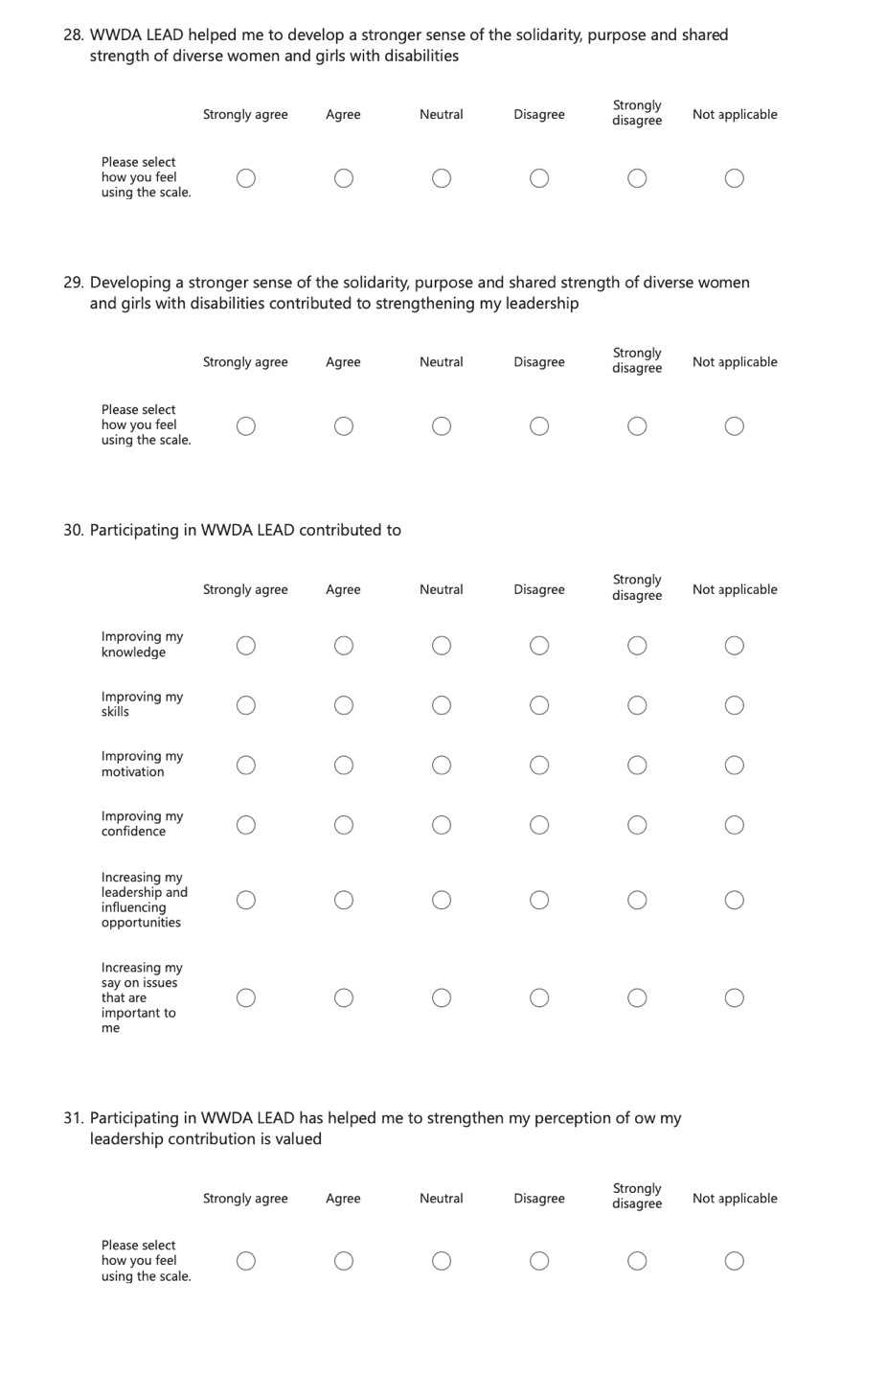

Appendix 3 – Annual Member Survey
The LEAD team developed an annual Member Survey for WWDA to release to gather feedback on areas of improvement for the organisation and key areas for WWDA to focus on regarding policy. Below is the cover page for the Easy Read version of the survey. The survey can be found on the WWDA website in multiple accessible formats.
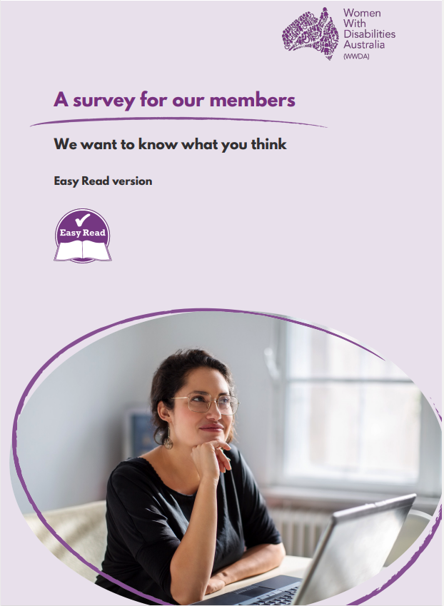

Appendix 4 – Peer Networking Survey

The LEAD Peer Networking Survey was open between the 25th January 2024 and the 19th March 2024. This survey was formed to capture the insight and feedback from participants of Peer Networking sessions during the three-year period that these events were held. Below is the survey that was sent to all participants.
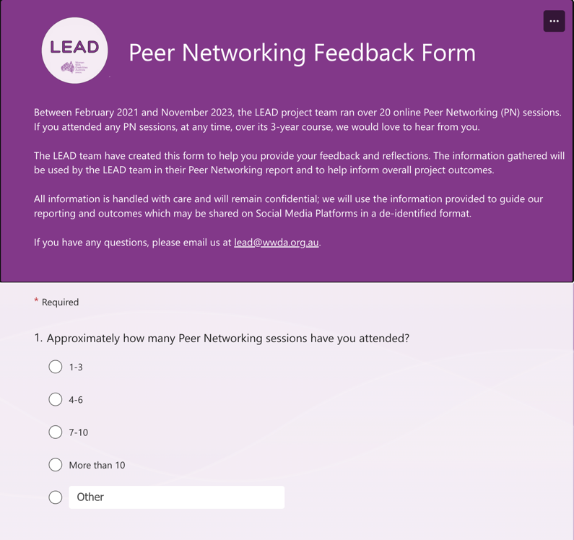
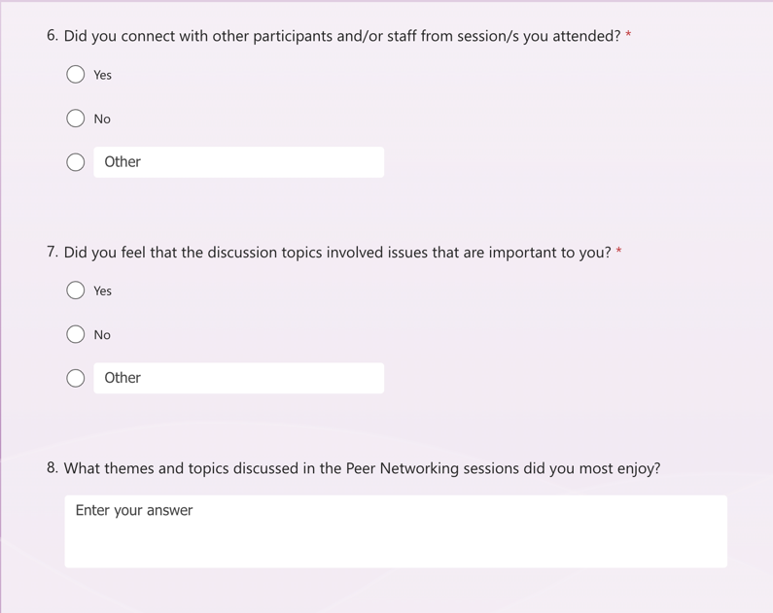

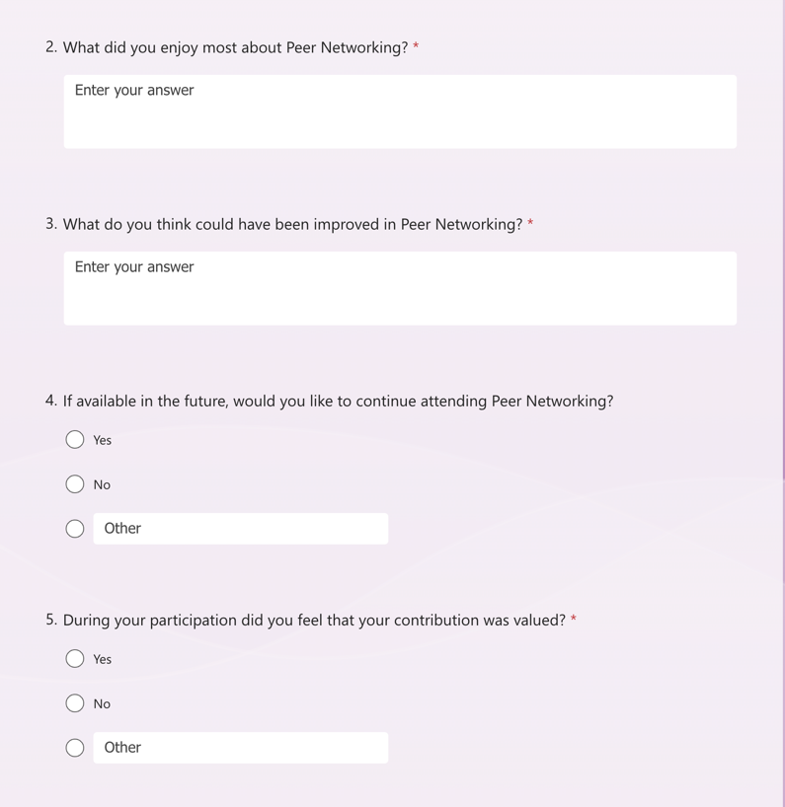
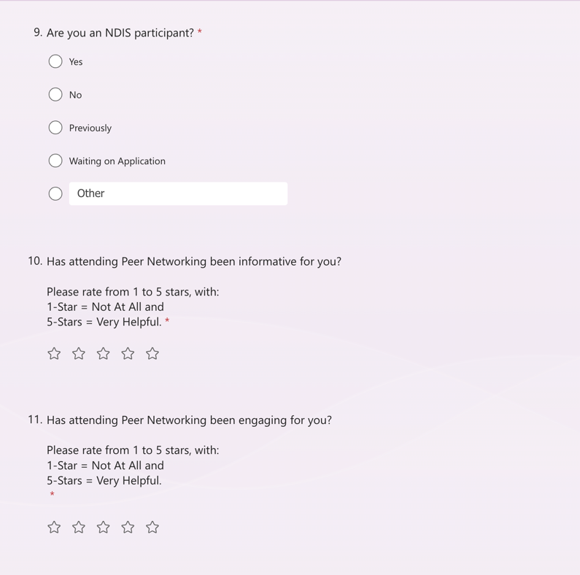
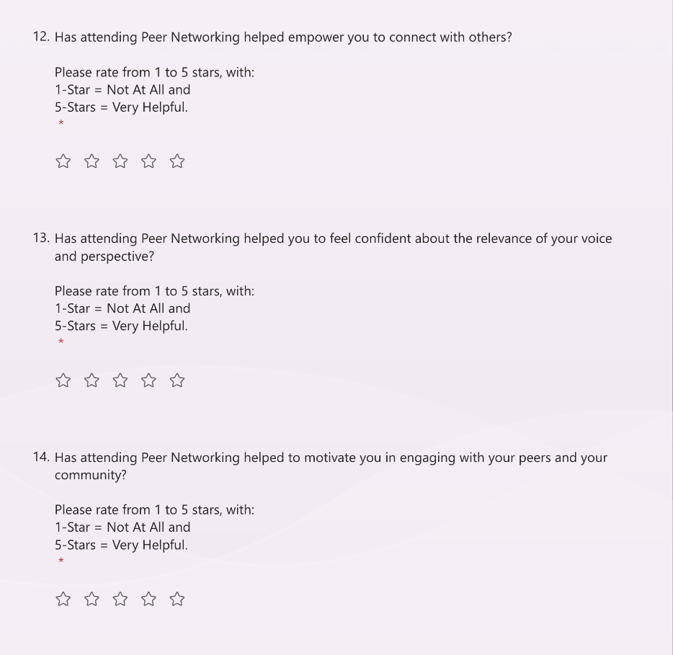

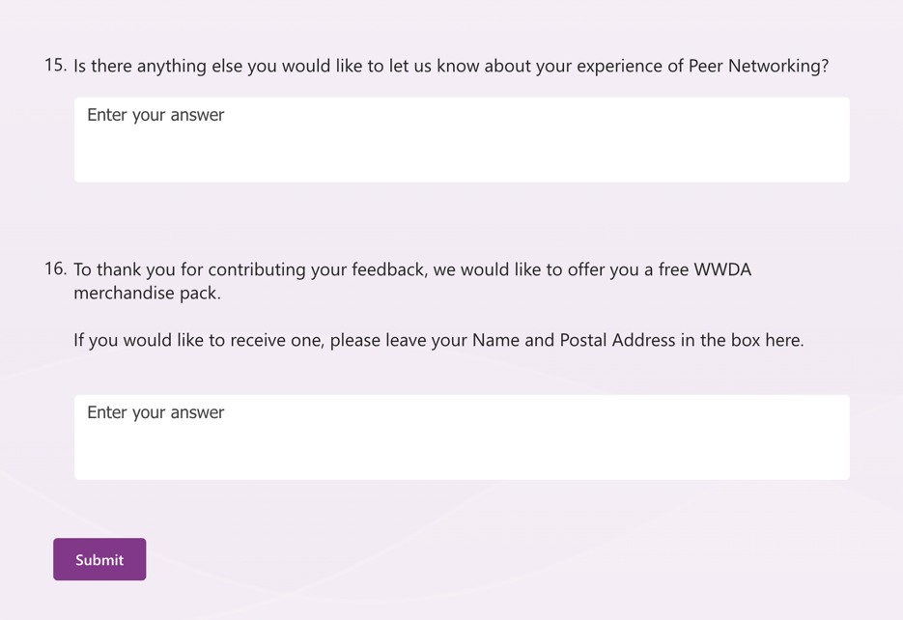

Appendix 5 – Leadership and Mentoring Toolkit – Post-launch survey
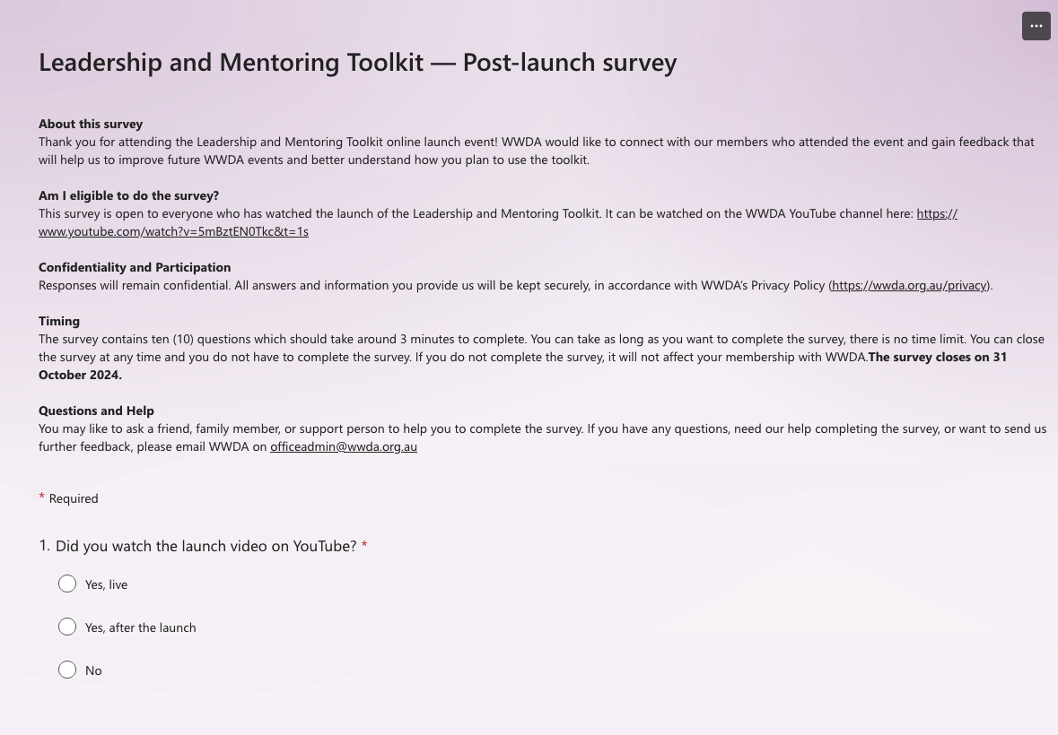
Following the launch of the Leadership and Mentoring Toolkit, the LEAD team sent out a survey to all registrants of the event to gather feedback of their experience of the launch and how WWDA could improve an event like this in the future.

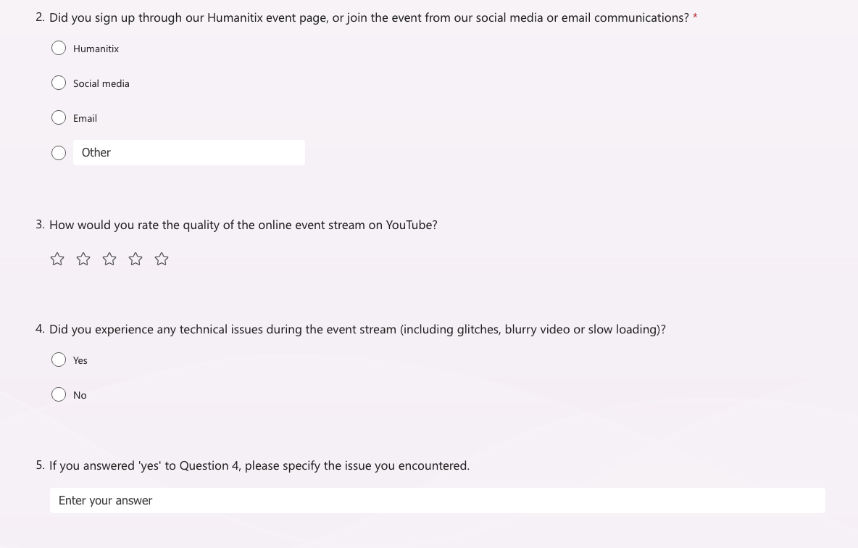
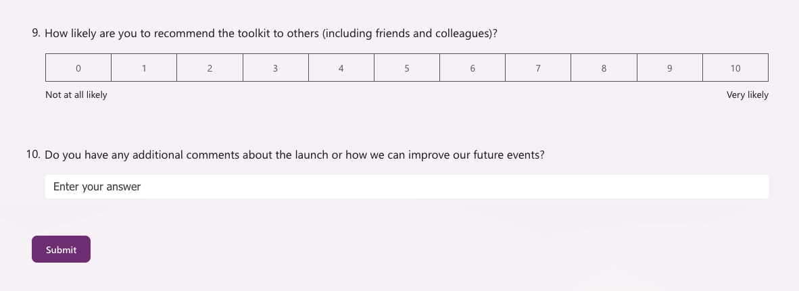
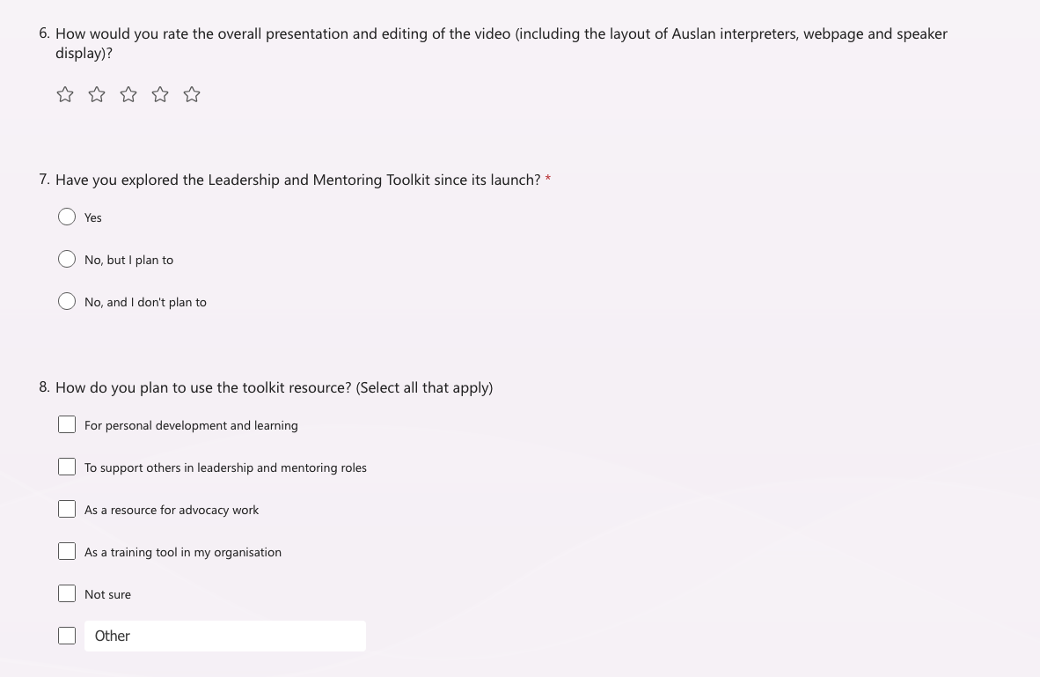

Appendix 6 – Member Skills and Interest Survey
The purpose of the Member Skills and Interest Survey was to collect information on members that would like to participate in opportunities for WWDA in the future. Data submitted from this survey has been added to each member profile.
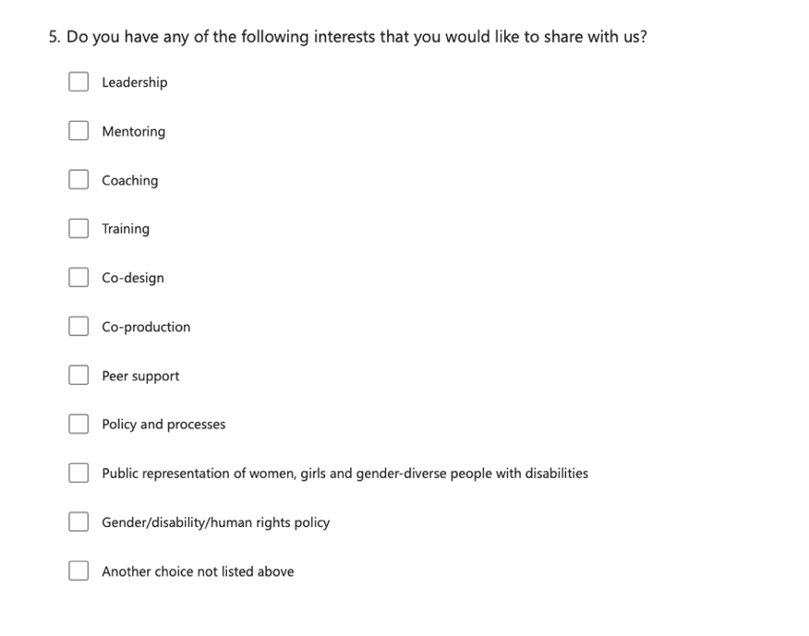
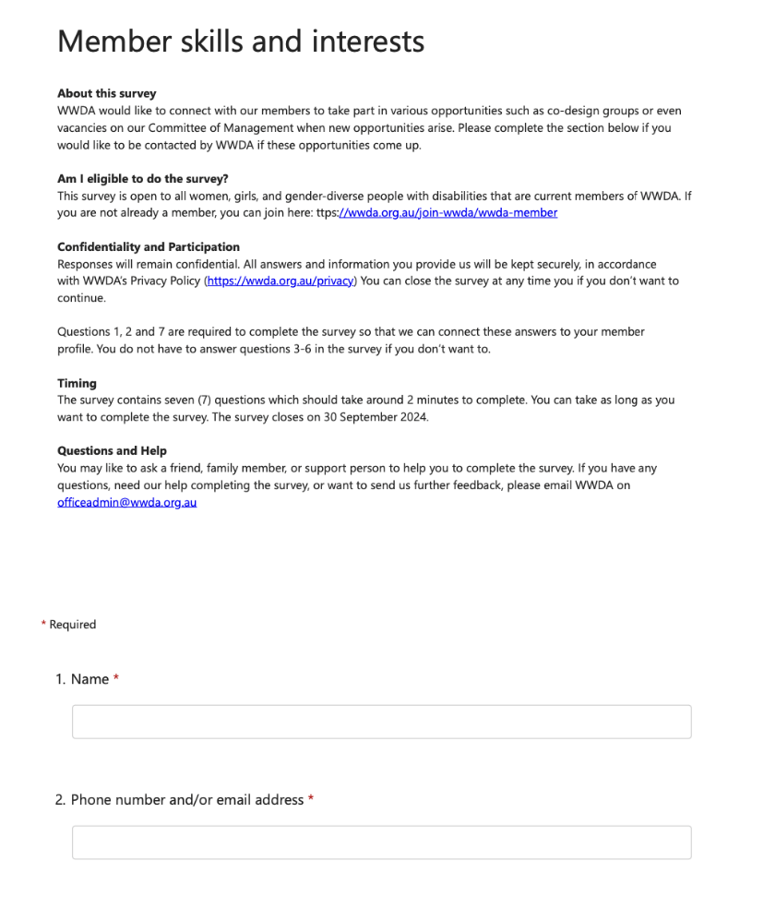
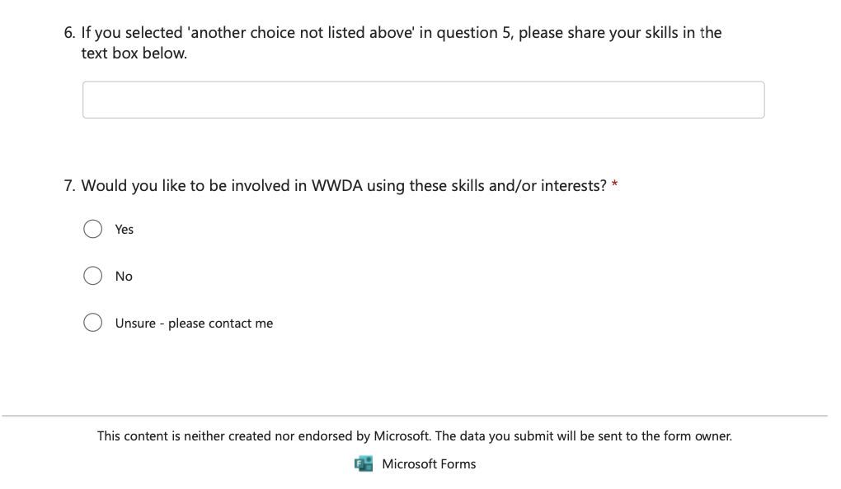
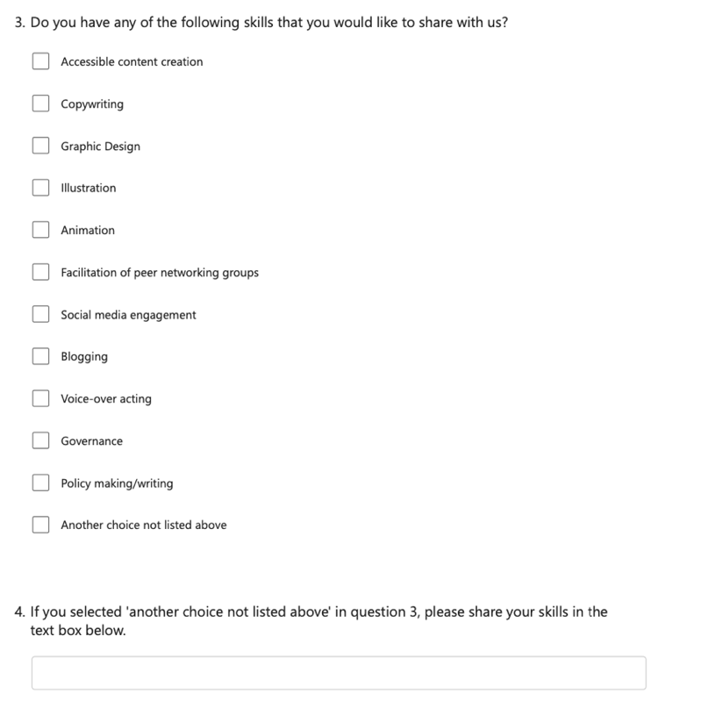

Appendix 7 – Membership Engagement Strategy
Below is the PowerPoint presentation that was presented at one of the LEAD PSC meetings in 2024.
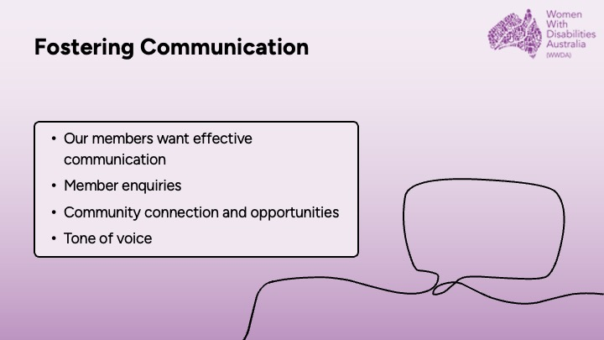
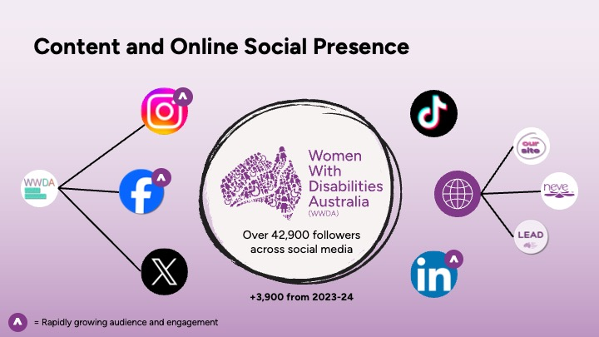
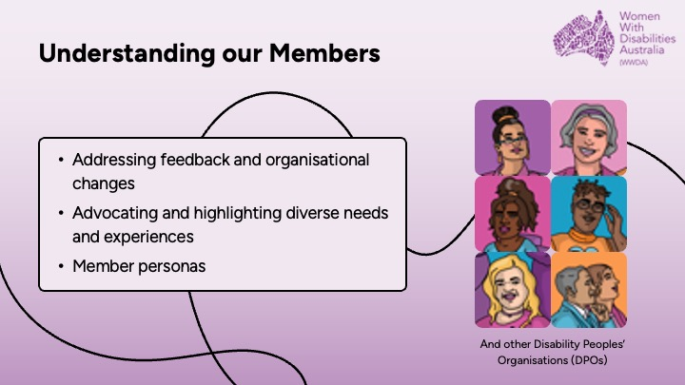
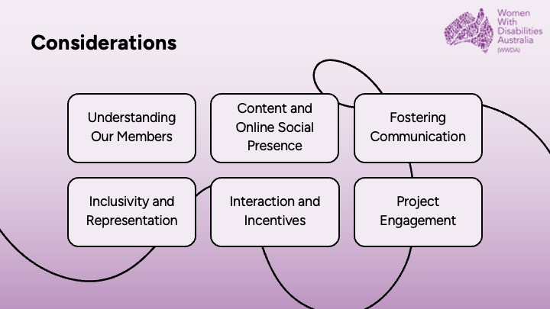
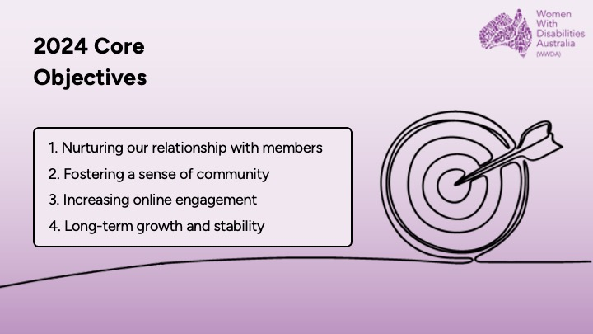
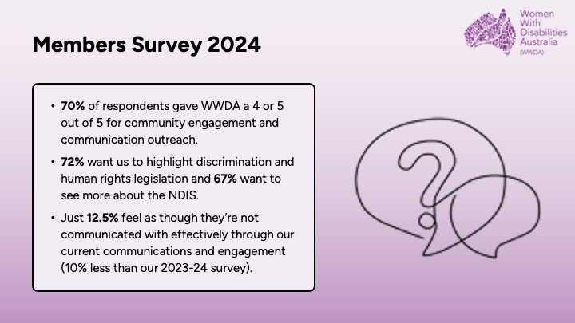
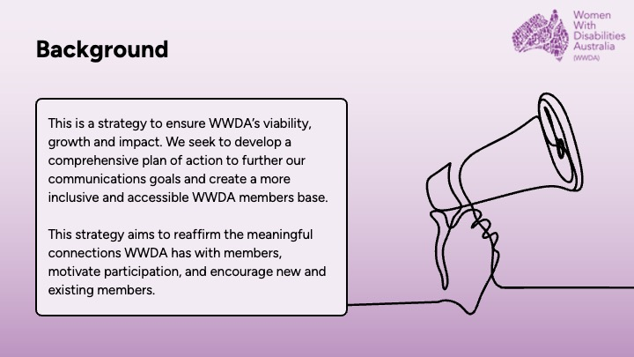
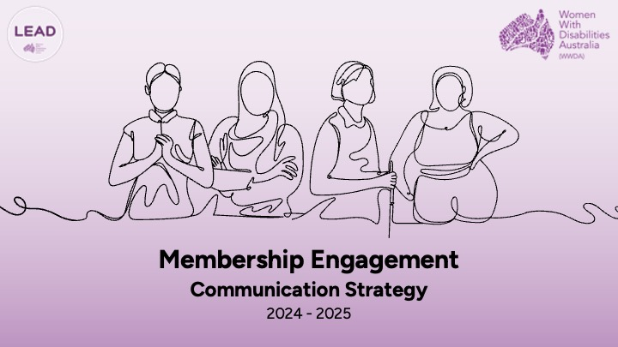
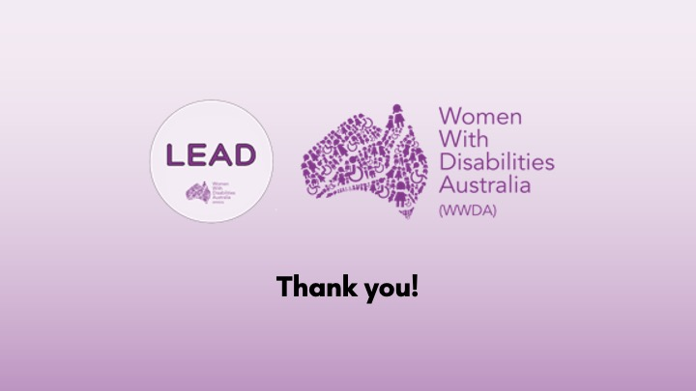
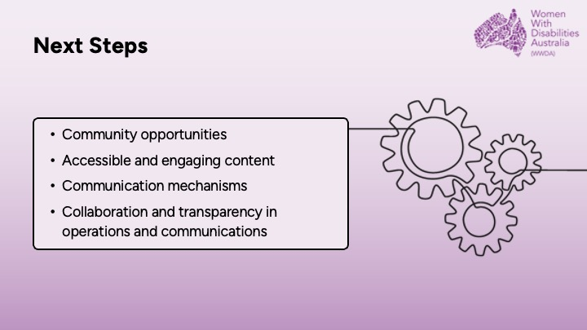
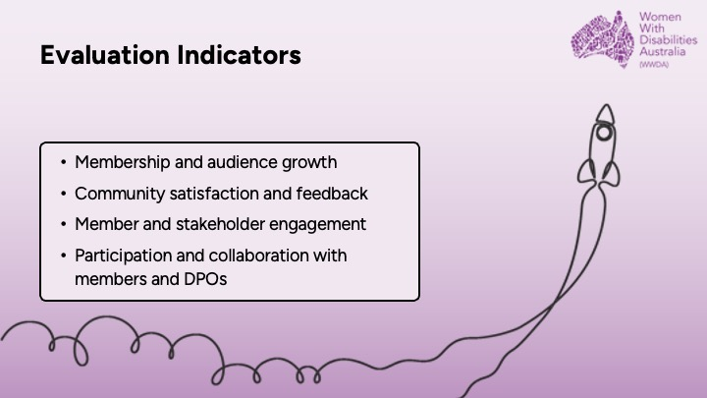
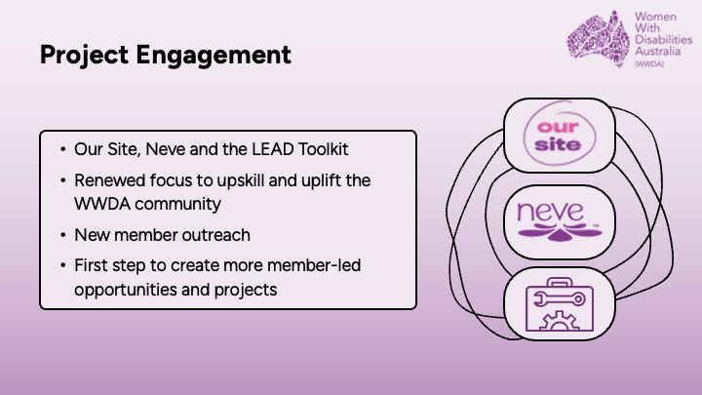
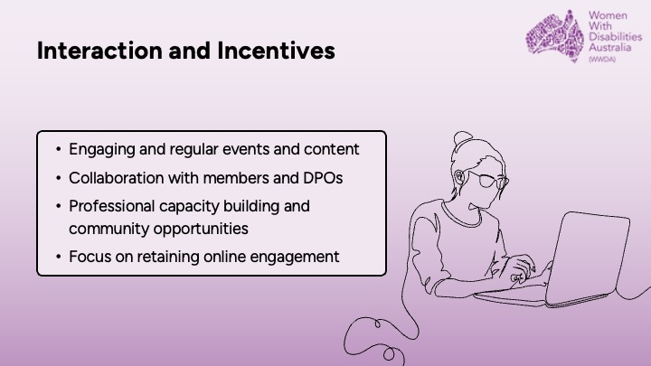
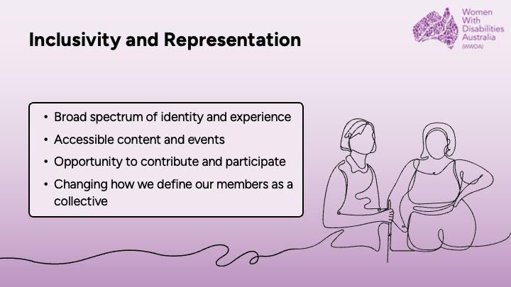

Appendix 8 – Monitoring, Evaluation and Learning
WWDA LEAD Monitoring, Evaluation and Learning Tools were provided in Word, PDF, and Easy Read. You can find all the information on our website here: https://wwda.org.au/home/wwda-lead-monitoring-evaluation-and-learning/
Below is the cover page for the Easy Read version of the MEL information provided to participants of the LEAD Project, which can be found on the link above.

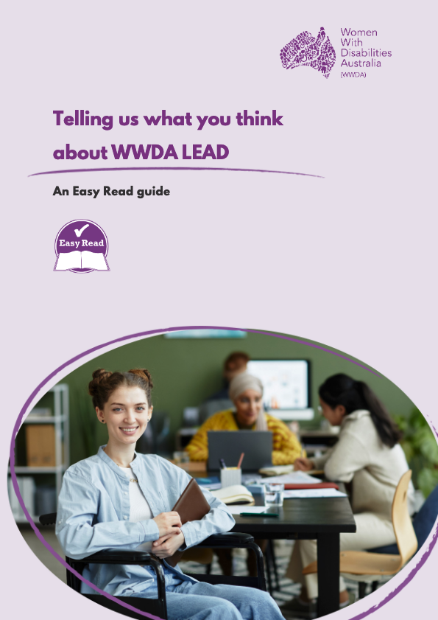

Section 8: Endnotes

- Women with Disabilities Australia (WWDA) (2020). ‘Response to the Employment Issues Paper of the Royal Commission into Violence, Abuse, Neglect and Exploitation of People with Disability’. August 2020. WWDA: Hobart, Tasmania.
- National Health and Medical Research Council, Australian Research Council and Universities Australia (2023). National Statement on Ethical Conduct in Human Research. Canberra: National Health and Medical Research Council.

