**WWDA 2025 Federal Election Member Social Media**

1. **Social Media Posts:**

**Social media post #1**

As we approach the 2025 Federal Election, Women With Disabilities Australia (WWDA) is calling for strong action to advance the rights, safety and wellbeing of women and girls with disabilities. Our Election Platform focuses on key areas that will create meaningful change and address systemic barriers. 

We have outlined 3 key asks to build a safer and more equitable future, including the funding of a disability-led gender-based violence working group, to guide the implementation of the National Plan to End Violence Against Women and Children.

Find out more and join us in advocating for change: <https://www.wwda.org.au/2025-federal-election-platform/>

#WWDA #2025Election #AusPol #DisabilityRights #Inclusion

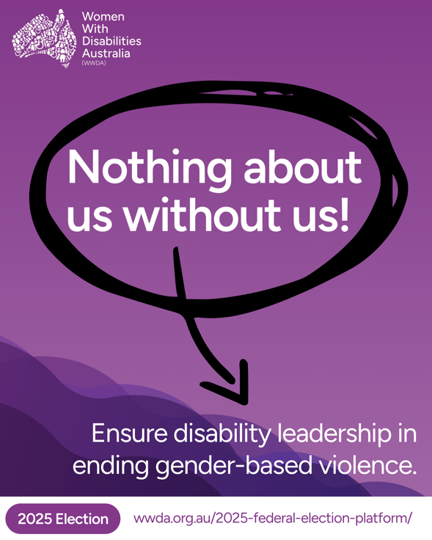

Image 1:

[Image description: This tile has a purple background, with a wavy purple pattern in the bottom half of the image. The white WWDA logo is in the top-left corner. White text reads: “Nothing about us without us! Ensure disability leadership in ending gender-based violence.” The first line is circled in black, with an arrow pointing at the second sentence. A white banner at the bottom of the tile reads: “2025 Election”, with the WWDA Federal Election platform link URL text next to it.]

**Social media post #2**

Mainstream laws, strategies and frameworks  can often ignore, avoid or misunderstand disability-specific barriers and experiences. WWDA is motivated to make sure our voices, our experiences, and our rights are considered, included and supported this election and beyond.

We deserve policies that see us, support us, and include us!

Find out more and join us in advocating for change: <https://www.wwda.org.au/2025-federal-election-platform/>

#WWDA #2025Election #NothingAboutUsWithoutUs #LivedExperienceMatters #EquityForDisabledWomen

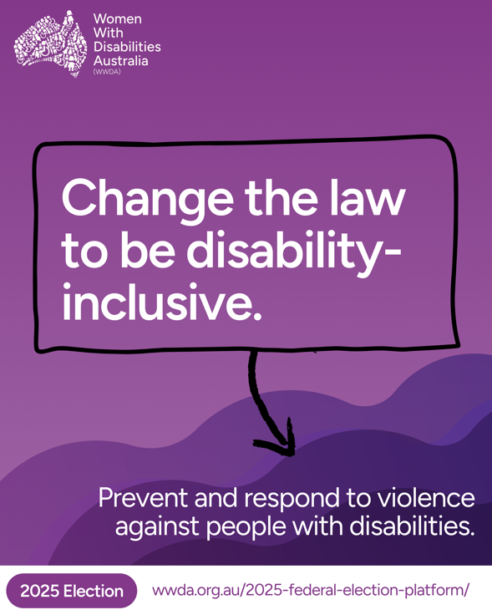

Image 2:

[Image description: This tile has a purple background, with a wavy purple pattern in the bottom half of the image. The white WWDA logo is in the top-left corner. White text reads: “ Change the law to be disability-inclusive. End violence with inclusive policies and support.” The first line is outlined in black, with an arrow pointing at the second sentence. A white banner at the bottom of the tile reads: “2025 Election”, with the WWDA Federal Election platform link URL text next to it.]

**Social media post #3**

As we approach the 2025 Federal Election, Women With Disabilities Australia (WWDA) is calling for strong action to advance the rights, safety and wellbeing of women and girls with disabilities. Our Election Platform focuses on key areas that will create meaningful change and address systemic barriers. 

We have outlined3 key asks to build a safer and more equitable future, including gender-responsive foundational supports for people with chronic health conditions, so they can get the support they need.

Find out more and join us in advocating for change: <https://www.wwda.org.au/2025-federal-election-platform/>

#WWDA #2025Election #AusPol #DisabilityRights #Inclusion

Image 3:

[Image description: This tile has a purple background with a wavy purple pattern in the bottom half of the image. The white WWDA logo is in the top-left corner. White text reads: “ Support for people with chronic health conditions. Improve access to disability support.” The first line is circled in black, with an arrow pointing at the second sentence. A white banner at the bottom of the tile reads: “2025 Election”, with the WWDA Federal Election platform link URL text next to it.]