**WWDA 2025 Federal Election Social Media Posts:**

**Facebook & LinkedIn**

As we approach the 2025 Federal Election, Women With Disabilities Australia (WWDA) is calling for strong action to advance the rights, safety and wellbeing of women and girls with disabilities. WWDA’s election platform focuses on key areas that will create meaningful change and address systemic barriers.  
  
We support WWDA in advocating for:  
🔹 A disability-led gender-based violence working group.  
🔹 Reform of legal definitions of ‘domestic and family violence’ to ensure they are disability-inclusive.  
🔹 Gender-responsive foundational supports for people with chronic health conditions.

WWDA’s election platform outlines key reforms to build a safer, more equitable future.   
Join us in advocating for change!  
  
Read more: <https://wwda.org.au/2025-federal-election-platform/>  
  
[#WWDA](https://www.facebook.com/hashtag/wwda?__eep__=6&__cft__%5b0%5d=AZVFEfIAjUdMiaYqu_yaYX8Qde_xCKO23_l6nA90nMnyqf2Vqb4UUcQTwqtGoIWSHQXSULgKayO_akC_4M_BIL7FfLpVs4-AQPBoImioabt8eEm8LJvQVY0H3Y_kUInytsc0HVTYuo6RzDzjxtX7kYIlW-t61JIcPEBPzsOEbTBZ1Zv_4_vLLTFNtpqn4v6QVnM&__tn__=*NK-R) [#2025Election](https://www.facebook.com/hashtag/2025election?__eep__=6&__cft__%5b0%5d=AZVFEfIAjUdMiaYqu_yaYX8Qde_xCKO23_l6nA90nMnyqf2Vqb4UUcQTwqtGoIWSHQXSULgKayO_akC_4M_BIL7FfLpVs4-AQPBoImioabt8eEm8LJvQVY0H3Y_kUInytsc0HVTYuo6RzDzjxtX7kYIlW-t61JIcPEBPzsOEbTBZ1Zv_4_vLLTFNtpqn4v6QVnM&__tn__=*NK-R) [#AusPol](https://www.facebook.com/hashtag/auspol?__eep__=6&__cft__%5b0%5d=AZVFEfIAjUdMiaYqu_yaYX8Qde_xCKO23_l6nA90nMnyqf2Vqb4UUcQTwqtGoIWSHQXSULgKayO_akC_4M_BIL7FfLpVs4-AQPBoImioabt8eEm8LJvQVY0H3Y_kUInytsc0HVTYuo6RzDzjxtX7kYIlW-t61JIcPEBPzsOEbTBZ1Zv_4_vLLTFNtpqn4v6QVnM&__tn__=*NK-R) [#DisabilityRights](https://www.facebook.com/hashtag/disabilityrights?__eep__=6&__cft__%5b0%5d=AZVFEfIAjUdMiaYqu_yaYX8Qde_xCKO23_l6nA90nMnyqf2Vqb4UUcQTwqtGoIWSHQXSULgKayO_akC_4M_BIL7FfLpVs4-AQPBoImioabt8eEm8LJvQVY0H3Y_kUInytsc0HVTYuo6RzDzjxtX7kYIlW-t61JIcPEBPzsOEbTBZ1Zv_4_vLLTFNtpqn4v6QVnM&__tn__=*NK-R) [#SupportDisabilitySupport](https://www.facebook.com/hashtag/supportdisabilitysupport?__eep__=6&__cft__%5b0%5d=AZVFEfIAjUdMiaYqu_yaYX8Qde_xCKO23_l6nA90nMnyqf2Vqb4UUcQTwqtGoIWSHQXSULgKayO_akC_4M_BIL7FfLpVs4-AQPBoImioabt8eEm8LJvQVY0H3Y_kUInytsc0HVTYuo6RzDzjxtX7kYIlW-t61JIcPEBPzsOEbTBZ1Zv_4_vLLTFNtpqn4v6QVnM&__tn__=*NK-R)

**Instagram**

As we approach the 2025 Federal Election, Women With Disabilities Australia (WWDA) is calling for strong action to advance the rights, safety and wellbeing of women and girls with disabilities. WWDA’s election platform focuses on key areas that will create meaningful change and address systemic barriers.  
  
We support WWDA in advocating for:  
🔹 A disability-led gender-based violence working group.  
🔹 Reform of legal definitions of ‘domestic and family violence’ to ensure they are disability-inclusive.  
🔹Gender-responsive foundational supports for people with chronic health conditions.

WWDA’s election platform outlines key reforms to build a safer, more equitable future. Join us in advocating for change! Share this post, tag your local candidates, and call for action.  
  
Read more at wwda.org.au/2025-federal-election-platform/ or search for ‘wwda 2025 federal election’.   
  
[#WWDA](https://www.facebook.com/hashtag/wwda?__eep__=6&__cft__%5b0%5d=AZVFEfIAjUdMiaYqu_yaYX8Qde_xCKO23_l6nA90nMnyqf2Vqb4UUcQTwqtGoIWSHQXSULgKayO_akC_4M_BIL7FfLpVs4-AQPBoImioabt8eEm8LJvQVY0H3Y_kUInytsc0HVTYuo6RzDzjxtX7kYIlW-t61JIcPEBPzsOEbTBZ1Zv_4_vLLTFNtpqn4v6QVnM&__tn__=*NK-R) [#2025Election](https://www.facebook.com/hashtag/2025election?__eep__=6&__cft__%5b0%5d=AZVFEfIAjUdMiaYqu_yaYX8Qde_xCKO23_l6nA90nMnyqf2Vqb4UUcQTwqtGoIWSHQXSULgKayO_akC_4M_BIL7FfLpVs4-AQPBoImioabt8eEm8LJvQVY0H3Y_kUInytsc0HVTYuo6RzDzjxtX7kYIlW-t61JIcPEBPzsOEbTBZ1Zv_4_vLLTFNtpqn4v6QVnM&__tn__=*NK-R) [#AusPol](https://www.facebook.com/hashtag/auspol?__eep__=6&__cft__%5b0%5d=AZVFEfIAjUdMiaYqu_yaYX8Qde_xCKO23_l6nA90nMnyqf2Vqb4UUcQTwqtGoIWSHQXSULgKayO_akC_4M_BIL7FfLpVs4-AQPBoImioabt8eEm8LJvQVY0H3Y_kUInytsc0HVTYuo6RzDzjxtX7kYIlW-t61JIcPEBPzsOEbTBZ1Zv_4_vLLTFNtpqn4v6QVnM&__tn__=*NK-R) [#DisabilityRights](https://www.facebook.com/hashtag/disabilityrights?__eep__=6&__cft__%5b0%5d=AZVFEfIAjUdMiaYqu_yaYX8Qde_xCKO23_l6nA90nMnyqf2Vqb4UUcQTwqtGoIWSHQXSULgKayO_akC_4M_BIL7FfLpVs4-AQPBoImioabt8eEm8LJvQVY0H3Y_kUInytsc0HVTYuo6RzDzjxtX7kYIlW-t61JIcPEBPzsOEbTBZ1Zv_4_vLLTFNtpqn4v6QVnM&__tn__=*NK-R) [#SupportDisabilitySupport](https://www.facebook.com/hashtag/supportdisabilitysupport?__eep__=6&__cft__%5b0%5d=AZVFEfIAjUdMiaYqu_yaYX8Qde_xCKO23_l6nA90nMnyqf2Vqb4UUcQTwqtGoIWSHQXSULgKayO_akC_4M_BIL7FfLpVs4-AQPBoImioabt8eEm8LJvQVY0H3Y_kUInytsc0HVTYuo6RzDzjxtX7kYIlW-t61JIcPEBPzsOEbTBZ1Zv_4_vLLTFNtpqn4v6QVnM&__tn__=*NK-R)

**X/ Threads/ Bluesky**

This election, we support @WWDA_AU in calling for action!

1. Disability-led gender-based violence working group.
2. Reform of legal definitions of ‘domestic and family violence’.
3. Gender-responsive foundational supports.

<https://wwda.org.au/2025-federal-election-platform/>

[#2025Election](https://www.facebook.com/hashtag/2025election?__eep__=6&__cft__%5b0%5d=AZXJvz7YAFi0aH1QHIFrkfbn_q1QMmyflhrlPL99xRSjbgaIh2TdWIImPM3WtF3zrhhqk86mCUMuMlvc4fZJOpHcpQ-xGAsBY9EjnDITny8kBk1uLOe55lIczDrHd_U0T2dRPDGb6FkDZFnihJoN20EQ2ujADMEismAD6lzjipB6JdR2CktWW2vb2pXjUUO1VhE&__tn__=*NK-R) [#AusPol](https://www.facebook.com/hashtag/auspol?__eep__=6&__cft__%5b0%5d=AZXJvz7YAFi0aH1QHIFrkfbn_q1QMmyflhrlPL99xRSjbgaIh2TdWIImPM3WtF3zrhhqk86mCUMuMlvc4fZJOpHcpQ-xGAsBY9EjnDITny8kBk1uLOe55lIczDrHd_U0T2dRPDGb6FkDZFnihJoN20EQ2ujADMEismAD6lzjipB6JdR2CktWW2vb2pXjUUO1VhE&__tn__=*NK-R) [#DisabilityRights](https://www.facebook.com/hashtag/genderbasedviolence?__eep__=6&__cft__%5b0%5d=AZXJvz7YAFi0aH1QHIFrkfbn_q1QMmyflhrlPL99xRSjbgaIh2TdWIImPM3WtF3zrhhqk86mCUMuMlvc4fZJOpHcpQ-xGAsBY9EjnDITny8kBk1uLOe55lIczDrHd_U0T2dRPDGb6FkDZFnihJoN20EQ2ujADMEismAD6lzjipB6JdR2CktWW2vb2pXjUUO1VhE&__tn__=*NK-R)

**Image/s**

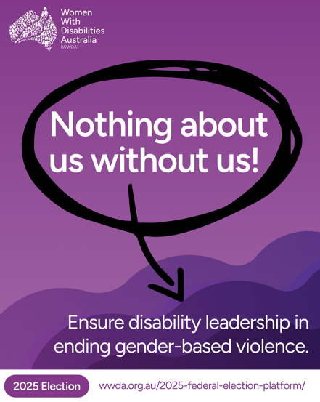 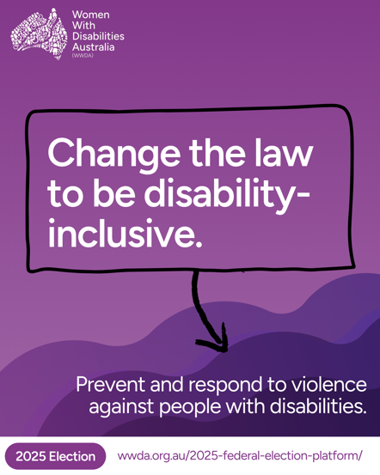 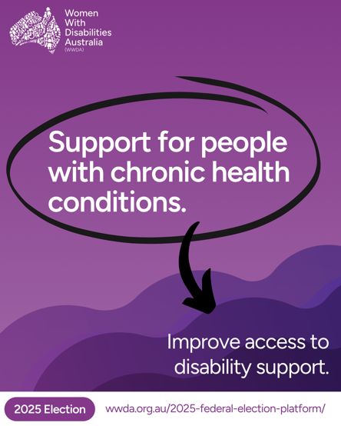

Image 1:

[Image description: This tile has a purple background, with a wavy purple pattern in the bottom half of the image. The white WWDA logo is in the top-left corner. White text reads: “Nothing about us without us! Ensure disability leadership in ending gender-based violence.” The first line is circled in black, with an arrow pointing at the second sentence. A white banner at the bottom of the tile reads: “2025 Election”, with the WWDA Federal Election platform link URL text next to it.]

Image 2:

[Image description: This tile has a purple background, with a wavy purple pattern in the bottom half of the image. The white WWDA logo is in the top-left corner. White text reads: “ Change the law to be disability-inclusive. End violence with inclusive policies and support.” The first line is outlined in black, with an arrow pointing at the second sentence. A white banner at the bottom of the tile reads: “2025 Election”, with the WWDA Federal Election platform link URL text next to it.]

Image 3:

[Image description: This tile has a purple background with a wavy purple pattern in the bottom half of the image. The white WWDA logo is in the top-left corner. White text reads: “ Support for people with chronic health conditions. Improve access to disability support.” The first line is circled in black, with an arrow pointing at the second sentence. A white banner at the bottom of the tile reads: “2025 Election”, with the WWDA Federal Election platform link URL text next to it.]