Disability representative organisations call for accountability after NDIA conduct targeting person with disability

Joint Statement by Disability Representative Organisations

**10 July 2025**

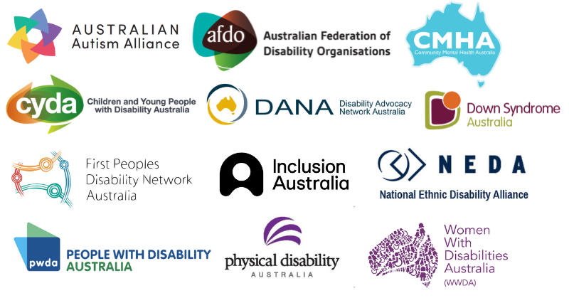

People with disability, families, kin and organisations are appalled and outraged by the actions taken by the National Disability Insurance Agency to remove a person with disability from the National Disability Insurance Scheme in apparent retaliation for expressing their views on social media about the Scheme.

Early this week, a group of Disability Representative Organisations (DROs) representatives wrote to the Acting CEO of the NDIA seeking urgent clarification on a number of issues pertaining to the report in the Saturday Paper on 5 July 2025. The NDIA confirmed their actions, but did not provide the answers we were seeking. Their response instead asserted the legality and alignment of all actions with the NDIS Act. We have grave concerns that they confirmed an eligibility reassessment had been in part triggered by the individual’s social media content.

DROs believe these actions have crossed a line and threaten any level of trust between the NDIA and the disability community. Advice, opinions about, or criticisms of the NDIS or NDIA are entirely separate from an individual's eligibility for the Scheme and vital need for supports, both in the law and the intent of the Scheme.

People with disability who rely on NDIS supports must not be placed at risk or live in fear that they will be summarily removed from the Scheme for their advocacy, views or any arbitrary decision of senior NDIA staff. If there are concerns about whether a person with disability meets the eligibility criteria for the NDIS, this must be dealt with in accordance with procedural fairness and operational guidelines.

The NDIA, like all government agencies and departments, must act in the public interest, and in this case, in the interests of people with disability.

We call for the following immediate and urgent actions:

* Establish an urgent, independent inquiry into the actions of the NDIA in this case, and potentially others, where the Agency has acted to remove people with disability from the NDIS without due process or fair treatment. The inquiry should be conducted by the Commonwealth Ombudsman, in consultation with the Disability Discrimination Commissioner, and be open to additional contributions from people with disability, families, kin and organisations. Anonymity and protection throughout any established inquiry is paramount.
* Release any and all legal advice that led to these actions.
* Hold an urgent roundtable between Disability Representative Organisations, the NDIA Acting CEO and senior staff, and NDIS Minister McAllister to discuss a way forward.

# About our organisations

This statement was developed by DROs with coordination support from Disability Advocacy Network Australia (DANA) in their role as the National Coordination. DROs are funded by the Department of Social Services (DSS) to represent people with disability.

The following organisations have contributed to and/or expressed their support for this joint position statement

* Australian Autism Alliance
* Australian Federation of Disability Organisations
* Children and Young People with Disability Australia
* Community Mental Health Australia
* Disability Advocacy Network Australia
* Down Syndrome Australia
* First Peoples Disability Network Australia
* Inclusion Australia
* National Ethnic Disability Alliance
* People with Disability Australia
* Physical Disability Australia
* Women With Disabilities Australia